**3GPP TSG-SA4 Meeting #127-bis-e *in revision of S4-240672***

**April 8 – 12 April 2024**

|  |  |  |  |  |  |  |  |  |
| --- | --- | --- | --- | --- | --- | --- | --- | --- |
| *CR-Form-v12.2* | | | | | | | | |
| **CHANGE REQUEST** | | | | | | | | |
|  | | | | | | | | |
|  | **26.8xx** | **pCR** | xxxx | **rev** | **-** | **Current version:** | **0.0.0** |  |
|  | | | | | | | | |
| *For* [***HELP***](http://www.3gpp.org/3G_Specs/CRs.htm#_blank)*on using this form: comprehensive instructions can be found at* [*http://www.3gpp.org/Change-Requests*](http://www.3gpp.org/Change-Requests)*.* | | | | | | | | |
|  | | | | | | | | |

|  |  |  |  |  |  |  |  |  |
| --- | --- | --- | --- | --- | --- | --- | --- | --- |
| ***Proposed change affects:*** | UICC apps |  | ME | **x** | Radio Access Network |  | Core Network | **x** |

|  |  |  |  |  |  |  |  |  |  |  |
| --- | --- | --- | --- | --- | --- | --- | --- | --- | --- | --- |
|  | | | | | | | | | | |
| ***Title:*** | Introduction of application-layer FEC schemes for Key issue #3 | | | | | | | | | |
|  |  | | | | | | | | | |
| ***Source to WG:*** | Qualcomm, Inc., Hisilicon Huawei | | | | | | | | | |
| ***Source to TSG:*** | S4 | | | | | | | | | |
|  |  | | | | | | | | | |
| ***Work item code:*** | FS_5G_RTP | | | | |  | ***Date:*** | | | 2024-04-02 |
| ***3*** |  | | | |  | |  | | |  |
| ***Category:*** | **B** |  | | | | | ***Release:*** | | | 19 |
|  | *Use one of the following categories:* ***F*** *(correction)* ***A*** *(mirror corresponding to a change in an earlier release)* ***B*** *(addition of feature),* ***C*** *(functional modification of feature)* ***D*** *(editorial modification)*  Detailed explanations of the above categories can be found in 3GPP [TR 21.900](http://www.3gpp.org/ftp/Specs/html-info/21900.htm). | | | | | | | | *Use one of the following releases: Rel-8 (Release 8) Rel-9 (Release 9) Rel-10 (Release 10) Rel-11 (Release 11) … Rel-16 (Release 16) Rel-17 (Release 17) Rel-18 (Release 18) Rel-19 (Release 19)* | |
|  |  | | | | | | | | | |
| ***Reason for change:*** | | The information about Application-layer (AL) FEC in the SID lacks details. | | | | | | | | |
|  | |  | | | | | | | | |
| ***Summary of change:*** | | Populate empty clause 5.3 to describe Key Issue #3  Provide more information about influential AL FEC schemes as potential solutions | | | | | | | | |
|  | |  | | | | | | | | |
| ***Consequences if not approved:*** | | TR is not complete | | | | | | | | |
|  | |  | | | | | | | | |
| ***Clauses affected:*** | | 10.2.0, 10.2.1.12 (new), 10.2.2, 10.2.3 | | | | | | | | |
|  | |  | | | | | | | | |
|  | | **Y** | **N** |  | | | |  | | |
| ***Other specs*** | |  | **x** | Other core specifications | | | | TS/TR ... CR ... | | |
| ***affected:*** | |  | **x** | Test specifications | | | | TS/TR ... CR ... | | |
| ***(show related CRs)*** | |  | **x** | O&M Specifications | | | | TS/TR ... CR ... | | |
|  | |  | | | | | | | | |
| ***Other comments:*** | |  | | | | | | | | |
|  | |  | | | | | | | | |
| ***This CR's revision history:*** | | Merged content from S4-240600 to have a single update to key issue number 3 | | | | | | | | |

*** First change ***

# References

The following documents contain provisions which, through reference in this text, constitute provisions of the present document.

- References are either specific (identified by date of publication, edition number, version number, etc.) or non‑specific.

- For a specific reference, subsequent revisions do not apply.

- For a non-specific reference, the latest version applies. In the case of a reference to a 3GPP document (including a GSM document), a non-specific reference implicitly refers to the latest version of that document *in the same Release as the present document*.

[1] 3GPP TR 21.905: "Vocabulary for 3GPP Specifications".

[x1] IETF RFC 5109: “RTP Payload Format for Generic Forward Error Correction (ULP FEC)：Uneven Level Protection, different redundancies for different packets with different importance.”

[x2] IETF RFC 8627: “RTP Payload Format for Flexible Forward Error Correction (Flex FEC): flexible FEC.”

[x3] IETF RFC 6681: “Raptor Forward Error Correction (FEC) Schemes for FECFRAME：FEC scheme based on the Raptor.”

[x4] IETF RFC 6865: “Simple Reed-Solomon Forward Error Correction (FEC) Scheme for FECFRAME：FEC scheme based on Reed-Solomon. “

[x5] IETF RFC 5053: “Raptor Forward Error Correction Scheme for Object Delivery”

[x6] IETF RFC 6330: “RaptorQ Forward Error Correction Scheme for Object Delivery”

[x7] IETF RFC 6363: “Forward Error Correction (FEC) Framework”

[x8] IETF RFC 8854: “WebRTC Forward Error Correction Requirements”

*** First change ***

*** Next change ***

6.3 Solution #1: introduction of AL-FEC schemes defined in IETF

6.3.1 Key Issue mapping

This maps to Key Issue #3

6.3.2 Description

IETF defined a few AL-FEC schemes including the codes, packet formatting and transmission methods, as detailed below. Some of them are Maximum Distance Seperable (MDS) codes, meaning that they enable a receiver to recover the k source symbols from any set of k received symbols.

* Non-MDS FEC schemes:
  + FlexFEC: or Flexible Forward Error Correction, as defined in RFC 8627
    - FlexFEC relies on XOR operation in generating repair packets from source packets.
    - FlexFEC currently is supported in the WebRTC implementation (RFC 8854).
    - The encoding may be done in 1-dimensional or 2-dimensional fashion.
    - A repair packet may prototect a limited number of source packets.
    - In the WebRTC implementation, the amount of redundancy depends on the packet loss rate, bitrate and RTT.
    - The source packets have the same RTP packet format as regular packets without FEC, and the repair packets carry encoding information in the FEC Header (shown below) indicating which of the source packets are protected by this repair packet.
      * Note that the FEC Header is part of the RTP payload and becomes invisible in the case of SRTP.

Figure 6.1: RTP packet format for the repair packet for FlexFEC.

* + ULPFEC: or Uneven Level Protection Forward Error Correction, as defined in RFC 5109
    - ULPFEC is similar to FlexFEC in the encoding operation but has the additional feature of providing multiple FEC levels for different parts of an application data unit.
    - ULPFEC currently is supported in the WebRTC implementation.
    - The source packet (called media packet in RFC 5109) follows the same RTP packet format without FEC, and the repair packet (called FEc packet in RFC 5109) follow the format shown below. Note that multiple FEC levels (protection levels) are supported.
      * Again, the FEC Headers will be invisible in the case of SRTP.

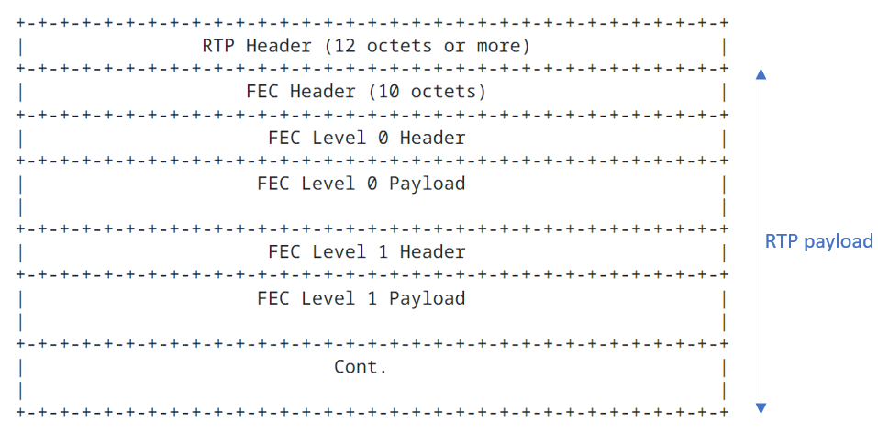

Figure 6.2 RTP packet format for ULPFEC

* MDS or near-MDS schemes:
  + Reed-Solomon (RS) FEC: defined in RFC 5510 and RFC 6865.
    - RS FEC codes are MDS.
    - They are commercially deployed in for example Meta Messenger.
    - The source packet format and the repair packet format are shown in Figure 6.3.

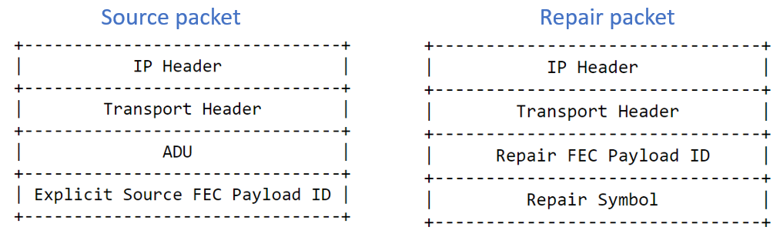

Figure 6.3 Format of the source packet and repair packet for RS FEC

* + Raptor: defined in RFC 5053.
    - Raptor is a fountain code, i.e., as many encoding symbols as needed can be generated by the encoder on-the-fly from the source symbols of a source block of data. The decoder can recover the source block from any set of encoding symbols only slightly more in number than the number of source symbols.
  + RaptorQ: defined in RFC 6330.
    - RaptorQ is a fountain code.
    - RaptorQ codes provide superior flexibility, support for larger source block sizes, and better coding efficiency than Raptor codes.

The RTP schemes for RaptorQ and Raptor are defined in RFC 6681.

* 6.3.3 Categorization

Table 1 categorizes available standardized FEC schemes from IETF based on different criteria.

In addition, for RFC 6681 and 6865, the source data is modified which may affect backward compatibility and the application of encryption (i.e. if it happens before or after FEC).

For Raptor RaptorQ different schemes are defined in RFC 6681.

* arbitrary sequence/arbitrary packet flow this needs additional information in the source packets
* single sequenced flow -> there is no change to the source packets

This is why in the fourth column both options yes and no are marked.

Performance is considered good if there is general repair capability for any loss without introducing too much latency. Performance is considered medium if there is general repair capability for any loss but introducing some latency and complexity. Performance is poor when reliability is still not guaranteed.

Table 1 categorization of AL-FEC schemes for RTP in IETF

|  |  |  |  |  |  |  |  |  |
| --- | --- | --- | --- | --- | --- | --- | --- | --- |
| Name | RFC | Type | format of source packets unchanged/  Backward compatible | Resilience to Arbitrary packet loss | Flexible redundancy | Overhead  (bytes) | Performance (repair capability) | MDS |
| ULP FEC | 5109 | Parity/XoR | Yes | NO | YES | High | Low | No |
| FlexFec | 8627 | Parity/XoR | Yes | NO | YES | High | Low | No |
| Raptor/  RaptorQ | 6681 | Fountain/LT | Yes/No | YES | YES | Medium | Good | Yes |
| Reed  Solomon | 6865 | polynomial | NO | YES | Limited | Medium | Good | Yes |

*** End of changes ***