**3GPP TSG-SA WG4 Meeting #126S4-231738**

**Chicago, USA, 13 – 17 November 2023**

**Source: NTT**

**Title: [FS_eiRTCW] Pseudo-CR on Solution #1 for possible architecture for eiRTCW**

**Spec: 3GPP TR 26.930**

**Agenda item: 10.9**

**Document for: Approval**

**1. Introduction**

Solution#1 was agreed in FS_eiRTCW Permanent Document v600.

**2. Reason for Change**

Solution#1 needs to be incorporated in TR 26.930 based on the agreement in FS_eiRTCW PD.

In incorporating the description of FS_eiRCTW PD in TR 26.930, the following modifications needs to be deployed.

- Correction of editorial errors. (e.g., replacement of capital letter with small letter and refining the words)

- Removal of the following Editor’s note since it is addressed in this solution.

Editor’s Note: Analyze gaps and identify required enhancements of terminal device and network architectures including additional functional entities (e.g., WebRTC Signalling Server, ICE-STUN Server, IMS Interworking Gateway, NNI Gateway).

- Stage2 work requirements

- Necessary functional blocks

- Architectural comparison (details are in annex)

- Adding the following EN in clause 6.2.1.

Editor’s Note: The description of this clause will be aligned with Key Issue #5 and corresponding solution as needed.

**3. Proposal**

It is proposed to agree on the following changes to 3GPP TR 26.930.

* * * First Change * * * *

## 6.2 Solution #1: Architecture for eiRTCW

### 6.2.1 Solution description

This solution addresses Key Issue #1.

This clause identifies a possible eiRTCW architecture considering what functional entities and reference points are needed for WebRTC-based immersibe RTC services in collaboraion scenario 4. This includes:

1) eiRTCW architecture based on WebRTC view point;

2) interaction between fuctional entities in eiRTCW architecture and 5GC;

3) media connnection model;

4) IP addressing;

5) alignment and gap analysis between the architectures eiRTCW and RTC; and

6) RTC Architecture for collaboration scenario 4.

As a conclusion of 1) to 6), the eiRTCW architecuter is proposed as a solution for Key Issue #1 in clause 6.2.8.

Editor’s Note: The description of this solution will be updated based on the study on Key Issue #5 as needed.

Editor’s Note: Terminologies in this document will be clarified and aligned (e.g., clarification of correspondence between Web APP and WebRTC browser type endpoint).

### 6.2.2 eiRTCW architecture based on WebRTC viewpoint

#### 6.2.2.1 Overview

Figure 6.2.2.1-1 depicts a possible eiRTCW architecture based on the WebRTC viewpoint. It contains the functional entities described in clause 6.2.2.2 and reference points described in clause 6.2.2.3. The names of functional entities and reference points described here are only for discussion of this solution and will be aligned with 3GPP TS 26.506 [XX] in the proposed solution (clause 6.2.8).



Figure 6.2.2.1-1: Possible eiRTCW architecture from WebRTC’s viewpoint

WebRTC Signalling Function (WSF) and Conference Supporting Function (CSF) may co-locate in a physical node. WebRTC NNI Signalling Gateway Function (WNSGF) and WebRTC NNI Media Gateway Function (WNMGF) are optional when gateway functions are not needed at the network boundary.

#### 6.2.2.2 Functional entities for WebRTC

##### 6.2.2.2.1 General

This clause enumerates functional entities in terms of 1) WebRTC specifications, 2) WebRTC implementations, and 3) providing inter-operator services.

1) Functional entities that are essential for this study and already defined in IETF RFCs or 3GPP specifications concerning WebRTC (see clause 6.2.2.2.2).

2) Functional entities that are not directly specified in WebRTC-related specifications in IETF RFCs or 3GPP specifications but considered to be widely implemented for realizing WebRTC services; they are essential for this study (see clause 6.2.2.2.3).

3) Functional entities that may be specifically required for inter-operator or third-party collaboration services if modification of signalling and termination of media on network boundaries are needed (see clause 6.2.2.2.4).

##### 6.2.2.2.2 Functional Entities defined in WebRTC specifications

###### 6.2.2.2.2.1 UE (User Equipment)

6.2.2.2.2.1.1 General

User Equipment (UE) contains a user agent function which is equivalent to "WebRTC Endpoint" as described below.

For the purposes of the present document, the following terms and definitions given in IETF RFC 8825 [XX] apply as follows:

**WebRTC Endpoint**: Either a WebRTC browser or a WebRTC non-browser. It conforms to the protocol specification.

**WebRTC Browser (also called a "WebRTC User Agent" or "WebRTC UA")**: Something that conforms to both the protocol specification and the JavaScript API specification (W3C WebRTC 1.0 [XX]).

**WebRTC Non-Browser**: Something that conforms to the protocol specification but does not claim to implement the JavaScript API. This can also be called a "WebRTC device" or "WebRTC native application".

In this study, both "WebRTC Browser" type endpoint and "WebRTC Non-Browser" type endpoint are supported on the eiRTCW architecture, as same as the RTC architecture specified in 3GPP TS 26.506 [XX]).

6.2.2.2.2.1.2 Considerations specific to WebRTC endpoint types

There are two types of WebRTC Endpoint as described in clause 6.2.2.2.2.1.1; one is "WebRTC Browser" type, and the other is "WebRTC Non-Browser" type. This clause shows possible functional model for each type of endpoints on eiRTCW architecture for identifying the specific issues related to the WebRTC endpoint types. If the application provider connects its server (e.g., media server, content server) to a WSF in an operator network without providing WSF functionality (i.e., connect to the operator's WebRTC DN via UNI not NNI), the server is treated as UE (WebRTC endpoint) for connecting to WSF in the operator's network.

Regarding the "WebRTC Browser" type WebRTC endpoint, a JavaScript application runs on a web browser that has capabilities of JavaScript APIs including WebRTC APIs defined by W3C (see Figure 6.2.2.2.2.1.2-1). According to the concept of WebRTC described in IETF RFC 8829 [XX], the procedures and protocols stated in this study are expected to be fully writable only with JavaScript.



Figure 6.2.2.2.2.1.2-1: "WebRTC Browser" type endpoint

However, in the current situation, most of the OSs (e.g., android, iOS) and the web browsers (e.g., chrome, firefox) do not support/provide the enablers (provided by RTC MSH) for immersive RTC as JavaScript API. Therefore, to provide functionalities for realizing immersive RTC to "WebRTC Browser" type WebRTC endpoint, the mechanisms other than RTC MSH need to be supported. In order to support "WebRTC Browser" type endpoint, the protocols and procedures shown in this study can be implemented without RTC MSH.

Regarding the "WebRTC Non-Browser" type WebRTC endpoint, an application written in a programming language specific to the UE platform runs on UE using libraries and/or system call handlers. (see Figure 6.2.2.2.2.1.2-2)



Figure 6.2.2.2.2.1.2-2: "WebRTC Non-Browser" type endpoint

NOTE: The programming language and programming APIs used to write applications depend on the UE platform. For example, Java and Android API (SDK) will be selected for Android platform UEs, Swift and its libraries will be selected for iOS platform UEs, and C++ and Win64 API will be selected for Windows platform UEs.

The application can be realized in a way other than JavaScript running on a web browser. The application can support the functions provided by RTC MSH since the application can be developed proprietary.

In this study, the solution which realizes the immersive RTC services without using RTC MSH is studied to support "WebRTC Browser" type endpoint and "WebRTC Non-Browser" type endpoint.

This study does not state details of the application's implementation; this study mainly discusses the network interface, which is applicable for both "Browser" and "Non-Browser" type UEs.

###### 6.2.2.2.2.2 WSF (WebRTC Signalling Function)

The WebRTC Signalling Function (WSF) is a functional entity that is responsible for WebRTC signalling mechanism including capability exchange and management of media sessions between UEs and the network. This functional entity is described as "Servers" or "Web Server" in clause 3 of IETF RFC 8825 [XX]. Each operator or third-party in this study is assumed to have their own WSF(s) in their network.

WSF also provides the following functionalities:

- Interaction with WMCF for media session (real-time streaming and data channel) control.

- Interaction with CSF for collaboration with web applications/services.

- Interaction with 5GC, using Network Support function AF's (NS-AF) functionality.

##### 6.2.2.2.3 Functional Entities widely implemented for WebRTC

###### 6.2.2.2.3.1 WMCF (WebRTC Media Centre Function)

The WebRTC Media Centre Function (WMCF) is a functional entity that performs media processing. WMCF terminates media path (including audio/video stream and data channel) and performs media processing (e.g., mixing, selective forwarding, transcoding) which are required for immersive RTC applications. It may also perform decryption and encryption of media packets if DTLS, SRTP, or TLS is used for a transport layer. It also has the function of storing contents (including text or other static material as well as audio and video) and providing them to the UE. For media transport control, the WMCF interacts with WSF.

In the case that the WMCF acts as a simple media relay function, the WMCF simply relays media data packets and supports IP packet connectivity. When UE behaves as ICE Agents defined in IETF RFC 8445 [XX] or IETF RFC 8838 [XX], WMCF may be either STUN servers defined in IETF RFC 8489 [XX] for connectivity check or TURN servers defined in IETF RFC 8656 [XX] for relaying media data packets. This functional entity facilitates NAT traversal of UE and the connectivity between UE and other network functions.

This functional entity is generally implemented in WebRTC Multipoint Control Unit (MCU) or Selective Forwarding Unit (SFU).

###### 6.2.2.2.3.2 CSF (Conference Supporting Function)

The Conference Supporting Function (CSF) provides the following functionalities:

- Conference session management, i.e., "CRUD" operation – create, read, update, delete of conference instances.

- Providing supplementary files (e.g., icon images of participants, and shared documents) via best-effort transport different from the channels for real-time media.

- Capability exposure to third-party application server to provide configuration of eiRTCW services.

- Storage of user subscription data specific to MNO's WebRTC services.

NOTE 1: In this study, it is assumed that a single user (i.e., identity) and its subscription data (associated with the identity) are assigned, owned, and managed by both operator and RTC application provider independently. The two identities have a link with each other via some technique. User subscription data specific to RTC application provider's services are stored in their networks. The definition of these identities are studied in Key Issue #5 and corresponding solution.

- Authorization endpoint and token endpoint of OAuth 2.0 described in IETF RFC 6749[XX] for establishing authentication linkage between MNO's ID and service provider's ID.

NOTE 2: OAuth token will be used to C-Plane authentication at WSF and service providers. STUN/TURN authentication with OAuth token is defined in IETF RFC 7635[XX]. Portal http(s) servers of WebRTC services provide this function in general implementations.

##### 6.2.2.2.4 Functional Entities needed for inter-operator services

###### 6.2.2.2.4.1 WNSGF (WebRTC NNI Signalling Gateway Function)

The WebRTC NNI Signalling Gateway Function (WNSGF) is located at the boundary of the networks where different operators or third-party network connects.

Each operator or third-party has its own WebRTC Signalling Functions (WSF) so that WSFs are connected to each other with border control functions such as security, policy management, charging, etc. WNSGF is inserted into "Signalling Path" in Figure 2 of IETF RFC 8825 [XX] and responsible for border control functions and supports session establishment between disparate address realm's networks.

WNSGF is able to support the functionality for interworking between WebRTC based signalling message and SIP message of IMS as a border control function.

###### 6.2.2.2.4.2 WNMGF (WebRTC NNI Media Gateway Function)

The WebRTC NNI Media Gateway Function (WNMGF) is a media relay located at the boundary of the networks where different operators or third-party network connects. WNMGF is responsible for the border control and transport of media data packets between different networks. WNMGF may also transcode media data packets.

WNMGF is able to support the functionality for interworking between WebRTC media and IMS media (e.g., transcoding of codec) as a border control function.

#### 6.2.2.3 Reference Points

The reference points shown in Figure 6.2.2.1-1 are enumerated as follows.

Reference points for signalling are called as "control plane" or "C-Plane" in this study. Reference points for media are similarly called as "user plane" or "U-Plane" in this study.

Reference Points for C-Plane:

**Rs-u:** Reference Point between a WSF and a UE.

**Rs-i:** Reference Point between a WSF and another WSF in the same network (DN) or between a WSF and a WNSGF.

**Rs-a:** Reference Point between a WSF and a CSF.

**Rs-n:** Reference Point between a WNSGF and another WNSGF in an external network.

Reference Points for U-Plane:

**Rm-u:** Reference Point between a WMCF and a UE.

**Rm-i:** Reference Point between a WMCF and another WMCF in the same network (DN) or between a WMCF and a WNMGF.

**Rm-n:** Reference Point between a WNMGF and another WNMGF in an external network.

Reference Points for signalling nodes to control media nodes:

**Mc-i:** Reference Point between a WSF and a WMCF.

**Mc-r:** Reference Point between a WNSGF and a WNMGF.

Other Reference Points:

**Rh-u:** Reference Point between a CSF and UE. This reference point is used for providing CSF functionalities (e.g., application usage assistance such as downloading an application) to UE.

**Rh-n:** Reference Point between a CSF and Application service provider. This reference point is used for interaction between CSF and Application service provider for media session set up related interaction.

Detailed protocol for each reference point will be discussed in the dedicated key issue and solution.

### 6.2.3 Interaction between functional entities in eiRTCW architecture and 5GC

#### 6.2.3.1 Overview

A possible architecture in terms of WebRTC view is described in clause 6.2.2. This clause shows a solution for integrating the eiRTCW architecture on pure WebRTC architecture with 5GC. In other words, this clause studies the possible interaction between the functional entities of eiRTCW architecture (based on WebRTC viewpoint) and the functional entities on 5GC.

NOTE: "pure WebRTC" means the original WebRTC described in IETF work, which basically does not take into account domain specific functions or features (e.g., mobile networks).

#### 6.2.3.2 Mapping of functional entities for interaction with 5GC

##### 6.2.3.2.1 General

This clause identifies the mapping of functional entities shown in Figure 6.2.2.1-1 into 5GC functional entities defined in 3GPP TS 23.501 [XX].

In this study, the mapping of WSF and AF, and the mapping of WNSGF and 5GC functional entities are considered. Other functional entities (i.e., CSF, WMCF, WNMGF) are not considered since these functional entities are not expected to interact with 5GC.

##### 6.2.3.2.2 WSF and AF

WSF is connected from UE and is expected to process the following:

1) authenticate a UE.

2) setup a WebRTC media session required by a UE, which may be in another network.

3) manage QoS for the media path of a WebRTC session.

Then it is expected that the WSF interacts with functional entities of 5GC and UE to perform 1) and 3) as the following:

1) WSF can retrieve the identity of a UE from 5GC, then authenticates and authorizes the UE.

3) WSF can request PCF to enable QoS control for the media path through e.g., N5, N32 (specified in 3GPP TS 23.501 [XX]) or CAPIF reference points (specified in 3GPP TS 23.222 [XX]).

Additionally, these processes are close to the processes of IMS functional entities such as P-CSCF and S-CSCF defined in 3GPP TS 23.228 [XX]. The process of 1) is similarly performed by S-CSCF and UDM, and 3) is similarly performed by P-CSCF and PCF.

WSF can be mapped into "AF (Application Function)" of 5GC according to the definition of AF in 3GPP TS 23.501 [XX] clause 5.2.10 due to the following reasons:

- WSF interacts with the 3GPP core network to provide services.

- The interaction between WSF and 5GC (e.g., PCF/UDM) is close to IMS interactions with 5GC.

##### 6.2.3.2.3 WNSGF

###### 6.2.3.2.3.1 Overview

This clause identifies the mapping of WNSGF to a 5GC functional entity. There are a couple of possibilities currently identified. The following two 5GC functional entities can be mapped from WNSGF:

- NEF (see clause 6.2.3.2.3.2)

- SEPP (see clause 6.2.3.2.3.3)

As another possibility, it may be appropriate that WNSGF is mapped to a new functional entity (like Interconnection Border Control Function (IBCF) in IMS). The exact mapping of WNSGF is described in proposed architecture clause 6.2.8.

###### 6.2.3.2.3.2 WNSGF and NEF

When WSF is mapped into an AF and if WNSGF is deployed as 5GC functional entity, WNSGF can be mapped into an NEF due to the following reasons:

- When WSF processes 2) of clause 6.2.3.2.2 and the media session relates to other operator's network, WSF (mapped to an AF) of operator-A is requested to interact with WNSGF on the boundary of operator-B to communicate with WSF (mapped into an AF) in operator-B due to operator-B's policy. In this model, the relationship between WSF (in operator-A) and WNSGF (in operator-B) is close to the relationship between AF and NEF described in clause 6.2.10 of 3GPP TS 23.501 [XX].

- The major function of WNSGF is close to the former three functionalities described in 3GPP TS 23.501 [XX] clause 6.2.5.0; WNSGF exposes WSF's WebRTC signalling capability and events. WNSGF interworks with WebRTC C-Plane signalling between Rs-i and Rs-n reference points in terms of security and translation of internal-external information.

When WNSGF is mapped into an NEF, the definition of the NEF may need to be modified as follows:

- Descriptions for the exposure of WSF's WebRTC signalling capability and the events by WNSGF are added in 3GPP TS 23.501 [XX] clause 7.2.8.

- Descriptions for the event exposure details are added in 3GPP TS 23.502 [XX] clause 4.15.3.

- Descriptions for the capability exposure details are added in 3GPP TS 23.502 [XX] clause 5.2.6.

###### 6.2.3.2.3.3 WNSGF and SEPP

Security Edge Protection Proxy (SEPP) is defined in 3GPP TS 33.501 [XX] and 3GPP TS 23.501 [XX]. The SEPP is an entity sitting at the perimeter of the PLMN for protecting control plane messages, hiding network topology. The SEPP enforces inter-PLMN security on the N32 interface that is a reference point between a SEPP in one PLMN and a SEPP in another PLMN.

If WNSGF is deployed as 5GC functional entity, WNSGF is also located at the perimeter of the PLMN and its function is protecting control plane messages and hiding network topology. The function of WNSGF is close to that of SEPP.

The difference between WNSGF and SEPP is the type of located PLMN. WNSGF is located at the edge of inter-HPLMN. On the other hand, SEPP is expected to be used for N32 that lies between HPLMN and VPLMN.

###### 6.2.3.2.3.4 New functional entity

WNSGF is a border control function over C-Plane signalling path and located at the boundary of the networks where different operators or third-party network connects, as described in clause 6.2.2.2.4.1. Then, WNSGF is not expected to interact with 5GC functional entities and act as the gateway function for SBI.

In this study, the C-Plane signalling messages are expected to be exchanged via a DN over N6 interfaces and WNSGF is located at the DN. Therefore, WNSGF needs to be specified as a new border control function for eiRTCW C-Plane signalling path in WebRTC domain.

#### 6.2.3.3 Possible Architecture integrated with 5GC

The functional entities shown in Figure 6.2.2.1-1 can be connected to 5GC as described in Figure 6.2.3.3-1.



Figure 6.2.3.3-1: Possible Architecture (integrated with 5GC)

WSF (with NS-AF functionality of RTC architecture) is mapped into an AF as the 5GC viewpoint.

WSF (with NS-AF functionality of RTC architecture) is interconnected with PCF via N5 interface. WSF manages QoS of real-time media packets and C-Plane signalling packets via N5 interface. WSF may interact with UDM to authenticate and to authorize the UE.

Both signalling packets and media packets between UE and the network are transmitted via N6 interface. Signalling packets (C-Plane packets) from UE are transmitted to WSF, and real-time media packets (U-Plane packets) from UE are transmitted to WMCF. C-Plane signals may travel to WNSGF via Rs-i, and may travel further to other operator's WNSGF via Rs-n. U-Plane signals may travel to WNMGF via Rm-i, and may travel further to other operator's WNMGF via Rm-n. (see Figure 6.2.3.3-2)



Figure 6.2.3.3-2: Possible Architecture (from 5GC view, with data flows of C/U-Planes)

#### 6.2.3.4 Mapping to iRTCW Collaboration Scenarios

The following table shows the mapping of functional entities in this study into iRTCW collaboration scenarios described in 3GPP TS 26.506 [XX]. Each box shows the condition (required or not) for MNO. The targets of this study are collaboration scenarios 3 and 4.

Table 6.2.3.4-1: Mapping to iRTCW collaboration scenarios

|  |  |  |  |
| --- | --- | --- | --- |
| Functional Entity | Collaboration Scenario 3 | | Collaboration Scenario 4 |
| 3A / Service Provider provides WebRTC services and MNO assists the services. | 3B / MNO provides WebRTC services only in the MNO’s network | MNO’s WebRTC service interconnects with other MNO’s or Service Provider’s service |
| WSF | Required | Required | Required |
| WMCF | Required | Required | Required |
| CSF | Required | Required | Required |
| WNSGF | N/A (NOTE) | N/A | Required |
| WNMGF | N/A (NOTE) | N/A | Required |
| NOTE: Scenario 3A in this table assumes service provider’s WebRTC functions communicate with WSF and WMCF via UNI-like interface, i.e., WSF and WMCF work as a gateway by themselves. Further Operator-Assistance models may be introduced. | | | |

### 6.2.4 Media connection model

#### 6.2.4.1 General

In the original WebRTC design, the communication between UEs is thought to be peer-to-peer (P2P). In most of the existing WebRTC implementations, however, the media connection is not P2P. An intermediate server (or servers) between UEs is used. In the multi-party call, the intermediate server which performs media processing is helpful for a UE because, for a UE, decoding all media from other UEs is a heavy load. Direct full-mesh connections among multiple UEs consumes a lot of network resources. Additionally, such an intermediate server is useful even for a one-to-one communication for offloading immersive media processing which needs more computation power than conventional media. This leads to the discussion about split rendering.

This study mainly focuses on the media connection model with intermediate servers.

P2P connection has some benefit for one-to-one communication (i.e., no need for an intermediate server and less server-relayed delay). For that reason, P2P connection is also considered for some special cases.

#### 6.2.4.2 Target use cases from network view

Based on the high-level network model and target interfaces described in clause 4.2 and the eiRTCW architecture in clause 6.2.2, eiRTCW signalling supports the following use cases of media session set up from network view.

<Media session set up with media resource served in the operator network via UNI>

a. UE - Media Resource (served by the same Operator)

b. UE - Media Resource (served by the same Operator) - UE (CP)

<Media session set up with media resource via NNI>

c. UE - Media Resource (served by other Operator)

d UE - Media Resource (served by an SP)

e. UE (served by other Operator) – Media Resource - UE (CP)

f. UE - Transit entity (served by other Operator) - Media Resource (served by an SP)

<Media session set up between UEs>

g. UE - UE (served by the same Operator) without media gateway

h. UE - UE (served by other Operator) without media gateway

i. UE - UE (CP) without media gateway

j. UE (connected to other Operator) - UE (CP) without media gateway

The overviews of these use cases are described below based on the possible eiRTCW architecture described in clause 6.2.2.

NOTE: Media Resource of Content Provider is treated as UE.

NOTE: CSF is not shown in the Figure for simplicity.

a. **UE - Media Resource (served by Operator)**:  
UE establishes a media session with a media resource (e.g., immersive conference room) served by the same operator. Figure 6.2.4.2-1 shows an example that UE_A and UE_B establish media sessions with the media resource to an immersive conference room to communicate with each other.

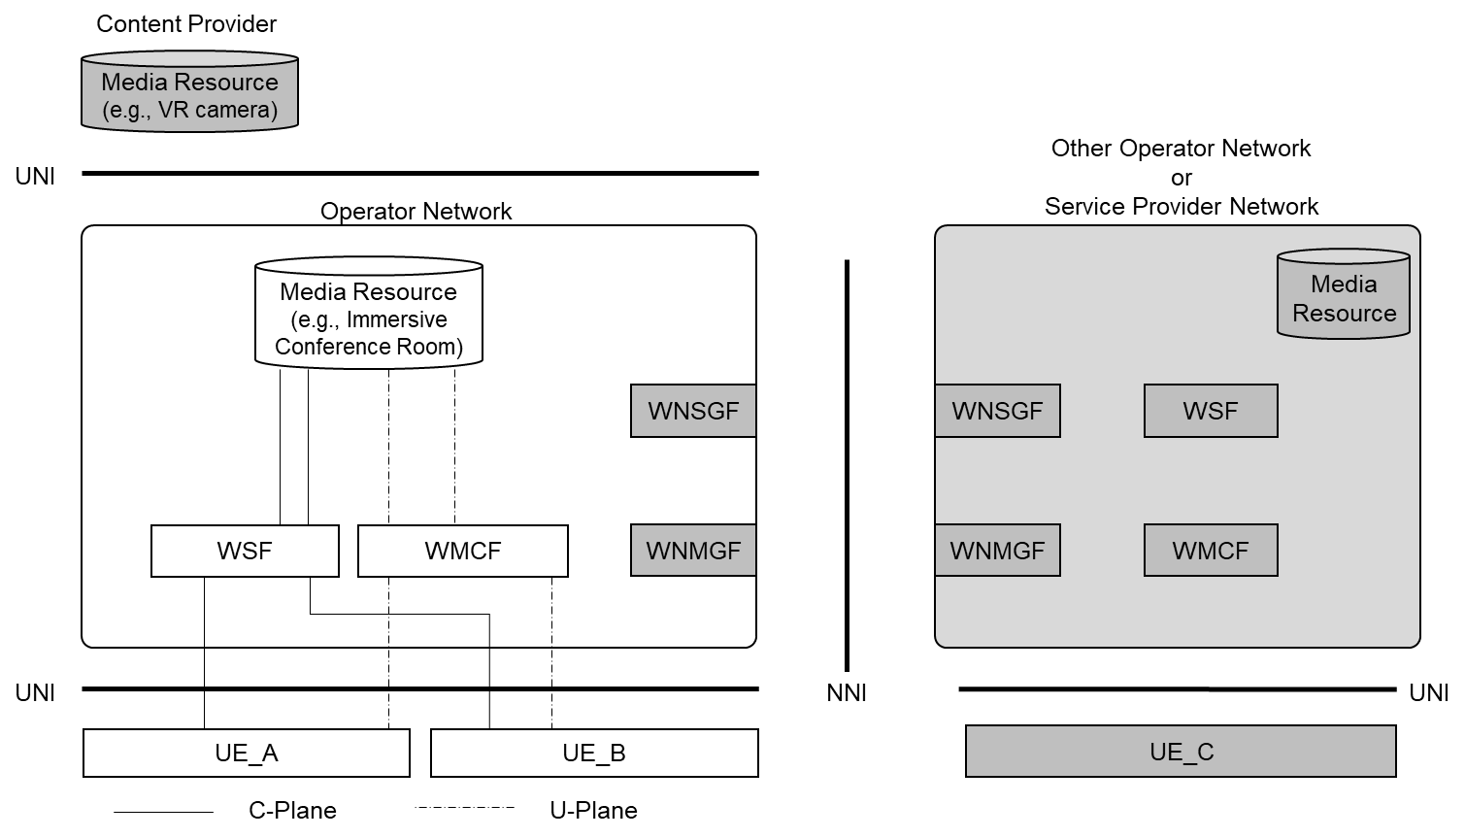

Figure 6.2.4.2-1: Media session: UE - Media Resource (served by the same Operator)

b. **UE - Media Resource (served by Operator) - UE (CP)**:  
A UE establishes a media session with a media resource (e.g., 3D video content) served by a CP which connected to the same Operator, via a media gateway (such as WMCF).

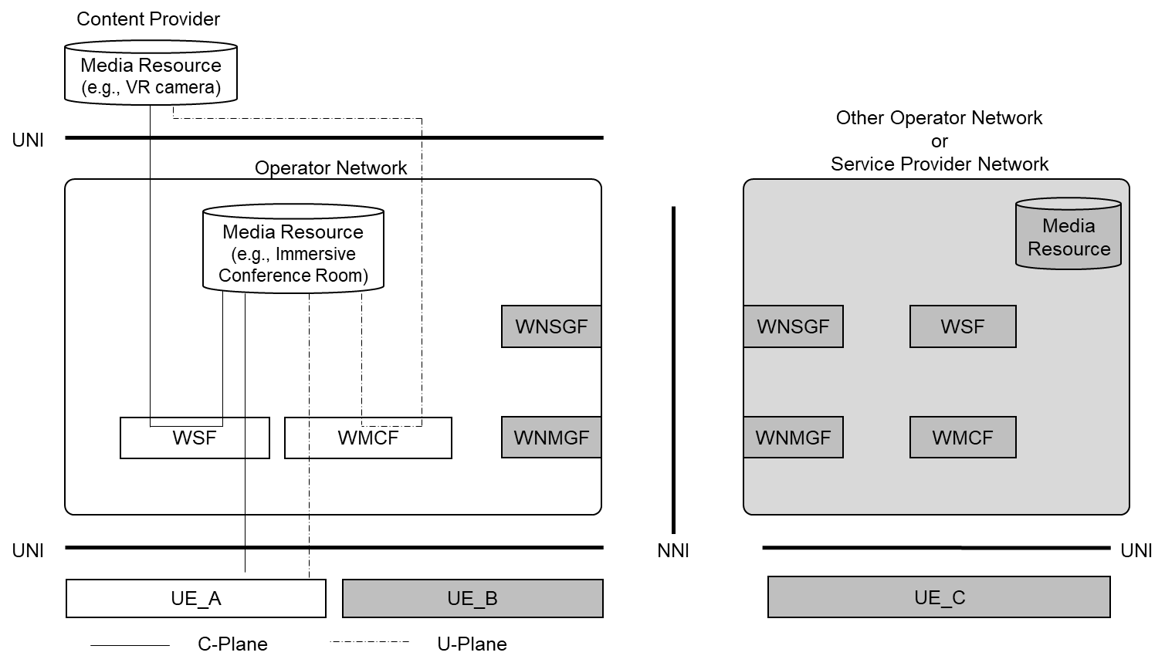

Figure 6.2.4.2-2: Media session: UE - UE (CP) - Media Resource (served by the same Operator)

c. **UE - Media Resource (served by other Operator)**:  
A UE establishes a media session with a media resource (e.g., Immersive conference room) served by the operator that different from the network which the UE is connected to. In this scenario, the C-Plane signalling message and media session stream are sent over the NNI. Other UEs can connect to the media resource as same as pattern a.

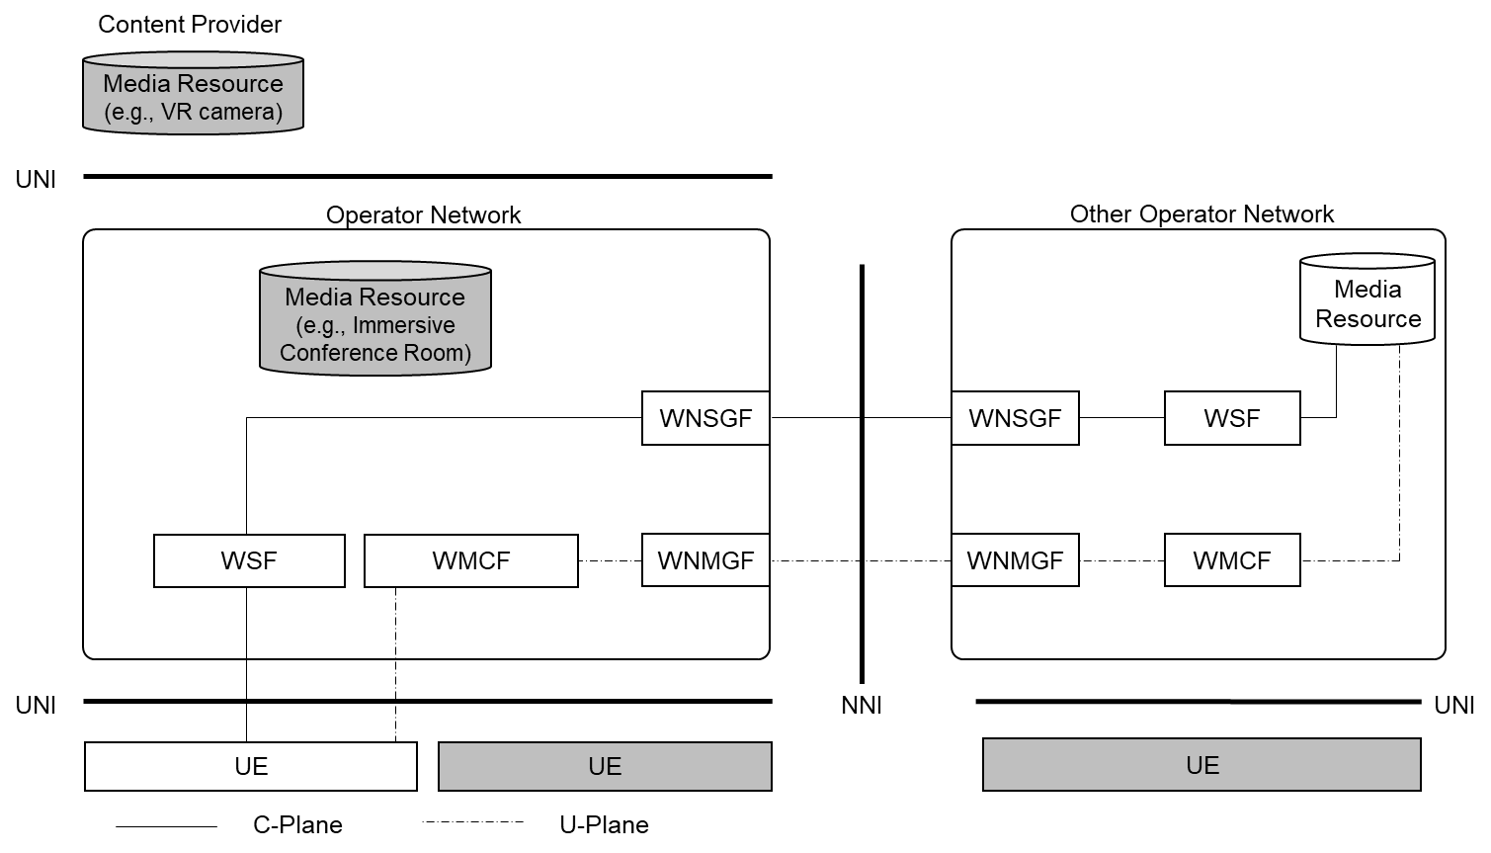

Figure 6.2.4.2-3: Media session: UE - Media Resource (served by other Operator)

d. **UE - Media Resource (served by an SP)**:  
A UE establishes a media session with a media resource (e.g., Immersive conference room) served by an SP. In this scenario, the C-Plane signalling message and media session stream are sent over the NNI.

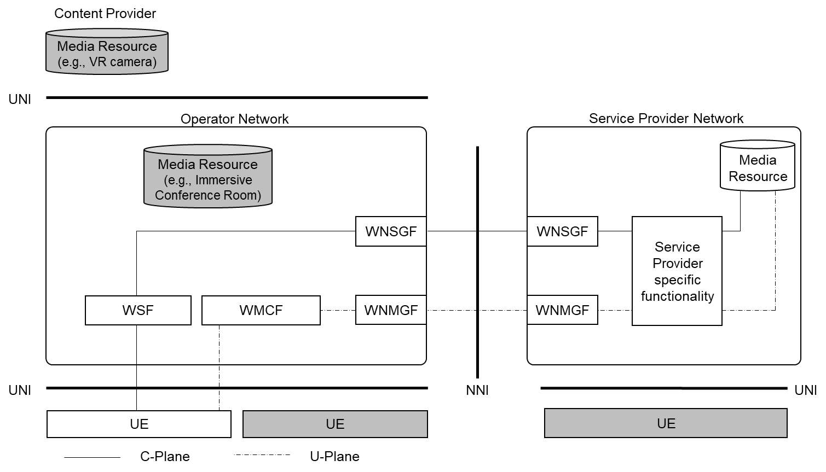

Figure 6.2.4.2-4: Media session: UE - Media Resource (served by an SP)

e. **UE - Media Resource (served by other Operator) - UE (CP)**:  
A UE in the other operator network and UE (CP) establishes a media session with a media resource (e.g., Immersive conference room) served by an operator network which the UE (CP) connected to. In this scenario, the C-Plane signalling message and media session stream are sent over the NNI.

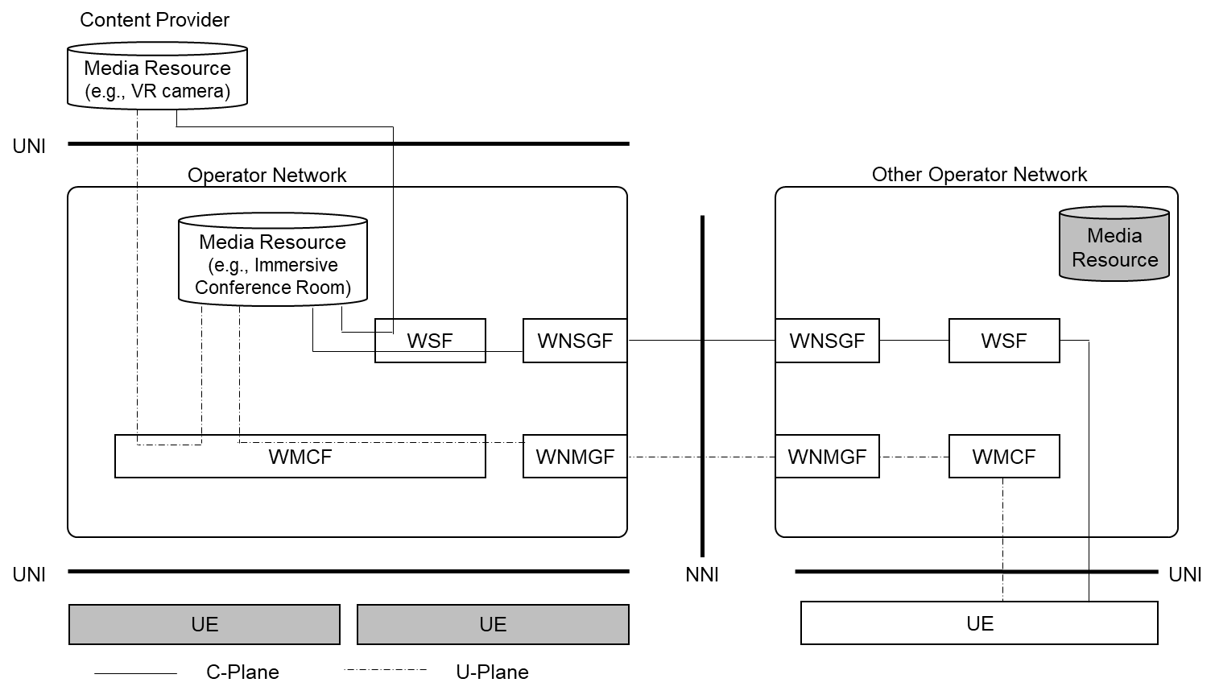

Figure 6.2.4.2-5: Media session: UE – Media Resource (served by other Operator) - UE (CP)

f. **UE - Transit NW (other Operator) - Media Resource (served by an SP)**:  
A UE establishes a media session with a media resource (e.g., Immersive conference room) served by an SP via transit NW (other operator). In this scenario, the C-Plane signalling message and media session stream are sent over the two different NNIs.

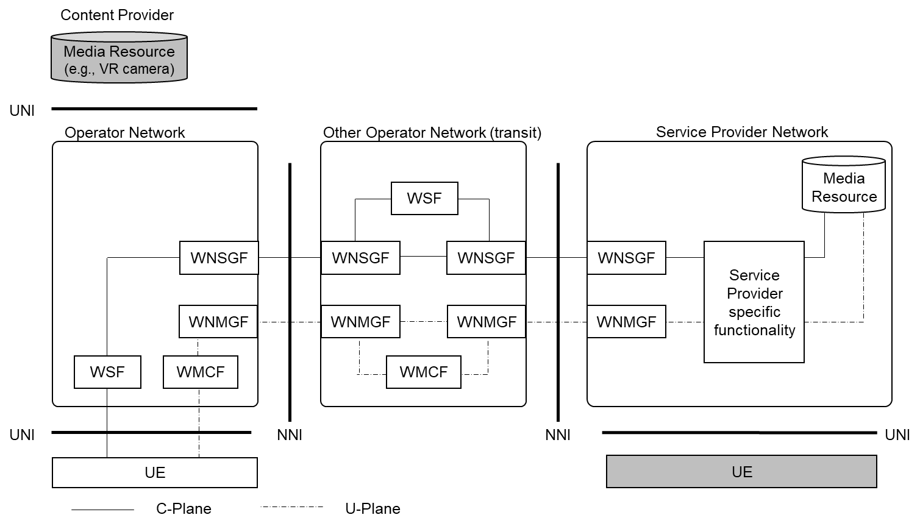

Figure 6.2.4.2-6: Media session: UE - Transit NW (other Operator) - Media Resource (served by an SP)

g. **UE - UE (served by the same Operator) without WMCF**:  
A UE establishes a media session (e.g., voice chat) with another UE served by the same operator, without using WMCF.

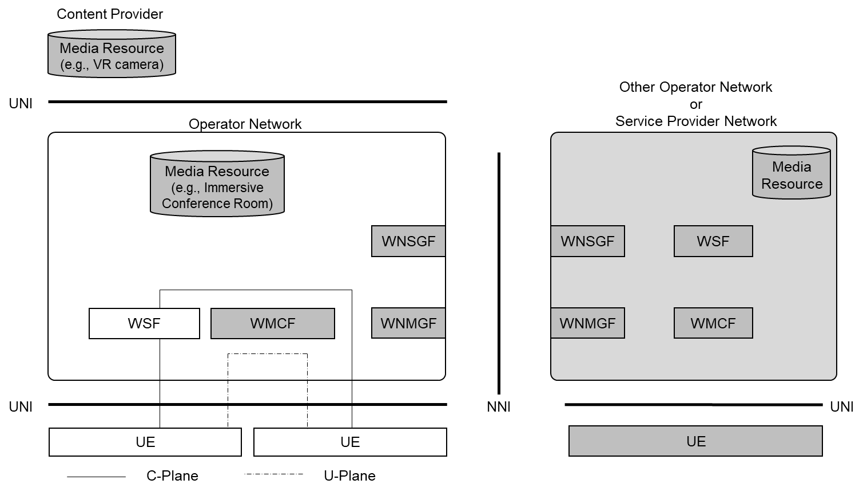

Figure 6.2.4.2-7: Media session: UE - UE (served by the same operator) without WMCF

h. **UE - UE (served by other Operator) without WMCF**:  
A UE establishes a media session (e.g., voice chat) with another UE served by the different operator, without using WMCF. In this scenario, the C-Plane signalling messages and media session stream are sent over the NNI.

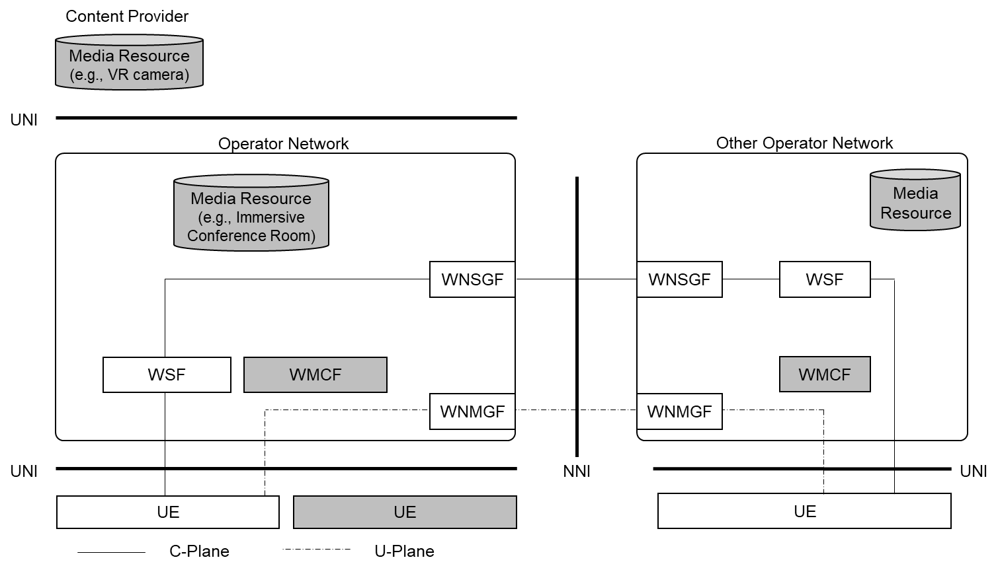

Figure 6.2.4.2-8: Media session: UE - UE (served by other Operator) without WMCF

i. **UE - UE (CP) without WMCF**:  
A UE establishes a media session with a UE (e.g., 3D video content) served by a CP which connected to the same operator, without using WMCF.

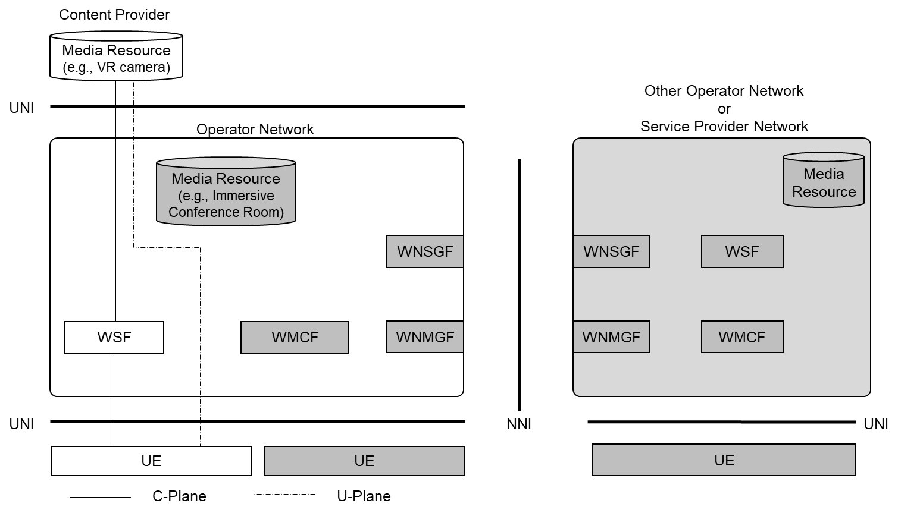

Figure 6.2.4.2-9: Media session: UE - UE (CP) without WMCF

j. **UE (connected to other Operator) - UE (CP) without WMCF**:  
A UE establishes a media session with a UE (e.g., 3D video content) served by a CP which connected to the different operator, without using WMCF. In this scenario, the C-Plane signalling messages and media session stream are sent over the NNI.

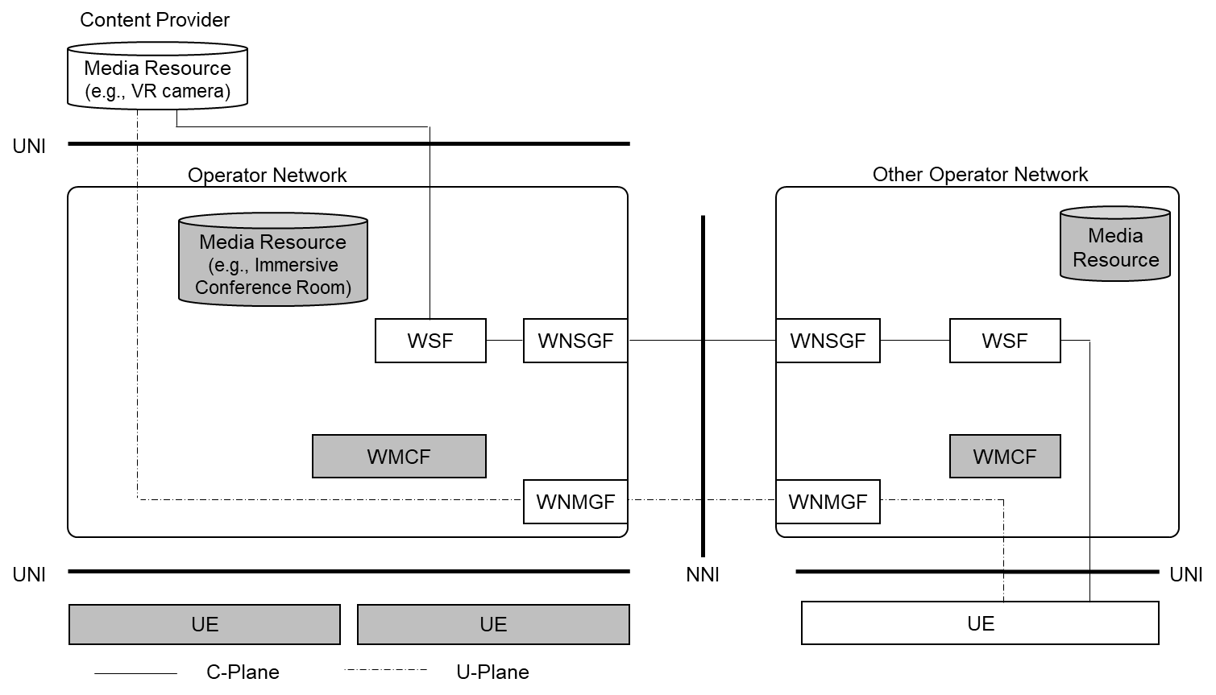

Figure 6.2.4.2-10: UE (connected to other Operator) - UE (CP) without media gateway

#### 6.2.4.3 QoS Enabled End-to-End Path

This study covers two collaboration scenarios as is described in the previous clause. In the collaboration scenario where the WebRTC functions in an MNO assist an external service provider (OTT or another MNO), setting up a QoS-enabled media path across different networks needs to be studied.

The media path from a UE to the external service provider is roughly divided into four sections:

Section 1) Between a UE and the UPF (Operator's CN section)

Section 2) Between the UPF and the operator's network edge (Operator's DN section)

Section 3) Between the operator's network edge and the external service provider network edge

Section 4) A network in the external service provider

Section 4) is a matter of a service provider and out of scope of this study.

Regarding Section 1), this section includes the operator's core network. In this section, QoS is controlled by the PCF. In the collaboration scenario with an external service provider, the main signalling server is placed in the service provider'’s domain. While UE exchanges control plane signalling messages with the signalling server placed in the service provider’s domain, UE sends a QoS-related request separately to the WSF placed in the operator network. The WSF receives and interprets the UE's request and requests the PCF to prioritize the UE's specific session.

Regarding Section 2), operator's DN may have sufficient bandwidth and other QoS mechanism may be adopted.

Regarding Section 3), this section's QoS control needs a bandwidth guaranteed path (i.e., a dedicated line). On the eiRTCW architecture, when the media path is connected to a media resource in other operator network or service provider network, the media packets to be prioritized are transmitted to WMCF placed in the operator's network and the WMCF relays the media to the main media server in the other operator network or service provider network via guaranteed path as shown in Figure 6.2.4.3-1 (red-line). If the media path is connected to a media resource (works as WebRTC endpoint) in a service provider network via WSF and WMCF (which work as a gateway) in the operator network, this section is treated as UNI, as shown in Figure 6.2.4.3-1 (blue-line).



Figure 6.2.4.3-1: Sections of E2E media path

### 6.2.5 IP Addressing

#### 6.2.5.1 Overview

IP addressing for UE has some options: assigning IPv4 address only, IPv6 address only, or both.

In the operator deployment, the number of available IPv4 addresses would be insufficient for its subscribers. Generally, operators use IPv4 private address (and ISP shared address defined in IETF RFC 6598[XX]) with network address translation (NAT).

In clause 6.2.5, appropriate IP addressing is identified, discussing NAT-traversal in the WebRTC user plane and network verified ID retrieval.

#### 6.2.5.2 NAT

##### 6.2.5.2.1 Overview

NAT, including port translation as NAPT (Network Address and Port Translation), is a method of mapping an IP address space into another, which is mainly used to translate a private IP address into a global IP address, and vice versa, for communicating with external networks.

Generally, UE can be assigned with an IP address through a PDU session in operator networks. When an IPv4 address is allocated, as mentioned in clause 6.2.5.1, a private IP address or an ISP shared address is used. On the contrary, when an IPv6 address is allocated, a global unicast address is assigned.

NAT is essential for carrier-grade network deployment. Subscribers can be much more than usually available IPv4 global address space, and they are treated by using IPv4 private address and NAT. The same private address can be reused in each different domain behind NAT. Although NAT deployments have a wide variety, NAT is generally installed in a DN (data network) and often put in the middle between the UPF and other functional entities (see Figure 6.2.5.2-1).

On the other hand, IPv6 global unicast addresses basically do not require NAT, except for special security reasons or some transition method between IPv6 and IPv4 domains.



Figure 6.2.5.2-1: Possible NAT location

##### 6.2.5.2.2 NAT Variation

NAT is classified into some types by its address translation and packet filtering behavior.

The first version of STUN in IETF RFC 3489 [XX] defines three types:

- Full Cone NAT,

- Restricted NAT (Restricted Cone NAT or Restricted Port Cone NAT), and

- Symmetric NAT.

Full cone NAT does not limit access to an internal UE from external network entities, which have not communicated with the internal UE. Any external entities can re-use the external IP address and port number mapped to a specific internal UE and can access to it (Figure 6.2.5.2.2-1). Full cone NAT is less restrictive than other NATs. Restricted NAT only permits external entities to access the internal UE if the NAT have received any packets from the internal UE directed to the external UE (Figure 6.2.5.2.2-2). Symmetric NAT uses a different pair of an external IP address and port, which are specific to each external entity and only the external entity can access to the internal UE through the IP address and port pair.



Figure 6.2.5.2.2-1: Full Cone NAT behaviour



Figure 6.2.5.2.2-2: Restricted or Symmetric NAT behaviour

##### 6.2.5.2.3 Existing NAT-traversal

###### 6.2.5.2.3.1 General

An effective NAT-traversal method is different depending on the NAT type described in clause 6.2.5.2.2.

In the original WebRTC design, STUN and TURN are listed, included as ICE, for major NAT-traversal methods. In addition, Hosted NAT Traversal (HNT, described in IETF RFC 7326 [XX]) and its similar mechanism are frequently used in real implementations for conversational applications.

###### 6.2.5.2.3.2 STUN

STUN is the method for UE behind the NAT to discover its external IP address observed by external networks. This method supports P2P communications and only works for full-cone NAT.

This study excludes STUN because the main communication model is not P2P but with intermediate servers (as described in clause 6.2.5), and general NATs deployed in operator networks are not limited to full-cone type.

###### 6.2.5.2.3.3 TURN

TURN is the method for UE behind the NAT to communicate with external nodes via an intermediate server. TURN is a protocol for the session management and requires an intermediate server.

Generally, this method is regarded as the last resort for NAT-traversal for UDP-based conversational services. This method does not require the alignment with other control plane signalling, but is equipped as its own user plane connection management mechanism. This method needs additional message exchanges and has a protocol overhead.

The TURN server has its authentication mechanism for UEs and can be used for the purpose of traffic steering for an inter-operator communication scenario detailed in clause 6.9.

###### 6.2.5.2.2.4 HNT

HNT (Hosted NAT Traversal) is the mechanism that a session border controller (SBC) placed at the edge of networks intermediates the communication between UEs behind NAT.

The problem tackled by HNT is that a UE behind a NAT tries to set up a session with its private address and port number for media, which have no clue to the SBC for the real media which comes later.

Regarding the control plane signalling, the signalling part of the SBC modifies media-related information represented by the private IP address and port number set in the SDP offered by an originating node into a global IP address and a new port number. This modification enables a terminating node to target the accessible IP address and port pair provided by the SBC. In the signalling return path, the SBC also modifies the terminating node's IP address and port number set in the SDP answered by the terminating node into new ones, and forwards it to the originating node. This is to solicit the originating node to send media to the SBC. Once the SBC receives the first media packet from the originating node targeting at the solicitation, the SBC recognizes the real NAT-ed IP address and port pair of the originating node. The SBC captures that information and uses it for relaying packets from the terminating node to the originating node. This is called "latching".

This method is embedded in the control plane signalling and does not require extra message exchange. For that reason, it has no additional protocol overhead. It is a better feature than TURN in the same condition requiring an intermediate server.

Since this study focuses on the connection model with an intermediate server, the NAT issues can be argued differently. Let's assume that all communication services are provided by the intermediate server as a conference. UEs can just join the open channel provided by the server and receives media from the server. UEs can also send their media to the intermediate server and the server mixes the media and distributes to other UEs. In this model, the first join packet from a UE to the NAT and the NAT to the server creates an address mapping at the NAT. The server simply sends packets to the source address of the join packet from the UE.

This mechanism does not need the dedicated protocol and there is no additional protocol overhead for NAT-traversal by sending media to the specific IP address and port pair exposed by WMCF. That points are analogous to HNT (Figure 6.2.5.2.3-1).



Figure 6.2.5.2.3-1: HNT like NAT-traversal

##### 6.2.5.2.4 Conclusion of NAT handling

NAT-traversal problems have been discussed and several solutions have been proposed as described above. However, if equipment for NAT-traversal is not required, certainly less server resources would be needed.

In short, it is preferable that only IPv6 global unicast address be assigned to UE and no dedicated NAT-traversal equipment be used. Intermediate servers are used mainly for media processing and for the media relay when there is no direct IP reachability (e.g., across inter-operator connection).

#### 6.2.5.3 IP Address and Trustable Subscriber Identifier

The operator uses subscription identifiers (e.g., GPSI (Generic Public Subscription Identifier) in 5GC) for managing its customer's service subscription and charging. In WebRTC support, the operator needs to check customer's service requests by checking against operator's subscriber database organized with the subscription identifier. An OTT-specific ID and password may be insufficient even in the collaboration scenario with external service providers because they cannot be securely linked with subscriber information in the viewpoint of the operator. The issue is how the MNO deduces (or retrieves) the trustable subscriber identifier from customer's requests, which are carried by IP packets.

Trustable subscriber identifiers in the MNO network are required for certain validity check, since a UE's self-claimed GPSI and source IP address are untrusted.

The EDGEAPP architecture specifies the method how the EAS function block retrieves the GPSI from terminal's source IP address. The AF regarded as an EAS can retrieve the GPSI bound to the UE by Eees_UEIdentifier API in EDGEAPP. This mechanism and its flow contain authentications conducted at the related network functions (i.e., EES and NEF), which enable the EAS to acquire the valid GPSI in the operator network as a trustable subscriber identifier.

Validity of the terminal's source IP address needs consideration. UE's self-claimed IP address, especially presented in an application level, is not trustable. The source IP address presented in an IP header can be relatively trustable when the IP packet is transmitted through a connection with some handshake procedures.

The IP address linkage with a subscriber identifier also has an issue when NAT is deployed. In release 18, the method with which the AF can identify the trustable subscriber identifier (e.g., GPSI) to invoke the 3GPP network service API for the UE (Application client) remains to be investigated in eEDGEAPP. In VoLTE, this linkage with NAT can be achieved with the help of additional operator-specific information (e.g., PDN session related value). In the AF for WebRTC, it depends on which additional information element can be acquired by the AF. There is no clear answer for the ID linkage between the NAT-ed IP address and the subscriber identifier.

Contrarily, the UE IP address without translated by NAT can be linked with GPSI by Eees_UEIdentifier API (though detailed specification is needed).

In terms of ID linkage, using IPv6 global unicast address for UE is reasonable.

Using IPv4 private address will be studied further when NAT-ed ID linkage issue is solved.

#### 6.2.5.4 Conclusion of IP Addressing

In terms of the required server resources for NAT-traversal and unclear retrieval of the trustable subscriber identifier, using IPv6 global unicast address for UE is reasonable. NAT deployments have a wide variety of behaviors and cannot be treated straightforward (refer to clause 6.2.5.2). Using media relay servers that act as either TURN or HNT covers most cases with NAT-traversal. However, there are still issues using IPv4 private address with NAT, such as ID linkage (refer to clause 6.2.5.3). For the sake of simplicity and to concentrate on identifying signalling requirements, this study considers IPv6-only use. Then the use of ICE Function and the enhancements of ICE function are excluded from the scope of this study.

NOTE: As specified in 3GPP TS 26.506 [XX], the use of ICE Function is optional and is not restricted.

Also, IPv6-only use is acceptable for future services because IPv6 address allocation to UEs is now widely available among operators. Also, IPv6-only deployment (or not using limited IPv4 address resource) leads to efficient system development and equipment utilization.

### 6.2.6 Alignment between eiRTCW architecture and RTC architecture

#### 6.2.6.1 General

This clause identifies the architectural and functional mapping between eiRTCW architecture studied in clause 6.2.2 of this document and RTC architecture specified in 3GPP TS 26.506 [XX]. Figure 6.2.6.1-1 shows the RTC general architecture specified in 3GPP TS 26.506 [XX].



Figure 6.2.6.1-1: RTC General Architecture

#### 6.2.6.2 WebRTC endpoint and RTC endpoint on UE

WebRTC endpoint on the UE is expected to be mapped to RTC endpoint on the UE on the RTC architecture. The following aspects need to be reflected in normative TS in the succeeding normative work.

- An WebRTC endpoint includes signalling related aspects of applications on the UE, however, an RTC endpoint does not include applications on the UE. To support the signalling protocol for media session setup, the signalling related functionality of application is included in the scope of the RTC endpoint. Application itself is not included in the scope.

- There is a possible case that an equipment of content provider connects to WebRTC EP function via UNI, as described in clause 4.2 and clause 6.2.4.2. In this case, the equipment of the content provider is treated as same as WebRTC endpoint on the UE.

#### 6.2.6.3 WSF and (RTC) WSF

WSF is expected to be mapped to WSF (integrated with NS-AF) on RTC architecture. The following aspects need to be reflected in normative specification in the succeeding normative work.

WSF provide the following functionalities in addition to the current functionality described in 3GPP TS 26.506 [XX]:

- Interaction with Application Supporting Web Function (ASWF) for collaboration with web applications/services.

- Interaction with 5GC, using network Support function (NS-AF) functionality.

- Retrieval of the identity of a UE from 5GC, and authentication of the UE.

#### 6.2.6.4 WNSGF and Inter-working Function

Inter-working Function (IWF) is specified in 3GPP TS 26.506 [XX] as an inter-working functionality to enable MNO-facilitated WebRTC sessions that involve endpoints across different MNOs (e.g., providing cross-network signalling functionality). This is the expected functionality for WNSGF, since WNSGF is a Gateway function for signalling messages between MNOs. Then, WNSGF is expected to be mapped to IWF on RTC architecture.

No gap is found between WNSGF and IWF

#### 6.2.6.5 CSF and Application Supporting Web Function

CSF is expected to be mapped to ASWF on RTC architecture. The following aspects need to be reflected in normative TS in the succeeding normative work.

ASWF provide the following functionalities in addition to the current functionality described in 3GPP TS 26.506 [XX]:

- Conference session management, i.e., "CRUD" operation – create, read, update, delete of conference instances.

- Providing supplementary files (e.g., icon images of participants, and shared documents) via best-effort transport different from the channels for real-time media.

- Capability exposure to 3rd party application server to provide configuration of eiRTCW services.

- Storage of user subscription data specific to MNO's WebRTC services.

- Authorization endpoint and token endpoint of OAuth 2.0 described in IETF RFC 6749[XX] for establishing authentication linkage between MNO's ID and service provider's ID.

#### 6.2.6.6 WMCF and Media Function

WMCF is expected to be mapped to Media Function (MF) on RTC architecture. The following aspects need to be reflected in normative specification in the succeeding normative work.

The MF provide the following functionalities in addition to the current functionality described in 3GPP TS 26.506 [XX]:

- performing decryption and encryption of media packets if DTLS, SRTP, or TLS is used for a transport layer.

- storing contents (including text or other static material as well as audio and video) and providing them to the UE.

#### 6.2.6.7 WNMGF and Transport Gateway Function

WNMGF is expected to be mapped to Transport Gateway Function (TGF) on RTC architecture.

No gap is found between WNMGF and TGF.

### 6.2.7 RTC Architecture for collaboration scenario 4

This clause identifies the possible architecture for collaboration scenario 4 specified in 3GPP TS 26.506 [XX] based on the consideration in above clauses. Figure 6.2.7-1 shows the derivative RTC architecture for collaboration scenario 4.



Figure 6.2.7-1: Possible derivative RTC architecture for collaboration scenario 4

NOTE 1: Other network includes RTC ASs in different MNO and service provider.

NOTE 2: If RTC AF and -RTC AS are controlled by a single operator and located in the same operator network, these functions are trusted. Inter-working Function and Transport Gateway Function act as a border controller function at the boundary of the network.

The following interfaces are expected to be introduced for collaboration scenario 4.

- **RTC-9**: This reference point is for C-Plane signalling and U-Plane media transport between RTC AS (Inter-working Function) and other network(s) that support the eiRTCW protocol. This interface is necessary for inter-connect RTC-AS with other-networks to realize collaboration scenario 4. RTC-9 may further be grouped into two sub-interfaces as follows.

i) **RTC-9s**: This interface is for C-Plane signalling between Inter-working Function and other network(s) that support the eiRTCW protocol.

ii) **RTC-9m**: This interface is for U-Plane media transport between Transport Gateway Function and other network(s) that support the eiRTCW protocol.

The following interfaces are expected to be introduced/extended for collaboration scenario 3 and collaboration scenario 4. These interfaces are to enable operator assistance for RTC application providers and UEs, then these interfaces are used not only for inter-MNO scenario (Collaboration scenario 4) but also single MNO assistance scenario (Collaboration scenario 3).

- **RTC-2**: This interface is application interface between RTC AS and RTC application provider. The interface is used for providing RTC AS functionalities via ASWF. (e.g., subscription of media resource in RTC-AS.). This interface is necessary for real-time interaction between RTC-AS and RTC application provider for media session control.

- **RTC-4m**: This interface needs to be extended for providing ASWF functionalities (e.g., application usage assistance such as downloading an application) to UE. This extension is necessary for providing RTC AS functionalities to UE as operator assistance.

The functions described in this study correspond to the functions in the architecture for collaboration scenario#4 of RTC Architecture specified in 3GPP TS 26.506 [TS26.506] as follows.

- **WSF (WebRTC Signalling Function)**: WebRTC Signalling Function

- **WMCF (WebRTC Media Centre Function)**: Media Function

- **CSF (Conference Supporting Function)**: Application Supporting Web Function

- **WNSGF (WebRTC NNI Signalling Gateway Function)**: Inter-working Function

- **WNMGF (WebRTC NNI Media Gateway Function)**: Transport Gateway Function

NOTE 3: As described in 3GPP TS 26.506 [XX], the integration/collocation of RTC AF and WebRTC signalling server is possible. Co-located WebRTC signalling server is able to act as a RTC AF which is accessible to 5GC, and replace some of this RTC AF's interfaces and APIs with WebRTC signalling. For example, interfaces and APIs between this RTC AF and UE will be replaced to avoid concurrent/redundant requests from UE.

The interfaces described in this study correspond to the interfaces in the architecture for collaboration scenario #4 specified in TS 26.506 [XX] as follows.

- **Rs-u**: RTC-4s

- **Rs-n**: RTC-9s

- **Rm-u**: RTC-4m

- **Rm-n**: RTC-9m

- **Rh-u**: RTC-4m

- **Rh-n**: RTC-2

For the study of C-Plane signalling aspects, this study focuses on RTC-4 based solutions as shown in Figure 6.2.7-2 to support the collaboration scenario 4 and the case for the application which is not able to use MSH (e.g., Web App).

- RTC AF functionalities are integrated in WebRTC signalling function, since MSH is not used. Then, MSH related interfaces are omitted in Figure 6.2.7-2.

- Functions of RTC AF are integrated within WebRTC Signalling Function, then RTC-3 is out of the scope.

- The use and usage of ICE Function is optional functionality and is not used for non- NAT case. Then the extension of ICE functionality and its usage are out of the scope, since no further extension is not identified in this study.

- The representation of RTC-4s and RTC-4m are simplified. Web App and Native WebRTC App are expected to use these interfaces as follows.

- Web App utilizes the web browser's JS API (including WebRTC API) to send/receive signalling message on RTC-4s and media / application data on RTC-4m.

- Native WebRTC App utilizes the SDK provided by the OS of the UE to send/receive signalling message on RTC-4s and media / application data on RTC-4m.



Figure 6.2.7-2: The focused interface of eiRTCW C-Plane signalling protocol

NOTE 4: RTC-4m is connected to ICE function when TURN server needs to be used. Otherwise, RTC-4m is connected to Media Function (MF) or Application Supporting Web Function (ASWF).

NOTE 5: The interfaces and the functionalities related to MSH, NS-AF, configuration function and provisioning function are not in the focus.

### 6.2.8 Proposed architecture

#### 6.2.8.1 General

In this clause, the following are described:

* Enhancements on 3GPP TS 26.506 [XX];
* The proposed enhancements on the RTC generic architecture;
* The proposed enhancements on the derivative architecture for collaboration scenario 3; and
* The proposed derivative architecture for collaboration scenario 4.
* The proposed eiRTCW architecture supporting collaboration scenario 3 and 4.

#### 6.2.8.2 Enhancements on 3GPP TS 26.506

The following reference points are expected to be introduced RTC general architecture defined in 3GPP TS 26.506 [XX] as shown in Figure 6.2.8.2-1, Figure 6.2.8.2-2 and Figure 6.2.8.2-3.

- **RTC-9**: This reference point is for C-Plane signalling and U-Plane media transport between RTC AS (Inter-working Function) and other network(s) supporting the eiRTCW signalling protocol. RTC-9 may further be grouped into two sub-interfaces as follows.

i) **RTC-9s**: This interface is for C-Plane between Inter-working Function and other network(s) supporting the eiRTCW signalling protocol.

ii) **RTC-9m**: This interface is for U-Plane between Transport Gateway Function and other network(s) supporting the eiRTCW signalling protocol.

- **RTC-2**: This reference point is application interface between RTC AS and RTC application provider. The interface is used for providing RTC AS functionalities via ASWF. (e.g., subscription of media resource in RTC-AS.)

- **RTC-4m**: This reference point is extended for providing ASWF functionalities (e.g., application usage assistance such as downloading an application) to UE.

The expected enhancements of RTC general architecture are shown in Figure 6.2.8.2-1. RTC-4 reference point is connected to UE rather than WebRTC Framework since the interface including signalling messages between application and RTC AS, and media (audio/video stream and data connection) between RTC endpoint and RTC AS. RTC-2 reference point and RTC-9 reference points are introduced.

Figure 6.2.8.2-1: Expected enhancements on RTC General Architecture

Figure 6.2.8.2-2 shows the expected enhancements on derivative RTC architecture for collaboration scenario 3 specified in 3GPP TS 26.506 [XX]. RTC-4m reference point is clarified that this interface is used for providing ASWF functionality to UE, and RTC-2 reference points is newly introduced to support the use of ASWF functionality for application provider.

Figure 6.2.8.2-2: Expected enhancements on derivative architecture for collaboration scenario 3

Figure 6.2.8.2-3 shows the expected derivative RTC architecture for collaboration scenario 4. Collaboration scenario 4 supports inter-operable WebRTC services. Then collaboration scenario 3 is extended with functions and interfaces to support MNO to MNO inter-operability. RTC-9 (RTC-9s and RTC-9m) reference point is introduced to support the inter-connection between MNO's RTC ASs.



Figure 6.2.8.2-3: Expected derivative architecture for collaboration scenario 4

#### 6.2.8.3 eiRTCW architecture

##### 6.2.8.3.1 General

This clause describes the proposed eiRTCW architecture according to clause 6.2.8.2. Figure 6.2.8.3.1-1 and Figure 6.2.8.3-2 show the logical connection between RTC AS functions and other entities on the RTC architecture.



Figure 6.2.8.3.1-1: eiRTCW architecture diagram

NOTE 1: NAT functionality and ICE functionality can be applied, as described in clause 6.2.5. However, these are snipped on the Figure 6.2.8.3-1.

NOTE 2: UNI: The interface between operator network and UE (e.g., smart phone, content server of the Content Provider).

NOTE 3: NNI: The interface between the two different operator networks, or that between operator network and service provider network.

NOTE 4 When an RTC application provider provides a media resource as a content provider without the RTC application provider's RTC AS;  
- the RTC application provider applies RTC-2 to interact with RTC AS in operator network.  
- the media resource is treated as WebRTC endpoint and RTC-4s/RTC-4m is applied for media session UNI (RTC-4s and RTC-4m) between RTC AS functions and RTC application provider are snipped in this figure.

The eiRTCW architecture based on RTC architecture specified in 3GPP TS 26.506 [XX] with 5GC interaction viewpoint is shown in Figure 6.2.8.3.1-2. NS-AF integrated WSF interacts with 5GC via N5 interface.



Figure 6.2.8.3.1-2: eiRTCW architecture diagram with 5GC interaction viewpoint

##### 6.2.8.3.2 Functional entities

###### 6.2.8.3.2.1 General

This clause describes the functional entities of the eiRTCW architecture.

###### 6.2.8.3.2.2 UE (User Equipment)

The User Equipment (UE) contains a user agent function for WebRTC. The user agent function is equivalent to "WebRTC Endpoint" as described below. WebRTC endpoint is the RTC endpoint including signalling rerated functionality of the application. Application itself is not scope of the study.

When a content provider provides the content service via UNI, the implementation (e.g., media server) of the content provider is treated as UE (WebRTC endpoint).

For the purposes of the present document, the following terms and definitions given in IETF RFC 8825 [XX] apply:

**WebRTC Endpoint**: Either a WebRTC browser or a WebRTC non-browser. It conforms to the protocol specification.

**WebRTC Browser (also called a "WebRTC User Agent" or "WebRTC UA")**: Something that conforms to both the protocol specification and the JavaScript API specification (W3C WebRTC 1.0 [XX]).

**WebRTC Non-Browser**: Something that conforms to the protocol specification but does not claim to implement the JavaScript API. This can also be called a "WebRTC device" or "WebRTC native application".

###### 6.2.8.3.2.3 WSF (WebRTC Signalling Function)

The WebRTC Signalling Function (WSF) is a function specified in 3GPP TS 26.506 [XX]. WSF is responsible for WebRTC signalling mechanism including capability exchange and management of media sessions between UEs and the network. This functional entity is described as "Servers" or "Web Server" in clause 3 of IETF RFC 8825 [XX]. Each operator or third-party in this study is assumed to have their own WSF in their network.

WSF also provide the following functionalities:

- Interaction with MF for media session (real-time streaming and data channel) control

- Interaction with CSF for collaboration with web applications/services.

- Interaction with 5GC, using network Support function (NS-AF) functionality.

- Retrieval of the identity of a UE from 5GC, and authentication/Authorization of the UE.

###### 6.2.8.3.2.4 MF (Media Function)

The Media Function (MF) is a functional entity specified in 3GPP TS 26.506 [XX]. MF performs media processing. MF terminates media path (including data channel path) and performs media processing (e.g., mixing, selective forwarding, transcoding) which are required for immersive RTC applications. The MF is able to perform decryption and encryption of media packets if DTLS, SRTP, or TLS is used for a transport layer. The MF has the function of storing contents (including text or other static material as well as audio and video) and providing them to the UE. For Media transport control, the MF is able to interact with WSF.

In cases, MF performs as a simple media relay function. It simply relays media data packets and supports IP packet connectivity. When UE behave as ICE Agents defined in IETF RFC 8445 [XX] or IETF RFC 8838 [XX], MF may be either STUN servers defined in IETF RFC 8489 [XX] for connectivity check or TURN servers defined in IETF RFC 8656 [XX] for relaying media data packets. This functional entity facilitates NAT traversal of UE and the connectivity between UE and other network functions.

This functional entity is generally implemented in WebRTC Multipoint Control Unit (MCU) or Selective Forwarding Unit (SFU).

###### 6.2.8.3.2.5 ASWF (Application Supporting Web Function)

The Application Supporting Web Function (ASWF) is a function specified in 3GPP TS 26.506 [TS26.506]. ASWF provides the following functionalities:

- Conference session management, i.e., "CRUD" operation – create, read, update, delete of conference instances.

- Providing supplementary files (e.g., icon images of participants, and shared documents) via best-effort transport different from the channels for real-time media.

- Capability exposure to 3rd party application server to provide configuration of immersive RTC services.

- Storage of user subscription data specific to MNO's WebRTC services.

NOTE 1: In this study, it is assumed that a single user (i.e., identity) and its subscription data (associated with the identity) are assigned, owned, and managed by both MNO and service provider independently. The two identities have a link with each other via some technique. User subscription data specific to Service Provider's services are stored in their networks.

- Authorization Endpoint and Token Endpoint of OAuth 2.0 described in IETF RFC 6749[XX] for establishing authentication linkage between MNO's ID and Service Provider's ID.

NOTE 2: OAuth token will be used to C-Plane authentication at WSF and Service Providers. STUN/TURN authentication with OAuth token is defined in IETF RFC 7635[XX]. Portal http(s) servers of WebRTC services provide this function in general implementations.

###### 6.2.8.3.2.6 IWF (Inter-working Function)

The Inter-working Function (IWF) is a function specified in 3GPP TS 26.506 [XX]. IWF is located at the boundary of the networks where different operators or third-party network connects.

Each operator or 3rd-party has its own WebRTC Signalling Functions (WSF) so that WSFs are connected to each other with border control functions such as security, policy management, charging, etc. IWF is inserted into "Signalling Path" in Figure 2 of IETF RFC 8825[XX] and responsible for border control functions and supports session establishment between disparate address realms' networks.

IWF is able to support the functionality for interworking between WebRTC based signalling message and SIP message of IMS as a border control function.

NOTE: Details of interworking with IMS is studied in Key Issue #4 (Interworking with IMS Network) and corresponding solutions.

###### 6.2.8.3.2.7 TGF (Transport Gateway Function)

The Transport Gateway Function (TGF) is a function specified in 3GPP TS 26.506 [XX]. TGF is a media relay located at the boundary of the networks where different operators or 3rd party network connects. TGF is the function responsible for the border control and transport of media data packets between different networks. TGF is able to transcode audio/video media data packets.

TGF is able to support the functionality for interworking between WebRTC media and IMS media (e.g., transcoding of codec) as a border control function.

NOTE: Details of interworking with IMS is studied in Key Issue #4 (Interworking with IMS Network) and corresponding solutions.

##### 6.2.8.3.3 Reference points

The reference points shown in Figure 6.2.8.3-1 are described as follows.

Reference points for C-Plane signalling:

**- RTC-4s**: Reference Point between a WSF and a UE. This reference point is specified in 3GPP TS 26.506 [XX].

**- RTC-9s**: Reference Point between a IWF and another IWF in an external network.

NOTE: Other reference points for C-Plane internal IFs are outside the scope of this study.

Reference points for U-Plane:

**- RTC-4m**: Reference Point between a MF and a UE. This reference point is specified in 3GPP TS 23.506 [XX]. This interface is extended to support application specific data exchange between ASWF and UE.

**- RTC-9m**: Reference Point between a TGF and another TGF in an external network.

NOTE: Other reference points for U-Plane internal interfaces are outside the scope of this study.

Reference Points between WSF (integrated with NS-AF) and MF, and between IWF and TGF are internal interface, then outside the scope of this study.

Other Reference Points:

**- RTC-2**: Reference Point between a ASWF and Application service provider.

**- N5**: Reference Point between a WSF and PCF. This reference point is specified in 3GPP TS 23.501 [XX].

### 6.2.9 Solution evaluation

The proposed architecture in clause 6.2.8 supports the functionalities and capabilities to support immersive RTC services for collaboration scenario 4 (also applicable for collaboration scenario 3) and these architectures are consistent with RTC architecture in 3GPP TS 26.506 [XX]. Then it is proposed to;

- reflect the architecture studied in clause 6.2.8 into the stage 2 specification of RTC (i.e., 3GPP TS 26.506 [XX]) as RTC General Architecture and the architecture for collaboration scenario 4; and

* study other eiRTCW key issues based on these architectures.

* * * End of Changes * * * *