Source: Nokia Corporation
Title: [5G_RTP] Signaling the Time to Next Burst
Document for Discussion
Agenda item: 10.8

Introduction
The most recent LS from SA2 (S4-230435) indicates that SA2 expects SA4 to define support for the End of Burst indication within the PDU set header extension (HE).
In this contribution, we discuss the benefit of indicating the idle time between two data bursts (time to next burst) in addition to the End of Burst indication.

Data burst in XR
TR 23.700-60 [1] defines a data burst as a set of multiple PDUs that are generated and sent by the application in a short period of time. A data burst can be composed of one or multiple PDU Sets. In their reply LS S4-230020, SA2 further clarifies what is meant by a “short period of time” in the definition: The “short period of time” referred to the definition of Data Burst (e.g. a video frame) means the interval between the reception time of the first packet and the reception time of the last packet of the Data Burst at the destination.
TS 23.501 [2] enables an End of Data Burst indication to be added to the last PDU of each Data Burst in the GTP-U header to configure the UE power management schemes like Connected Mode Discontinuous Reception (CDRX). The procedure is as follows:
- PCF may provision the Protocol Description within Policy and Charging Control (PCC) rules based on the information provided by the AF and/or the local operator policies.
- Session Management Function (SMF) should request the UPF to detect the last PDU of the data burst and mark the End of Data burst in the GTP-U header of the last PDU in downlink, according to the PCC rule and/or the local operator policies.
- UPF identifies the last PDU of a Data burst in the DL traffic based on the End indication according to the Protocol Description and provides an End of Data Burst indication to the RAN in the GTP-U header of the last PDU of a Data burst.

RAN CDRX
In NG-RAN, the DRX mechanism could be applied to UEs in Connected, Inactive and Idle modes. For Inactive and Idle modes, the DRX procedure is also known as paging. In the context of XR data transmission, only Connected Mode DRX (CDRX) is considered for power optimization.
The central concept of CDRX is to allow UEs to temporarily stop monitoring the wireless channel when there is no downlink traffic during the Connected state (RRC_CONNECTED). Physical Downlink Control Channel (PDCCH) monitoring and data receiving are two most power-consuming downlink processes for UEs. PDCCH is primarily used to schedule downlink and uplink transmission and contains the Downlink Control Information (DCI) that includes modulation and coding format, resource allocation etc. When a UE is active, it is required to monitor the control channel to check whether a new downlink packet is sent. If a new packet is sent, the UE decodes the corresponding wireless resources in the PDCCH; otherwise, the UE keeps monitoring PDCCH. Thus, the central concept of the CDRX is to skip the PDCCH monitoring when there is no downlink packet indication.
In TS 38.300 [3], C-DRX is mainly characterized by 1) DRX cycle, 2) on duration timer, and 3) inactivity timer. The functionality is summarized in the following paragraph.
A DRX cycle is defined as the duration of one ‘ON’ + one ‘OFF’ time interval. As seen in Figure 1, when a UE is configured with DRX, it periodically turns on and starts its on duration timer according to the DRX cycle. Until the on duration timer expires, the UE must monitor the PDCCH to check whether any downlink traffic exists. If the UE receives any downlink packets in this time interval, it starts the inactivity timer to extend the active time to receive consecutive packets. The inactivity timer specifies how long the UE should remain 'ON' after the reception of a PDCCH. Each successful reception resets the inactivity timer and extends the active time, so the UE does not have the opportunity for DRX until the expiry of the inactivity timer. It is also possible that the extended active time covers the whole DRX cycle (no sleep). If the inactivity timer expires, the UE has a window of opportunity for DRX where it can skip decoding PDCCH and turn off its RF module in different extents to save energy.
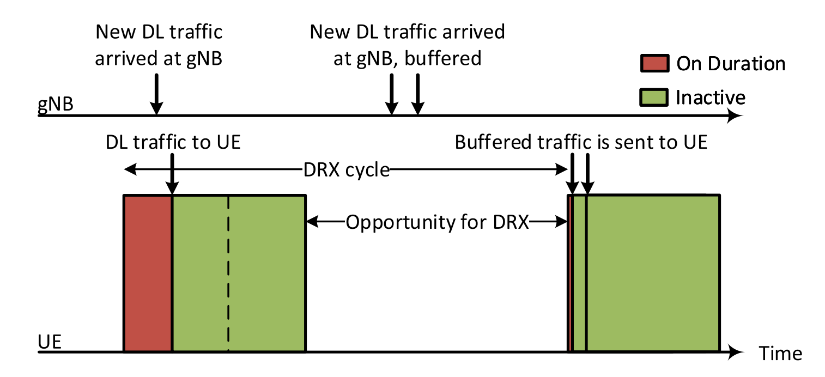
Figure 1. Illustration of DRX operation [4].
TR 38.840 [5] defines different power states associated with different active operations according to a device power model. The table below shows the relative power consumption and total transition time (ramping down and up) of each sleep state for FR1 (frequency range 1, up to 7 GHz).
Power State | Relative Power | Total transition time
Deep Sleep | 1 | 20 ms
Light Sleep | 20 | 6 ms
Micro sleep | 45 | 0 ms*
* Immediate transition is assumed for power saving study purpose from or to a non-sleep state

Figure 2 illustrates the UE power consumption at different power states and during state transition. The time spent by the UE in the Deep/Light Sleep states should be larger than the total transition time entering and leaving these states (20ms and 6ms, respectively).
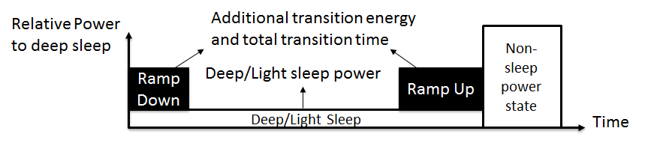
Figure 2. Illustration of UE power consumption at state transition [5].

RTP sender behavior
For real-time communication, the configuration of CDRX is tightly coupled with the behavior of the RTP sender. When multiple RTP packets are generated for each frame (as is common for video), the sender must choose between a) sending the packets in a single burst, or b) spreading their transmission across the frame interval. These two options are summarized below:
 | Advantages | Disadvantages
Single burst  Send the packets as fast as possible at the beginning of the frame interval. Long silent period afterwards. | Less end-to-end delay (assuming no congestion) | May overwhelm the limited buffering capacity of the network (buffer bloat) and cause instantaneous bit rate peaks, network congestion and packet loss
Paced sending  Smooth the flow of packets sent to the network by spreading transmission across the frame interval. | Avoids buffer bloat, bit rate peaks and reduces network congestion | May increase end-to-end delay compared to the transmission with a single burst

An implementation of paced sending is found in WebRTC (libwebrtc) [6]. In the implementation, the RTP sender puts the packets into a queue within the pacer, awaiting opportune moments to send them. The packets are sent at a calculated time based on a dynamically determined target sending rate. This is an inherent form of rate control. The API also enables specifying the longest time the packets can spend waiting in the pacer queue in order to avoid very large delays.

Signaling the time to next burst
A Data Burst is a set of multiple PDUs generated and sent by the application such that there is an idle period between two bursts. A Data Burst can be composed of one or multiple PDU sets.
Note: The definition of an idle period is FFS.
The End of Burst indication informs the UE that there is an opportunity to sleep until the beginning of the next burst and enables the usage of CDRX mechanisms. However, by itself it does not provide enough information for the UE or RAN to determine the appropriate power/sleep state for maximal power saving. The optimal power state depends on the idle period until the next burst is received by the UE (time to next burst).
In the case of single-burst transmission, the idle period is largely determined by the frame interval (e.g., ~33 ms for 30 fps). However, it may vary from burst to burst depending on the variations in frame rate and when a PDU set (slice or frame) is made available by the encoder, which may depend on the scene complexity. Furthermore, encoders that enable frame reordering may pass multiple frames to the RTP sender at once, such that the sender may send the PDUs belonging to consecutive frames in a single burst that lasts for multiple frame intervals. In the case of paced sending, the pacer sets the sending time of next packet/group of packets, meaning that the idle period is determined by the pacer, taking into account also the other constraints such as frame rate.
A PDU set header extension with a 3-bit field for burst indication in the mandatory fields of the header is proposed in S4-230487. The next section proposes semantics for the 3-bit field and an extension when more accurate time to next burst is known.

Guidelines for setting Burst indication
The three bit B field in the PDU set information RTP HE can be set using the following semantics.
Value | Description
000 | The sender does not have the means to sufficiently determine the time to next burst.
001 | The PDU is not the last PDU in the burst.
010 | The PDU is the last PDU of the burst and the time to next burst is more than the interval defined for micro sleep, i.e, 0ms. The UE can be put in micro sleep.
011 | The PDU is the last PDU of the burst and the time to next burst is more than the interval defined for light sleep, i.e., 6ms.
100 | The PDU is the last PDU of the burst and the time to next burst is more than the interval defined for deep sleep, i.e., 20ms.

The deep sleep, light sleep and micro sleep states are as defined in the TR 38.840.
An RTP sender shall determine the time to next burst based on its wall clock time. Note that network jitter aspects are not included in the burst indication and the timing is determined based on the time the sender transmits the PDU and not the time it reaches the receiver. Further optimization based on jitter is not in the scope of this contribution but can be implemented in the UPF or RAN. Jitter estimates should not use the burst indicators and rely on traditional mechanisms used for RTP traffic, e.g., using RTP headers and RTCP reports.
If the sender does not have the means to sufficiently determine the time to next burst, the field shall be set to 000b and the network can use other methods to estimate time between bursts e.g., based on traffic monitoring.

NOTE: Whether the burst indications for multiple flows can be combined at UPF or RAN needs to be checked with SA2 .
NOTE: Whether the intervals of deep sleep and light sleep need to be fixed or set can be further defined after checking with RAN.
NOTE: Further guidelines for application developers on how to set the modes may be defined at a later time.

Extension for time to next burst
The PDU set information RTP HE may be extended to include a time to next burst indication. A sender that includes the time to next burst shall be signaled in SDP using the line:
a=extmap:1 3gpp:pdu-set-info burst
When the extension is used, the PDU set information HE shall include a TTNB (Time To the Next Burst) field. The TTNB field shall appear immediately after the PSS (PDU Set Size) when it is used or immediately after the basic fields of the PDU set information RTP HE when PSS is not used. The TTNB field is 8 bits in length and is expressed in milliseconds. The TTNB indication can be used by the receiver UE to initiate the corresponding sleep state. The TTNB field shall be set to 0 if B is equal to 000b, i.e., the sender does not have the means to determine the idle period, or if B is equal to 001b, i.e., the current PDU is not the last PDU of the burst.
NOTE: Currently, 5GC only supports the End of Burst indication. Support of idle period indication in 5GC and signaling to RAN needs to be aligned with SA2 and RAN2.
NOTE: Latency impact of determining TTNB at the RTP sender is FFS.

Proposal
We propose to agree on adding the End of Burst and Time to Next Burst indications to the PDU set information RTP header extension and work on the guidelines for setting these fields. If agreed, we propose to move section 5-7 to the 5G_RTP permanent document.

References
[1] TR 23.700-60, Study on XR (Extended Reality) and media services
[2] TS 23.501, System architecture for the 5G System (5GS)
[3] TS 38.300, NR; NR and NG-RAN Overall description; Stage-2.
[4] Lin, Kuang-Hsun, et al. "A Survey on DRX Mechanism: Device Power Saving from LTE and 5G New Radio to 6G Communication Systems." IEEE Communications Surveys & Tutorials (2022).
[5] TR 38.840, Study on User Equipment (UE) power saving in NR
[6] https://chromium.googlesource.com/external/webrtc/+/master/modules/pacing/g3doc/index.md

Contact: Serhan Gül, Saba Ahsan, Igor Curcio, Nokia Technologies, Finland. Emails: ⎨firstname.lastname⎬@nokia.com.

