3GPP TSG SA4 Meeting #118e S4-220473
Online, > 6 – 14 April 2022
Agenda item: 8.7
Source: Ericsson LM
Title: Identification of ingest scenarios for MBS Object Distribution
Document for: Discussion and Agreement

1 Introduction
When using the MBS Object Distribution method, the MBSTF is de-coupling the ingesting of objects from the actual distribution of objects (See the figure below). For example, the MBSTF can re-order objects or repeat objects. The MBSTF may also ingest other objects between two ingested objects.

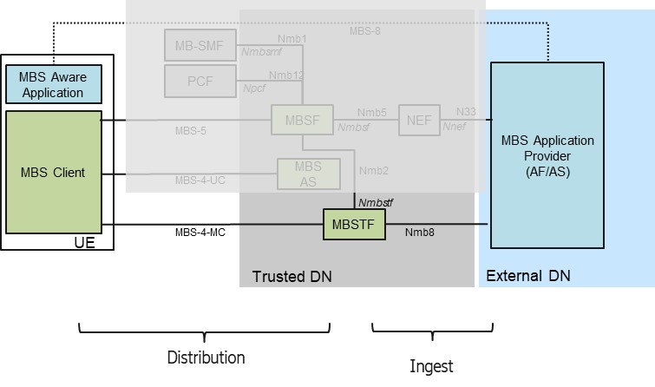
The intention of this discussion document is to identify some key use-cases, in order to help the specification work.

2 Identification of scenarios
In the following a set of MBS Object distribution scenarios are presented and discussed, focusing on the actual media data. For each distribution scenarios, several ingest scenarios are identified.

MBS Object Distribution Scenario | Ingest alternatives
DASH / HLS Media Distribution.
Note, the sequence of media segments follow a certain program schedule
Continuous Delivery of DASH Content.  The receiver identifies the segments based on a manifest | Push Ingest: The DASH Packager pushes a sequence of CMAF Segments into the MBSTF.  The DASH manifest (potentially conditioned) is provided through the MBSF towards the receiver.
Pull Ingest: The MBSTF pulls the CMAF segments as described by a manifest individually from an Origin server.
The DASH manifest (potentially conditioned) is provided through the MBSF towards the receiver.
The DASH manifest is provided through the MBST to the MBSTF.
Continuous Delivery of DASH/ HLS Content.  The receiver identifies the segments based on a manifest. Two (or more?) manifests are provided, and the receiver may use one of the manifests | Push Ingest: The DASH/HLS Packager pushes a sequence of CMAF Segments into the MBSTF.  Both / all manifests (potentially conditioned) are provided through the MBSF towards the receiver.
Pull Ingest: The MBSTF pulls the CMAF segments as described by a manifest individually from an Origin server
Both / all manifests (potentially conditioned) are provided through the MBSF towards the receiver.
One manifest (e.g. DASH) is provided through the MBST to the MBSTF.
Using other entry point documents, like a Web Presentation (HTML formatted entry point)
Note, the sequence of distributed objects may end, when the complete web presentation is sent.
Distribution of objects, linked by the web presentation within an MBS Distribution session.  The receiver identifies the objects based on a manifest (HTML document).  Object Repair may be activated | Push Ingest: The sender pushes a sequence of Web Objects (HTML, CSS, PNG, etc) into the MBSTF.  The Web Presentation manifest (potentially conditioned) is provided through the MBSF towards the receiver.
Pull Ingest: The MBSTF pulls the Web Objects as described by a Web presentation document (HTML document) individually from an Origin server.
The Web Presentation manifest is provided through the MBST to the MBSTF.
The Web Presentation manifest (potentially conditioned) is provided through the MBSF towards the receiver.
Object delivery without an entry point document (i.e. no manifest).
Note, these scenarios may be of interest for MCData.
Single object delivery, e.g. a software update  Object Repair may be activated  A session & file schedule document may describe the precise timing of the transmission, so that the receiver can wake-up in time.  The MBS Client may notify the app upon reception of an object. | Push Ingest: The Sender pushes / uploads object into the MBSTF prior to distribution time.
Pull Ingest: The MBSTF fetches the objects from an origin server prior to distribution time.
The Object URL to fetch is provided through the MBST to the MBSTF.

Sequence of objects, e.g. a statistics channel  The sequence of object may e.g. describe a statistics channel. Thus, objects are repeated, either with identical content or with updated content.  Object Repair may NOT be activated (small files, which are repeated).  A session schedule may describe the time window, during which objects are distributed.  The MBS client may notify the app, upon reception of a NEW object. | Push Ingest: The Sender pushes / uploads objects into the MBSTF. Objects are immediately put onto distribution.  The sender may repeatedly push / upload same file in case of repetitions.
Pull Ingest: The MBSTF fetches the objects from an origin server. The MBSTF may use HEAD requests to check, whether an already downloaded object version can be repeated.
The Object URLs to fetch / monitor are provided through the MBST to the MBSTF.
Repeating a single object, with idle intervals, e.g. retransmitting SW updates  A single object (may be tar-ed group of objects) is retransmitted with some idle intervals (e.g. several houds).  Object Repair may be activated.  A session & file schedule document may describe the precise timing of the transmission, so that the receiver can wake-up in time.  The MBS Client may notify the app upon reception of an object. | Push Ingest: The Sender pushes / uploads objects into the MBSTF prior to the transmission. In case a new object is uploaded between retransmissions, the new version is used for the transmission.  The MBSTF caches the object for upcoming retransmissions.
 | Pull Ingest: The MBSTF fetches the objects from an origin server prior to the transmission. Before a retransmission, the MBSTF may use HEAD requests to check, whether an already downloaded object version can be repeated.
More…?

3 Proposal
It is proposed to agree a set of “MBS Object Distribution with according ingest” scenarios for the Stage 3 work on 5MBP3.
It is proposed to agree the scenarios, presented in Clause 2 as a first set of scenarios. Other scenarios may be added as needed.

