**3GPP TSG- S4 Meeting #118-e *S4-220469***

**Electronic Meeting, 6-14 April 2022**

|  |  |  |  |  |  |  |  |  |
| --- | --- | --- | --- | --- | --- | --- | --- | --- |
| *CR-Form-v12.2* | | | | | | | | |
| **Pseudo CHANGE REQUEST** | | | | | | | | |
|  | | | | | | | | |
|  | **26.805** | **CR** | **<CR#>** | **rev** | **<Rev#>** | **Current version:** | **1.1.0** |  |
|  | | | | | | | | |
| *For* [***HE******LP***](http://www.3gpp.org/3G_Specs/CRs.htm#_blank)*on using this form: comprehensive instructions can be found at* [*http://www.3gpp.org/Change-Requests*](http://www.3gpp.org/Change-Requests)*.* | | | | | | | | |
|  | | | | | | | | |

|  |  |  |  |  |  |  |  |  |
| --- | --- | --- | --- | --- | --- | --- | --- | --- |
| ***Proposed change affects:*** | UICC apps |  | ME | **X** | Radio Access Network |  | Core Network | **X** |

|  |  |  |  |  |  |  |  |  |  |  |
| --- | --- | --- | --- | --- | --- | --- | --- | --- | --- | --- |
|  | | | | | | | | | | |
| ***Title:*** | [FS_NPN4AVProd]: Device On Boarding | | | | | | | | | |
|  |  | | | | | | | | | |
| ***Source to WG:*** | Ericsson LM, Dolby Laboratories | | | | | | | | | |
| ***Source to TSG:*** | S4 | | | | | | | | | |
|  |  | | | | | | | | | |
| ***Work item code:*** | FS_NPN4AVProd | | | | |  | ***Date:*** | | | 31/03/2022 |
|  |  | | | |  | |  | | |  |
| ***Category:*** | B |  | | | | | ***Release:*** | | | Rel-17 |
|  | *Use one of the following categories:* ***F*** *(correction)* ***A*** *(mirror corresponding to a change in an earlier release)* ***B*** *(addition of feature),* ***C*** *(functional modification of feature)* ***D*** *(editorial modification)*  Detailed explanations of the above categories can be found in 3GPP [TR 21.900](http://www.3gpp.org/ftp/Specs/html-info/21900.htm). | | | | | | | | *Use one of the following releases: Rel-8 (Release 8) Rel-9 (Release 9) Rel-10 (Release 10) Rel-11 (Release 11) … Rel-16 (Release 16) Rel-17 (Release 17) Rel-18 (Release 18) Rel-19 (Release 19)* | |
|  |  | | | | | | | | | |
| ***Reason for change:*** | | Lack of information and guidelines regarding Device onboarding on Non-Public Networks | | | | | | | | |
|  | |  | | | | | | | | |
| ***Summary of change:*** | | New Key Issue on Device onboarding and initial configuration | | | | | | | | |
|  | |  | | | | | | | | |
| ***Consequences if not approved:*** | |  | | | | | | | | |
|  | |  | | | | | | | | |
| ***Clauses affected:*** | |  | | | | | | | | |
|  | |  | | | | | | | | |
|  | | **Y** | **N** |  | | | |  | | |
| ***Other specs*** | |  | **X** | Other core specifications | | | | TS/TR ... CR ... | | |
| ***affected:*** | |  | **X** | Test specifications | | | | TS/TR ... CR ... | | |
| ***(show related CRs)*** | |  | **X** | O&M Specifications | | | | TS/TR ... CR ... | | |
|  | |  | | | | | | | | |
| ***Other comments:*** | |  | | | | | | | | |
|  | |  | | | | | | | | |
| ***This CR's revision history:*** | |  | | | | | | | | |

**** First Change ****

## 6.X Key Issue #X: Device onboarding and initial configuration

### 6.X.1 General

#### 6.X.1.1 Introduction

One general issue is the onboarding of devices into an NPN and the initial device configuration. Temporary devices such as rental devices are often used in media production events. Other media production events even happen at Outside Broadcast locations where a temporary production network is set up before the event and torn down afterwards.

The Media Production vertical has very use-case specific device usage. Devices in a studio evnvironment are often statically assigned to a network; devices deployed as part of an Outside Broadcast or a Live Touring event are often configured specifically for each event. Rented devices are frequently integrated into a media production. These devices should only have access to the NPN during the duration of the event; after the event, their access needs to be revoked.

#### 6.X.1.2 Media production event timeline

A simplified time sequence for a media production event is illustrated in figure 6.X.1.2-1 and shows different activity periods of the devices during a media production event. A *media production event* is defined here as the time period during which the 5G System is used to produce media. A media production event may, for example, be the airing of a breaking news story or the capturing of a sporting event.

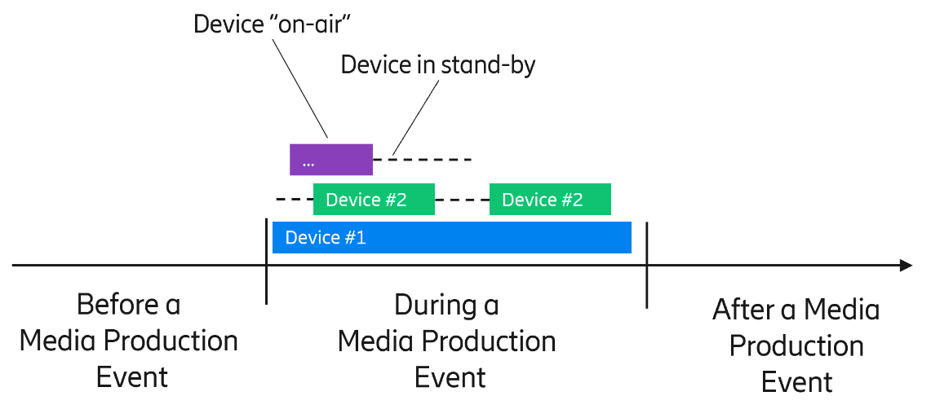

Figure 6.X.1.2-1: Media production event timeline

- Before the media production event, devices such as 5G-enabled professional cameras or displays need to first get access to the 5G System and to receive some initial configuration information. Some devices have conveniently large displays even with touch capability. Other devices like wireless microphones have only small or no displays and only simple buttons.

- During the media production event, devices may not be used continuously.

- At the end of the media production event, devices that were temporarily added to the 5G System need to be "offboarded".

#### 6.X.1.3 Media production event activities

##### 6.X.1.3.1 Introduction

The following clauses describe the basic activities before (clause 6.X.1.3.2), during (clause 6.X.1.3.3) and after (clause 6.X.1.3.4) a media production event.

##### 6.X.1.3.2 Onboarding and configuration activities before a media production event

1: The *5G network configuration* activity includes IP address planning and configuration, data network configurations (inlcluding DNN) and provisioning of device authorization information (including access credentials provisioned on a SIM). For permanent installations (e.g. a media production studio), there is a high degree of re-use across multiple media production events; for temporary setups (e.g. an Outside Broadcast), each production event is unique and the configuration is therefore bespoke.

2: The *Device onboarding* activity is the procedure that provides basic 5G network access information to devices, such as the Network Id (e.g. PLMN ID or a NID) and the network access credentials. The device then acts as either an SNPN-enabled UE (a UE configured to use standalone Non-Public Networks with PLMN ID and NID – see clause 5.30.2 of TS 23.501 [xx]) or a regular UE with the appropriate PLMN subscription for the PNI-NPN acces through e.g. a Closed Access Group (CAG – see clause 5.30.3 of TS 23.501 [xx]) and needs to connect to the correct network to successfully authenticate itself using the network access credentials provisioned above. The network access credentials are typically stored on a SIM card, which is unlocked using a PIN code, although modern devices may support an embedded SIM (eSIM) solution, which removes the dependency on a physical SIM card. For SNPNs, authentication based on EAP-TLS may instead be used.

3: The *Event-specific network configuration* activity realises the requirements placed on the 5G System supporting a specific media production event. Appropriate configurations need to be applied to devices according to the number used and the respective application. This activity may also include the configuration of different QoS flows and other network services.

4: The *Device (remote) configuration* activity is the procedure to provide event-specific configuration information to the device e.g, depending on the Radio Access Network used for the production event (e.g. mid band or high band), and the uplink bit rate consequently available, the device may use a different codec configuration. Further, the IP senders and receivers may change from one event to another and the device configuration may need to be adjusted accordingly. See Key Issue #3 and Key Issue #8.

Editor’s Note: Media Network Configuration and Flow Configuration.

##### 6.X.1.3.3 Activities during an ongoing media production event:

5: The *Device configuration changes* activity involves dynamic configuration changes, e.g. to change the encoding profile of a camera. See Key Issue #4.

6: The *Device control changes* activity covers device-specific control operations, such as camera iris control or pan/tilt/zoom (PTZ) camera control.

7: The *Network monitoring* activity is the monitoring of devices deployed in the NPN and potential actions due to connectivity changes.

##### 6.X.1.3.4 Activities after a media production event

### 6.X.2 Solutions

Editor’s Note: List of solutions:

### 6.X.3 Discussion

**** Last Change ****