Source: Facebook

**Title: Splitting TS 26.114 into Multiple Documents**

**Agenda Item: 11.6**

**Document for: [Draft] Discussion & Agreement**

Background

TS 26.114, whose V.1.0.0 had only 56 pages, has grown to 471 pages in V17.3.0, making it difficult to load or scroll in the document.

TS 26.445, which has 661 pages in V16.1.1, consists of 11 documents, to avoid such problems but it is more complex to update and manage. Such a splitting also makes browsing through different clauses and searches over entire documents difficult.

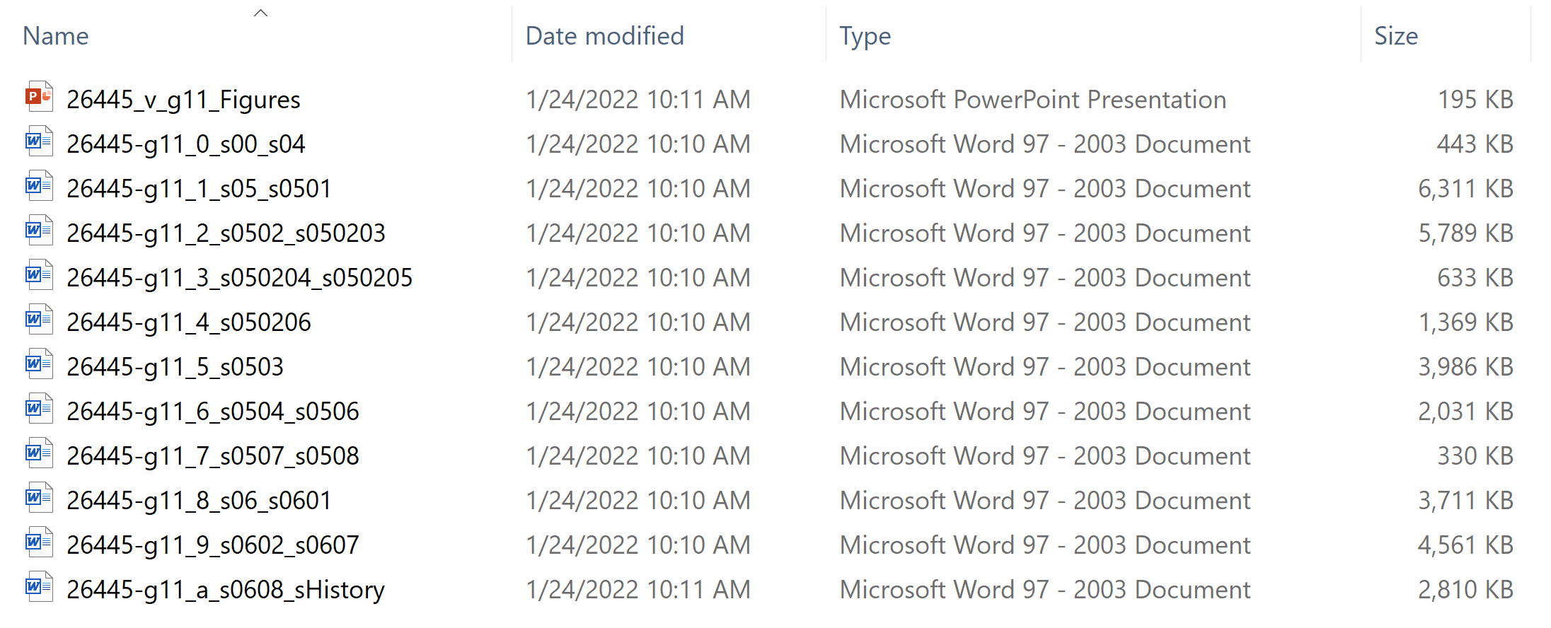

**Proposal**

It is proposed to discuss and decide about a potential split of TS 26.114.

Providing a PDF version of 26.114 is an alternative that can be considered as the format enables fast loading and parsing.

If SA4 decides to split, its new structure is required to be determined, using the following format.

|  |  |  |  |  |
| --- | --- | --- | --- | --- |
| **Number** | **File Name** | **From** | **To** | **Pages** |
| 0 |  | Cover | Clause *X* |  |
| 1 |  | Clause *X*+1 |  |  |
| … |  |  |  |  |
| *M* |  |  |  |  |
| *N* |  |  | Change History |  |

To simplify the file names, it is recommended to apply a page break before each clause and annex such that each page corresponds to a single clause or annex.