**3GPP TSG- S4 Meeting #117e *S4-220143***

**, 17th February – 23rd February 2022**

|  |  |  |  |  |  |  |  |  |
| --- | --- | --- | --- | --- | --- | --- | --- | --- |
| *CR-Form-v12.2* | | | | | | | | |
| **Psuedo CHANGE REQUEST** | | | | | | | | |
|  | | | | | | | | |
|  |  | **CR** |  | **rev** |  | **Current version:** |  |  |
|  | | | | | | | | |
| *For* [***HE******LP***](http://www.3gpp.org/3G_Specs/CRs.htm#_blank)*on using this form: comprehensive instructions can be found at* [*http://www.3gpp.org/Change-Requests*](http://www.3gpp.org/Change-Requests)*.* | | | | | | | | |
|  | | | | | | | | |

|  |  |  |  |  |  |  |  |  |
| --- | --- | --- | --- | --- | --- | --- | --- | --- |
| ***Proposed change affects:*** | UICC apps |  | ME |  | Radio Access Network |  | Core Network |  |

|  |  |  |  |  |  |  |  |  |  |  |
| --- | --- | --- | --- | --- | --- | --- | --- | --- | --- | --- |
|  | | | | | | | | | | |
| ***Title:*** | [FS_NPN4AVProd]: Introduction to Candidate Solutions and updates to KI#2 | | | | | | | | | |
|  |  | | | | | | | | | |
| ***Source to WG:*** |  | | | | | | | | | |
| ***Source to TSG:*** |  | | | | | | | | | |
|  |  | | | | | | | | | |
| ***Work item code:*** | FS_NPN4AVProd | | | | |  | ***Date:*** | | |  |
|  |  | | | |  | |  | | |  |
| ***Category:*** |  |  | | | | | ***Release:*** | | |  |
|  | *Use one of the following categories:* ***F*** *(correction)* ***A*** *(mirror corresponding to a change in an earlier release)* ***B*** *(addition of feature),* ***C*** *(functional modification of feature)* ***D*** *(editorial modification)*  Detailed explanations of the above categories can be found in 3GPP [TR 21.900](http://www.3gpp.org/ftp/Specs/html-info/21900.htm). | | | | | | | | *Use one of the following releases: Rel-8 (Release 8) Rel-9 (Release 9) Rel-10 (Release 10) Rel-11 (Release 11) … Rel-16 (Release 16) Rel-17 (Release 17) Rel-18 (Release 18) Rel-19 (Release 19)* | |
|  |  | | | | | | | | | |
| ***Reason for change:*** | |  | | | | | | | | |
|  | |  | | | | | | | | |
| ***Summary of change:*** | | This contribution characterizes key production and contribution scenarios within the introduction of the solution section. The contribution also provides a first summary of the Traffic Prioritization Key Issue. | | | | | | | | |
|  | |  | | | | | | | | |
| ***Consequences if not approved:*** | |  | | | | | | | | |
|  | |  | | | | | | | | |
| ***Clauses affected:*** | |  | | | | | | | | |
|  | |  | | | | | | | | |
|  | | **Y** | **N** |  | | | |  | | |
| ***Other specs*** | |  |  | Other core specifications | | | | TS/TR ... CR ... | | |
| ***affected:*** | |  |  | Test specifications | | | | TS/TR ... CR ... | | |
| ***(show related CRs)*** | |  |  | O&M Specifications | | | | TS/TR ... CR ... | | |
|  | |  | | | | | | | | |
| ***Other comments:*** | |  | | | | | | | | |
|  | |  | | | | | | | | |
| ***This CR's revision history:*** | |  | | | | | | | | |

**** First Change ****

# 2 References

The following documents contain provisions which, through reference in this text, constitute provisions of the present document.

…

[x] ITU-R BT.2069-7, "Tuning ranges and operational characteristics of terrestrial electronic news gathering (ENG), television outside broadcast (TVOB) and electronic field production (EFP) systems", October 2017, https://www.itu.int/dms_pub/itu-r/opb/rep/R-REP-BT.2069-7-2017-PDF-E.pdf

[x1] BBC White Paper WHP 277, "BBC halfRF MIMO Radio-camera Programme Trial", February 2014, http://downloads.bbc.co.uk/rd/pubs/whp/whp-pdf-files/WHP277.pdf

**** Next Change ****

# 6 Potential issues and Candidate Solutions

## 6.1 General

This clause describes and discusses a set of candidate solutions for addressing the different production use-cases and deployment options as introduced in clause 4.1 and clause 5.

- **Local Production:** The expectation for a local production is low-latency operation (a few frames of delay) at high bit rates. With today’s COFDM technology [x][x1], a fixed capacity (e.g. 8 MHz) is allocated to a production device (like a camera). This enables a camera to operate at low latency. The rate control of the video encoder is tuned to never exceed the allocated capacity. With 5G NPN, this can only be achieved when allocating a Guaranteed Bit Rate (GBR) QoS flow to the media. Non-GBR QoS flows may lead to situations where the UE needs to discard packets because the capacity is currently not available. Local Production may leverage specifically Deployment #1 (local SNPN deployment) or Deployment #2 (Local PNI-NPN with support for on-site edge computing).

- **Remote Production:** The expectation for a remote production is also low-latency operation at high bit rates. However, there is a possibility to compromise, e.g. slightly higher latencies than in local production but lower latencies as in contribution. Solutions need to account for some packet loss and potentially for automatic bit rate adaptation. Remote Production may leverage specifically Deployment #2 (Remote Production) or Deployment #3.

- **Contribution:** The expectation for contribution is different than for production. Contribution links often operate at higher latencies than production links. However, a very flexible and on-demand (or even spontaneous) capacity allocation is important, e.g. as needed for Electronic News Gathering (ENG). Specifically Deployment #2 (Contribution) is in focus for most contribution cases. In some cases, Deployment #3 (with a nomadic SNPN) may also be applicable.

Editor’s Note: Considerations for *Installed and Live Sound* is ffs.

**** Next Change ****

## 6.3 Key Issue #2: Media Protocols on 5G: Traffic segregation and traffic prioritization

### 6.3.1 General

This clause focuses on the usage of 5G Systems, assuming that multiple application flows – either from multiple cameras or from a single camera unit (see Figure 5.2-1) – would experience a different priority treatment by the RAN traffic scheduler and likely by the traffic policing function in 5GC. Different protocols may be used to carry media and other data.

An application flow is typically described by a 5-tuple, i.e. source and destination IP addresses (Layer 3), Layer 4 protocol and Layer 4 source and destination ports. Some protocols may multiplex multiple elementary streams (and potentially other data) into one application flow. Other protocols map one elementary stream to one application flow.

The traffic characteristics and the main flow direction (uplink or downlink) depend on the usage. For example, a program video stream, produced by a camera, is typically of higher bit rate than a return video stream.

NOTE: Some application flows may carry non-media content, for example camera control, telematics (e.g. battery status), and position information for AR tracking.

Editor’s Note: Solutions may use IP multicast or IP unicast packet routing to transport media streams. IP multicast is popular in AV Production because the same feed from a camera, microphone or talkback circuit can then be consumed by monitoring devices (screens, headphones, etc.) as well as feeding into vision mixers, sound mixers, etc. However, there are challenges to be overcome in using IP multicast over Wide-Area Networks and therefore in Remote Production scenarios.

### 6.3.2 Application flow prioritisation

Figure 6.3.2‑1 depicts the same media flows of a single camera as shown in figure 5.2-1, but categorized into three priority groups:

- Group 1, with the highest priority, comprises essential media essence flows.

- Group 2, with medium priority, comprises communications flows.

- Group 3, with the lowest priority, comprises control flows.

Depending on the media production scenario, a certain set of media flows are present. For example, a telepromter application flow is only present when a teleprompter (autocue) device is attached to the camera.

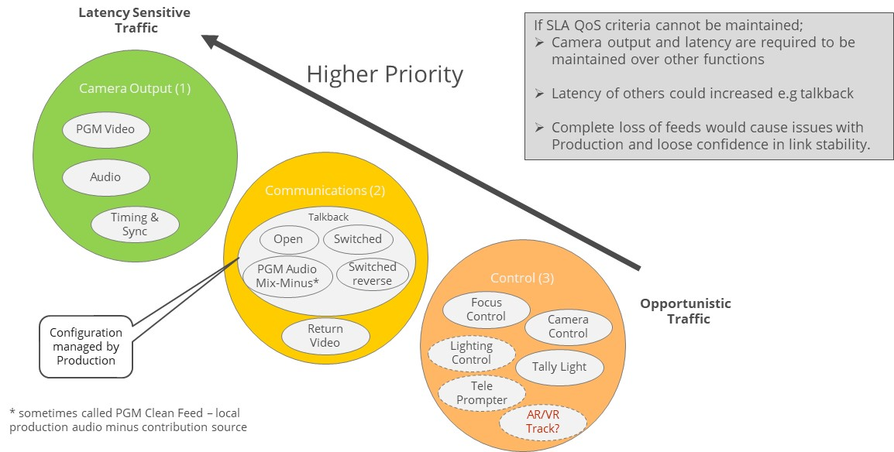

Figure 6.3.2‑1: Flow Priority

Typically, highest priority is program (PGM) video, which is always present when using a 5G-enabled camera. An audio media flow related to the program video flow is not necessarily present in all scenarios, but when present, it often has an even higher priority than the program video. A time synchronization related media flow (e.g. PTP or NTP) is always present and is essential for production.

### 6.3.3 Applying Quality of Service to application flows

Quality of Service (QoS) is a tool which only becomes relevant at times of high network utilisation. In these situations, the 5G System may need to prioritize some packets over others. In a well-planned production scenario, the 5G Systems is dimensioned to fit the needs of the media production and high network utilisation only occurs rarely. However, proper planning and dimensioning might not be achievable in all media production scenarios. Thus, it might be preferred to degrade the output of a camera, keeping the most essential traffic intact. Depending on the scenario, different media flows are more essential than others to the media production.

An example communication protocol stack is illustrated in Figure 6.3.3‑1 below. The different media flows may use different higher layer protocols. For audio and video streams, the RTP protocol is often used, which typically uses UDP as its Layer 4 protocol. Data streams such as tally light control may be carried using, for example, MQTT [48] (AMWA NMOS recommendation) which uses TCP as its Layer 4 protocol. NMOS is described in Clause 4.5.2 in more detail.

MQTT [48] is a message-oriented application protocol based on the publish–subscribe paradigm. It was developed as an OASIS open standard and published as ISO/IEC 20922. MQTT uses TCP as its transport protocol. MQTT adds some message headers, which allow (among other things) the byte-stream-oriented TCP protocol to be used for message separation.

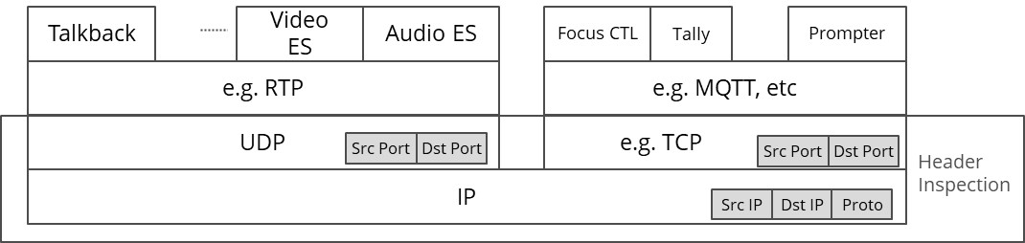

Figure 6.3.3‑1: Example protocol stacks for different media application flows

The different combinations of media flows (Figure 5.2-1) depend on the media production scenario. In the following, the mappings for some example scenarios are presented and discussed.

### 6.3.4 Solutions leveraging 3GPP QoS

#### 6.3.4.1 General

The 3GPP Quality of Service framework contains many tools to define media flow specific treatment with respect to relative priority, target bit rate, packet delay budget and packet error rate. To apply these tools, the 5G System must be able to identify the associated media flow, based on network-level parameters such as a UDP port number or an IP address. The 5G System (UE and UPF) uses packet header inspection techniques for traffic detection. Based on header inspection, each individual IP packet is associated with a QoS flow and is marked accordingly in the 5G System.

#### 6.3.4.2 Solution Example A: Coarse-grained separation with separated media

It is very common in IP-based media production scenarios to keep elementary streams like audio and video separated in independent UDP/IP flows. Thus, audio and video are not multiplexed together.

It is assumed here that all media flows within one group can be treated with the same QoS class. Thus, audio is equally important as video. All the control data flows are also treated with equal priority.

For Group 1, the application traffic can be identified by a (wildcarded) 5-tuple of packet headers comprising:

- Layer 3 parameters:

- *UE IP:* Any (wildcard).

- *Server IP:* IP address of media gateway or vision/sound mixer.

- *Transport Protocol:* Indicating that UDP is used as the Layer 4 protocol.

- Layer 4 Parameters:

- *UE UDP Port:* Any.

- *Server UDP Port:* Separate UDP ports for audio and video on the Media Gateway or Vision Mixer side.

For Group 3, the application traffic can be identified by a different (wildcarded) 5-tuple comprising:

- Layer 3 parameters

- *UE IP:* Any (wildcard).

- *Server IP:* IP address of MQTT Broker or WebSocket server.

- *Transport Protocol:* Indicating that TCP is used as the Layer 4 protocol.

- Layer 4 parameters

- *UE TCP Port:* Any.

- *Server TCP Port:* TCP Port of the MQTT Broker or WebSocket server.

In cases where all video and audio elementary streams are treated with the same priority, the elementary streams can be multiplexed onto the same UDP/IP flow, e.g. using a multi-programme MPEG‑2 Transport Stream.

NOTE: When using MPEG‑2 Transport Stream as a Payload Format, all multiplexed elementary streams are treated with the same QoS by the 5G System.

#### 6.3.4.3 Solution Example B: Fine-grained separation with separated media

In this example, a finer-grained separation of media is used:

- Within Group 1, the audio elementary stream has a higher priority than the video elementary stream.

- Talkback (Group 2) audio has a lower priority than Group 1 traffic.

- In Group 3, tally light control has a higher priority than general camera control.

As result, the individual media flows should be separated into separate application flows, e.g. UDP/IP flows or TCP/IP flows.

In order to enable the 5G System to prioritise the audio elementary stream higher than the video elementary stream in Group 1, the elementary streams need to be carried as individual UDP/IP media flows.

- RIST Simple profile allows usage of separated RTP sessions for different elementary streams, when a native RTP payload format (like RFC 7798 [47] for HEVC or RFC 6416 [49] for AAC) is used.

- RIST Main profile uses GRE tunnelling to encapsulate all media flows in order to simplify NAT/firewall traversal. However, the usage of a GRE tunnel also disables the 5G System capability of providing media flow based QoS.

The talkback audio flow needs to be separated from the main output using dedicated TCP/IP or UDP/IP transmission resources.

If tally light control requires a higher priority than other camera control messages, the event messages should be carried using uniquely identifiable network resources. When MQTT is used for carrying control event messages, the camera needs to set up two MQTT/TCP connections, which can then be clearly prioritized by the 5G System. When WebSockets are used for carrying the event message, the camera should set up two WebSocket/TCP connections to enable separate message prioritization.

### 6.3.5 Solutions leveraging Network Slices

#### 6.3.5.1 General

Network Slicing is a feature which allows a Mobile Network Operator to provide customized networks. Network resources are logically separated so that they can be individually controlled. Each Network Slice contains at least one PDU Session. PDU Sessions cannot be shared across multiple Network Slices.

The UE obtains one IP address for each established PDU Session (Type IP). When a UE establishes multiple PDU sessions, either within a single Network Slice or in different Network Slices, the UE obtains a corresponding number of IP addresses.

#### 6.3.5.2 Solution Example C: Separation using Multiple Network Slices

In this example, the traffic separation is realized using multiple Network Slices. Here, similar to Example A, a coarse-grained separation is assumed: all application flows belonging to Group 1 are carried by Network Slice #1, Group 2 uses Network Slice #2 and Group 3 uses Network Slice #3.

In general, a Network Slice may contain one or more PDU Sessions. For this example, however, it is assumed that each Network Slice contains only a single PDU Session.

The UE obtains an IP address for each PDU Session. The camera then sends all Group 1 traffic with the IP address for PDU Session in Network Slice #1. All Group #2 application flows are sent with the IP address associated with the PDU Session in Network Slice #2, and all Group 3 traffic has the IP address of the PDU Session in Network Slice #3.

The 5G System then handles the traffic according to the Network Slice priority.

#### 6.3.5.3 Solution Example D: Separation using Network Slices and QoS

In this example, traffic separation is realized by combining Network Slices with QoS. Here, a more fine-grained separation is assumed, as in Example B:

- Within Group 1, the audio elementary stream has a higher priority than the video elementary stream.

- Group 2 talkback audio has a lower priority than Group 1 traffic.

- In Group 3, tally light control has a higher priority than general camera control.

In this example, all talkback related traffic uses a dedicated Network Slice for talkback. Meanwhile, all Group 1 camera traffic, all Group 3 traffic, and the return video from Group 2 share a second Network Slice.

As in Example C, each Network Slice is configured with a single PDU Session. The camera is therefore assigned a different IP address for the PDU Session in each Network Slices.

The camera uses the IP address associated with the talkback Network Slice for all talkback audio flows. All other application flows use the IP address associated with other Network Slice. Fine-grained prioritization using QoS is then applied for application flows within the second Network Slice.

### 6.3.6 Summary

This section describes different solutions for traffic segregation in order to prioritize different application flows according to the needs of a media production. In principle, all the different production use-cases (see clause 6.1) require traffic prioritization in some shape or form. Depending on the collaboration scenario, the network can be provisioned (e.g. for QoS or Network Slicing) based traffic prioritization.

Generally, the traffic prioritization configuration can be provisioned statically (e.g. using Operation and Maintenance interfaces) or dynamically (using control APIs). For dynamic provisioning, the 5G System offers a set of APIs which can be used based on the collaboration.

In local production scenarios, the target is to operate at low latency, providing a constant media quality. No additional latency is accounted for in IP-level retransmissions or similar. It is recommended to use QoS flows with a Guaranteed Bit Rate (GBR) for media flows (e.g. program video and audio). Other application flows can use QoS without a bit rate guarantee (i.e., non-GBR).

Remote production scenarios still target low latency. However, certain application-level adaptation schemes may be involved.

For contribution scenarios, the target is to provide a constant quality during a production event. The actual quality can vary from one production event to another.

**** Last Change ****