**3GPP TSG-WG SA4 Meeting #117E e-meeting  *S4-220120***

**Elbonia, February 14th– 23rd, 2022**

|  |  |  |  |  |  |  |  |  |
| --- | --- | --- | --- | --- | --- | --- | --- | --- |
| *CR-Form-v12.1* | | | | | | | | |
| **CHANGE REQUEST** | | | | | | | | |
|  | | | | | | | | |
|  | **26.247** | **CR** | **0170** | **rev** | **-** | **Current version:** | **16.5.1** |  |
|  | | | | | | | | |
| *For* [***HE******LP***](http://www.3gpp.org/3G_Specs/CRs.htm#_blank)*on using this form: comprehensive instructions can be found at* [*http://www.3gpp.org/Change-Requests*](http://www.3gpp.org/Change-Requests)*.* | | | | | | | | |
|  | | | | | | | | |

|  |  |  |  |  |  |  |  |  |
| --- | --- | --- | --- | --- | --- | --- | --- | --- |
| ***Proposed change affects:*** | UICC apps | **X** | ME | **X** | Radio Access Network | **X** | Core Network |  |

|  |  |  |  |  |  |  |  |  |  |  |
| --- | --- | --- | --- | --- | --- | --- | --- | --- | --- | --- |
|  | | | | | | | | | | |
| ***Title:*** | Support of RAN Visible QoE | | | | | | | | | |
|  |  | | | | | | | | | |
| ***Source to WG:*** | Huawei, HiSilicon | | | | | | | | | |
| ***Source to TSG:*** | SA4 | | | | | | | | | |
|  |  | | | | | | | | | |
| ***Work item code:*** | NR_QoE-Core | | | | |  | ***Date:*** | | | 2022-01-28 |
|  |  | | | |  | |  | | |  |
| ***Category:*** | **F** |  | | | | | ***Release:*** | | | Rel-17 |
|  | *Use one of the following categories:* ***F*** *(correction)* ***A*** *(mirror corresponding to a change in an earlier release)* ***B*** *(addition of feature),* ***C*** *(functional modification of feature)* ***D*** *(editorial modification)*  Detailed explanations of the above categories can be found in 3GPP [TR 21.900](http://www.3gpp.org/ftp/Specs/html-info/21900.htm). | | | | | | | | *Use one of the following releases: Rel-8 (Release 8) Rel-9 (Release 9) Rel-10 (Release 10) Rel-11 (Release 11) … Rel-15 (Release 15) Rel-16 (Release 16) Rel-17 (Release 17) Rel-18 (Release 18)* | |
|  |  | | | | | | | | | |
| ***Reason for change:*** | | As indicated in LS R2-2202018 from RAN2, the maximum sizes of one QoE configuration container and QoE report container is up to 8000 bytes and 144000 bytes, respectively, with RRC segmentation enabled. Alignments in SA4 specs are needed for support of that. | | | | | | | | |
|  | |  | | | | | | | | |
| ***Summary of change:*** | | Add support of maximum size of one QoE report container. | | | | | | | | |
|  | |  | | | | | | | | |
| ***Consequences if not approved:*** | | Support for NR QoE features is not complete in SA4 specifications. | | | | | | | | |
|  | |  | | | | | | | | |
| ***Clauses affected:*** | | 2, L.1 | | | | | | | | |
|  | |  | | | | | | | | |
|  | | **Y** | **N** |  | | | |  | | |
| ***Other specs*** | |  | **X** | Other core specifications | | | | TS/TR ... CR ... | | |
| ***affected:*** | |  | **X** | Test specifications | | | | TS/TR ... CR ... | | |
| ***(show related CRs)*** | |  | **X** | O&M Specifications | | | | TS/TR ... CR ... | | |
|  | |  | | | | | | | | |
| ***Other comments:*** | |  | | | | | | | | |
|  | |  | | | | | | | | |
| ***This CR's revision history:*** | |  | | | | | | | | |

* * * * First change * * * *

# 2 References

The following documents contain provisions which, through reference in this text, constitute provisions of the present document.

## …..

[69] 3GPP TS 38.331: "NR; Radio Resource Control (RRC); Protocol specification".

* * * * Second change * * * *

## L.1 Configuration and reporting

As an alternative to configuration via MPD or OMA-DM, the QoE configuration can optionally be specified by the QoE Measurement Collection (QMC) functionality. In this case the QoE configuration is received via specific RRC [53] messages for UMTS, RRC [59] messages for LTE, and RRC messages for NR [X] over the control plane, and the QoE reporting is also sent back via RRC messages over the control plane.

If QMC is supported, the UE shall support the following QMC functionalities:

- QoE Configuration: The QoE configuration will be delivered via RRC to the UE as a container according to "Application Layer Measurement Configuration" (see [53]) for UMTS, "measConfigAppLayer" (see [59]) for LTE. The container is an octet string with gzip-encoded data (see [18]) stored in network byte order . The maximum size of the container is 1000 bytes for UMTS and LTE, and 8000 bytes for NR (see [69]). The container shall be uncompressed, and is then expected to conform to XML-formatted QoE configuration data according to clause L.2 in the current specification. This QoE Configuration shall be forwarded to the DASH client. The interface towards the RRC signalling is handled by the AT command +CAPPLEVMC [61].

- QoE Metrics: QoE Metrics from the DASH client shall be XML-formatted according to clause 10.6 in the current specification. The XML data shall be compressed with gzip (see [18]) and stored in network byte order into an octet string container. The maximum size of the container is 8000 bytes for UMTS and LTE. For NR [69] the maximum size is 8000 bytes if RRC segmentation is not enabled, and 144000 bytes if enabled. The container shall be delivered via RRC to the RNC according to "Application Layer Measurement Reporting" (see [53]) for UMTS, to the eNB according to "measReportAppLayer" (see [59]) for LTE. The behaviour if the compressed data is larger than the maximum container size is unspecified in this version of the specification. The interface towards the RRC signalling is handled by the AT command +CAPPLEVMR [61].

- The UE shall also set the QMC capability "QoE Measurement Collection for streaming services" (see [53]) to TRUE for UMTS, and include the QMC capability "qoe-MeasReport" (see [59]) for LTE.

- The QoE configuration AT command +CAPPLEVMC [61] may also indicate with an Within-area Indication if the UE is inside or outside a wanted geographic area. Such an indication may arrive with or without any QoE configuration container attached. If the DASH client is informed that it is not inside the area, it shall not start any new QoE measurements even if it has received a valid QoE configuration container, but shall continue measuring for already started sessions.

- When a new session is started, the QoE reporting AT command +CAPPLEVMR [61] shall be used to send a Recording Session Indication. Such an indication does not contain any QoE report, but indicates that QoE recording has started for a session.

- When the QoE configuration is to be released, an unsolicited result code, associated with the AT command +CAPPLEVMC [61] and containing the parameter <start-stop_reporting> set to "1" shall be sent to the DASH client as notification of a discard request. Then the DASH client shall stop collecting quality metrics and discard any already collected information [63].

The exact implementation is not specified here, but example signalling diagrams for UMTS and LTE below show the QMC functionality with a hypothetical "QMC Handler" entity.



Figure L-1: Example signalling diagram for UMTS

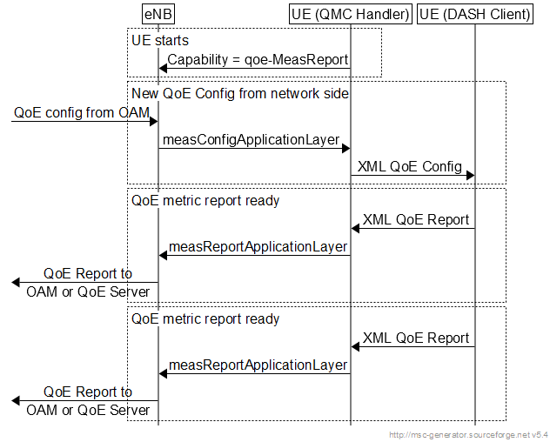

Figure L-2: Example signalling diagram for LTE

Note that the QMC Handler is only shown here as one possible implementation, and it need not be implemented as such. The corresponding QMC functionality could be built into the DASH client or into other UE entities. In this version of the specification the detailed implementation of the above functionalities is left to the UE vendor.

* * * * End of changes * * * *