**3GPP TSG-SA4 Meeting #116-e *S4-211629***

**Online, 10 – 19 November 2021**

|  |  |  |  |  |  |  |  |  |
| --- | --- | --- | --- | --- | --- | --- | --- | --- |
| *CR-Form-v12.1* | | | | | | | | |
| **DRAFT CHANGE REQUEST** | | | | | | | | |
|  | | | | | | | | |
|  | **26.132** | **CR** | **<CR#>** | **rev** | **-** | **Current version:** | **16.2.0** |  |
|  | | | | | | | | |
| *For* [***HE******LP***](http://www.3gpp.org/3G_Specs/CRs.htm#_blank)*on using this form: comprehensive instructions can be found at* [*http://www.3gpp.org/Change-Requests*](http://www.3gpp.org/Change-Requests)*.* | | | | | | | | |
|  | | | | | | | | |

|  |  |  |  |  |  |  |  |  |
| --- | --- | --- | --- | --- | --- | --- | --- | --- |
| ***Proposed change affects:*** | UICC apps |  | ME | **x** | Radio Access Network |  | Core Network |  |

|  |  |  |  |  |  |  |  |  |  |  |
| --- | --- | --- | --- | --- | --- | --- | --- | --- | --- | --- |
|  | | | | | | | | | | |
| ***Title:*** | Test methods for HaNTE | | | | | | | | | |
|  |  | | | | | | | | | |
| ***Source to WG:*** | Qualcomm Incorporated | | | | | | | | | |
| ***Source to TSG:*** | S4 | | | | | | | | | |
|  |  | | | | | | | | | |
| ***Work item code:*** | HaNTE | | | | |  | ***Date:*** | | | 2021-11-18 |
|  |  | | | |  | |  | | |  |
| ***Category:*** | **B** |  | | | | | ***Release:*** | | | Rel-17 |
|  | *Use one of the following categories:* ***F*** *(correction)* ***A*** *(mirror corresponding to a change in an earlier release)* ***B*** *(addition of feature),* ***C*** *(functional modification of feature)* ***D*** *(editorial modification)*  Detailed explanations of the above categories can be found in 3GPP [TR 21.900](http://www.3gpp.org/ftp/Specs/html-info/21900.htm). | | | | | | | | *Use one of the following releases: Rel-8 (Release 8) Rel-9 (Release 9) Rel-10 (Release 10) Rel-11 (Release 11) … Rel-15 (Release 15) Rel-16 (Release 16) Rel-17 (Release 17) Rel-18 (Release 18)* | |
|  |  | | | | | | | | | |
| ***Reason for change:*** | | UEs featuring non-traditional earpieces pose challenges for handset mode acoustic testing. For example, a UE may exclusively use a vibrating display to produce sound when operating in handset mode, offering no clearly identifiable centre of an earpiece to position the headset for testing. Additionally, such UE could have its acoustic response affected by the choice of handset positioner mechanism. | | | | | | | | |
|  | |  | | | | | | | | |
| ***Summary of change:*** | | Update 3GPP TS 26.132 with reference to the appropriate version of ITU-T P.64 that addresses HaNTE devices  Establish guidelines for mounting of HaNTE devices to ensure a repeatable and reproducible measurement method in 3GPP TS 26.132  Add privacy test method  Add testing of receive frequency response at maximum volume setting  Add testing at alternative fork positions (this provides an easy way to diagnose a device with unwanted vibration) | | | | | | | | |
|  | |  | | | | | | | | |
| ***Consequences if not approved:*** | | Handsets Featuring Non-Traditional Earpieces (HaNTE) cannot be properly tested. | | | | | | | | |
|  | |  | | | | | | | | |
| ***Clauses affected:*** | | 2, 3.2, 5.1.1, 5.1.7 (new), 7.4.2, 7.14 (new), 8.4.2, 8.14 (new), 9.4.2.1, 9.14 (new), 10.14 (new) | | | | | | | | |
|  | |  | | | | | | | | |
|  | | **Y** | **N** |  | | | |  | | |
| ***Other specs*** | |  |  | Other core specifications | | | | TS/TR ... CR ... | | |
| ***affected:*** | | **x** |  | Test specifications | | | | TS 26.131 CR ... | | |
| ***(show related CRs)*** | |  |  | O&M Specifications | | | | TS/TR ... CR ... | | |
|  | |  | | | | | | | | |
| ***Other comments:*** | |  | | | | | | | | |
|  | |  | | | | | | | | |
| ***This CR's revision history:*** | |  | | | | | | | | |

# 2 References

The following documents contain provisions which, through reference in this text, constitute provisions of the present document.

- References are either specific (identified by date of publication, edition number, version number, etc.) or non‑specific.

- For a specific reference, subsequent revisions do not apply.

- For a non-specific reference, the latest version applies. In the case of a reference to a 3GPP document (including a GSM document), a non-specific reference implicitly refers to the latest version of that document *in the same Release as the present document*.

[1] 3GPP TS 26.131: "Terminal Acoustic Characteristics for Telephony; Requirements".

[2] ITU-T Recommendation B.12 (1988): "Use of the decibel and the neper in telecommunications".

[3] ITU-T Recommendation G.103 (1998): "Hypothetical reference connections".

[4] ITU-T Recommendation G.111 (1993): "Loudness ratings (LRs) in an international connection".

[5] ITU-T Recommendation G.121 (1993): "Loudness ratings (LRs) of national systems".

[6] ITU-T Recommendation G.122 (1993): "Influence of national systems on stability and talker echo in international connections".

[7] Void.

[8] ITU-T Recommendation P.11 (1993): "Effect of transmission impairments".

[9] ITU-T Recommendation P.38 (1993): "Transmission characteristics of operator telephone systems (OTS)".

[10] ITU-T Recommendation P.50 (1993): "Artificial voices".

[11] 3GPP TS 43.058 : "Digital Cellular Telecommunications System Characterization test methods and quality assessment for hands-free mobiles".

[12] IEC Publication 60651: "Sound Level Meters".

[13] ITU-T Recommendation P.51 (1996): "Artificial mouth".

[14] ITU-T Recommendation P.57 (12/2011): "Artificial ears".

[15] ITU-T Recommendation P.58 (05/2013): "Head and torso simulator for telephonometry."

[16] ITU-T Recommendation P.79 (11/2007) with Annex A: "Calculation of loudness ratings for telephone sets."

[17] 3GPP TS 46.077: "Minimum Performance Requirements for Noise Suppresser Application to the AMR Speech Encoder".

[18] ITU-T Recommendation P.64 (06/2019): "Determination of sensitivity/frequency characteristics of local telephone systems".

[19] ITU-T Recommendation P.581 (02/2014): "Use of head and torso simulator (HATS) for hands-free and handset terminal testing".

[20] ITU-T Recommendation P.340 (05/2000): "Transmission characteristics and speech quality parameters of hands-free terminals".

[21] ITU-T Recommendation G.712 (11/2001): "Transmission performance characteristics of pulse code modulation channels".

[22] ITU-T Recommendation P.501 (06/2015): "Test signals for use in telephonometry".

[23] ITU-T Recommendation O.41 (10/1994): "Psophometer for use on telephone-type circuits".

[24] ITU-T Recommendation O.131 (11/1988): "Quantizing distortion measuring equipment using a pseudo-random noise test signal".

[25] Void.

[26] ISO 3745: "Acoustics - Determination of sound power levels of noise sources using sound pressure - Precision methods for anechoic and hemi-anechoic rooms".

[27] ITU-T Recommendation O.132 (11/1988): "Quantizing distortion measuring equipment using a sinusoidal test signal".

[28] ETSI TS 103 737 (2010-08) V1.1.2: "Transmission requirements for narrowband wireless terminals (handset and headset) from a QoS perspective as perceived by the user".

[29] ETSI TS 103 738 (2010-09) V1.1.2: "Transmission requirements for narrowband wireless terminals (handsfree) from a QoS perspective as perceived by the user".

[30] ETSI TS 103 739 (2010-09) V1.1.2: "Transmission requirements for wideband wireless terminals (handset and headset) from a QoS perspective as perceived by the user".

[31] ETSI TS 103 740 (2010-09) V1.1.2: "Transmission requirements for wideband wireless terminals (handsfree) from a QoS perspective as perceived by the user".

[32] ITU-T Recommendation P.380 (11/2003): "Electro-acoustic measurements on headsets".

[33] ITU-T Recommendation P.501 Amendment 1 (2012): "Test signals for use in telephonometry".

[34] ETSI TS 103 106(2013-03) V1.2.1: "Speech Quality performance in the presence of background noise: Background noise transmission of mobile terminals-Objective test methods".

[35] ETSI ES 202 396-1 (2012-10) V1.4.1: "Speech quality performance in the presence of background noise; Part 1: Background noise simulation technique and background noise database".

[36] ETSI EG 202 396-3 (2011-02) V1.3.1: "Speech quality performance in the presence of background noise; Part 3: *Background noise transmission – objective test methods*: Background noise simulation technique and background noise database".

[37] ITU-T Recommendation P.56 (12/2011): "Objective measurement of active speech level".

[38] IEC 61672: "Electroacoustics – sound level meters - part 1: specifications".

[39] 3GPP TS 26.114: "IP Multimedia Subsystem (IMS); Multimedia Telephony; Media handling and interaction".

[40] 3GPP TS 43.050: "Transmission planning aspects of the speech service in the GSM Public Land Mobile Network (PLMN) system".

[41] 3GPP TS 51.010: "Mobile Station (MS) conformance specification; Part 1: Conformance specification".

[42] 3GPP TS 23.203: "Policy and charging control architecture".

[43] ETSI TS 103 224 (2015-08): V1.2.1 "A sound field reproduction method for terminal testing including a background noise database".

[44] ITU-T Recommendation P.863 (09/2014): "Perceptual objective listening quality assessment".

[45] ITU-T Recommendation P.863.1 (09/2014): "Application guide for Recommendation ITU-T P.863".

[46] 3GPP TS 36.521-1: "User Equipment (UE) comformance specification Radio transmission and reception; Part 1: Conformance Testing".

[47] 3GPP TR 21.905: "Vocabulary for 3GPP specifications".

[48] 3GPP TS 23.402: "Architecture enhancements for non-3GPP accesses".

[49] 3GPP TS 24.302: "Access to the 3GPP Evolved Packet Core (EPC) via non-3GPP access networks; Stage 3".

[50] ETSI TS 103 281(2017-04) V1.1.1: "Speech quality in the presence of background noise: Objective test methods for super-wideband and fullband terminals".

[51] ITU-T Recommendation P.10/G.100 (06/2019).

[52] 3GPP TR 26.921: "Investigations on ambient noise reproduction systems for acoustic testing of terminals".

[53] ITU-T Recommendation P.700 (06/2021): Calculation of loudness for speech communication.

## 3.2 Abbreviations

For the purposes of the present document, the abbreviations given in 3GPP TR 21.905 [47] and the following apply. An abbreviation defined in the present document takes precedence over the definition of the same abbreviation, if any, in 3GPP TR 21.905 [47].

5GC 5G Core Network

ADC Analogue to Digital Converter

AMR Adaptive Multi Rate

CSS Composite Source Signal

DAC Digital to Analogue Converter

DRP Eardrum Reference Point

DTX Discontinuous Transmission

ECRP Ear Cap Reference Point

EEC Electrical Echo Control

EEP Ear Entrance Point

EL Echo Loss

ERP Ear Reference Point

EVS Enhanced Voice Services

FFT Fast Fourier Transform

G-MOS-LQOn Global (Overall) - Mean Opinion Score - Listening Quality Objective - Narrowband

G-MOS-LQOw Global (Overall) - Mean Opinion Score - Listening Quality Objective - Wideband

G-MOS-LQOfb Global (Overall) - Mean Opinion Score - Listening Quality Objective - Fullband

HATS Head and Torso Simulator

IMS IP Multimedia Subsystem

LSTR Listener Sidetone Rating

LTE Long Term Evolution

MECRP Manufacturer Ear Cap Reference Point

MRP Mouth Reference Point

MS Mobile Station

MTSI Multimedia Telephony Service for IMS

N-MOS-LQOn Noise (Background) - Mean Opinion Score Listening Quality Objective - Narrowband

N-MOS-LQOw Noise (Background) - Mean Opinion Score Listening Quality Objective - Wideband

N-MOS-LQOfb Noise (Background) - Mean Opinion Score Listening Quality Objective - Fullband

NR New Radio

OLR Overall Loudness Rating

PCM Pulse Code Modulation

PDA Personal Digital Assistant

POI Point of Interconnection (with PSTN)

PSTN Public Switched Telephone Network

RLR Receive Loudness Rating

RMC Reference Measurement Channel

RMS Root Mean Squared

SLR Send Loudness Rating

S-MOS-LQOn Speech Signal Quality - Mean Opinion Score - Listening Quality Objective - Narrowband

S-MOS-LQOw Speech Signal Quality - Mean Opinion Score - Listening Quality Objective - Wideband

S-MOS-LQOfb Speech Signal Quality - Mean Opinion Score - Listening Quality Objective - Fullband

SS System Simulator

STMR Sidetone Masking Rating

SS System Simulator

TX Transmission

UE User Equipment

UMTS Universal Mobile Telecommunications System

WLAN Wireless Local Area Network

### 5.1.1 Setup for handset terminals

A suitable test position shall be defined for each handset UE and documented in the test report. When using a handset UE, the handset is placed on HATS as described in ITU-T Recommendation P.64 Annex E [18]. The handset position for handset UEs featuring non-traditional earpieces is defined in P.64 Annex D.5 [18]. The criteria for determining the ECRP follows this order:

1. At the manufacturer defined position (MECRP), if provided.
2. If not, at the centre of the earpiece, if the handset features a traditional earpiece.
3. If not, following a graphical user interface showing the location of optimal sound radiation, if provided in a handset featuring a non-traditional earpiece.
4. If not, through an objective determination procedure of ECRP as described in Annex XX.
5. If not, after a subjective determination by the test operator of the optimal holding position.

The position of the handset positioner support pins should also be documented.

The artificial mouth shall conform to ITU-T Recommendation P.58 [15]. The artificial ear shall conform to ITU-T Recommendation P.57 [14]. Type 3.3 ear shall be used and positioned on HATS according to ITU-T Recommendation P.58 [15].

**Position and calibration of HATS**

The sending and receiving characteristics shall be tested with the HATS. It shall be indicated what application force was used. If not stated otherwise in TS 26.131, an application force of 8 ± 2 N shall be used.

The horizontal positioning of the HATS reference plane shall be guaranteed within ± 2º.

### 5.1.7 Test setup for handset privacy testing

For handset UE, the test setup for simulating different orientations of HATS in a lab-type environment is described in Figure 15b1 with the corresponding definition of orientations in Table 1.

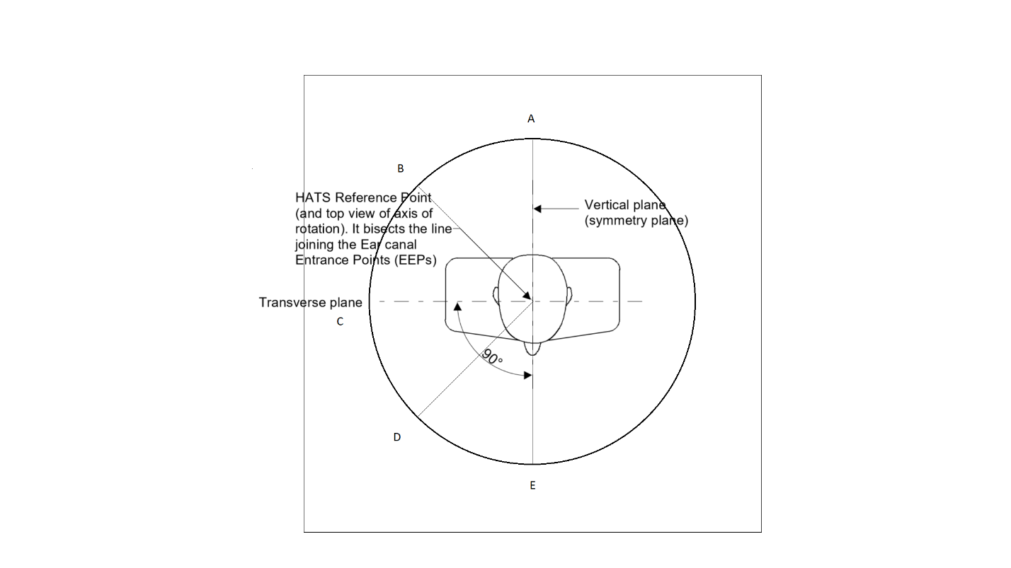

Figure 15b1: HATS orientation

Table 1: Definition of orientations A, B, C, D and E

|  |  |
| --- | --- |
| Measuring position | Measuring angle (starting from E) |
| A | -180° |
| B | -135° |
| C | -90° |
| D | -45° |
| E | 0° |

An omnidirectional measurement microphone with a linear frequency response between 50 Hz and 12 kHz is placed according to Figure 15b2. A low noise microphone is recommended. If a second HATS is used as a measurement microphone, then it is free-field equalized as described in ITU-T Recommendation P.581 [19]. The HATS should be positioned so that the HATS Reference Point is at a distance *d*HF from the centre point of the visual display of the Mobile Station. The distance *d*HF shall be 42 cm and HF shall be 0º.

Figure 15b1: Position of measurement microphone

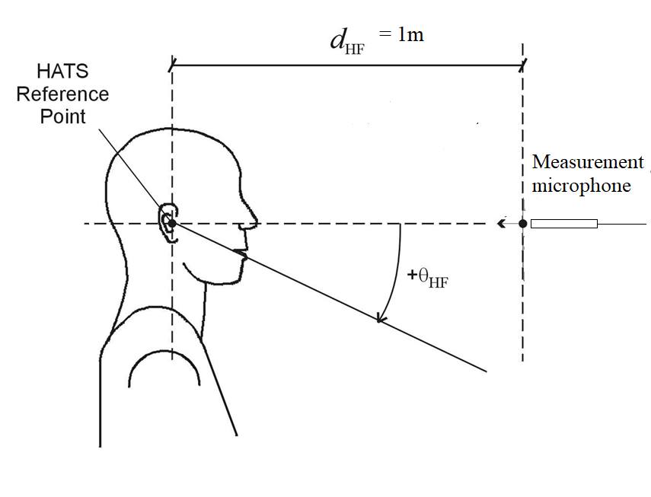

42cm

### 5.1.7 Test setup for variation of fork positions

Three different handset holding positions are tested to evaluate the impact of the clamping fork positions. Three positions are defined as offsets in the Ye-axis as shown in table 1bis. This positioning is independent to the vendor-specific handset positioner.

Table 1bis: Fork positions

|  |  |  |  |
| --- | --- | --- | --- |
|  | Bottom | Middle | Top |
| Fork position #1 | ✓ | ✓ |  |
| Fork position #2 | ✓ |  | ✓ |
| Fork position #3 |  | ✓ | ✓ |

Values for bottom, middle and top fork position shall be documented using the template defined in Table 1ter. Default values for bottom, middle, top are respectively 25, 95, 150 mm.

Table 1ter: Fork positions

|  |  |  |  |
| --- | --- | --- | --- |
|  | Bottom [mm] | Middle [mm] | Top [mm] |
| DUT |  |  |  |

The following general positioning strategy is suggested to reach the fork positions in Table 1ter:

- Bottom position: the fork is moved and tightened as close as possible to the lowest edge of the device. This fork positioning generally does not conflict with any button at the sides of the devices. In case of collisions with buttons at the sides of the device, the fork is moved upwards to the closest collision-free position. In particular, when supported by the handset positioner, a short fork is used by default. For long devices, a long fork is used.

- Mid position: the fork is moved and tightened as close as possible to the center of the device (regarding Ye axis). In case of collisions with buttons at the sides of the device, the fork is moved to the closest collision-free position (typically, this is towards the lower edge of the device, since most buttons are located in the upper half of the device). In particular, when supported by the handset positioner, a short fork is used by default. For long devices, a long fork is used.

- Top position: the fork is moved and tightened as close as possible to the most upper edge of the device. In case of collisions with buttons at the sides of the device, the fork is moved downwards to the closest collision-free position. In particular, when supported by the handset positioner, a short fork is used by default. For long devices, a long fork is used.

In addition, for the Mid and Top positions, care should be taken that the clamps of the forks do not produce an overhang, as shown in Figure 15b2. In this case, the head of the clamp (red color) might push against the ear/cheek of the HATS and the screen of the device (green color) is not mounted correctly.

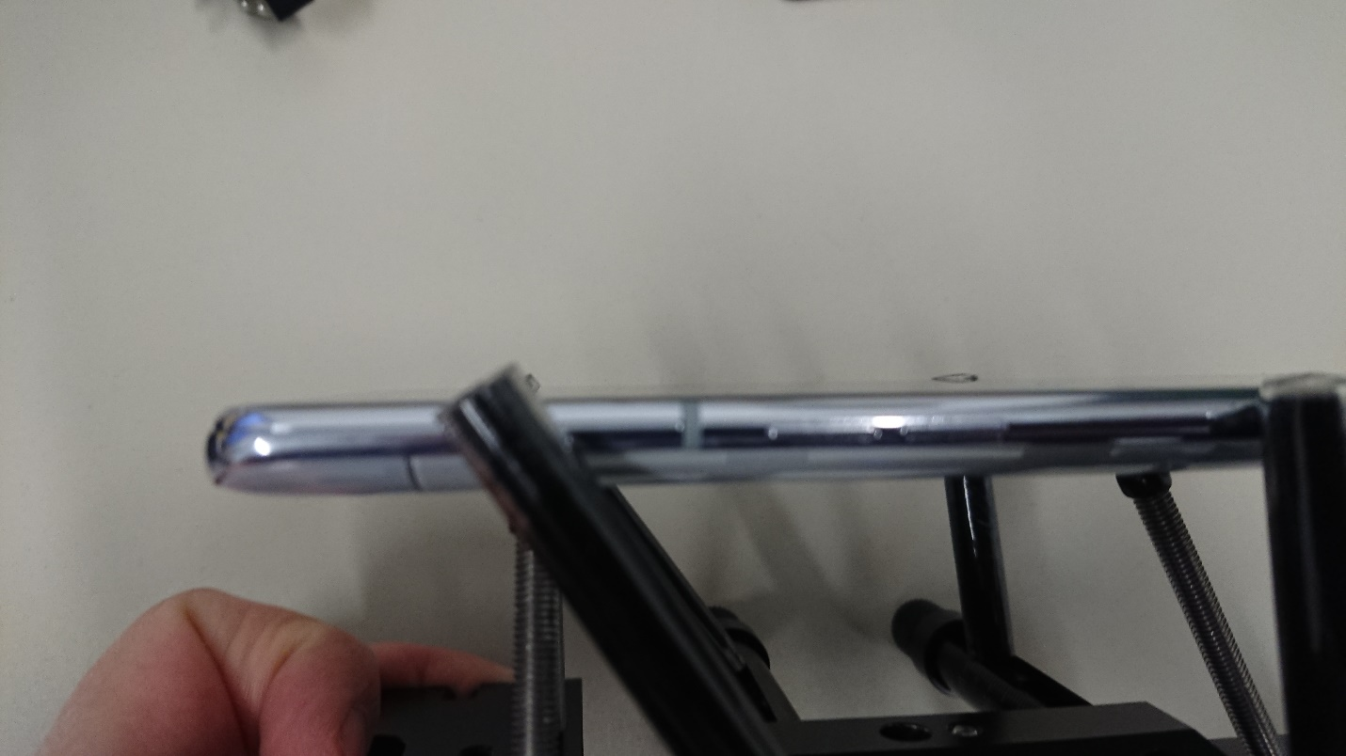

Figure 15b2: Possible overhang of fork positions

### 7.4.2 Handset and headset UE receiving

a) The test signal to be used for the measurements shall be the British-English single talk sequence described in ITU-T Recommendation P.501 [22]. The test signal level shall be -16 dBm0 measured at the digital reference point or the equivalent analogue point. The test signal level is calculated over the complete test signal sequence.

b) The handset terminal is setup as described in clause 5. Measurements shall be made at 1/12-octave intervals as given by the R.40 series of preferred numbers in ISO 3 for frequencies from 100 Hz to 4 kHz inclusive. For the calculation, the averaged measured level at each frequency band is referred to the averaged test signal level measured in each frequency band.

c) The HATS is diffuse-field equalized. The sensitivity is expressed in terms of dBPa/V. Information about correction factors is available in subclause 5.1.4.

Except where noted, if a user operated volume control is provided, the measurements shall be carried out at the nominal setting of the volume control.

Optionally, the measurements may be repeated with:

* the maximum volume control setting
* a 2 N and 13 N application force
* the alternative fork positions defined in Clause 5.1.7

For these test cases no normative values apply. They are recommended to ensure quality consistency at different usage conditions.

### 7.14 Privacy in Receive Direction (max volume)

a) The test signal to be used for the measurements shall be the short male/female British-English single talk sequence described in ITU-T Recommendation P.501 Annex D [22]. The test signal level shall be -16 dBm0 measured at the digital reference point or the equivalent analogue point. The test signal level is calculated over the complete test signal sequence.

b) The handset terminal or the headset terminal is setup as described in clause 5.1.1.

c) The volume control setting of the handset, if any, is adjusted to its maximum volume setting.

d) The monaural Loudness level at the intended listener position, LA, is measured with HATS. The monaural Loudness level is calculated according to Clause 8 of ITU-T Recommendation P.700.

e) The binaural Loudness level at an eavesdropper position, LB, is measured at each of the orientations in A, B, C, D and E of Figure 15b1 with a measurement microphone positioned at the HATS Reference Point (HRP) height (ear height) and located 42cm from the HRP (see Figure 15b2). The binaural Loudness level is calculated according to Clause 8 of ITU-T Recommendation P.700.

f) The difference in Loudness level between the intended listener and eavesdropper positions, L, is calculated as = L = (LA - LB).

### 8.4.2 Handset and headset UE receiving

a) The test signal to be used for the measurements shall be the British-English single talk sequence described in ITU-T Recommendation P.501 [22]. The test signal level shall be ‑16 dBm0 measured at the digital reference point or the equivalent analogue point. The test signal level is calculated over the complete test signal sequence.

b) The handset terminal is setup as described in clause 5. Measurements shall be made at 1/12-octave intervals as given by the R.40 series of preferred numbers in ISO 3 for frequencies from 100 Hz to 8 kHz inclusive. For the calculation, the averaged measured level at each frequency band is referred to the averaged test signal level measured in each frequency band.

c) The HATS is diffuse-field equalized. The sensitivity is expressed in terms of dBPa/V. Information about correction factors is available in subclause 5.1.4.

Except where noted, if a user operated volume control is provided, the measurements shall be carried out at the nominal setting of the volume control.

Optionally, the measurements may be repeated with:

* the maximum volume control setting
* 2 N and 13 N application force.
* the alternative fork positions defined in Clause 5.1.7

For these test cases no normative values apply. They are recommended to ensure quality consistency at different usage conditions.

### 8.14 Privacy in Receive Direction (max volume)

a) The test signal to be used for the measurements shall be the short male/female British-English single talk sequence described in ITU-T Recommendation P.501 Annex D [22]. The test signal level shall be -16 dBm0 measured at the digital reference point or the equivalent analogue point. The test signal level is calculated over the complete test signal sequence.

b) The handset terminal or the headset terminal is setup as described in clause 5.1.1.

c) The volume control setting of the handset, if any, is adjusted to its maximum volume setting.

d) The monaural Loudness level at the intended listener position, LA, is measured with HATS. The monaural Loudness level is calculated according to Clause 8 of ITU-T Recommendation P.700.

e) The binaural Loudness level at an eavesdropper position, LB, is measured at each of the orientations in A, B, C, D and E of Figure 15b1 with a measurement microphone positioned at the HATS Reference Point (HRP) height (ear height) and located 42cm from the HRP (see Figure 15b2). The binaural Loudness level is calculated according to Clause 8 of ITU-T Recommendation P.700.

f) The difference in Loudness level between the intended listener and eavesdropper positions, L, is calculated as = L = (LA - LB).

#### 9.4.2.1 Handset UE receiving

a) The test signal to be used for the measurements shall be the British-English single talk sequence described in ITU-T Recommendation P.501 [22]. The test signal level shall be ‑16 dBm0 measured at the digital reference point or the equivalent analogue point. The test signal level is calculated over the complete test signal sequence.

b) The handset terminal is setup as described in clause 5. Measurements shall be made at both 1/3-octave and 1/12-octave intervals as given by the R.10 and R.40 series of preferred numbers in ISO 3 for frequencies from 100 Hz to 16 kHz inclusive. For the calculation, the averaged measured level at each frequency band is referred to the averaged test signal level measured in each frequency band.

c) The HATS is diffuse-field equalized. The sensitivity is expressed in terms of dBPa/V. Information about correction factors is available in subclause 5.1.4.

Except where noted, if a user operated volume control is provided, the measurements shall be carried out at the nominal setting of the volume control.

Optionally, the measurements may be repeated with:

* the maximum volume control setting
* 2 N and 13 N application force.
* the alternative fork positions defined in Clause 5.1.7

For these test cases no normative values apply. They are recommended to ensure quality consistency at different usage conditions.

### 9.14 Privacy in Receive Direction (max volume)

a) The test signal to be used for the measurements shall be the short male/female British-English single talk sequence described in ITU-T Recommendation P.501 Annex D [22]. The test signal level shall be -16 dBm0 measured at the digital reference point or the equivalent analogue point. The test signal level is calculated over the complete test signal sequence.

b) The handset terminal or the headset terminal is setup as described in clause 5.1.1.

c) The volume control setting of the handset, if any, is adjusted to its maximum volume setting.

d) The monaural Loudness level at the intended listener position, LA, is measured with HATS. The monaural Loudness level is calculated according to Clause 8 of ITU-T Recommendation P.700.

e) The binaural Loudness level at an eavesdropper position, LB, is measured at each of the orientations in A, B, C, D and E of Figure 15b1 with a measurement microphone positioned at the HATS Reference Point (HRP) height (ear height) and located 42cm from the HRP (see Figure 15b2). The binaural Loudness level is calculated according to Clause 8 of ITU-T Recommendation P.700.

f) The difference in Loudness level between the intended listener and eavesdropper positions, L, is calculated as = L = (LA - LB).

### 10.14 Privacy in Receive Direction (max volume)

The test method is the same as in super-wideband (see sub-clause 9.14).

End of changes