Source: Samsung Electronics Co., Ltd. (Rapporteur)
Title: FS_5GSTAR Permanent Document
Version 0.3.0
Agenda Item: 11.9
Document for: Discussion and Agreement

Introduction
During SA4#109 the New Study Item on “5G Glass-type AR/MR Devices” in SA4-200897 was agreed and afterwards approved in by SA plenary#88 in SP-200399.
The objective of this study item are primarily to identify the AR glasses structures, media flow architecture, media exchange formats and profiles, and necessary content delivery protocols for glass-type AR/MR services. Key performance indicators, QoE factors for the AR use cases and device form-factor issues are also identified.
The concrete objectives are as follows:
- Provide formal definitions for the functional structures of AR glasses, classified as device types of XR5G-A4 (standalone) and XR5G-A2, A5 (wirelessly tethered) in TR 26.928, including their capabilities and constraints with respect to communication, computing and graphics processing, tracking, sensors, display, and power consumption
NOTE 1: Device type of XR5G-A3 (video see-through HMD) are not the primary scope of this study, but are not excluded per se.
- Describe key use cases for AR services over 5G based on those in Table 4.10 of TR 26.928, map each use case to suitable device types, and define relevant processing functions and reference architectures for the devices that are required to support the use cases, taking into account the constraints and capabilities identified under the first objective.
NOTE 2: The preferred cases will be those capable of delivering experiences previous or existing media services could not support, e.g., those requiring features for AR/MR 3D download, communication or conversational (related to use cases 1, 2, 7, 8, 11, 15, 16, 17, 19, 20, or 23). The study also allows new use cases not covered in TR 26.928.
- Describe the architecture for media flow relevant to the use cases identified in the second objective. Identify media (exchange) formats and profiles relevant to the use cases identified in the second objective that can be processed on AR platforms as defined under the first objective. Identify where media processing functions occur and which type of media formats are used for exchange between these elements to the described architecture.
NOTE 3: Exchange formats include both, formats and signals consumed on AR devices (e.g. overlays, scenes, animations) as well as those that are generated (and shared) on/by those (for example to support spatial localization, object recognition and tracking).
- Identify necessary content delivery transport protocols and capability exchange mechanisms, as well as suitable 5G system functionalities (e.g., device, edge, network) and QoS (including radio access and core network technologies) required for the use cases. If existing technologies and protocols cannot serve the cases sufficiently, describe the necessary functionalities and features.
- Identify key performance indicators and quality of experience factors (such as immersiveness, presence, localization, and world tracking accuracy) for the AR use cases based on the initial considerations in TR26.928, clause 4.2 with additional emphasis on the use cases, device platforms and exchanges formats for AR as identified in earlier objectives.
NOTE 4: As there can be several approaches for the optical implementation of displays, this study does not prefer any display types, nor will it define any detailed criteria or quality requirements.
- Identify relevant radio and system parameters (required bitrates, latencies, loss rates, range, etc.) to support the identified AR use cases and the required QoE, in particular when the AR device is connected via 5G sidelink interfaces.
NOTE 5: Depending on the use cases, other types of peripheral devices, such as external cameras and sensors, can also be connected to the UEs in a similar fashion.
- For each of the identified use cases and AR device platforms, provide a detailed overall power analysis for media AR related processing and communication building on the information in TR26.928, clause 4.8. Different design options should be considered, for example if media processing is carried out on the device, on a puck/smartphone or in the edge/cloud. It is recommended to contact relevant 3GPP WGs, in particular, and RAN4, on expected modem power consumption for certain use cases.
NOTE 6: Support other 3GPP WGs and other SDOs on relevant aspects related to their work and responsibilities for these new design options and form factors on a need basis, in particular when requested for processing functions in scope of SA4.
- Identify potential areas for normative work as the next phase and communicate with other 3GPP WGs on relevant aspects related to the study.
This permanent document collects additional agreed information that either needs more refinement or input before added to the technical report or document the status of issues that are of no immediate relevance for the TR26.998.

Use Cases under Consideration

2.1 Use Cases 1: Streaming volumetric video for glass-type MR devices

Use Case Description: Streaming volumetric video for glass-type MR devices
Bob and Patrick are gym instructors and run a gym ‘VolFit’. ‘VolFit’ provides their clients with a mixed-reality application to choose and select different workout routines on a 5G-enabled OHMD. The workout routines are available as high-quality photorealistic volumetric videos of the different gym instructors performing the routines. Bob and Patrick book a professional capture studio for a high-quality photorealistic volumetric capture of the different workout routines for their clients. Bob and Patrick perform the workout routines in the studio capture area. The studio captures Bob and Patrick volumetrically.
Alice is a member of ‘VolFit’ gym. Alice owns a 5G-enabled glass-type OHMD device. The ‘VolFit’ MR application is installed on her OHMD. The OHMD has an untethered connection to a 5G network.

Alice wears her OHMD device. The MR application collects and maps spatial information of Alice’s surrounding from the set of sensors available on the OHMD. The OHMD can further process the spatial mapping information to provide a semantic description of the Alice’s surrounding.
Alice wants to learn a workout routine from her instructors, Bob and Patrick. The photorealistic volumetric videos of Alice’s instructors are streamed to the MR application installed on her OHMD. The MR application allows Alice to position the volumetric representations of Bob and Patrick on real-world surfaces in her surroundings. Alice can move around with 6DoF, and view the volumetric videos from different angles. The volumetric representations are occluded by real-world objects in the XR view of Alice; when Alice move to a location where the volumetric objects are positioned behind real-world objects or vice-versa. During the workout session, Alice gets the illusion that Bob and Patrick are physically present in her surroundings, to teach her the workout routine effectively.

The MR application allows Alice to play, pause and rewind the volumetric videos. The functions can be triggered for example by hand-gestures, a dedicated controller connected to the OHMD, etc.
Categorization
Type: MR (XR5G-A1, XR5G-A2, XR5G-A4, XR5G-A5)
Degrees of Freedom: 6DoF
Delivery: Streaming, Split-rendering
Device: OHMD with/without a controller
Preconditions
- The application uses existing hardware capabilities on the device, including A/V decoders, rendering functionalities as well as sensors. Inside-out tracking is available.
- Spatial mapping to provide a detailed representation of real-world surfaces around the device
- Media is captured properly (refer to clause 4.6.7. TR 26.928). The quality of the capture depends on different factors:
  - Point-cloud based workflows
    - Studio setup i.e. camera lenses, distance of the captured object from the camera(s), stage lights
    - Filtering/Denoising algorithms
  - Mesh-based workflows
    - Mesh reconstruction algorithms (e.g. Poisson surface reconstruction)
    - Geometric resolution of the object i.e. poly counts
    - Texture resolution e.g. 4K, 8K, etc.
- Media is accessible on a server
- Connectivity to the network is provided
Requirements and QoS/QoE Considerations
- QoS:
- bitrates and latencies that are sufficient to stream a high-quality volumetric content within the immersive limits
- bitrate for a single compressed volumetric video (mesh compression using tools such as Google DracoTM (https://google.github.io/draco/) and texture compression using video encoding tools such as H.264), for example, “Boxing trainer” sequence [X.2] further processed to generate a 3D mesh sequence with 65,000 triangles; 25fps, Texture: 2048x2048 pixels; 25fps:
  - Data rate of 47.3Mbps, which constitutes of following:
    - Mesh sequence: 37 Mbps (using Google DracoTM )
    - Texture sequence: approximately 10 Mbps (encoding using H.264)
    - Audio: 133 kbps (AAC)
- access link bitrate estimates in case of split-rendering delivery methods (multiple objects):
- approximately 30% higher bitrate due to ultra-low delay coding structure (e.g. IPPP)
- left and right view (packed stereo frame)
- bitrates of a compressed stereo video depend on rendered objects resolution
- bitrates approximately 1Mbps (small objects)-35 Mbps (objects covering majority of the rendered viewport)
- Required QoE:
- volumetric video captured roughly in the range of ~1-10 million points per frame (this is dependent on capturing workflows as well as the level of details in captured object e.g. clothes’ textures)
- high geometric resolution of the volumetric object’s geometry to achieve accurate realistic simulations of rendering equations
- frame rate at least 30 FPS and above
- high-quality content rendering according to the user’s viewpoint
- real-time rendering of multiple high-quality volumetric objects
- fast reaction to user’s head and body movements
- fast reaction to hand-gestures, or a connected controller, etc
- real-time content decoding
- accurate spatial mapping
- accurate tracking
- accurate scene lighting
Feasibility
Volumetric content production:
- Volucap studios: https://volucap.de/
- Mixed Reality studio: https://www.microsoft.com/en-us/mixed-reality/capture-studios
- Metastage: https://metastage.com/

Device Features:
- Spatial mapping
- Tracking
- Scene understanding
- A/V decode resources

Selected Devices/XR Platforms supporting this:
- Microsoft Hololens: https://www.microsoft.com/en-us/hololens
- Nreal Light glasses: https://www.nreal.ai/
- MagicLeap 1: https://www.magicleap.com/en-us/magic-leap-1

Current solutions:
For a real-time mobile on-device mesh-based system, an acceptable-quality experience for 30 FPS can be achieved using at least 30,000-60,000 poly count for a volumetric object’s geometry with at least 4K texture resolution. On-device rendering of multiple complex 3D models is limited by graphics capabilities of the device.
In addition, advanced rendering techniques for lighting, reflection and etc, are subject to complex rendering equations which may result in inconsistent frame rate and increased power consumption. Therefore, it is challenging to achieve a real-time volumetric streaming for multiple high-quality 3D models with current networks and on-device hardware resources. Some existing solutions use remote rendering for streaming volumetric video:
- Azure remote rendering, https://azure.microsoft.com/en-us/services/remote-rendering/ , allows to render a huge and complex 3D model with millions of polygons remotely in cloud and stream in real-time to a MR device such as HoloLens. An intuitive demonstration of the Azure remote rendering of 3D model with approximately 18 million polygons on HoloLens is publicly available at: https://www.youtube.com/watch?v=XR1iaCcZPrU
- Mesh-based multiple high-quality volumetric video streaming using remote rendering [X.3]. More information is available at: https://www.hhi.fraunhofer.de/5GXR
Nvidia CloudXRTM: https://developer.nvidia.com/nvidia-cloudxr-sdk
Potential Standardization Status and Needs
The following aspects may require standardization work:
- Storage and access formats
- Network conditions that fulfill the QoS and QoE Requirements
- Relevant rendering APIs
- Scene composition and description
- Architecture design

2.2 Use Cases 2: AR Remote Cooperation

Use Case Name
AR remote cooperation
Description
In use case 8 in TR26.928, Annex A.9, remote experts provide AR actions (e.g. overlaying graphics and drawing of instructions) to the received local video content. This use case highlights that both parties can share their own video streams and overlay 2D/3D objects on top of these video streams compared with the scenario from TR 26.928.
For example, a car technician contacts the technical support department of the car components manufacture by phone when he has some difficulty in repairing a consumers' car. The technical support department can arrange an engineer to help him remotely via real-time communication supporting AR.
The car technician makes a video call with the remote engineer, captures the car parts as video contents and shares them with the remote engineer in-call. And he marks possible points of failure by drawing instructions on the top of these video contents in order that the remote engineer can see the marks and make a detailed discussion. Also, they have respectively FOVs on their sides to check the failure. The remote engineer can also overlay graphics and animated video models based on these shared video contents to adjust or correct the technician's operations. In addition, if the maintenance procedures are complex, the remote engineer can show the maintenance procedures step by step, and his camera captures the demonstrating video content in real-time to share it with the local technician. Therefore, the local technician can follow the operations. Finally, they find out the problems and fix it. It looks like that the remote engineer is beside the technician, discusses and solves the problems together.
In the extension to this use case, it can overlay another video stream captured by his front-facing camera based on the shared video stream to achieve more attentive experiences.
Categorization
Type: AR, MR
Degrees of Freedom: 3DoF+, 6DoF
Delivery: Interactive, Conversational
Device: XR5G-P1, XR5G-A2, XR5G-A3, XR5G-A4, XR5G-A5, others
Preconditions
<provides conditions that are necessary to run the use case, for example support for functionalities on the end device or network>

Requirements and QoS/QoE Considerations
<provides a summary on potential requirements as well as considerations on KPIs/QoE as well as QoS requirements>

Feasibility and Industry Practices
<How could the use case be implemented based on technologies available today or expected to be available in a foreseeable timeline, at most within 3 years?
- What are the technology challenges to make this use case happen?
- Do you have any implementation information?
- Demos
- Proof of concept
- Existing services
- References
- Could a reduced experience of the use case be implemented in an earlier timeframe or is it even available today?
>
Potential Standardization Status and Needs
<identifies potential standardization needs>

2.3 Use Cases 3: AR Remote Advertising

Use Case Name
AR remote advertising
Description
Conversational related use cases described in TR 26.928 including case 7, Annex A.8, a real-time 3D communication is constructed based on local user’s media stream (e.g. 3D capture capability camera, pre-captured 3D model and local AR effects) and case 11, Annex A.12, shop assistant help the buyer to choose furniture over AR scene captured by the buyer in a real time conversation. This use case emphasizes that the shared video streams between the two parties of a session are from a third party based on the above description. The shared video streams may be 360 degree and even free-viewpoint in order to help people have more interaction and immersive experiences.
For example, a real estate salesman introduces houses to a client. The real estate salesman can get some video content with 2D or 3D objects for houses from the third content provider and share them with his client. The client is able to see layout and furnishings of the virtual house which can be rendered following his viewpoint. The real estate salesman or the 3D model of the estate salesman can introduce what the client is seeing or is asking via audio and/or overlaying graphics based on the video content.
In an extension to the use case, the video content is free-viewpoint. It as if the client is just inside the advertised house, and is able to walk around rooms (e.g., dining room and living room and bedroom). Furthermore, the client can move a small couch in the living room couch, and touch the murals hanging on the dining room wall.
In another extension to the use case, the client can invite his friend to see the virtual house together. They can see it from their respectively viewpoint.
Categorization
Type: AR, MR
Degrees of Freedom: 6DoF
Delivery: Interactive, Conversational, Download, Streaming
Device: XR5G-P1, XR5G-A2, XR5G-A3, XR5G-A4, XR5G-A5, others
Preconditions
<provides conditions that are necessary to run the use case, for example support for functionalities on the end device or network>

Requirements and QoS/QoE Considerations
<provides a summary on potential requirements as well as considerations on KPIs/QoE as well as QoS requirements>

Feasibility and Industry Practices
<How could the use case be implemented based on technologies available today or expected to be available in a foreseeable timeline, at most within 3 years?
- What are the technology challenges to make this use case happen?
- Do you have any implementation information?
- Demos
- Proof of concept
- Existing services
- References
- Could a reduced experience of the use case be implemented in an earlier timeframe or is it even available today?
>
Potential Standardization Status and Needs
<identifies potential standardization needs>

2.4 Use Cases 4: AR Conferencing
Use Case Description: AR Conferencing
This clause describes an AR conferencing use-case that allows participants to be represented as 3D point clouds in order to provide an immersive conferencing experience.

3.2.1 AR Conferencing (1:1)
Bob and Alice want to make an AR conferencing call. Both are wearing AR headsets. Bob is located in Stockholm while Alice is located in Aachen. One or more cameras are placed in each location and are filming Bob and Alice, respectively. Bob can see a 3D point cloud representation of Alice on his AR headset and Alice can see a 3D point cloud representation of Bob on her AR headset. Bob and Alice can enjoy a truly immersive audio-visual experience.

Figure 5.X-1: AR Conferencing (1:1)

3.2.1 AR Conferencing (1:many)
Bob and Alice are invited to an escalation meeting. Bob is able to physically attend the meeting, whereas Alice is virtually joining the meeting. Alice can be seen by Bob and other participants as a 3D point clouds on their AR glasses. Bob and other participants can interact with the 3D point cloud representations (e.g. rotate, zoom-in, resize). Alice can see and interact with Bob and other participants. Alice may use a laptop, phone, AR or VR device to visualize participants in the office. All participants can enjoy a truly immersive audio-visual experience.

Figure 5.X-1: AR Conferencing (1:many)
Categorization
Type: AR
Degrees of Freedom: 3DoF+ or 6DoF
Delivery: Conversational
Device: AR glasses
Preconditions
- The participants are located in a room that is equipped with cameras that allow the capturing of participants including depth information. The movements can be captured by other means (e.g. AR glasses or phone camera).
- The participants are wearing AR glasses that allow the 3D point cloud representation of other participants.
Requirements and QoS/QoE Considerations
The network shall support the delivery of point cloud streams for real-time conversational services:
An audio stream has a bandwidth requirement of 128 kbps.
A point cloud stream has raw bandwidth requirement of up to 2 Gbps. The transmission bandwidth is expected to be lower after encoding and optimization. Preliminary data from MPEG V-PCC codec evaluation indicates 1:100 compression ratios can be achieved. For high-quality sequences of 1M points per frame and 30 fps this gives expected bitrates around 30Mbps.
Feasibility
The point cloud stream can be defined with mesh, texture and UV or similar representation. The bandwidth and latency requirements for AR conferencing using point cloud communications present a challenge to mobile networks. The complexity of the point cloud stream is challenging for the endpoints and introduces additional delay for processing and rendering functions. Intermediate edge or cloud components are needed.
Potential Standardization Status and Needs
The following aspects may require standardization work:
- Standardized formats for point cloud representation of participants on AR glasses.
- Cloud APIs for processing and rendering of point cloud streams.

2.5 Use Cases 5: AR Gaming

Use Case Name
AR gaming
Description
By using AR technology, AR gaming is to apply virtual models to the real world and then provides game entertainment experience in a world of virtual-reality combination, which is difficult to experience in reality. People can interact with virtual objects controlled by game operations in the foreground of the real world. For many consumers, immersion is a key factor in their enjoyment of games, and AR can help users achieve such experiences exactly.
For example, Alice wears AR glasses at home and opens an AR golf game application. The AR glasses display a virtual sand table of golf course and golf ball through the spatial location on the floor of her house. Alice needs to use a certain gesture to hit the golf ball and make it go into the hole. Finally, the AR golf game application can calculate Alice's score.
AR gaming can also support multi-player games. Alice invites Bob and Clare to play an online AR shooting game in her living room. They wear AR glasses, log in to the AR shooting game application, select the multi-player team mode, and then they can control the shooting action through a gesture or the tethering device. The virtual target set in the shot game will appear in the living room, and have corresponding response according to their operation and display in their AR glasses. Then they can complete the game task and upgrade.
Categorization
Media Type: Visual / Audio, 3D
Media Source Type: CGI (Computer-Generated Imagery)
Delivery: Uplink, Download, Interactive
Device Type: XR5G-A2, XR5G-A3, XR5G-A4, XR5G-A5
Preconditions
<provides conditions that are necessary to run the use case, for example support for functionalities on the end device or network>
-A game application on an AR device.
-Connectivity to the network
- Rendering according to user data
- Gesture acquisition or other control mode
- Spatial Computing Service
- Content synchronization

Requirements
<provides a summary on potential requirements for following aspects>
- Device functions
- Media processing functions
- KPIs/QoE and QoS>
-
- QoS:
- Sufficiently low latency for rendering.
- low packet loss rate
- QoE:
- Gaming time before vertigo
- Game jams
Feasibility and Industry Practices
<How could the use case be implemented based on technologies available today or expected to be available in a foreseeable timeline, at most within 3 years?
- What are the technology challenges to make this use case happen?
- Do you have any implementation information?
- Demos
- Proof of concept
- Existing services
- References
- Could a reduced experience of the use case be implemented in an earlier timeframe or is it even available today?
>
There are some AR game demonstration examples using AR glasses.
1. The Tech Behind Tilt Five's AR Gaming System
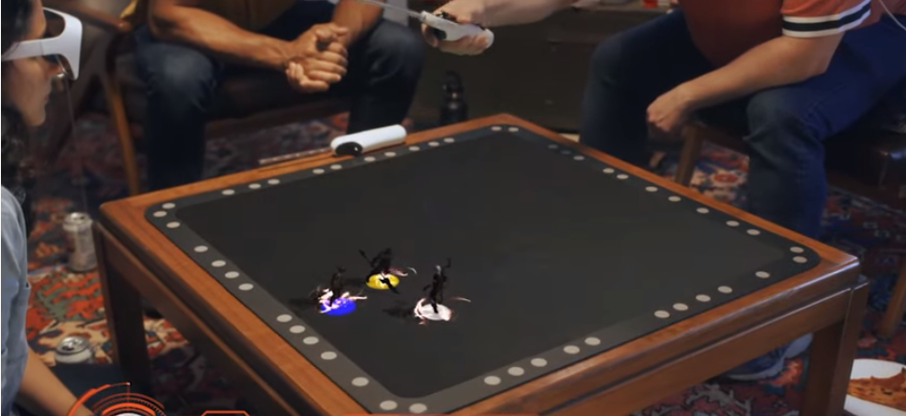
https://www.youtube.com/watch?v=Z3qAio315ak

2.Super Mario Bros Recreated as Life Size Augmented Reality Game
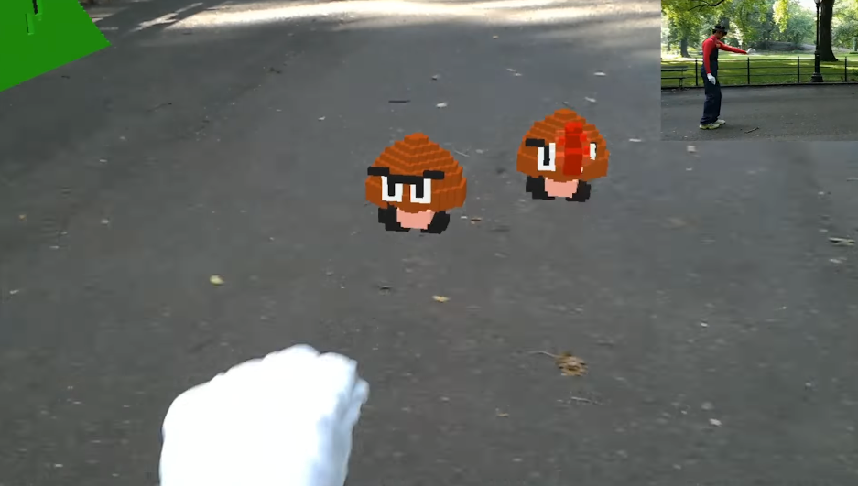
https://www.youtube.com/watch?v=QN95nNDtxjo
During the 2018 World Mobile conference, China Mobile, Tencent and Huawei jointly announced the completion of AR game experimental verification based on 5G enhanced bandwidth stable delay network slice.
Potential Standardization Status and Needs
<identifies potential standardization needs>

Device Functional Structure
[Editor’s note] The text in this clause were further improved and moved to clause 4.2.2 in TR26.998 (v0.3.0)

Device configurations
[Editor’s note] The text in this clause were further improved and moved to clause 4.2.2 in TR26.998 (v0.3.0)

Interfaces
Based on device configuration #1, we provide further details on the interfaces between the different functions of the device configuration:

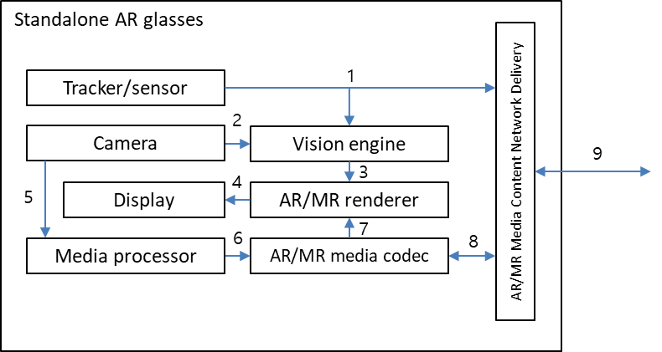
Figure 3.4: Interfaces for standalone AR glasses

- Tracker/sensor output interface
Raw outputs from various tracking and sensor device components, namely IMUs (inertial measurement unit). These outputs are typically sent as inputs to the vision engine, or to a cloud entity when cloud-based processing is utilised.
Current commercialised state of the art AR/MR devices might contain the following related components [X.4]:
- Accelerometer – used by the system to determine linear acceleration along the X, Y and Z axes and gravity
- Gyro – used by the system to determine rotations
- Magnetometer – used by the system to estimate absolute orientation

- Camera output to Vision engine interface
Depending on the device hardware, different types of camera outputs can be used as inputs into the vision engine, these may include [X.4]:
- Visible light environment tracking cameras – typically gray-scale cameras used by a system for head tracking and map building
- Depth cameras (ToF)– these may be short-throw (near-depth) or long-throw (far-depth), depending on the application desired (e.g. hand tracking, or spatial mapping)
- Infrared (IR cameras) – used for eye tracking
- World facing RGB camera – used for image processing tasks and locating the camera’s position in and perspective on the scene
Microsoft HoloLens 2 includes 4 visible light cameras for head tracking, 2 IR cameras for eye tracking, 1-MP ToF depth camera for capturing depth, and one world facing RGB camera capable of 8-MP stills and 1080p30 video [X.4].

- Vision engine to AR/MR renderer interface
The vision engine provides all the information required for the AR/MR renderer to adapt the rendering for a consistent combination of virtual content with the real world [X.5]. This information may be the output of vision engine processes such as spatial mapping, scene understanding, and room scan visualization [X.4]. Vision engine processes are typically SLAM related, differing depending on the specific device and/or platform implementation.
One typical output of the vision engine is the device/user pose information, which may include estimation properties depending on the service and application.

- AR/MR renderer to Display interface
The AR/MR rendering typically outputs a rendered 2D frame (per eye) for a given time instance according to the device/user’s current pose in his/her surrounding environment. This rendered 2D frame is sent as an input to the device display. In the future, it can be predicted that non-2D displays will require a different output from the AR/MR renderer in order to support 3D displays e.g., Light Field 3D display.

- Camera output to Media processor interface
RGB and depth cameras are be used to capture RGB/depth images and videos, which can be consumed as regular images and videos, or may be used as inputs to a media processor for further media processing.

- Media processor to AR/MR media codec interface
A media processor performs processes such as 3D modelling, in order to output uncompressed media data into the AR/MR media codec for encoding. One example of the media data at this interface is raw point cloud media data (in a format such as a ply file).

- AR/MR media codec to AR/MR renderer interface
Compressed AR/MR media content intended for rendering and display is decoded by the AR/MR media codec, and fed into the AR/MR renderer. This is typically a decoded video bitstream (for 2D AR/MR media), or a decoded 3D media bitstream (for 3D AR/MR media).

- AR/MR media codec to Network delivery interface
Media contents that are captured or generated by the device (from interface 5 and 6) are encoded by the AR/MR media codec before being passed onto the network delivery entity for packetization and delivery over the 5G network. For 2D AR/MR media contents, this is typically a compressed video bitstream that is conformant to the video codec used by the AR/MR media codec.
Network delivery to AR/MR media codec interface
Media contents that are received through the network delivery interface over the 5G network are depacketized by the network delivery entity and fed into the AR/MR media codec. The subsequent decoded bitstream is handled through interfaces 7 and 4.

- Network delivery interface
Network interface for AR/MR content delivery.

Case Study
Device types #1 and #2 were selected as the types for the case study since device type #3 is covered by the descriptions for device type #2. Generic reference device functional structures do not include any cloud-based entities, and as such are shown here as-is without the inclusion of cloud-based entity functions.
Note: The differences in specific requirements between the individual use cases (such as media formats, processing power, function latency, network latency etc) are not highlighted in this case study since the capabilities of each functional block in the entities specified in the device types are implementation dependent. Depending on the capabilities of the device type implemented, the service described by specific a use case may or may not be achievable by the device type alone.

3.3.1 Mapping to use cases 7, 8, 9, 12, 15, 16, 17, 18, 19, 2.2, 2.3, 2.4
7 | Real-time 3D Communication
8 | AR guided assistant at remote location (industrial services)
9 | Police Critical Mission with AR
12 | 360-degree conference meeting
15 | XR Meeting
16 | Convention / Poster Session
17 | AR animated avatar calls
18 | AR avatar multi-party calls
19 | Front-facing camera video multi-party calls
2.2 | AR remote cooperation
2.3 | AR remote advertising
2.4 | AR Conferencing

The use cases above have in common the following characteristics (this is not an exclusive list):
- The use of a camera(s) for the real time capture of either the user, or the real time capture of his/her surroundings (including objects), or both
- Bidirectional communication between 2 or more users for services similar to that of video telephony
- Media processing support, including in some services: video stitching, 3D media modelling, avatar modelling
Device type #1
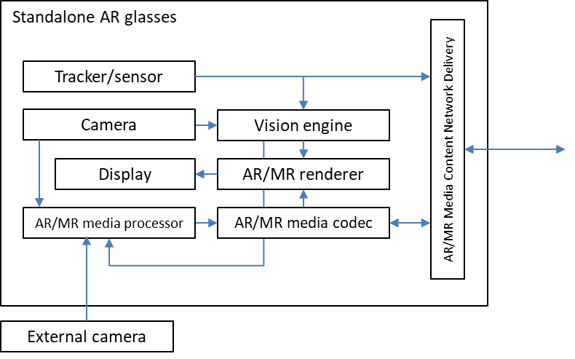
- Real time capture of the user or his/her surroundings) by either an external camera, or by the camera integrated into the standalone AR glasses, or both
- Video telephony similar service function flow realised by the combination of relevant functions within the standalone AR glasses, namely:
  - for capturing and uplink: camera/external camera, tracker/sensor, vision engine, AR/MR media processor, AR/MR media codec, content network delivery
  - for downlink and media presentation: content network delivery, AR/MR media codec, tracker/sensor, vision engine, AR/MR renderer, display
- Media processing support by the AR/MR media processor

Device type #2
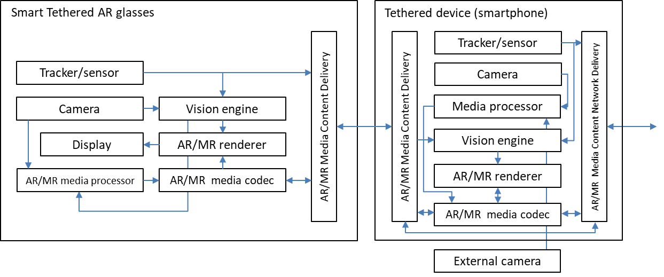
- Real time capture of the user or his/her surroundings by either an external camera, or by the camera integrated into the smart tethered AR glasses, or by the camera in the tethered device, or by a combination of these
- Video telephony similar service function flow realised by the combination of relevant functions within the smart tethered AR glasses and tethered device, namely:
  - for capturing and uplink: camera/external camera, tracker/sensor, vision engine, AR/MR media processor, AR/MR media codec, content delivery, content network delivery
  - for downlink and media presentation: content network delivery, content delivery, AR/MR media codec, tracker/sensor, vision engine, AR/MR renderer, display
- Media processing support by the AR/MR media processors in both the glasses and tethered device

3.3.2 Mapping to use cases 1, 11, 2.3
1 | 3D Image Messaging
11 | Real-time communication with the shop assistant
2.3 | AR remote advertising

The use cases above have in common the following characteristics (this is not an exclusive list):
- The use of a camera(s) for the capture of either the user, or of his/her surroundings (including objects), or both
- Bidirectional communication between 2 users for services similar to that of the traditional multimedia messaging service (MMS)
- Media processing support, including in some services: 3D media modelling

Device type #1
- Capture of the user or his/her surroundings) by either an external camera, or by the camera integrated into the standalone AR glasses, or both
- MMS similar service function flow realised by the combination of relevant functions within the standalone AR glasses, namely:
  - for capturing and uplink: camera/external camera, tracker/sensor, vision engine, AR/MR media processor, AR/MR media codec, content network delivery
  - for downlink and media presentation: content network delivery, AR/MR media codec, tracker/sensor, vision engine, AR/MR renderer, display
- Media processing support by the AR/MR media processor

Device type #2
- Capture of the user or his/her surroundings by either an external camera, or by the camera integrated into the smart tethered AR glasses, or by the camera in the tethered device, or by a combination of these
- MMS similar service function flow realised by the combination of relevant functions within the smart tethered AR glasses and tethered device, namely:
  - for capturing and uplink: camera/external camera, tracker/sensor, vision engine, AR/MR media processor, AR/MR media codec, content delivery, content network delivery
  - for downlink and media presentation: content network delivery, content delivery, AR/MR media codec, tracker/sensor, vision engine, AR/MR renderer, display
- Media processing support by the AR/MR media processors in both the glasses and tethered device

3.3.3 Mapping to use cases 2, 10, 23
2 | AR Sharing
10 | Online shopping from a catalogue – downloading
23 | Spatial Shared Data

The use cases above have in common the following characteristics (this is not an exclusive list):
- The download of AR/MR media by the AR/MR device, which has been created and made available for download prior to the service
- Presentation of the AR/MR media after download, in the manner of stored media consumption

Device type #1
- The download of AR/MR media by the AR/MR device through the content network delivery function
- Presentation of the AR/MR media after download and storage inside the device, by the function flow realised by the combination of relevant functions in the standalone AR glasses, namely:
  - AR/MR media codec, tracker/sensor, vision engine, AR/MR renderer, display

Device type #2
- The download of AR/MR media by the AR/MR device through the content network delivery function
- Presentation of the AR/MR media after download and storage inside the device (either the AR glasses or the tethered device), by the function flow realised by the combination of relevant functions in the smart tethered AR glasses and tethered device, namely:
  - AR/MR media codec, tracker/sensor, vision engine, AR/MR renderer, display

3.3.4 Mapping to use cases 20, 2.1
20 | AR Streaming with Localization Registry
2.1 | Streaming volumetric video for glass-type MR devices

The use cases above have in common the following characteristics (this is not an exclusive list):
- AR/MR media constantly received by the AR/MR device, where the AR/MR media is created and is being delivered by a provider, in a manner similar to that of current streaming services
- Presentation of the AR/MR media immediately after it is received, in a manner similar to that of current streaming services

Device type #1
- AR/MR media constantly received by the AR/MR device through the content network delivery function
- Presentation of the AR/MR media immediately after it is received, by the function flow realised by the combination of relevant functions in the standalone AR glasses, namely:
  - AR/MR media codec, tracker/sensor, vision engine, AR/MR renderer, display

Device type #2
- AR/MR media constantly received by the AR/MR device through the content network delivery function
- Presentation of the AR/MR media immediately after it is received, by the function flow realised by the combination of relevant functions in the AR glasses and the tethered device, namely:
AR/MR media codec, tracker/sensor, vision engine, AR/MR renderer, display

3.3.5 Case study implications
The case study above mapping the generic reference device functional structures with the 5GSTAR use cases (which were group for ease of mapping) has several implications that can be summarised as below:
- The generic reference device functional structures contain a set of functions that are sufficient in covering the broad set of use cases in 5GSTAR.
- Depending on the use case, certain functions in the device functional structures may not be required or instantiated for the function flow requested by the AR/MR service.
- Likewise, depending on the use case, certain function interfaces in the device functional structure may not be required.
The processing power and latency requirements for the functions required for each use case may be different, and are not considered in this case study. It can be expected that once these requirements are identified for each use case, the support for achieving those requirements will be further studied.

Comparison to ETSI ISG AR Framework
ETSI Industry Specification Group AR Framework (ISG ARF) has developed a framework for AR components and systems. It addressed the characteristics of an AR system and describes the functional building blocks of the AR reference architecture and their mutual relationships [X.5]. This clause provides an analysis of comparison between the device functional structure in TR 26.998 v0.5.0 and their work.
Using the ETSI ARF as the foundational architecture for TR26.998 would add value to TR26.998 in three ways:
1. The eleven functional blocks of ETSI ISG AR Framework cover all the functional blocks proposed in TR26.998 and they group subfunctions thematically. Additionally, ETIS ISG ARF has other subfunctions which are not currently in the TR26.998 architecture. Using the ETSI ISG AR Framework significantly simplifies the architecture for describing Glass-type AR/MR Devices. For example, in TR26.998 cameras, microphones and sensors are separated. In ETSI ARF, they are three possible subfunctions of World Capture.
2. The ARF provides greater detail than the current TR26.998 architecture in two of the functions that are most likely to be distributed between network and device: World Analysis and World Storage. Scene Management and 3D Rendering functions are, as shown in Figure 1 in TDoc S4-210427, also well suited to edge computing.
3. Currently, the TR26.998 architecture distinguishes between 2D and 3D media or world capture and “adds on” the device (user) pose. Pose is fundamental to all XR experiences and should not be separated from the assets or interactions. The device pose with respect to anchors is inherent in ETSI ISG ARF. All the ETSI ARF functions and subfunctions are agnostic with respect to 2D and 3D tracking, encoding or decoding, and their position on AR glasses, puck or edge/cloud.
Device Functions
The section 4.2.1 of the TR26.998 v0.5.0 describes seven “device functions” and their subfunctions. In Table 3.4.1, each is mapped to the corresponding ETSI ISG ARF section.
Table 3.4.1. TR26.998 AR Functions Mapped with ETSI ISG ARF
 | From TR26.998 | Is it included in ETSI ISG ARF | Corresponding section or function in ETSI ISG ARF
a. | Tracking and Sensing | Yes | 5.7 User Interactions
 | Inside-out tracking for 6DOF user pose | In two parts | 5.2.2 AR Device Relocalization  5.2.3 AR Device Tracking
 | Eye-tracking | Yes | 5.7.4 Gaze
 | Hand-tracking | In two parts | 5.7.2 3D Gesture  5.7.3 Tactile
 | Tracker/Sensors | In two parts (tracking & user interactions) | 5.1 world Capture  5.7 User Interactions
b. | Capturing | Yes | 5.1 World Capture
c. | Basic AR Functions
 | 2D media encoders | Yes but not solely 2D | 5.11.3 Communications
 | 2D media decoders | Yes but not solely 2D | 5.11.3 Communications
 | Vision engine | Yes | 5.2 World Analysis
 | Pose corrector | Yes | 5.10 Rendering Adaptation
d. | AR/MR Functions
 | Immersive media decoders | Yes | 5.11.3 Communications
 | Immersive media encoders | Yes | 5.11.3 Communications
 | Compositor | Yes | 5.10 Rendering Adaptation
 | Immersive media renderer | Yes | 5.9 3D Rendering
 | Semantic perception | In two parts | 5.2.4 Object Recognition & Identification  5.3.5 Object 3D Segmentation
e. | Networking Interfaces | Yes | 5.11 Transmission
f. | Physical Rendering | Yes | 5.8 Scene Management (light sources pose estimation done by “5.2.5 Object Relocalization” and “5.2.6 Object Tracking” if lights are moving)
g. | AR/MR Application | In two parts | 5.4 Assets Preparation  5.6 AR Authoring

In table 3.4.2 below, the sections that are provided in ETSI ISG ARF GS003 and that are absent or not identified from TR26.998 architecture are captured.

Table 3.4.2. ETSI ISG ARF Functions and Subfunctions for Augmented Reality not currently in TR26.998 architecture.
 | ISG ARF function/subfunction | Role of the function/subfunction
5.1.2 | Positioning | GNSS and other non-vision based positioning systems are not explicitly defined in the TR26.998 and, yet, are widely used for positioning AR devices.
5.2.2  5.2.3  5.2.4  5.2.5 | AR Device/Object Relocalization vs AR Device/ObjectTracking | Relocalization estimates the pose of the AR device or objects with just one capture (for initialization, when tracking is lost or to correct the tracking drift), while, in contrast, the device or object tracking estimates the movement of the AR device or objects at a high frequency.  The difference in the frequency of execution of the two subfunctions and the optimization available on the AR devices to process these two subfunctions can determine their location (device or cloud).
5.2.2  5.2.3  5.2.4  5.2.5 | Object Relocalization/Tracking vs AR device Relocalization/Tracking | The pose of an AR device is defined in relation to a world coordinate system while the object pose is generally defined in relation to the AR Device coordinate system (and could be defined in the world coordinate system if the AR device pose estimation is available).
5.2.7 | 3D Mapping | As most AR systems are implementing a SLAM algorithm which reconstructs a 3D map of the world for visual-based relocalization, this is an essential (arguably the most important) subfunction of an AR architecture.
5.3.2 | World Representation | The 3D map used for relocalizing an AR device can be shared and updated in real-time by any AR device (the potential of what is called “AR Cloud”).  This allows experiencing AR anywhere (even in very large scale and dynamic environments), at any time, on any device (continuously). This subfunction could become the most valuable and crucial for widescale AR adoption.
5.3.3  5.3.4 | Relocalization Information Extraction and Recognition & Identification Information Extraction | These subfunctions extract the information required for the World Analysis subfunction, using the global representation managed by the World Representation subfunction (3D maps, deep neural network, etc.), depending on the user context.
5.3.5 | Object 3D segmentation | Analyzes and segments the 3D map to generate/estimate 3D objects from the 3D map.
5.3.6 | Scene Meshing | Creates a 3D mesh from the 3D point cloud stored into the World Representation subfunction. Useful for managing occlusions between real environment and virtual content if no depth sensor is available on the AR device.
5.4 | Asset Preparation | Prepares the digital content to be displayed in AR. The ISG ARF encompasses several types of content: Synthetic content (2D or 3D with textures), Audiovisual contents (video displayed in the space of the screen or mapped on a 3D plane or audio), Object behavior (defining how the content will behave according to system/user/other content interactions), and Scenario defining the different steps of the AR application (game scenario, maintenance procedure, etc.).
5.6 | AR Authoring | Creates the AR scene by defining the position of the AR assets in relation to the real world (3D compositing), and can optimize and convert the assets for a given device. This function will package the AR scene and store it in a ready-to-use representation.
5.5 | External Application Support | Manages real-time data streams produced by external systems (e.g., IoT management system) which will update the AR scene displayed to the user at runtime.
5.7 | User interactions | As AR experiences are, by definition, interactive, the user interacts with the AR assets or even the elements of the real world. This function handles all the user interactions interfaces in the same way. This includes the 3D gesture and eye-tracking, but also interactions on a tactile screen, vocal commands and bio-metric capture (e.g. to adapt display to the cognitive load of the user).
5.8.2 | Interaction Technique | Transforms raw inputs produced by user interaction subfunction to a unified action on the AR scene (manipulation, selection, etc.) in order to adapt automatically the interactions defined in an AR scene to any AR device.
5.8.5  5.4.6 | AR experience Reporting and Report Evaluation | For delivering reports related to the AR experience back to the AR Authoring or Asset preparation to improve, for instance, the quality of the user experience or collecting some information set by the user (annotations, maintenance report, etc.).
5.9.4  5.10.6 | Haptics | Some use cases require haptic feedback (vibrations, forces, textures or motion) to improve the feeling of immersion.
5.10.4 | Projection-based | Some use cases (e.g. industry 4.0) require displaying AR assets on surfaces of the real world with a video projector.
5.11.2 | Security | This subfunction can encrypt or decrypt data exchanged between or stored on the device/nodes of the cloud to ensure its security.

Mapping to 5G System Architecture
<Proposal of service level architecture, including network and edge can be documented in this clause>

5GMS Immersive downlink streaming procedures

4.1.1 STAR-based
[Current text in clause 6.2.4 of TR 25.998]

4.1.2 EDGAR-based
Note: This procedure below needs to be aligned with FS_EMSA work.
Figure 6.2.4 illustrates the procedure diagram for 5G immersive media downlink streaming using a EDGAR-based UE.

Figure 6.2.4: EDGAR-based 5GMS Downlink Procedure
Prerequisites:
- AR/MR Application Provider has established a Provisioning Session and its detailed configurations has been exchanged.
- AR/MR Application Provider has completed to set up ingesting immersive contents.
Procedures:
1. Edge Computing provisioning phase as described in TR 26.803.
2. 5GMS Application Provider Provisioning phase as described in TR 26.803.
2a. Optional 5GMS Application Provider Provisioning phase as described in TR 26.803.
3. UE Edge Computing Discovery phase as described in TR 26.803.
3a. Optional 5GMS Application Provider Provisioning phase as described in TR 26.803.
4. The 5GMS Session phase starts as described in TR 26.803 with further steps below.
5. Service Announcement is triggered by AR/MR Application. Service Access Information including Media Player Entry or a reference to the Service Access Information is provided through M8d interface.
6. Desired media content is selected.
7. AR/MR Application sends the Media Player Entry to Media Player.
8. The Media Player establishes the transport session to acquire manifest information (e.g., MPD for DASH streaming)
9. The Media Player requests the MPD.
10. 5GMSd AS provides the MPD.
11. The Media Player processes the MPD to acquire the necessary information for accessing media content.
12. The Media Player notifies the necessary information acquired from the MPD to the Media Session Handler.
13. The Media Player configures the media playback pipeline.
14. The Media Player establishes the transport session(s) to acquire the media content.
15. The Media Player notifies to the Media Session Handler that the playback is ready.
16. The 5G EDGAR UE provides the AR/MR application with content captured by the camera, pose information and potentially AR/MR metadata for rendering (e.g., position of the object to be inserted into the real world in MR scenarios)
17. The MR/AR application provide the Media Player with pose information.
18. The Media Player requests the immersive media segments according to the MPD (possibly taking into account the pose information)
19. The Media Player receives the immersive media segments and triggers the media rendering pipeline.
20. The Media Player sends the decoded immersive media to the AR/MR application for rendering.
21. The AR/MR application renders the viewport with the content captured by the camera, pose information and potentially AR/MR metadata for rendering provided by the 5G EDGAR UE.
22. The AR/MR application sends rendered viewport and metadata (e.g., pose for which the viewport is generated) to the 5G EDGAR UE.
23. The 5G EDGAR UE processes the received viewport applies pose correction and displays it.

Media Exchange Formats

  - General
AR/MR functions include encoding, decoding, rendering and compositing of AR/MR content, after which localization and correction is performed based on the user’s pose information.
STAR-based architecture has both basic AR functions and AR/MR functions on the device. EDGAR-based architecture has only basic AR functions on the device.
Since AR/MR functions are on-device for the STAR-based architecture, immersive media including 2D media can be considered as the input media for the architecture.
Examples of immersive media are 2D/3D objects such as overlay graphics and drawing of instructions (UC#16 in A.2 of TR26.998), 3D objects such as furniture, a house and an animated representation of 3D modeled person (UC#17 in A.3 of TR26.998), a photorealistic volumetric video of a person (UC#18 in A.4 of TR26.998), a 3D volumetric representation of conference participants (UC#19 in A.5 of TR26.998), 2D video, and volumetric information and simple textual overlays (UC#20 in A.6 of TR26.998).
For the EDGAR-based architecture, basic AR functions are on-device therefore 2D media and additional information (such as depth map) generated from immersive media renderer can be considered as the input media for basic AR functions. A rasterized and physically-based rendering (PBR) image is an example of 2D media.
The functions listed in clause 4 of TR 26.998 include:
[AR/MR functions]
- Immersive media encoder, immersive media decoder, compositor, immersive media renderer, immersive media reconstruct process, and semantic perception process.
[Basic AR functions]
- 2D media encoder, 2D media decoder, vision engine and pose corrector

According to the input of each AR/MR function, the media format for each function can be summarized as follows:
[AR/MR functions]
- Input of immersive media encoder, immersive media renderer
  - Immersive media with user pose
- Input of immersive media decoder, STAR-based architecture
  - Compressed immersive media
- Input of compositor, pose corrector
  - 2D media with user pose information
- Input of reconstruct process
  - 2D media with camera information
- Input of semantic perception process
  - 2D media
[Basic AR functions]
- Input of 2D media encoder
  - 2D media
- Input of 2D media decoder, EDGAR-based architecture
  - Compressed 2D media
- Input of vision engine
  - Sensory data, 2D media

As specified in bold, not only do functions have inputs, but each device type also has an input. The input to each device type is output from the 5G system, such as from the 5GMS AS.
A study into the existing technologies to be considered as inputs to each function are identified and presented as a non-exclusive list below.

Considerations on AR/MR functions and their input media formats

5.2.1 Immersive media

5.2.1.1 General
Immersive media is a media which can be used to provide an immersive experience to users. The immersive experience may include a volumetric presentation of such media. The volumetric presentation does not bind to a specific display technology. For example, a mobile phone can be used to present either the whole AR media, or a part of the AR media. Users can see a volumetric presentation of a part of the AR media augmented in real space. Therefore, immersive media includes not only volumetric media formats such as omnidirectional visual formats_{ERP image}, 3D meshes_{Primitives}, point clouds_{Primitives}, light fields_{Plenopotic image}, scene description, and 3D audio formats, but also 2D video_{2D image} as studied in TR 26.928. Elements that construct 3D object(Primitive), projection of volumetric scene(2D image) and their composition in volumetric space(Scene description) can be considered as the components of the immersive media.

5.2.1.2 Primitives (Vertex, Edge, Face, Attribute, Texture)
3D meshes and point clouds consists of thousands and millions of primitives such as vertex, edge, face, attribute and texture.
Primitives are the very basic elements in all volumetric presentation. A vertex is a point in volumetric space, and contains position information in terms of three axes in coordinate system. In a Cartesian coordinate system, X, Y, and Z make the position information for a vertex. A vertex may have one or more attributes. Color and reflectance are typical examples of attributes. An edge is a line between two vertices. A face is a triangle or a rectangle formed by three or four vertices. The area of a face is filled by interpolated color of vertex attributes or from textures.
- File formats for Primitives
OBJ, PLY, and GPU command buffer in OpenGL-based languages (e.g., glTF Buffer) are methods of encapsulating the primitives. A sequence of primitive files – such as multiple OBJs, PLYs or a set of GPU command buffers in a time can present an animation of volumetric presentation.

5.2.1.3 2D media (RGB, Depth, ERP, Plenoptic image)
2D media can be used to deliver a volumetric presentation. One camera or one view frustum in a scene may return a perspective planar capture of the volumetric scene. Such a 2D capture can consist of pixels with color attributes (RGB).
Each pixel may represent the distance between the surface of a volumetric scene and the camera (or the view frustum). A depth map contains pixels with the distance attribute (Depth). Distance is one-dimensional information and can be represented in an absolute/relative or linear/non-linear manner. Metadata to explain the depth map can be provided.
The capturing of a volumetric scene can also be expressed as an omnidirectional image in a spherical coordinate system. Equirectangular Projection (ERP) is an example projection method to map a spherical coordinate system into a cylindrical coordinate system. The surface of the cylindrical coordinate system can be considered as 2D media.
Capturing of a volumetric scene can be further improved/elevated with hundreds of cameras in an array; HDCA (High Density Camera Array) or lenticular are methods to capture rays of light. Each point surface of a volumetric scene has countless rays of colors in multiple different directions. Each position of a camera captures a different color from the same point surface of the volumetric scene. 2D images from the camera array can be packed together to form a larger plenoptic image.
A sequence of multiple 2D media in time can present an animation of volumetric presentation.
- Formats for 2D media
Still image formats can be used for 2D media. The 2D media may have metadata for each image or for a sequence of images. For example, pose information describes the rendering parameter of one image. The frame rate or timestamp of each image are typically valid for a sequence of such images. The place for metadata encapsulation – whether the 2D media is compressed or uncompressed – can be considered based on the usage of the metadata.

5.2.2 Scene description
A volumetric media containing primitives ranging from one vertex to multiple objects can be described by a scene description. A scene description typically has a tree structure to represent the components of the scene. A primitive or a group of primitives are referenced as a leaf node of the scene tree. A skeleton to allow for motion rigging or an animation of motion of the skeleton in time can present an animation of volumetric presentation.
- Formats for scene description
Khronos glTF2.0 is one example of a scene description format. It has a tree structure and internal/external resource references. Many 3D contents are authored in the glTF format. Since the current version of glTF2.0 does not allow glTF reference other glTF [https://github.com/KhronosGroup/glTF/issues/1831], immersive media formats other than glTF is considered for use of a glTF as scene description.
Apple Universal Scene Description(USD) allows for the layering of USD files and can therefore be considered to have both scene description and transmission format roles at the same time.[https://graphics.pixar.com/usd/docs/Usdz-File-Format-Specification.html]

5.2.3 Compressed immersive media formats
There exist technologies developed to compress each type of immersive media. For 2D image sequence, 2D video codecs can be used. Especially for 2D ERP image sequence, compression of images and relevant metadata information signalling are handled by MPEG OMAF. For compression of volumetric media, MPEG V3C/V-PCC and G-PCC can be considered.
- 2D Video codecs
In general, 2D video codecs can compress the 2D media listed in clause 3.1. However, there are differences in the context of 2D media such as RGB image versus depth map image, 2D image from one planar perspective camera versus ERP, or 2D image from one camera versus HDCA plenoptic image. Such differences can be considered in the proper encoder/decoder coding tools. AVC and HEVC are industry wide examples of 2D video codecs.[ref: TS26.511]
- MPEG OMAF
OMAF consists of two parts; the first part is a pre-processing which includes a projection of spherical volumetric media onto a 2D image, and the second part is an encapsulation of the compressed 2D frame packed image with metadata signalling the projection.
For the compression of the 2D images, 2D video codecs can be considered and the pre-processing operations are agnostic to specific 2D codec technology.
- MPEG V3C and V-PCC
V3C and V-PCC consists of two parts; the first part is a pre-processing which includes the decomposition of a part of the volumetric media into the planar projection of different characteristics, such as texture, geometry and occupancy, and the second part is an encapsulation of the compressed 2D packed images, with metadata signalling the decomposition.
For the compression of the 2D images, 2D video codecs can be considered and the pre-processing operations are agnostic to specific 2D codec technology.
- MPEG G-PCC
G-PCC divides volumetric media into multiple sub-blocks. Triangle (Trisoup) or leaf (Octree) are used as the units of the divisions. A volumetric media is subdivided recursively until no more sub-blocks are left. The dimension (or level) of the tree is relatively large, such as 2^24. Tools including arithmetic encoding are used to encode all the tree information into the bitstream.

5.2.4 2D media
2D media is the output of the immersive media renderer. One view frustum that represents the user’s viewport is placed in a scene, and in turn, a perspective or an orthogonal projection of the volumetric media is produced. To minimise motion sickness, a pose corrector performs a correction of the 2D media at the last stage of presentation. The pose corrector may require additional information such as the estimated or measured user pose that was used for the rendering of the 2D media. For the case that the latest user pose does not match with the estimated user pose, additional information that provides knowledge on the geometry, such as a depth map, can be delivered from immersive media renderer.
As listed in 5.2.1.3, 2D image with pixels containing RGB and Depth information can be considered for this purpose. The consideration of 2D media formats described in clause 5.2.1.3 can be adopted.

5.2.5 Compressed 2D media format
As discussed in clauses 5.2.1.3, 2D image with pixels having RGB and Depth information can be considered for use of the 2D media decoder in the AR/MR device. The same consideration of compressed 2D media formats in clause 5.2.3 can be adopted.

5.2.6 User pose information
An AR/MR user stands at a position facing a certain direction at a particular moment.
A position can be represented as a geolocation with longitude and latitude. The position can also be represented as a point in a scene. The scene can be represented as a virtual box on a geometry/mesh which represents user’s real environment. When an AR/MR device reports the user position to obtain a split render of the immersive media from a server, the device calculating the user pose should report either a geolocation, a point in a scene or a point in a geometry. Depending on the representation, to make a point in a scene, or a point in a geometry, valid to the immersive media renderer, the server should be aware of the underlying scene or the geometry. A device should update whenever there is any change in the scene or the geometry through user interaction (e.g., rotating a scene by hand gesture) and/or SLAM (e.g., finer modelling of surrounding environment).
A direction can be represented with a rotation matrix, or roll, pitch, and yaw. The direction is relative to a scene/geometry and the scene/geometry has an origin and default direction of the three axes.
The devices representing a user’s pose moves continuously, and if the device is worn on the user’s head, it can be assumed that he or she frequently turns their head around. A set of position and direction information is only meaningful at a certain moment in time. Since the device reports the user pose at around a frequency of 1KHz, any pose information should include a timestamp to specify when it was measured or created. A pose corrector (e.g., ATW and LSR) in a server may estimate the user’s future pose, whilst a pose corrector in a device may correct the received rendered image to fit the latest user pose.
- Formats for user pose
A position in Cartesian coordinate system can be represented by either X, Y and Z or by a translation matrix. A direction can be represented by a rotation matrix or by quaternions.
OpenXR [https://www.khronos.org/registry/OpenXR/specs/1.0/html/xrspec.html] describes a possible format for user pose. It consists of 4 quaternions for orientation and 3 vectors for position. Timestamp is represented by a 64 bit monotonically increasing nano-second-based integer.

5.2.7 Camera information
Immersive media can be captured by camera(s). The camera parameters such as focal length, principal points, calibration parameters and the pose of the camera all contribute in understanding the relevance between points in the volumetric scene and pixels in the captured image. Photogrammetry is the technology used to construct immersive media from a continuous capturing of images. Depth sensor-based cameras can be used to capture immersive media from one capturing of the volumetric scene
- Formats for camera information
Camera intrinsic parameters can be represented by a camera matrix. Extrinsic parameters can be represented by a transform matrix.

Summary and Way forward
Clause 5.2 has been focused on media processing aspects in the device architectures, but two main aspects in the both device types need to be further identified:
- An AR/MR scene renderer/handler/manager/presentation/viewer: This function sets up the scene and its relation to the real world and also manages the presentation of virtual objects in this scene and by this, in the real world. This can be part of the application, but preferably a dedicated function is added. This function also sets up connectivity, decoding and rendering workflows in a dynamic session. The handler arranges individual objects dynamically and puts it into the context of the scene. Preferably, this is described by a graph and we get the notion of nodes in the graph. A graph can be simple and have a single node, but can also be complex with many nodes.
  - For STAR, the scene handler may have many functionalities and can handle many different nodes
  - For EDGAR, the scene handler may be simple and most of the processing is in the edge. Maybe it can only handle a single node (1 object)
- Connectivity engine/Media Access Function: This function accesses media streams on the network or on the local device and provides the decoded media to the scene renderer which maps the decoded media to a node and renders the buffers in an iterative fashion.
We want to make sure that people are not “overloaded” by a specific instantiation of a scene graph/description, we have an abstracted view – more a data model. There are likely different ways to describe graphs, but the concept of nodes is probably quite ubiquitous.
A few scene description formats exist and clause 5.2.2 documented an overview.
Within the scene, in general and based on the above, each of the nodes gets assigned some properties that relate to the scene (position, space, etc.), but also some associated formats that are understood by the graph to be rendered in the scene dynamically, depending on the users pose.
Nodes have for example associated the following information
- Formats
- Physical instantiation of media (codec, access link, etc.)
In the context of this document,
- several visual media representation formats were documented in clause 5.2.1
- several compression technologies for some of these formats were documented in clause 5.2.3
- metadata such as user pose information and camera information were documented in clause 5.2.6 and 5.2.7, respectively
It is important that for use cases we create call flows. Preferably we should start with a simple use case. Below is an example of call flows when the pre-captured dancer’s performance is streamed.
- Mapping with use cases; from simple one that showing role of scene description, referring stream-able immersive media,
  - Device is registered to the world
  - Select AR media; the dancer (scene + plugged-in media)
  - Register the dancer object on device’s registered world (as if it’s on real environment)
  - Put some accessories (e.g., necklace, bracelet) on the dancer.

Delivery Protocol and Quality-of-Service

Device Form-factor related Issues

References
[1] 3GPP TS 26.928: "Extended Reality (XR) in 5G".
[X.2] T.Ebner, O.Schreer, I. Feldmann, P.Kauff, T.v.Unger, “m42921 HHI Point cloud dataset of boxing trainer”, MPEG 123rd meeting, Ljubljana, Slovenia
[X.3] Serhan Gül, Dimitri Podborski, Jangwoo Son, Gurdeep Singh Bhullar, Thomas Buchholz, Thomas Schierl, Cornelius Hellge, “Cloud Rendering-based Volumetric Video Streaming System for Mixed Reality Services”
Proceedings of the 11th ACM Multimedia Systems Conference (MMSys'20), June 2020
[X.4] https://docs.microsoft.com/en-us/windows/mixed-reality
[X.5] ETSI GS ARF 003 V1.1.1 “Augmented Reality Framework (ARF); AR framework architecture”

