Agenda item: 9.7
Source: Huawei Technologies Co. Ltd.
Title: Possible Deployment Options for EMSA Architecture
Document for Discussion and Agreement

Introduction
After discussion in the last SA4#112e meeting, it is agreed to collect the deployment scenarios as the Annex A of the TR. This paper proposes two possible deployment scenarios.

Possible Deployment Options

Deployment Scenario Option A
In one possible deployment option, the 5GMS functions and the SA6 MEC functions are co-located together and the 5GMS functions would be special instantiations of the corresponding SA6 MEC functions.
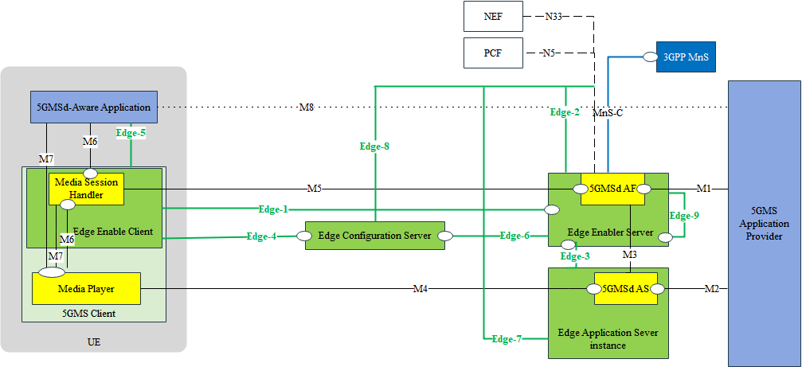
Figure 1 Potential deployment architecture option A
5GMS entities in the media function layer runs over the top of the SA6 MEC entities in the general function layer. Some parameter exchanges between these layers may be needed to trigger or receive the outcome of Edge-related procedures, i.e. the service provisioning, registration, EAS discovery, Service Continuity. For instance, during the EAS relocation procedure, the EES may help to find the target EAS instance and also to provide the selected target AS instance to the media function layer.

Deployment Scenario Option B
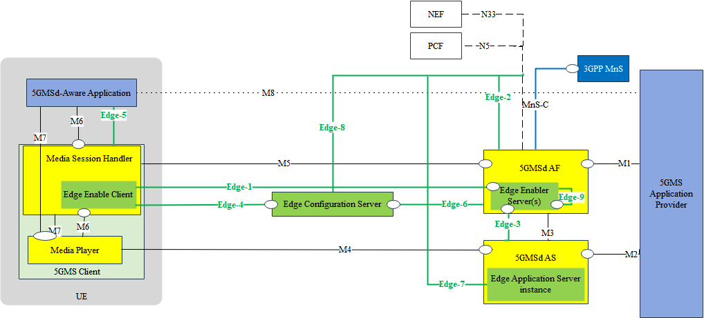
Figure 3 Potential deployment architecture option B
The 5GMS functions and SA6 MEC functions are co-located and the SA6 MEC functions are realized inside the 5GMS functions. This means that the 5GMS functions also realize the SA6 MEC functionalities to enable the edge-based 5GMS service, including the necessary edge server management functionalities, like registration, service provisioning, EAS discovery, etc.

Proposal
We propose to accept the Section 2 as possible deployment options and add to the Annex A “Deployment Scenarios” of TR.

References
[1] 3GPP TS 23.558, Architecture for enabling Edge Applications, Rel-17.

