Source: Huawei Technologies Co.,Ltd.
Title: Use case for multiple video camera capturing for A/V Production
Agenda Item: 9.9
Document for: Discussion and Agreement

Introduction
This contribution presents the use case targeted for FS_AVPro on multiple video camera capturing.

Use Case
Use Case Name
Multiple video camera capturing for A/V Production
Description
As a famous dancer, Sophia, will provide her livestream dance show in the recording studio tonight. The dance show will be recorded and edited for live distribution to the audiences.
When the dance show starts, Sophia goes up to the stage and dances following the playback of the music. The audio/video capturing equipment are located around the stage in order to record every detail in the audio and video for the dance show. It is quite necessary to provide sufficient details in order to provide the best perspective for the presentations.
Within the recording studio, each audio/video capturing equipment is able to connect to the Internet via one or more type of connections, e.g. 5G New Radio, WLAN, wireline Access. The high quality audio/video content with rich details shall be immediately transmitted to the local/edge/remote servers for real time video editing, e.g. video stitching, video transcoding, video clipping, etc. For example, the captured video contents will be stitched into an omnidirectional/360-degree video in real time in order to bring immersive experience to the audiences.
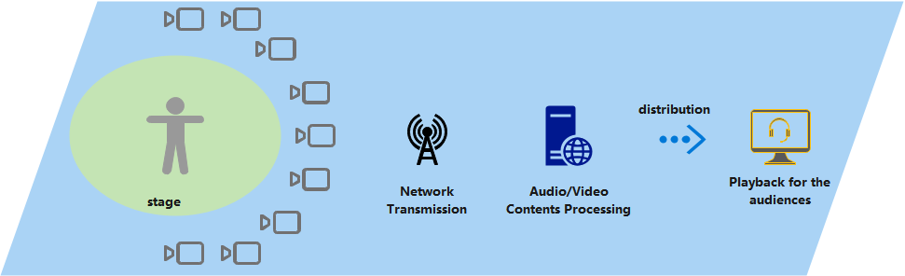
Figure 1 Multiple video camera capturing for A/V Production
After the real-time audio/video processing, the presentation-ready audio/video will be distributed to the audiences. And the audiences can see the live dance show via the TV, web or applications installed in the mobile devices.

Categorization
Type: AR, MR, XR, 2D, 3D, Cloud Computing
Delivery: Downlink, Uplink, Live streaming
Device: Video Camera, Audio Capturing equipment
Preconditions
On the network side, there is a local area network deployed, like NPN, to provide network communication service.
On the audio/video capturing equipment side, network connection and reporting of relevant capability are available.
On the local/edge/remote server side, powerful computing capability is needed to perform real-time audio/video processing, like rendering, stitching, transcoding etc.
Requirements in terms of Capabilities and QoS/QoE Considerations
<provides a summary on potential requirements as well as considerations on KPIs/QoE as well as QoS requirements>
Potential requirements
- Real-time audio/video processing.
- High-bandwidth, low-latency and high-reliability transmission.
- Synchronization of multiple audio/video streams.
KPIs
- The QoS parameters of the Non-public Network for high-bandwidth, low-latency and high-reliability transmission.
- The time difference among different audio/video streams.
Feasibility and Industry Practices
<How could the use case be implemented based on technologies available today or expected to be available in a foreseeable timeline, at most within 3 years?
- What are the technology challenges to make this use case happen?
- Do you have any implementation information?
- real world application
→ In the 2021 CCTV Spring Festival Gala, the director selects the best perspective according to the presentation effect of the program to generate a “condensed time and space” moment video, with a 360-degree rotating perspective Full display of the actors’ actions.
- Proof of concept
- Existing services
- References
- Could a reduced experience of the use case be implemented in an earlier timeframe or is it even available today?
>
Cost Analysis
< How does the use case scale with an increasing number of users? >
With the increase of the number of users and their UE capabilities, a group of users can be segmented with UEs similar capabilities, or even same model. Caching and reuse of transcoded 3D content can be utilized multiple times.
Potential Standardization Status and Needs
<identifies potential standardization needs>
How to measure the network performance with regarding to the high quality audio/video content.
How to keep the multiple uplink streaming synchronized.
How to efficiently make use of the network capabilities, like NPN, network slicing, to enable the high-bandwidth, low-latency and high-reliability transmission.

