Dear all,

On behalf of Ericsson I have the pleasure to confirm our preliminary commitment at the SA4#25bis meeting to host the low-rate audio ad-hoc meeting.
The meeting will be held from April 7 to 9 in some Ericsson premises in Kista, which is a suburb of Stockholm.

Please find below some useful information about the locality of the meeting venue.
Don’t hesitate to contact me if you like to have any more specific information.

Best regards and see you in Stockholm,

Stefan Bruhn
e-mail: Stefan.Bruhn@ericsson.com
Tel: +46-8-4044926

Travel information:
Stockholm has several airports. However, typically you will take flights to/from Stockholm/Arlanda.
From there, you can go to Kista or downtown Stockholm (depending on your hotel choice) via taxi. The price should not exceed much more than SEK 400. Please negotiate the price beforehand!
To downtown Stockholm (central station), the alternative is a fast train (http://www.arlandaexpress.com/), which costs SEK 180 per travel.

Hotel Information:
A hotel in the vicinity of the meeting venue is:
http://www.memoryhotel.se/
Tel. 46-8-793 07 00
Fax 46-8-793 08 00
hotel@memoryhotel.se

You reach the meeting venue from that hotel in about 5 - 10 min walk.

For those, who prefer to stay in downtown Stockholm, the following hotels are advisable (you should calculate about 45 min to get to the meeting venue):
First Hotel Amaranten
Address | Telephone | Fax | Email | WWW
Kungsholmsgatan 31 104 20 Stockholm Sweden | +46 8 692 52 00 | +46 8 652 62 48 | amaranten@firsthotels.se

Hilton Stockholm Slussen
Address | Telephone | Fax | Email | WWW
Guldgränd 8 104 65 Stockholm Sweden | +46 8 517 353 00 | +46 8 517 353 11 | slussen@scandic-hotels.com | <http://www.scandic-hotels.com>

Radisson SAS Royal Viking
Address | Telephone | Fax | Email | WWW
Vasagatan 1 101 24 Stockholm Sweden | +46 8 50 65 40 00 | +46 8 50 65 40 01 | sales.royal.stockholm@radisonSAS.com | <http://www.radisson.com/stockholmse_royalviking>

Rica City Hotel Kungsgatan
Address | Telephone | Fax | Email | WWW
Kungsgatan 47 111 56 Stockholm Sweden | +46 8 723 72 20 | +46 8 723 72 99 | reservations@rica.se

Scandic Hotel Anglais
Address | Telephone | Fax | Email | WWW
Humlegårdsgatan 23 102 44 Stockholm Sweden | +46 8 517 340 00 | +46 8 517 340 11 | anglais@scandic-hotels.com

Getting to the venue
The meeting will take place in an Ericsson building (BSYS-house) with street address Kistavägen 25 (see map). The meeting room is called ‘Pacific Ocean’. It is in the public area of the building. However, you might need to ask for it at the reception and mention my name (Stefan Bruhn).

From Memory Hotel
(Easiest!) Just follow the arrow in the map.

From downtown Stockholm, T-centralen (central station), by subway (T-Bana)
(Easy) Take the train with direction Akalla and leave at station Kista. Follow the red arrow in the map. You should calculate with approx. 30 min from central station (incl. the walk from the subway station to the venue).

From downtown Stockholm, T-centralen (central station), by commuter train (Pendeltåg)
(Quite easy) Take the train with direction Märsta and leave at station Helenelund. Walk down the road to the southwest. After passing a tunnel under the motorway follow the red arrow on the map. You should calculate with approx. 30 min from central station (incl. the walk from the train station to the venue).

From downtown Stockholm by taxi
The taxi should not cost more than 400 SEK. Again, negotiate the price beforehand. It will take you about 20 min, depending on the traffic.

Lunch
Kista Centrum offers a wide selection of lunch restaurants with reasonable price (< 100 SEK per lunch). See map.

Currency
1 Euro approximates 9 SEK.
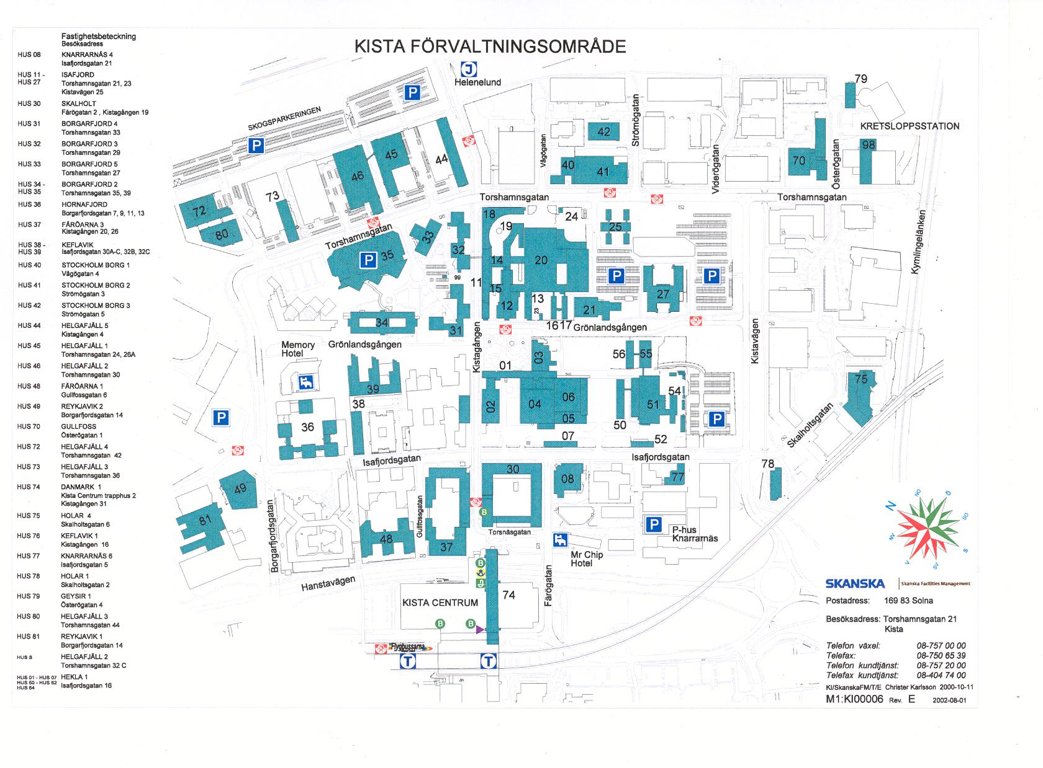
Lunch
Hotel
Meeting
Kistavägen 25
(Room: Pacific ocean)
Subway
(T-bana)
Commuter train
(Pendeltåg)

