3GPP TSG-SA3 Meeting #119AdHoc-e S3-250069-r1
Electronic meeting, online 13-16 January 2025

Source: Nokia

Title: Proposal for a resolution to an EN concerning device constrains

Document for: Approval
Agenda Item: 5.9

1 Decision/action requested
This contribution proposes resolution to an EN concerning device constrains.

2 References
[1] 3GPP TR 38.769: "Study on solutions for ambient IoT (Internet of Things)".

3 Rationale
The contribution proposes a resolution of an editor’s note in solution #35 concerning the device capabilities to perform cryptographic operations and store/increment a counter. The proposal is based on the following rational. Device type A harvest energy from a backscatter signal and type B from the backscatter signal and other sources like vibration, solar etc. [1]. Both device types have the capability to store the energy in e.g. a capacitor. This implies, that the worst case of harvesting energy is when only the RF harvesting is the single source available.
RF harvested energy originates from the backscatter signal provided by the receiver, which is also the receiver of the reply from the AIoT device based on the request provided earlier. As the AIoT device cannot send unsolicited messages, every request/reply cycle can be described in the following way.
- The receiver applies backscatter.
- The AIoT device wakes up and starts to listen.
- The receiver sends a request.
- The AIoT device will receive the request.
- The AIoT device will process the request.
- The AIoT device will send a reply.
- The receiver will receive the reply and send it to the AIoTF for processing.
- If further requests need to the send the procedure restarts at step 3.
- The receiver removes the backscatter.
The use of cryptography and storage only influences step 5, which implies that the AIoT device’s ability to wake up, receive and send messages is not influenced. The backscatter is applied from step 2 to 8 and the device will be able harvest during that period and maintain it’s capability to execute. Due to the fact, that harvesting is possible during step 5, and it can be assumed the AIoT device can maintain its ability to execute, the only effect of applying cryptography and storage is an extended execution time. There are multiple implementation specific measures to maintain the capability to execute, e.g. core suspension, clock reduction, hardware offload etc. All these measures are strongly bound to the hardware and therefore an objective quantitative measure, qualifying the extension in time for a given cryptographic algorithm cannot be given when the hardware by itself is not standardised. It can also not be concluded, whether the time extension added by cryptography is noticeable in the overall time spent in step 5 or not. Additionally, it shall be noted, that as long the backscatter remains, the device will be able to store data, of course with the cost of a time extension too, as the device shall not send the reply to the receiver, before counter has been correctly stored.
As the proposed solution gives the capability of configuring the means of protection, it’s left for deployment of the device to decide, the time extension acceptable for cryptographic and storage operations for a given use case on the cost of protection.
The proposed resolution updates the evaluation reflecting the above rational.

4 Detailed proposal
It is suggested to approve the pCR.
*************** Start of the change ****************

6.35 Solution #35: Configurable device/network authentication, data confidentiality, integrity and id privacy protection

6.35.1 Introduction
The solution proposes a solution to KI#3, KI#4 and KI#5. It gives a proposal to how a AIoT device can establish a secure connection with a reader, within the RAN procedure to resolve contention. This minimizes the signaling between the AIoT device and reader and thereby also the signaling overhead related to security establishment.

6.35.2 Solution details
The solution details how a shared session key can be derived while providing the means for mutual authentication (if required), confidentiality, integrity, reply and privacy protection. The explicit procedure is shown in figure 1. The solution is based on the 3-step contention based random access.

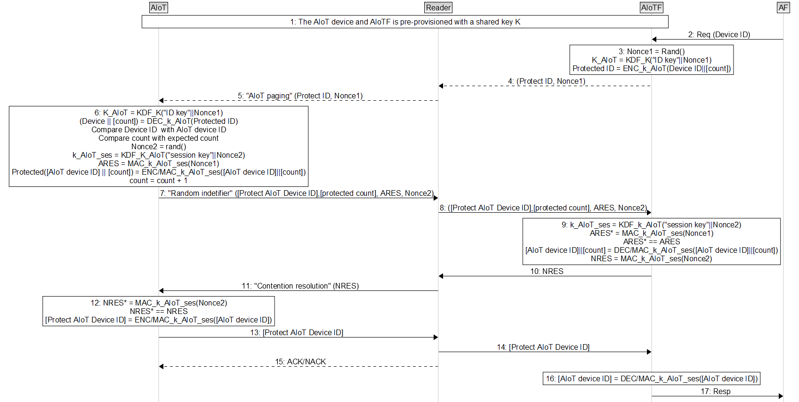
Figure 6.35-1: Security context establishment based on 3-step contention based random access
- The AIoT device and AIoTF is provisioned with a share secret K and a configuration of which primitives to enable like replay protection, integrity protection, privacy protection etc. Furthermore, the AIoT device contains a non-volatile counter and the AIoTF keeps track of the counter.
- An AF requests the inventory from a AIoT device.
- The AIoTF draws a random nonce1 and uses the nonce to derive a new key k_AIoT from the shared secret. K_AIoT is used to encrypt the device ID and optionally the counter value if reply protection is required. Please note that the same device ID produces different ciphertexts due to the nonce, hereby addressing the privacy concerns.
  - The Protected Id and nonce1 is send to the AIoT device.
The AIoT device derives k_AIoT and decrypts the protected ID. If the device ID doesn’t match the AIoT device ID rest of the steps can me omitted. If replay protection is enabled, the AIoT device compares the internal counter with count. If the counter values don’t match, the AIoT device can decide to omit rest of the steps or return the correct counter value to get the AIoTF back to sync (Please note that the counter is protected with the session key k_AIoT_ses). The decision is taken based on configuration and if the counter is s returned, the procedure restarts at step 3. The AIoT device draws a random number Nonce2 and uses Nonce2 and k_AIoT to derive the session key k_AIoT_ses. Using the session key, the device creates a MAC of nonce1 called ARES. If authentication of the network isn’t required, the AIoT device ID can be encrypted/integrity protected using the session key. The step finalises by incrementing the non-volatile counter.
  - ARES and Nonce2 and optional protected counter and protected ID are sent to the AIoTF.
- The AIoTF derives the session k_AIoT_ses and calculates the MAC ARES*. If ARES equals ARES* the device is authenticated. This step can be omitted if device authentication isn’t required. The AIoTF creates the MAC NRES using Nonce2 and the session key as input. If network authentication isn’t required, calculation of NRES can be omitted. If counter is returned form the AIoT device, the AIoTF re-adjust the internal counter and restarts at step 3.
  - NRES is send to the AIoT device.
- The AIoT device calculates NRES* and compares it to NRES. If the values are equal, the AIoT device have authenticated the network. The device encrypts/integrity protects the AIoT device ID
13-14. The protected ID is sent to the AIoTF.
15. The reader might acknowledge the AIoT device – This is part of the contention based random access procedure.
16-17. The AIoTF decrypts and verifies the integrity of the Protected ID and send it to the AF,
The key k_AIoT_ses can further be used to confidentiality and integrity protect command messages. If confidentiality and integrity protection isn’t required, NULL ciphering and integrity protection algorithms can be used.
Editor’s note: How the solution addresses a group of devices including key identification in step 9 is FFS.

Editor’s note: How the counter is resynced when the AIoTF and device gets out for sync is FFS.
Editor’s note: The solution needs to be aligned with RAN2 conclusions.
NOTE: According to TR 38.769 [9] legacy is paging is not support and the baseline for the random access procedure is slotted-ALOHA.
NOTE: The device will maintain state as long backscatter is applied, which implies if backscatter is removed, only the configuration, key K and count maintain state. Procedure starts at step 3, when backscatter is reapplied.

6.35.3 Evaluation
The solution fulfils the requirements of KI#3 by protecting the device identifier such same device ID produces different ciphertexts in each paging message, hereby avoiding ciphertext attack. Furthermore, when the real device ID is transferred from the device to the AIoTF, the ID is protected by a session key, implying the same ID is producing different ciphertexts for each session, hereby also avoiding ciphertext and likability attacks.
The solution fulfills the requirements of KI#4 by providing the means for confidentiality, integrity and replay protecting. The enablement of the protection profile is based on configuration both in the AIoT device and AIoTF. The solution doesn’t mandate a given profile, but leaves it for deployment and implementation,
The solution fulfills the requirement of KI#5 by providing the means for authentication both one-way and mutual. The selection of authentication scheme is part of configuration of the AIoT and AIoTF.
The configurability of the protection means enables the AIoT framework to adapt to different use cases, and hereby also reduce the device complexity and encounter for the constraints. If applying all protection means, the execution time of a message will be prolonged, but quantitative measure cannot be given due to the influence by hardware optimizations. The prolonged time can be reduced by carefully evaluating the necessity of the protection mean and disable if not required. It’s not recommended to reduce execution time by disabling without careful evaluation.
Editor’s note: Further evaluation is FFS.

*************** End of the change ****************

