3GPP TSG-SA3 Meeting #108e S3-222160

e-meeting, 22 - 26 August 2022

Source: China Mobile

Title: Adding contents of chapters 4.7 for type 1 of 3GPP virtualized networ product in TR 33.936

Document for: Approval
Agenda Item: 4.2

1 Decision/action requested
This contribution proposes to add contents of chapters 4.7 for type 1 of 3GPP virtualized networ product in TR 33.936.

2 References
[1] 3GPP TR 21.905: "Vocabulary for 3GPP Specifications".
[2] 3GPP TR 33.916 Security Assurance Methodology (SECAM) for 3GPP network products
[3] 3GPP TR 33.818 Security Assurance Methodology (SECAM) and Security Assurance Specification (SCAS)
for 3GPP virtualised network products (Release 17).

3 Rationale
This contribution proposes to add the roles in SECAM for type 1 of 3GPP virtualized network products into clause 4 by following the output in TR 33.818.

4 Detailed proposal
It is suggested to approve the following changes.
********************Start of the Change ****************************

4.7 Roles in SECAM for 3GPP virtualized network products
The roles involved in SECAM evaluation and accreditation described in TR 33.916 [2] also apply to type 1 of 3GPP virtualized network products , i.e. vendor, test laboratory, operator, 3GPP and SECAM Accreditation Body. The clause 4.6.1 of TR33.916 also applies to GVNP.
This example below of complete self-evaluation is similar to the SECAM defined Security assurance process in the figure 4.7-1 except that the vendor conducts all the phases of evaluation.
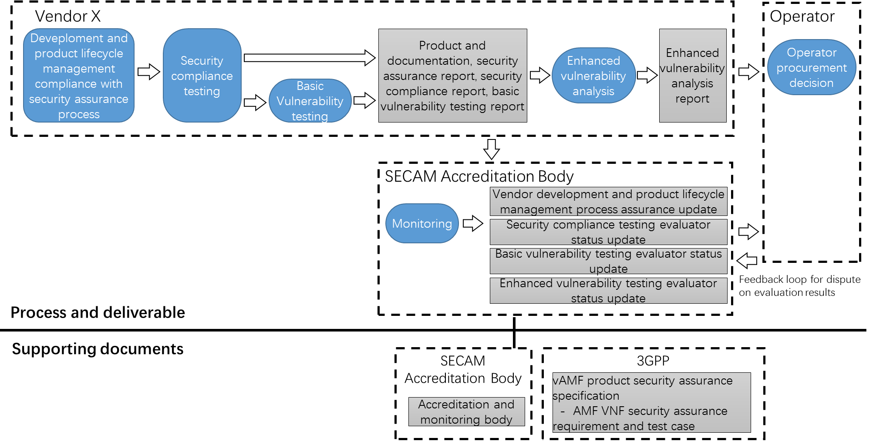
Figure 4.7-1: Complete self-evaluation of a 3GPP virtualized network product
(e.g. vAMF (AMF VNF) from vendor X)
Evaluation results are checked by operators and dispute on evaluation results is resolved by the SECAM Accreditation Body.
********************End of the Change ****************************

