3GPP TSG-SA3 Meeting #108-e-Ad-hoc draft_S3-222846-r2

e-meeting, 10th – 14th October, 2022

Source: Samsung

Title: New Solution for end-to-end security establishment over the Layer-3 UE-to-UE Relay

Document for: Approval
Agenda Item: 5.3

1 Decision/action requested
In this box give a very clear / short /concise statement of what is wanted.

2 References
[1] 3GPP TR 33.740: "Study on security aspects of Proximity Based Services (ProSe) in the 5G System (5GS); Phase 2".
[2] 3GPP TR 23.700-33: "Study on System enhancement for Proximity based Services (ProSe) in the 5G System (5GS); Phase 2".
[3] 3GPP TR 23.752: "Study on system enhancement for Proximity based Services (ProSe) in the 5G System (5GS)".
[4] 3GPP TS 33.536: "Security aspects of 3GPP support for advanced Vehicle-to-Everything (V2X) services"
[5] 3GPP TS 33.503: "Security Aspects of Proximity based Services (ProSe) in the 5G System (5GS)"

3 Rationale
This solution addresses Key Issue #2 and Key Issue #3 in TR 33.740 [1]. In a UE-to-UE Relay scenario, Source/Target UEs can be authorized by the network to act as Source/Target UEs and to use a UE-to-UE Relay. In the same manner, the UE-to-UE Relay can be authorized by the network to act as a UE-to-UE Relay and to relay the traffic between the Source UE and the Target UE (KI#3).
The end-to-end link between the Source UE and the Target UE over the UE-to-UE Relay as well as the direct PC5 links in between shall support integrity and/or confidentiality protection, because failure to do so will allow various attacks such as unauthorized disclosure and modification of the information (KI#2).
The authorization and end-to-end security establishment shall be supported both within and out of the network coverage as described in Key Issue #1 of TR 23.700-33 [2]. For this reason, this solution proposes a means to establish the end-to-end security between a Source UE and a Target UE communicating over UE-to-UE Relay, where each UE can be authorized both within and out of the network coverage.

4 Detailed proposal
**** Start of Change ****

6.X Solution #X: End-to-end security establishment over the Layer-3 UE-to-UE Relay

6.X.1 Introduction
This solution addresses Key Issue #2 and Key Issue #3. When Source/Target UEs and a Relay UE are in the network coverage, they are authorized and provisioned with the required information for security establishments during the registration procedure that includes the primary authentication (i.e., 5G-AKA and EAP-AKA).
The Source UE sends a Direct Communication Request to the Target UE over the UE-to-UE Relay, so that the direct authentication takes place and an end-to-end session key is established regardless of whether the UEs (Source UE, Target UE and/or UE-to-UE Relay) are within or outside the network coverage.
Editor’s note: The need of end-to-end security in Layer-3 solution is FFS.

6.X.2 Solution details
Figure 6.X.2-1 illustrates the end-to-end security establishment procedure between the Source UE and the Target UE over the UE-to-UE Relay.

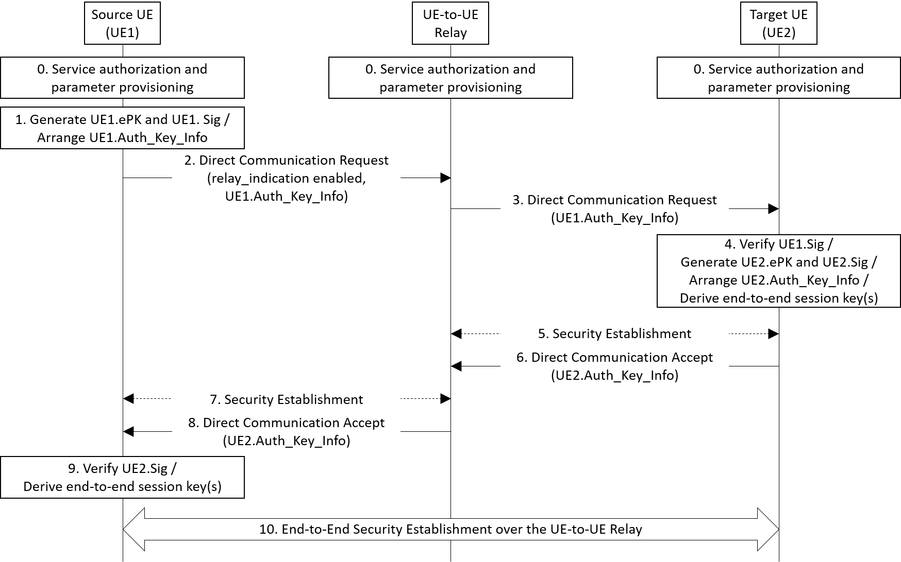
Figure 6.X.2-1: End-to-end security establishment procedure over the UE-to-UE Relay
- The Source/Target UEs and the UE-to-UE Relay shall be registered with the network.
The Source/Target UE shall be authenticated and authorized by the network during the primary authentication procedure (i.e., 5G AKA or EAP-AKA’). The Source/Target UE initiates the procedure by sending a Registration Request message to the network, and the UDM checks the subscription information related to the UE-to-UE relay service, which indicates:
- whether the Source/Target UE is authorized to receive UE-to-UE Relay service;
- whether the Source/Target UE requires end-to-end security establishment;
- available methods for Direct Authentication and Key Establishment between the Source UE and the Target UE (e.g., Certification-based approach, Identity-based approach, etc).
Based on the subscription information, the Source/Target UE may send its information to the network (i.e., the AUSF) to get provisioned with security materials for the Direct Authentication and Key Establishment. For examples, ID and public key of the Source/Target UE shall be provisioned to the network in Certificate-based approach and ID of the Source/Target UE shall be provisioned to the network in Identity-based approach.
Note: the security materials provisioned to the Source/Target UE by the network are associated with an expiration time after which they become invalid.
Based on the subscription information from the UDM and the information provisioned by the Source/Target UE, the network decides whether to generate and provision the security materials to the Source/Target UE: the authorized Source/Target UE is provisioned with the security materials when it has not been provisioned with the security materials or when the validity of the security materials is expired.
The UE-to-UE Relay shall also be authenticated and authorized by the network to provide UE-to-UE Relay service.
Editor’s note: How the public key is provisioned to the network is FFS.
Editor’s note: How the security material is generated is FFS.
- There are various authentication and key establishment methods to be used between the Source UE and the Target UE over a UE-to-UE Relay. Hence, all the authentication is specified to be carried in a generic container called Auth_Key_Info in the following steps.
The Source UE generates ephermeral public key (UE1.ePK) and secret key (UE1.eSK), and UE1.Sig using the security materials provisioned in step 0. The Source UE arranges the data for the direct authentication and key establishment with the Target UE (UE1.Auth_Key_Info), e.g., by carrying UE1.ID, UE1.ePK, and UE1.Sig. At each step of the flow, the Auth_Key_Info may contain different data required for key establishment.
The solution, for example, may employ certificated-based approach or identity-based approach. For the certificate-based approach, a UE is provisioned with its certificate and root CA’s public key to verify the certificate as security materials. Then, the UE puts a digital signature signed with its private key and its certificate to verify the signature into the Auth_Key_Info. For the Identity-based approach, a UE is provisioned with its identity, secret signing key (SSK), public validation token (PVT), and KMS public authentication key (KPAK) as security materials. Then, the UE puts a digital signature signed with SSK, PVT to verify the signature, and its identity into the Auth_Key_Info.
- The Source UE wants to establish unicast communication with the Target UE via a UE-to-UE Relay. The Source UE sends to the UE-to-UE Relay a Direct Communication Request message with its Auth_Key_Info included and relay_indication enabled. The message includes the source UE information, target UE information, Application ID, as well as Relay Service Code (RSC), if there is any.
Note: The relay_indication is a newly proposed field in Sol#8 for KI#4 from TR 23.752 [3] to indicate whether a relay can be used in the communication and to integrate the relay discovery/selection into the unicast link establishment procedure. The relay discovery/selection step can be added before step 2 to replace the relay_indication field.
Editor’s note: The solution needs SA2 coordination.
- The UE-to-UE Relay receives the Direct Communication Request with the relay_indication set and forwards the message to the Target UE with the relay_indication disabled.
- Upon reception of the Direct Communication Request message, the Target UE verifies the Source UE with the UE1.Sig included in UE1.Auth_Key_Info. If the verification test is successful and the Target UE decides to accept the request, the Target UE generates ephermeral public key (UE2.ePK) and secret key (UE2.eSK), and UE2.Sig using the security materials provisioned in step 0.
The Target UE arranges the data for the direct authentication and key establishment with the Source UE (UE2.Auth_Key_Info), e.g., by carrying UE2.ID, UE2.ePK, and UE2.Sig.
In this step, the Target UE derives the end-to-end session key(s) to protect the data between the Source UE and the Target UE using the Source UE’s public key (UE1.ePK) and its own secret key (UE2.eSK).
- In this step, the PC5 unicast link security can be established between the Target UE and the Relay UE as defined in clause 5.3 of TS 33.536 [4].
Note: this solution focus on end-to-end security establishment between the Source UE and the Target UE, as the security establishment between the Source/Target UE and the UE-to-UE Relay can be achieved by reusing the unicast mode direct communication mechanism defined in TS 33.503 [5] or by repeating this solution.
- The Target UE sends to the UE-to-UE Relay a Direct Communication Accept message with its Auth_Key_Info included.
- In this step, the PC5 unicast link security can be established between the Target UE and the Relay UE as defined in clause 5.3 of TS 33.536 [4].
- The UE-to-UE Relay receives the Direct Communication Accept message and retrieves the source UE information stored in step 2. The UE-to-UE Relay forwards the Direct Communication Accept message to the Source UE.
- Upon reception of the Direct Communication Accept message, the Source UE verifies the Target UE with the UE2.Sig included in UE2.Auth_Key_Info. If the verification test is successful, the Source UE derives the end-to-end session key(s) to protect the data between the Source UE and the Target UE using the Target UE’s public key (UE2.ePK) and its own secret key (UE1.eSK).
- The Source UE and the Target UE finish setting up the secure communication link over the UE-to-UE Relay with the shared end-to-end session key. The encryption key and integrity key are derived from the end-to-end session key and used in the chosen confidentiality and integrity algorithms, respectively.
Editor's note: The impact on protocol stack for end-to-end security is FFS.

6.X.3 Evaluation
TBD

**** End of Change ****

