3GPP TSG-SA3 Meeting #108Adhoc-e draft_S3-222601-r1

e-meeting, October 10-14, 2022

Source: MITRE

Title: Solution #7 – Evaluation and addressing EN

Document for: Approval
Agenda Item: 5.2

1 Decision/action requested
This pCR proposes to update TR 33.848 Solution #7 by addressing the EN and providing an evaluation

2 References
[1] 3GPP TR 33.848 v0.13.0 "Study on Security Impacts of Virtualisation"

3 Rationale
This pCR proposes to make three changes in solution #7 (clause 6.8) of TR 33.848 [1].
Change 1: Removes the EN “Editor’s Note: It is FFS whether the interaction between the Admin and the KDC is in scope of 3GPP.”.
The Kerberos configuration (e.g., KDC deployment, principals, realms) is implementation specific and out of 3GPP scope. The KDC does not need to be collocated with the resource, in this case the resource is the VNF or the NFVI depending on the administrative task and role. The interface between the admin and the KDC is out of 3GPP scope.
Change 2: Removes the EN “Editor’s Note: It is FFS whether the interaction between the Admin and the NFVI or the VNF is in scope of 3GPP.”.
The reference point between the admin and the NFVI or the VNF, Nf-Vi and Ve-Vnfm reference points respectively, are defined in ETSI NFV 002 [2]. Security for the Nf-Vi and Ve-Vnfm reference points is in ETSI GS NFV-SEC 003 [17].
Change 3: Provides an evaluation of Sol#7.
This solution supports protection from MANO single point of failures (KI #22) and malicious global admins (KI #10). This solution is one possibility for addressing KI #10 and #22 and depends on some aspects outside of 3GPP (e.g., implementation of ticket based access control (e.g., Kerberos, OAuth 2.0), ABAC setup, and the Nf-Vi and Ve-Vnfm reference points.)

4 Detailed proposal
********************** Start of Changes ****************************

6.8 Solution #7: Ticket-based access control for NFV

6.8.1 Introduction
This solution aims to provide one approach to address KI 10: Single Administrator Domain, and KI 22: MANO Single Point of Failures.
Administrators (“admins”) have many responsibilities in the NFV such as starting/stopping VNF instances, ensuring resources are provided to the VNF, and orchestrating the NFV infrastructure. These responsibilities should only be given to privileged admins. If the admin account is compromised or the admin is malicious then the account can be used to conduct attacks on the NFV (e.g., data exfiltration/espionage, selling user data, unauthorized configuration or package modification, service disruption). To reduce the risk of a malicious admin or MANO single point of failure the principles highlighted in Annex A. and Solution #3 must be followed.
To that end, this solution proposes using a ticket-based authentication system and Attribute Based Access Control (ABAC) on the NFV management plane. Within ETSI GS NFV-SEC 003 [17] it suggests a token-based authentication mechanism such as Kerberos may be used between the Tenant Domain and Infrastructure Domain. Similarly, this solution uses an Authentication Server (AS) to authenticate the admin. Next, a Ticket Granting Server (TGS) issues a ticket to authenticated admins which is used to connect securely to an NFV component. Tickets issued should be restricted by both time and number of usages. All other connection requests to the NFV environment shall be denied.
Another token-based authorization framework that can be used is OAuth 2.0, specified in IETF RFC 6749 [19]. Herein we only give details for the Kerberos option.
Once, the admin is authenticated and has established a secure connection with the NFV environment, they must also be authorized to perform tasks. ABAC may be used to provide fine grain access control to resources within the NFVI or the VNFs. ABAC uses policies that are based on subject attributes (e.g., user, admin, senior admin), object attributes (e.g., VNF, NFVI), and environmental conditions (e.g., time, location, authentication strength). Such attribute based policies help protect the NFV environment from unusual/ suspicious behaviour, even when the source is authenticated. Together, ticket-based authentication and ABAC provide secure access to the NFV resources, and fine grain access control.

6.8.2 Solution details
To implement necessary access controls, this solution proposes using a ticket-based authentication mechanism and ABAC. Kerberos, described in IETF RFC 4120 [18], is a network authentication protocol that uses tickets to authenticate a client’s connection to a server. It uses shared secret key cryptography to provide a secure connection between the client, Key Distribution Center (KDC), and server.
In this solution, a ticket-based authentication protocol, like Kerberos, is used to authenticate admins attempting to gain access to the NFV resources (VNF or the NFVI). In this case the client is an admin requesting access to the NFV environment. Additionally, ABAC is used on the resource side to authorize the admin. The ABAC server is per domain (VNF or NFVI) and implemented in such a way as to not be a single point of failure (e.g., distributed or redundant). The procedure for admin authentication and authorization to perform Management and Orchestration (MANO) functions is depicted in figure 6.8.2.1.
We note that the VNFs themselves and the infrastructure they run on (NFVI) can and should be two different administrative domains. The KDC can be per domain or can serve several domains. A policy server can be a part of the KDC and handles access control for each domain.

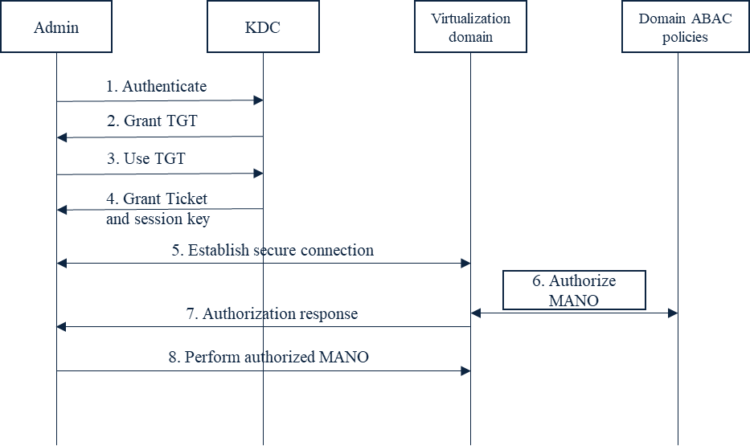
Figure 6.8.2.1: Procedure for admin authentication and authorization to perform Management and Orchestration (MANO) functions, applicable for each of the domains: NFVI and VNF.
Step 1: The admin (i.e., client) sends an authentication request to the Authentication Server (AS) that is part of the Key Distribution Center (KDC). The Kerberos configuration (e.g., KDC deployment, principals, realms) is implementation specific and out of 3GPP scope. The KDC does not need to be collocated with the resource, in this case the resource is the VNF or the NFVI depending on the administrative task and role. The interface between the admin and the KDC is out of 3GPP scope.
NOTE: The Kerberos protocol has built-in security measures for protection of messages on the interface between a client and the KDC such as timestamps, cache, and symmetric key cryptography.
Step 2: Upon successful authentication the KDC issues a Ticket Granting Ticket (TGT) to the admin.
Step 3: The admin sends the TGT to the Ticket Granting Service (TGS) that is part of the KDC to request access to the resource (NFVI/VNF).
Step 4: If access is approved, the KDC sends the admin a session key and ticket to access the resource (NFVI/VNF). If the KDC limits the number of access attempts, then the remaining access attempts should be decreased by one every time a ticket is issued.
Step 5: Once authenticated and authorized by the KDC, the admin can send the ticket with the session key to the resource (NFVI/VNF). Admin can use the session key to communicate securely with the resource (NFVI/VNF) for the duration of time on the ticket. The reference point between the admin and the NFVI or the VNF, Nf-Vi and Ve-Vnfm reference points respectively, are defined in ETSI NFV 002 [2]. Security for the Nf-Vi and Ve-Vnfm reference points is in ETSI GS NFV-SEC 003 [17].

Step 6: The resource (NFVI/VNF) sends an authorization request to the ABAC server on behalf of the admin. The ABAC server may be co-located with the resource (NFVI/VNF), but access must only be granted to authorized admins with the highest privileges. The ABAC server grants authorization using attribute based rules (e.g., admin A is allowed access to resource B from IP address: 1.2.3.4 from 9:00-10:00 UTC).
Step 7: The resource (NFVI/VNF) sends an authorization response. If the admin is unauthorized to perform the requested MANO functions, then the resource drops the connection.
Step 8: The admin performs the authorized MANO functions.
Step 9: Once the allotted time on the Ticket is reached, the resource (NFVI/VNF) drops the connection with the admin.

6.8.3 Evaluation
TBDThis solution is used as a reference model for secure NFV administration and addresses the key issues relating to protection from MANO single point of failures (KI #22) and malicious global admins (KI #10).
Aspects of this solution defined outside of 3GPP include implementation of ticket based access control (e.g., Kerberos, OAuth 2.0), ABAC setup, and the Nf-Vi and Ve-Vnfm reference points.
********************** End of Changes ****************************

