3GPP TSG-SA3 Meeting #107-e draft_S3-220845-r1

e-meeting, 16 - 20 May 2022 merger of S3-220737

Source: Huawei, HiSilicon

Title: Resolving the EN on the needs and usage of 5GPRUK ID

Document for: Approval
Agenda Item: 4.7

1 Decision/action requested
This contribution proposes to resolve the EN on the needs and usage of 5GPRUK ID.

2 References
[1] 3GPP TS33.503 Security Aspects of Proximity based Services (ProSe) in the 5G System (5GS).

3 Rationale
This document proposes to resolve the following three Editors Notes:
Editor's note: Further details on the needs and usage of 5GPRUK ID are FFS.

4 Detailed proposal
*************** Start of the Change ****************

6.3.3.3.2 Connection with 5G ProSe UE-to-Network Relay connection with setup of network Prose security context during PC5 link establishment
This subclause describes a procedure for a 5G ProSe Remote UE to establish a PC5 link between a 5G ProSe Remote UE and a 5G ProSe UE-to-Network Relay. The procedure includes how the 5G ProSe Remote UE is authenticated by AUSF via 5G ProSe UE-to-Network Relay and 5G ProSe UE-to-Network Relay's AMF during 5G ProSe PC5 establishment. The mechanism can be used by a 5G ProSe Remote UE while out of coverage.

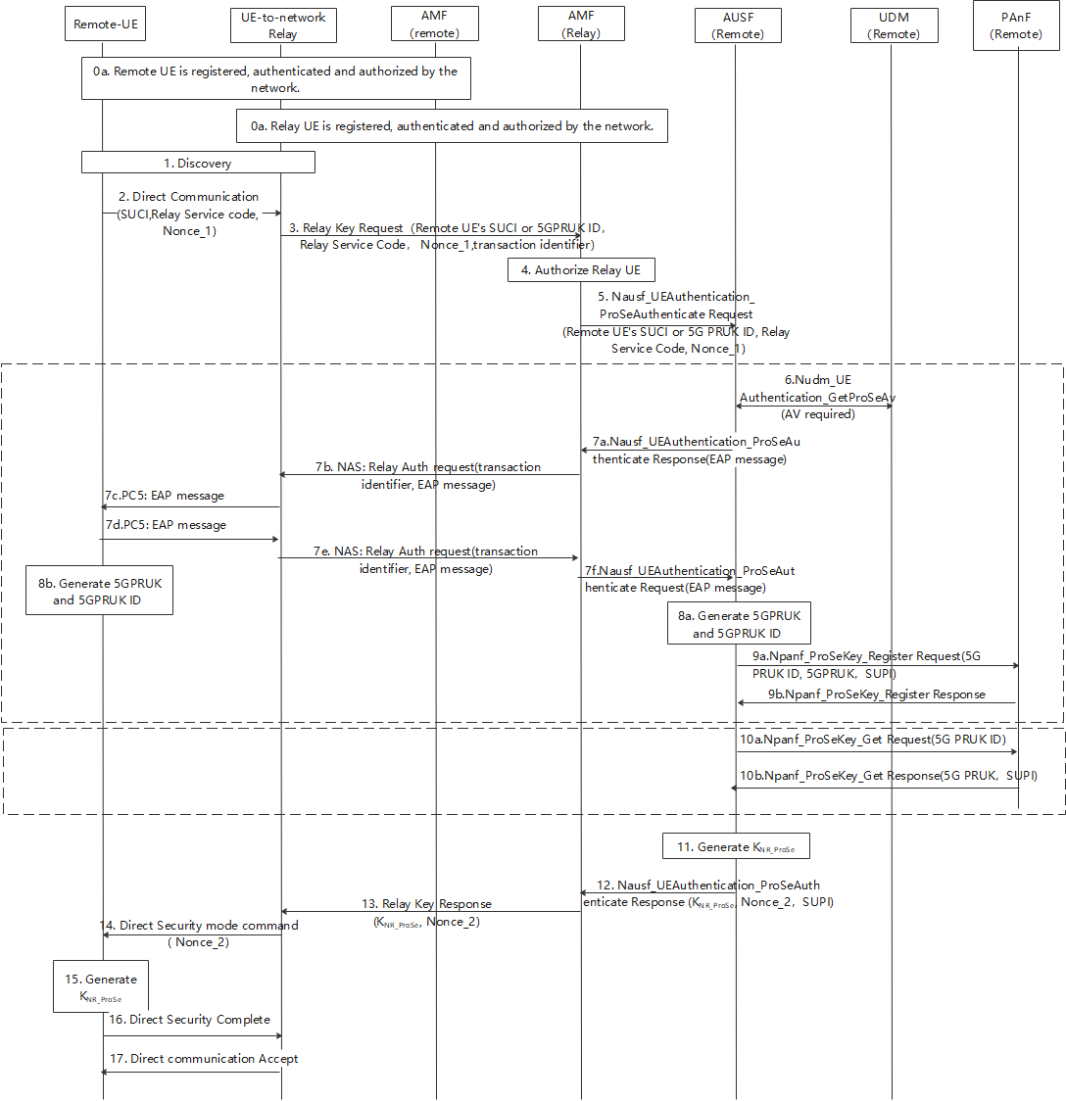
Figure 6.3.3.3.2-1: 5G ProSe UE-to-Network Relay security procedure with setup of network Prose security context during PC5 link establishment
0. The 5G ProSe Remote UE and the 5G ProSe UE-to-Network Relay shall be registered with the network. The 5G ProSe UE-to-Network Relay shall be authenticated and authorized by the network to provide UE-to-Network relay service. The 5G ProSe Remote UE shall be authenticated and authorized by the network to receive UE-to-Network relay service. PC5 security policies are provisioned to the 5G ProSe Remote UE and the 5G ProSe UE-to-Network Relay respectively during this authorization and information provisioning procedure.
1. The 5G ProSe Remote UE shall initiate discovery procedure using any of Model A or Model B method as specified in clause 6.3.1.2 or 6.3.1.3 of TS 23.304 [2] respectively.
2. After the discovery of the 5G ProSe UE-to-Network Relay, the 5G ProSe Remote UE shall send a Direct Communication Request to the 5G ProSe UE-to-Network Relay for establishing secure PC5 unicast link. The 5G ProSe Remote UE shall include its security capabilities and PC5 security signalling policy in the DCR message as specified in TS 33.536 [6]. The message shall also includeRelay Service Code, Nonce_1.
If the 5G ProSe Remote UE does not have a valid 5GPRUK, the 5G ProSe Remote UE shall include SUCI in the DCR to trigger 5G ProSe Remote UE specific authentication and establish a 5GPRUK.
If the 5G ProSe Remote UE already has a valid 5GPRUK, the 5G ProSe Remote UE shall include the 5GPRUK ID in the DCR to indicate that the 5G ProSe Remote UE want to get relay connectivity using the 5GPRUK.
3. Upon receiving the DCR message, the 5G ProSe UE-to-Network Relay shall send the Relay Key Request to the AMF of the 5G ProSe UE-to-Network Relay, including SUCI or 5GPRUK ID, RSC and Nonce_1 received in the DCR message. The 5G ProSe UE-to-Network Relay shall also include in the message a transaction identifier that identifies the 5G ProSe Remote UE for the subsequent messages over 5G ProSe UE-to-Network Relay's NAS messages and PC5 messages.
4. The AMF of the 5G ProSe UE-to-Network Relay shall verify whether the 5G ProSe UE-to-Network Relay is authorized to provide the UE-to-Network relay service.
5. The AMF of the 5G ProSe UE-to-Network Relay shall select an AUSF based on SUCI or 5G PRUK ID and forward the parameters received in Relay Key Request to the AUSF in Nausf_UEAuthentication_ProseAuthenticate Request message. The Nausf_UEAuthentication_ProseAuthenticate Request message shall contain the 5G ProSe Remote UE’s SUCI, Relay Service Code, Nonce_1. If 5GPRUK ID is received from AMF, the AUSF skip steps 6-9.
6. If the 5G ProSe Remote UE’s SUCI is received from AMF, the AUSF shall initiate a 5G ProSe Remote UE specific authentication using the ProSe specific parameters received (i.e., RSC, etc.) and skip step 10. The serving network name handling is same as defined in TS 33.501 [3].
The AUSF of the 5G ProSe Remote UE shall retrieve the Authentication Vectors from the UDM via Nudm_UEAuthentication_GetProseAv Request message and trigger authentication of the 5G ProSe Remote UE . This authentication is performed between the AUSF of the 5G ProSe Remote UE and the 5G ProSe Remote UE via the AMF of the 5G ProSe UE-to-Network Relay and the 5G ProSe UE-to-Network Relay. Based on SUPI, the UDM shall choose the authentication method.

7a. If EAP-AKA' is selected by UDM, the AUSF of the 5G ProSe Remote UE shall trigger authentication of the 5G ProSe Remote UE based on EAP-AKA'. The AUSF of the 5G ProSe Remote UE generates the EAP-Request/AKA'-Challenge message defined in clause 6.1.3.1 of TS 33.501 and send EAP-Request/AKA'-Challenge message to the AMF of the 5G ProSe UE-to-Network Relay in a Nausf_UEAuthentication_ProSeAuthenticate Response message.
7b. The AMF of the 5G ProSe UE-to-Network Relay shall forward the Relay Authentication Request (including the EAP-Request/AKA'-Challenge) to the 5G ProSe UE-to-Network Relay over NAS message, including transaction identifier of the 5G ProSe Remote UE in the message. The NAS message is protected using the NAS security context created for the 5G ProSe UE-to-Network Relay.
7c. Based on the transaction identifier, the 5G ProSe UE-to-Network Relay shall forwards the EAP-Request/AKA'-Challenge to the 5G ProSe Remote UE over PC5 messages.
The USIM in the 5G ProSe Remote UE verifies the freshness of the received values by checking whether AUTN can be accepted as described in TS 33.102 [11].
For EAP-AKA', the USIM computes a response RES. The USIM shall return RES, CK, IK to the ME. The ME shall derive CK' and IK' according to Annex A.3 in TS 33.501.
7d. The 5G ProSe Remote UE shall return EAP-Response/AKA'-Challenge to the 5G ProSe UE-to-Network Relay over PC5 messages.
7e. The 5G ProSe UE-to-Network Relay forwards the EAP-Response/AKA'-Challenge together with the transaction identifier of the 5G ProSe Remote UE to the AMF of the 5G ProSe UE-to-Network Relay in a NAS message Relay Authentication Response.
7f. The AMF of the 5G ProSe UE-to-Network Relay forwards EAP-Response/AKA'-Challenge to the AUSF of the 5G ProSe Remote UE via Nausf_UEAuthentication_ProSeAuthenticate Request.
The AUSF of the 5G ProSe Remote UE performs the UE authentication by verifying the received information as described in TS33.501.
For EAP-AKA’, the AUSF of the 5G ProSe Remote UE and the 5G ProSe Remote UE may exchange EAP-Request/AKA’-Notification and EAP-Response /AKA’-Notification messages via the AMF of the 5G ProSe UE-to-Network Relay. After the exchanges, the AUSF of the 5G ProSe Remote UE derives K_{AUSF} without calculating the K_{SEAF}.
The AUSF of the 5G ProSe Remote UE and the 5G ProSe Remote UE shall derive a new K_{AUSF_P} (different from K_{AUSF}). NAS SMC procedure is not performed between 5G ProSe Remote UE and AMF of the 5G ProSe UE-to-Network Relay.
8. On successful authentication, the AUSF of the 5G ProSe Remote UE and the 5G ProSe Remote UE shall generate 5GPRUK as specified in Annex A.2 and 5GPRUK ID as specified in Annex A.3 using the newly derived K_{AUSF_P}.
9a. The AUSF of the 5G ProSe Remote UE shall select the PAnF and send the SUPI, RSC, 5GPRUK and 5GPRUK ID in Npanf_ProseKey_Register Request message to the PAnF.
9b.The PAnF shall store the Prose context info (i.e., SUPI, RSC, 5GPRUK, 5GPRUK ID) for the 5G ProSe Remote UE and send Npanf_ProseKey_Register Response message to the AUSF.
10a. The AUSF of the 5G ProSe Remote UE shall select the PAnF based on 5GPRUK ID and send received 5GPRUK ID in Npanf_ProseKey_get Request message。
10b. The PAnF retrieves 5G PRUK and SUPI based on the 5GPRUK ID from the Prose context info (i.e., SUPI, 5GPRUK, 5GPRUK ID) for the 5G ProSe Remote UE and send Npanf_ProseKey_get Response message with 5GPRUK to the AUSF.
11. The AUSF of the 5G ProSe Remote UE shall generate the K_{NR_ProSe} key as defined in Annex A.4.
12. The AUSF of the 5G ProSe Remote UE shall send the K_{NR_ProSe}, Nonce_2 in Nausf_UEAuthentication_ProseAuthenticate Response message to the 5G ProSe UE-to-Network Relay via the AMF of the 5G ProSe UE-to-Network Relay. EAP Success message shall be included if step 7 is performed successfully, The AMF shall forward it transparently to the UE. The AUSF of the 5G ProSe UE-to-Network Relay shall also include the 5GPRUK ID in the message if generated in step 8.
13. When receiving a K_{NR_ProSe} from the AUSF of the 5G ProSe Remote UE, the AMF of the 5G ProSe UE-to-Network Relay shall not attempt to trigger NAS SMC procedure with the 5G ProSe Remote UE. The 5G ProSe UE-to-Network Relay derives PC5 session key K_{relay-sess} and confidentiality and integrity keys from K_{NR_ProSe}, as defined in clause 6.3.3.3.3 of this document. K_{NR_ProSe} ID and K_{relay-sess} ID are established in the same way as K_{NRP} ID and K_{NRP-sess} ID in TS 33.536 [6].The EAP Success message and 5GPRUK ID are also sent from the AMF to UE-to-Network Relay if received from AUSF.
14. The 5G ProSe UE-to-Network Relay shall send the received Nonce_2 to the 5G ProSe Remote UE in Direct Security mode command message, which is protected using K_{relay-int} or/and K_{relay-enc} derived from K_{relay-sess} according to the negotiated PC5 signalling policies between the 5G ProSe Remote UE and the 5G ProSe UE-to-Network Relay. EAP Success message shall be included is received from the AMF.
15. The 5G ProSe Remote UE shall generate the K_{NR_ProSe} key to be used for Remote access via the 5G ProSe UE-to-Network Relay in the same way as defined in step 11. The 5G ProSe Remote UE shall derive PC5 session key K_{relay-sess} and confidentiality and integrity keys from K_{NR_ProSe} the same way as defined in step 11.
16. The 5G ProSe Remote UE shall send the Direct Security Mode Complete message containing its PC5 user plane security policies to the 5G ProSe UE-to-Network relay, which is protected by K_{relay-int} or/and K_{relay-enc} derived from K_{relay-sess} according to the negotiated PC5 signalling policies between the 5G ProSe Remote UE and the 5G ProSe UE-to-Network Relay.
17. After the successful verification of the Direct Security Mode complete message, the 5G ProSe UE-to-Network Relay responds a Direct Communication Accept message to the 5G ProSe Remote UE to finish the PC5 connection establishment procedures and store the 5GPRUK ID in the security context associated to the PC5 link with the 5G ProSe Remote UE.
Further communication between the 5G ProSe Remote UE and the Network takes place securely via the 5G ProSe UE-to-Network Relay.

************** Next Change ****************

7.3.2 Nausf_UEAuthentication Service

7.3.2.1 Nausf_UEAuthentication_ProseAuthenticate service operation
Service operation name: Nausf_UEAuthentication_ProseAuthenticate
Description: Authenticate the 5G ProSe Remote UE and provides Prose related keying material.
Input, Required: One of the options below.
1. In the initial authentication request: SUPI or SUCI of the 5G ProSe Remote UE, Relay Service Code, Nonce_1.
2. In the subsequent authentication requests: EAP message.
Input, Optional: None.
Output, Required: EAP message, Authentication result and if success K_{NR_ProSe}, Nonce_2 and 5GPRUK ID.
Output, Optional: None.

************** End of the Change ****************

