3GPP TSG-SA3 Meeting #107-e S3-220xxx

e-meeting, 16 - 20 May 2022 merger of S3-220778 and S3-220769

Source: China Mobile, China Telecom

Title: Proposal to add GVNP model of type 1

Document for: Approval
Agenda Item: 4.2

1 Decision/action requested
It proposes to add description about GVNP model of type 1.

2 References
[1] 3GPP TR 33.926: “Security Assurance Specification (SCAS) threats and critical assets in 3GPP network product classes”
[2] 3GPP TR 33.818: “Security Assurance Methodology (SECAM) and Security Assurance Specification (SCAS) for 3GPP virtualized network products”
[3] ETSI GS NFV 002: "Network Functions Virtualisation (NFV); Architectural Framework".
[4] ETSI GS NFV-EVE 001: "Network Functions Virtualisation (NFV); Virtualisation technologies; Hypervisor Domain Requirements Specification".

3 Rationale
It introduces type 1 model for GVNP, which is the final description made in TR 33.818[2]..

4 Detailed proposal
================Start of Change===============

2 References
The following documents contain provisions which, through reference in this text, constitute provisions of the present document.
- References are either specific (identified by date of publication, edition number, version number, etc.) or non-specific.
- For a specific reference, subsequent revisions do not apply.
- For a non-specific reference, the latest version applies. In the case of a reference to a 3GPP document (including a GSM document), a non-specific reference implicitly refers to the latest version of that document in the same Release as the present document.
[1] 3GPP TR 21.905: "Vocabulary for 3GPP Specifications".
[2] 3GPP TR 33.926 Security Assurance Specification (SCAS) threats and critical assets in 3GPP network product classes
[x] ETSI GS NFV 002: "Network Functions Virtualisation (NFV); Architectural Framework".
[y] ETSI GS NFV-EVE 001: "Network Functions Virtualisation (NFV); Virtualisation technologies; Hypervisor Domain Requirements Specification".
================Next of Change===============

3.3 Abbreviations
For the purposes of the present document, the abbreviations given in 3GPP TR 21.905 [1] and the following apply. An abbreviation defined in the present document takes precedence over the definition of the same abbreviation, if any, in 3GPP TR 21.905 [1].

GVNP Generic Virtualized Network Product
NFVI Network Functions Virtualization Infrastructure
VM Virtual Machine
SCAS Security Assurance Specification
OAM Operation and Management
MnF Management Function
NFVO Network Functions Virtualization Orchestrator
VIM Virtualized Infrastructure Manager
VNFM Virtualized Network Function Manager
EM Element Management
NFV Network Functions Virtualization
================Next of Change===============

4.3.x Generic virtualized network product model of type 1

4.3.x.1 Description of the GVNP model
For the virtualized network product class type 1 (i.e. implementing 3GPP defined functionalities only), the following figure 4.3-x depicts the components of a generic virtualized network product model at a high level.
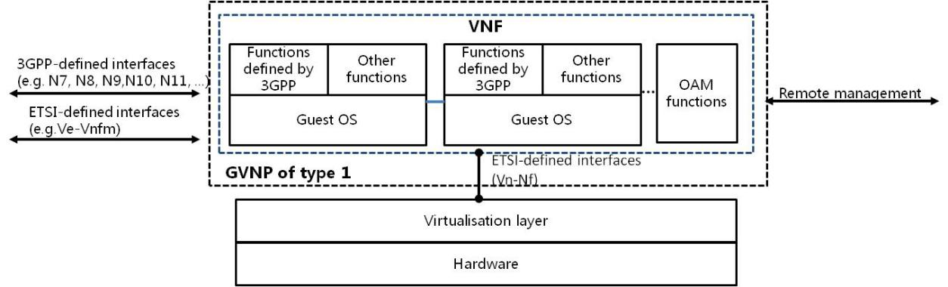
Figure 4.3-x: GVNP model of type 1
The components in the figure 4.3-x are further described in the following clauses.

4.3.x.2 Functions defined by 3GPP
For a generic virtualized network function, it will implement 3GPP-defined functions. Unlike a generic physical network product defined in [2], a 3GPP-denfined function can be deployed in multiple VMs and the feature s supported in different VM of the GVNP are up to the implementation of vendors.
To maintain generality and avoid overlap, the GVNP SCAS intends to explicitly address all GVNP functions that, if present in a GVNP, need to be evaluated and hence covered by the requirements in the GVNP SCAS.

4.3.x.3 Other functions
A GVNP will also contain functionalities not or not fully covered in 3GPP specifications.
Examples include, but are not limited to, remote management functions.

4.3.x.4 Operating system (OS)
The present document assumes that the functions of GVNP are implemented on multiple VMs. Each VM which is running on a common platform requires a guest operating system to run.

4.3.x.5 Interfaces
Compared to generic physical network product defined in [2], GVNP has also two types of logical interfaces, i.e. execution environment interfaces and remote logical interfaces.
The remote logical interfaces are interfaces which can be used to communicate with the GVNP from another network node and also include the remote access interfaces to the GVNP for its maintenance through e.g. an Element Management (EM), a Virtualized Network Function Manager (VNFM).
A GVNP hosts the following remote logical interfaces:
- Service interfaces that are defined in pertinent 3GPP specifications
- Service interfaces that are not defined by 3GPP
- Remote OAM interface
- Interface between EM (Element Management) and VNF which proprietary interface (see figure 4.3-y)
- EMS (Element Management System) interface
- Interface defined by ETSI NFV specifications [x] and [y]:
- Interface between VNF and VNFM for GVNP lifecycle management, configuration information exchange, state information exchange necessary for network service lifecycle management, etc. This interface refers to Ve-Vnfm in the figure 4.3-y.
- An execution environment interface is an interface that can be used to provide the GVNP with the underlying execution environment, to guarantee hardware independent lifecycle, portability, and performance requirements of the GVNP.
A GVNP type 1 hosts the following execution environment interface:
- Interface towards the underlying Virtualization layer for execution environment provision. This interface refers to Vn-Nf in the figure 4.3-y.
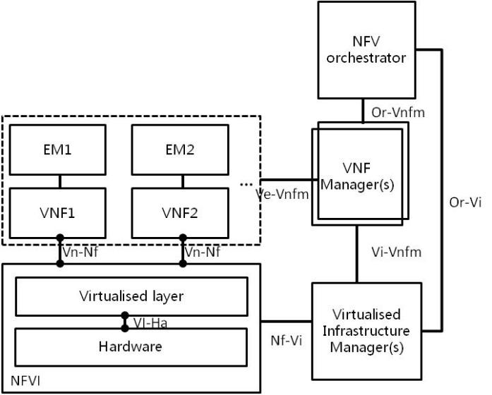
Figure 4.3-y: NFV reference architectural framework

================End of Change===============

