3GPP TSG-SA3 Meeting #105-e S3-214320

e-meeting, 8 – 19 November 2021

Source: Philips International B.V.

Title: Update Solution#9

Document for: Approval
Agenda Item: 5.9

1 Decision/action requested
Remove Editor’s Notes in Solution #9 in TR 33.850.

2 Rationale
Addresses Editor’s Notes in Solution #9.

3 Detailed proposal

*** BEGIN OF 1st CHANGE ***

6.9.3 Evaluation
This solution addresses Key issue #3 to manage, distribute, and update the keys required to protect the MBS traffic in the context of transport layer solution #1.
This solution can be applied to service layer solutions, e.g., Solution #2 uses it.
This solution describes a default and two communication optimized approaches.
The communication optimized approaches allow updating the group key used to protect the MBS traffic in a group with N devices with around root square of N (SQRT(N)) unicast messages in contrast with the default approach that requires N unicast messages. This means that for the same key update signaling overhead, the communication optimized approach allows supporting MBS groups a quadratic factor larger compared with the default approach without increasing the computational or communication overhead to protect/transmit the MBS traffic.
The choice M~L~SQRT(N) minimizes the total message size required to distribute a new group key and the total number of required encryptions to update the group key. This is because L-1 unicast messages need to be sent to L-1 UEs and the MGKM message includes M = N/L (rounded upwards) protected group keys. Thus, the total overhead in terms of protected group keys is L-1+N/L. This is minimized when L~SQRT(N).
Using M>1 transport keys and including the hash of the group key makes the communication optimized solutions more resilient.

The communication overhead of the default approach is similar to the communication overhead of the rest of solutions of KI#3 in this TR in terms of the number of unicast messages required to distribute/update a group key.
Compared with communication optimized approach 1, the communication optimized approach 2 reduces the overhead in the multicast channel since the update of the group key due to too long usage only requires the transmission of a single protected group key value.
Overall, the communication optimized approaches with multiple transport keys offer the best performance even for very few MBS membership changes if a group key is used to protect at least 2^22 bytes of data before group key update. A symmetric key can be used to protect much more than 2^22 bytes in a secure way. For instance, in TS 33.501 for the update of K_{gNB} and other keys and triggered when the PDCP COUNTs are about to be re-used. PDCP COUNTs are 32 bit values according to TS 38.323.
Performing the key update when a single UE has joined/left/been removed minimizes the security risk. The communication optimized approaches allow performing this key update at the cost of M-1 unicast messages while the default approach or the communication optimized approach with a single transport key require N-1 unicast messages. In contrast, if the key update procedure is only triggered when at least a minimum number C>1 of UEs have joined/left/been removed, the security risk increases because potentially several malicious devices still have access to the MBS keys. Note that for a given C and a group of size N divided into M subsets, the expected number of devices that require update equals L*M*(1 – binomial(N-M, C)/binomial(N,C)). This is shown in Figure 6.9.3-1 for N= 400 (blue), 1600 (red), 3600 (green), 6400 (black), and 10000 (purple). It is possible to observe that for C = 1 the number of devices that need to be updated equals SQRT(N)-1 and when C increases, the number of devices increases.
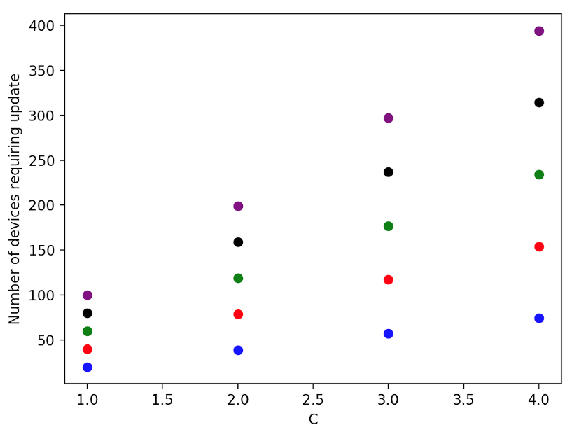
Figure 6.9.3-1. This figure shows-- for the communication optimized approaches with multiple transport keys -- the number of devices requiring key update as a function of C. C is the minimum number of UEs that have to leave/join/be compromised before the key update procedure is triggered. The default approach and the communication approach 1 with a single transport key require always N-1 unicast messages for any value of C.
Overall, the communication optimized approach 2 as applied to Solution#1 or Solution#11 (Section 6.9.2.3) offers the best performance independently of how often the group key is updated.
In the comparison an MBS application is used requiring the highest data rate in TS 22.261/TS 22.246. The performance of the different solutions is compared based on the required number of key updates due to (i) MBS group membership changes or (ii) key update because of a long usage of the group key. It is further assumed that the group key is updated as soon as key update condition is triggered.
Editor’s Note: the key update scenarios used for comparative evaluations require justification.
Editor’s Note: Further evaluation is FFS.

*** END OF 1st CHANGE ***

