3GPP TSG SA WG3 Meeting #103-e S3-211852

e-meeting, 17 – 28 May 2021 revision S3-21abcd

Source: China Unicom, Huawei, HiSilicon

Title: Address ENs for User Consent for Exposure of information to Edge Applications in Real Time

Document for: Approval
Agenda Item: 5.14

Decision/action requested
This contribution proposes to address ENs for solution#1 in TR 33.867

References

Rational
This contribution proposes to address existing ENs and add evaluation for solution #1 in TR 33.867.
For EN “how would the UCF know from what user it collected the user consent form is ffs.”, a new clause 7.1.2.2 is added.
For EN “It is FFS if UCF should communicate with user”, some text is added to evaluation part.
For EN “If UCF communicates with user, it is FFS how. It is also FFS how UCF can determine the user.”, the call flow is modified to make it more clear.
For EN “If UCF communicates with user, it is FFS how. It is also FFS how UCF can determine the user.”, the call flow is modified.
For EN “If UCF communicates with user, it is FFS how. It is also FFS how UCF can determine the user.”, it is proposed to change it as NOTE since the key issue #1 does not address revocation and deletion case.

Detailed proposal
*************** Start of 1st Change ****************

7.1 Solution #1: User Consent for Exposure of information to Edge Applications in Real Time

7.1.1 Solution overview
The solution addresses key issue #1 “User Consent for Exposure of information to Edge Applications”.
The solution introduces a new function user consent function (UCF), the UCF can collect and maintain user consent from user in real time. The UCF is operator’s internal AF which can be merged with other internal AF, and can communicate with user.

7.1.2 Solution details

7.1.2.1 Authorization for NF Provider

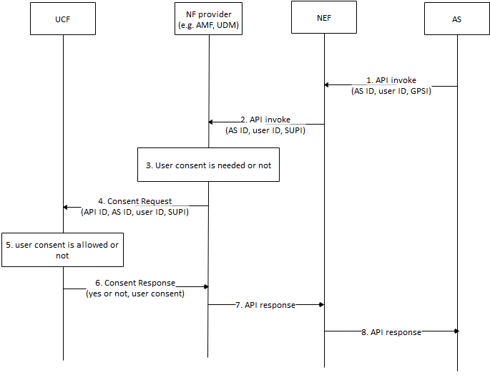
Figure 7.1.2.1 Authorization based on User Consent
- AS sends API invocation to NEF, requesting for user’s sensitive information, e.g. location. The invocation includes AS ID, GPSI and user ID. The user ID is associated to specific user. The GPSI is associated to UE.
- The NEF sends the API invocation with the AS ID, SUPI and the user ID to NF provider to retrieve the information.
- The NF provider checks whether authorization of user consent is needed or not based on the invocated API according to local policy, e.g. regulation, if the invocation requests the user’s sensitive data, the NF provider may check whether user is allowed based on local policy. Otherwise, if the invocation requests non-user information or policy is not needed, the NF provider may not check the consent.
- If check of consent is needed, the NF provider sends Consent Request message with the API ID, the AS ID, the SUPI and the user ID to the UCF.
- The UCF checks whether consent is allowed. The UCF may push application request to the user for consent via application layer, the UCF may also push SMS to the user associated with the MISDN identified by the SUPI. The request shows that user consent is needed for sharing your sensitive information to 3rd party which is derived from API ID and AS ID. If consent is received or rejected, the UCF replies result to the NF provider. The UCF may store the consent as depicted in clause 7.1.2.2 for future use.
- The UCF sends Consent Response to the NF provider with the result. In addition, the user consent may be sent to the NF.
- If the result shows that consent is allowed, the NF provider response to the API invocation, otherwise, the invocation is cancelled. The NF may store the user consent for future use.
Editor’s Note: How AS’s purpose for data processing is determined is FFS.

NOTE: How to track where data has been communicated to in case of a requirement for later deletion is not addressed in this solution.
Editor’s Note: When the policy enhancement happens is ffs.

7.1.2.2 User Consent Format
The UCF maintains the following parameters for user consent for transmission of personal data:
- User ID: refers to an end-user, it is defined as an ID identified by the AS.
- Purpose of data processing:
  - Initiator: optional, source of the action, e.g. PLMN ID
  - Action: transmission,
  - Target entity: target of the action, e.g. external application identified by AS ID
  - Target data: personal data, e.g. location, GPSI, etc..
  - Time period: expiration time for this consent.
Those parameters are combined to indicate that a specific end-user has user consent that the PLMN will transmit his or her personal data to 3rd party, i.e. MEC application.
Editor’s Note: How will “action” field be catered for myriad of actions that are present in real business operation is ffs.
7.1.3 Solution evaluation

The solution addresses security requirement of key issue #1, since some regulations may require current data controller to request user consent from user if the data controller or the user wants to share his or her personal data to 3rd party.

*************** End of 1st Change ****************

