3GPP TSG-SA3 Meeting #103-e S3-211712r1

e-meeting, 17- 28 May 2021

Source: Apple

Title: New solution on authentication between EEC and ECS based on AKMA

Document for: Approval
Agenda Item: 5.8

1 Decision/action requested
It is proposed to add a new solution in MEC TR 33.839.

2 References
[1] 3GPP TS 23.558: "Architecture for enabling Edge Applications (EA)"

3 Rationale
This pCR proposes a new solution in TR 33.839 to address the authentication between EEC and ECS based on AKMA.

4 Detailed proposal
****START OF CHANGES ***

6.X Solution #X: Authentication between EEC and ECS based on AKMA

6.2.1 Introduction
This solution addressed key issue#2 Authentication and Authorization between EEC and ECS.
This solution proposes the authentication between EEC (Edge Enabler Client) and ECS (Edge Configuration Server) based on AKMA. To be more specific, it is proposed to use the K_{AKMA} derived from the AKMA procedure as the trust root to perform the authentication between EEC and ECS.
It is assumed in this solution that ECS is located outside of the MNO’s network.

6.2.2 Solution details

6.2.2.1 Procedure

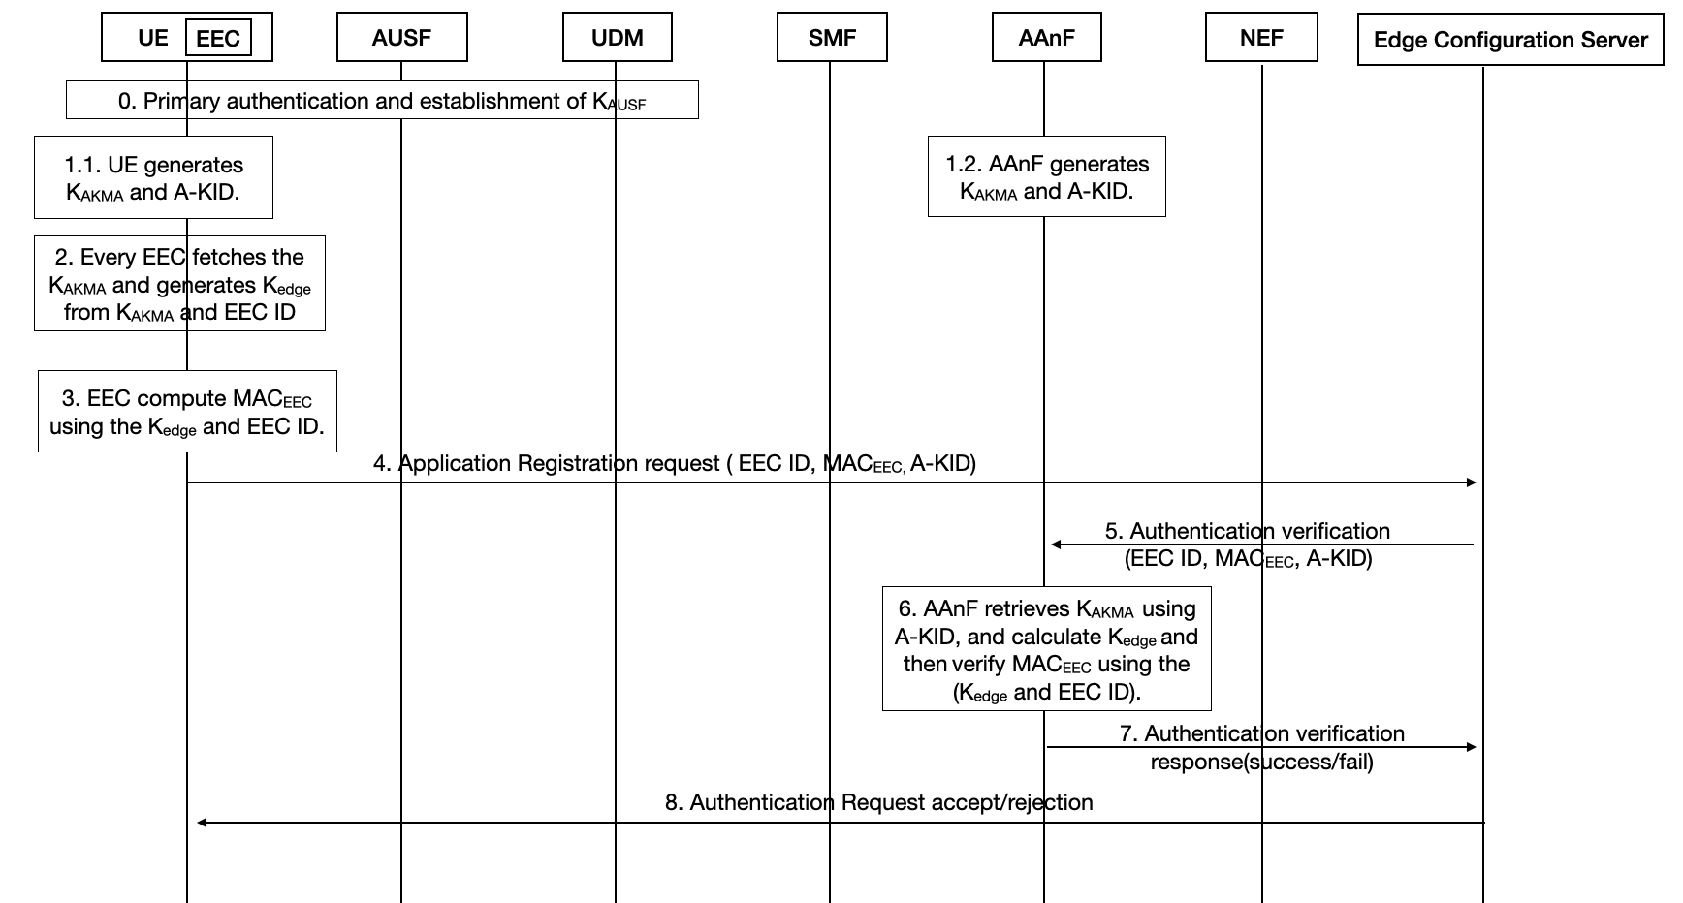
Figure-6.2.2.1-1. Authentication between the EEC and ECS based on AKMA
The authentication procedure details are as following:
Step 0: UE performs primary authentication with the network. Then K_{AUSF} is shared between UE and AUSF in Home network.
Step 1.1: UE generates K_{AKMA} and A-KID following AKMA procedure in TS 33.535 and stores them securely.
Step 1.2: AAnF generates K_{AKMA} and A-KID following AKMA procedure in TS 33.535 and stores them securely.
Step 2: Every EEC in this UE fetches the K_{AKMA} and generates K_{edge} from K_{AKMA} and EEC ID.
NOTE：In this way, there will be one K_{AKMA} and multiple K_{edge} in every UE.
Step 3: Every EEC computes MAC_{EEC} using the K_{edge} and EEC ID.
Step 4: UE sends Application Registration request (EEC ID, MAC_{EEC}, A-KID) to ECS.
Step 5: ECS sends Authentication verification (EEC ID, MAC_{EEC}, A-KID) to AAnF for verification.
Step 6: AAnF retrieves K_{AKMA} using A-KID and calculates K_{edge} using K_{AKMA} and EEC ID, then verify MAC_{EEC} using the (K_{edge} and EEC ID).
Step 7: If AAnF verification success, then AAnF sends Authentication verification response(success) back to ECS, otherwise, AAnF sends Authentication verification response(fail) to ECS.
Step 8: Based on the verification results, ECS decides whether to accept or reject the authentication request, and sends Authentication Request accept/rejection to EEC in the UE.
Editor’s Note: It is FFS how EEC ID is authenticated.
Editor’s Note: It is FFS whether ECS could perform the authentication instead of AAnF.

6.2.2.2 Derivation of K_{edge} and K_{edge} ID
K_{edge} is generated using KDF defined in Annex B.2.0 of TS 33.220 [8]. When deriving a K_{edge} from K_{AKMA}, the following parameters should be used to form the input S to the KDF:
- FC = xxxx(to be allocated by 3GPP)
- P0 = <SUPI>,
- L0 = length of <SUPI>.
The input key KEY should be K_{AKMA}.

6.2.2.3 Generation of MAC_{EEC}
When deriving MAC_{EEC} in the UE and AAnF, the following parameters should be used to form the input S to the SHA-256 hashing algorithm:
- P0 = K_{edge},
- P1 = EEC ID,
The input S should be equal to the concatenation P0||P1 of the P0 and P1.
The MAC_{EEC} is identified with the 32 least significant bits of the output of the SHA-256 function.

6.X.3 Solution Evaluation
This solution requires AAnF to perform the verification of the MAC_{EEC}.
This solution applies to the case when there are multiple EECs in one UE.
Editor’s Note: Further evaluation is FFS.

****END OF CHANGES ***

