3GPP TSG-SA3 Meeting #103-e S3-211628-r2

e-meeting, 17 - 28 May 2021 Revision of S3-20xxxx

Source: Huawei, HiSilicon

Title: Evaluation of solution 8

Document for: Approval, Information, Discussion
Agenda Item: 5.8

1 Decision/action requested
In this box give a very clear / short /concise statement of what is wanted.

2 References
[1] 3GPP TR 33.839 "Study on security aspects of enhancement of support for edge computing in 5G Core (5GC) ".

3 Rationale
This document proposes an evaluation of Solution #8.

4 Detailed proposal
*************** Start of the Change ****************

6.8 Solution #8: Authentication between EEC and EES

6.8.1 Solution overview
This solution addresses the security requirement for the Authentication between EEC and EES in key issue #1.
In this solution, UE knows to use AKMA with EES via interact with ECS before communication with EES. If the EES deployed by MNO is considered to be trusted by the operator, the EES interacts directly with AAnF. Otherwise, the EESs not allowed by the operator to access directly the Network Functions should use the NEF to interact with AAnF.

6.8.2 Solution details
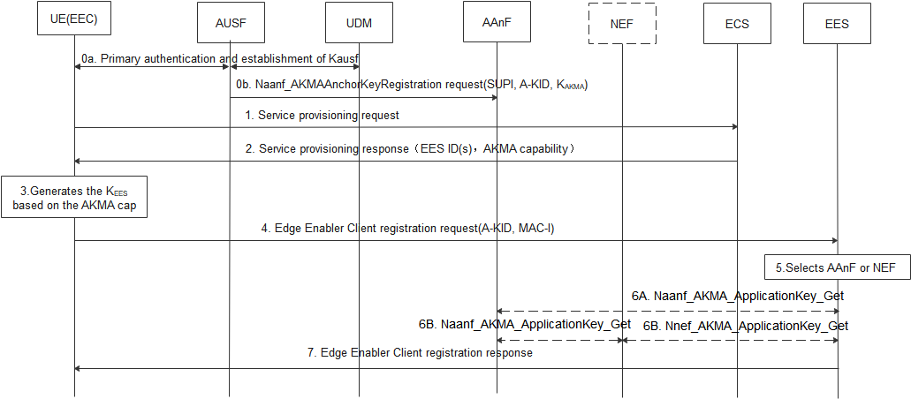
Figure 6.8.2-1 Authentication between the EEC and EES based AKMA
0a. UE performs primary authentication with the network. Then K_{AUSF} is shared between UE and AUSF in Home network. If the AUSF receives the AKMA indication from the UDM, the AUSF should generate the AKMA Anchor Key (K_{AKMA}) and the A-KID from K_{AUSF} after the primary authentication procedure is successfully completed.
0b. After AKMA key material is generated, the AUSF should send the generated A-KID, and K_{AKMA} to the AAnF.
1-2. The UE initiates the service provisioning procedure with the ECS. The ECS provides Edge Enabler Server Information (EES ID (i.e. FQDN or IP address(es) of EES), AKMA capability) to the UE. The AKMA capability indicates the EES support to use AKMA.
3. When the UE determines to communicate with EES, if the UE supports AKMA, the UE derives the AKMA key and the K_{EES}(i.e. Kaf) as specified in TS 33.535 [6] based on the received AKMA capability.
4. The UE computes the MAC-I over the request message using the K_{EES} and sending Edge Enable Client registration request with A-KID and MAC-I.

NOTE: TLS based on AKMA PSK solution is defined in other solutions.
5. Upon receiving the request, the Edge Enabler Server discovers the AAnF or NEF.
NOTE : In the case of architecture without CAPIF support, the EES is locally configured with the API termination points for the service. In the case of architecture with CAPIF support, the EES obtains the service API information from the CAPIF core function via the Availability of service APIs event notification or Service Discover Response as specified in TS 23.222 [9].
6. The EES contacts AAnF directly or via NEF to obtains the corresponding key K_{EES} of the UE (as defined in TS33.535 [6])..
7. The EES verifies the MAC-I using the K_{EES}, when the verification is succeed, and if the UE is authorized to perform the operation. The EES computes MAC-I over the response message using K_{ECS} and sends Edge Enable Client registration response with the MAC-I to the UE.

6.8.3 Solution evaluation

This solution addresses the security requirement for authentication between EEC and EES in the key issue #1 based on the AKMA.
This solution requires the ECS to provide the AKMA capability of EES(s) to the UE, then the UE can determine to use AKMA when establish connection with EES.
This solution also requires that the EEC and EES supports the AKMA.
Authentication of apps in the UE before accessing to the key is out of scope of this solution.

*************** End of the Change ****************

