3GPP TSG-SA3 Meeting #103-e S3-211528

e-meeting, 17 - 28 May 2021 Revision of S3-20xxxx

Source: NEC

Title: Resolving ENs of solution 6.2.10

Document for: Approval
Agenda Item:

1 Decision/action requested
This contribution will resolve ENs of the solution

2 References

3 Rationale
This contribution aims to resolve following two key ENs.
Resoliving EN
Editor's Note: It is FFS how the UDM avoid replay attack when the UDM deletes the SUCI and replay attack is mounted when the MO signalling is initiated by the target UE within 60 seconds of initiation of replay attack.
Discussion
The probability of mounting an attack within 60 seconds of initiation of replay attack is negligible due to following reasons:
i) When the MiTM starts replay attack, the timer in the UDM is started. The target UE needs to start the MO or MT call within the 1 minute. The probability to initiate the MO or MT call within 1 minute is very small.
ii) the cell area is very big so it is difficult to trace the UE. Also the UE may select another cell if the UE comes to idle mode. so it is very difficlult to track the UE.
Proposal 1:
Update the evaluation section capturing above scenarios that there is chance that when if MO or MT signalling is initiated within 60 seconds of initiaition of MiTM attack the UE can be detected at cell level but the chances of intiating MO/MT singaling is very low within 60 seconds.
Resolving EN
Editor's Note: It is FFS whether the proposed method is subject to the poisoning attack
Discussion
It was commented that the MiTM can send different SUCIs to start a timer for many SUCIs of a UE. therefore, hogging the UDM resouces.
The poisioing impact will not happen because the UDM is stoing a SUCI per SUPI and starting a timer per SUCI corresponding to a SUPI (Please see the capture solution below). It is very difficult for a MiTM to get more than one SUCI of a UE, because the MiTM can not correlate whether two SUCI belongs to same SUPI. Therefore, the MiTM can not have more than one SUCI of a particular SUPI.
In addition, when the UDM starts receiving different SUCIs of a SUPI within the timer T or the authentication procedure starts failing then the UDM can decides that MiTM is working and may not stores the SUCI per SUPI for which the authentication procedure has failed.

6.2.10.2 Solution details
When a UDM receives a SUCI from the AUSF, the UDM de-conceals the SUCI to SUPI. The UDM starts a timer T equivalent T3519 and stores the SUC corresponding to the SUPI. The UDM initiates the authentication procedure.
When the UDM receives the SUCI again, then it determines if the timer T is running. if the timer T is running then the UDM shall initiate authentication procedure otherwise the UDM determines either the UE is fake or there is man in the middle on receiving SUCI 1 after the timer T expires and the UDM rejects the authentication procedure as SUCI retransmission is not expected after T3519. The UDM stores the SUCI per SUPI for period of time (e.g. 24 hours or 48hours or longer).

Proposal 2:
i) Since it is extremely rare to capture more than one SUCI of a SUPI, the poisoing effect will not happen. therefore it is proposed to remove the EN.

4 Detailed proposal

6.2.10 Solution to Key Issue #2.2: SUCI replay.

6.2.10.1 Introduction
The solution is proposed to solve Key Issue #2.2: SUCI replay.

6.2.10.2 Solution details
When a UDM receives a SUCI from the AUSF, the UDM de-conceals the SUCI to SUPI. The UDM starts a timer T equivalent T3519 and stores the SUC corresponding to the SUPI. The UDM initiates the authentication procedure.
When the UDM receives the SUCI again, then it determines if the timer T is running. if the timer T is running then the UDM shall initiate authentication procedure otherwise the UDM determines either the UE is fake or there is man in the middle on receiving SUCI 1 after the timer T expires and the UDM rejects the authentication procedure as SUCI retransmission is not expected after T3519. The UDM stores the SUCI per SUPI for period of time (e.g. 24 hours or 48hours or longer).
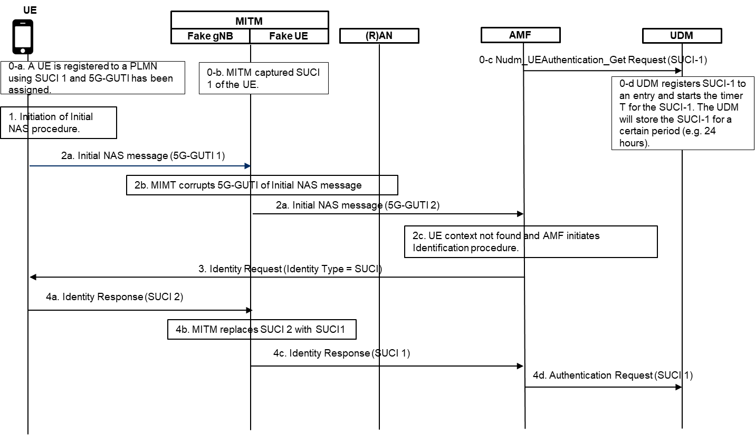
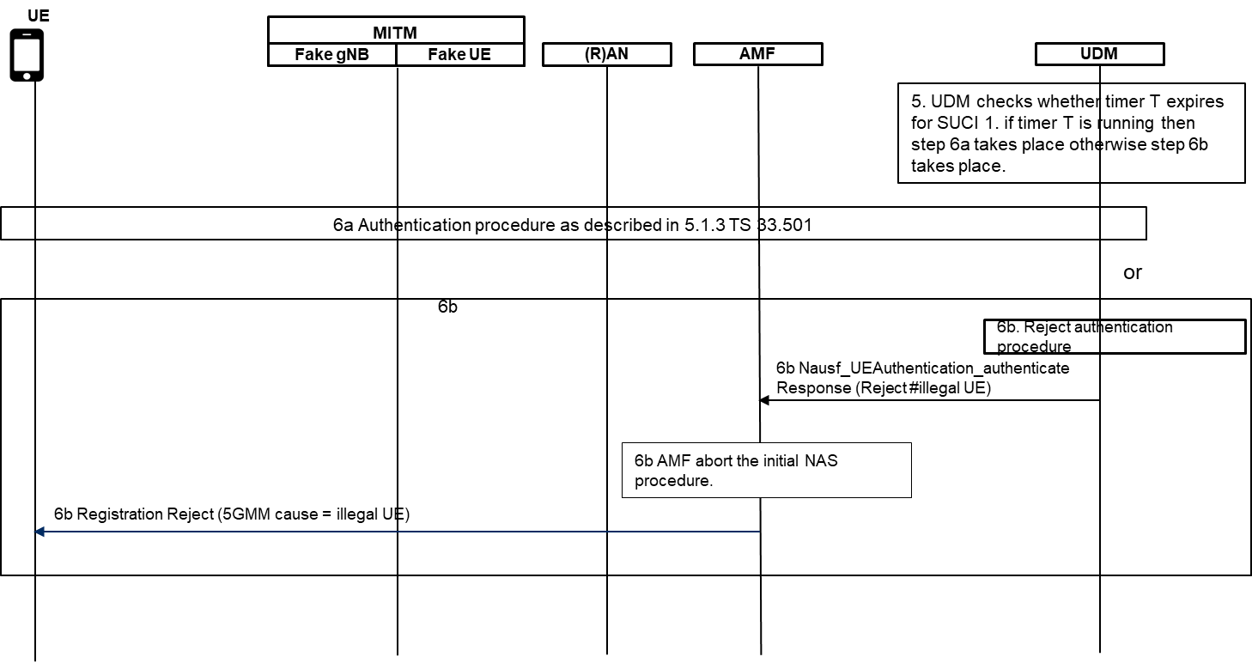
Figure 6.2.10.2-1: Procedure to handle SUCI parameter in the UDM

The detailed steps of the solution is as described below.
1. The UE is registered to the network for the first time by sending SUCI-1 in the registration procedure. The UE has been assigned 5G-GUTI 1. The UDM stores the SUCI 1 and start a timer T equivalent to T3519. The UDM stores the SUCI per SUPI for period of time (e.g. 24 hours or 48hours or longer). The UE also starts timer T3519.
2-3. The UE initiates an initial NAS procedure including the 5G-GUTI 1 in an initial NAS message. The MITM corrupts the 5G-GUTI 1. The context is not found in the AMF and the AMF initiates the identification procedure requesting SUCI.
4. Upon receiving the identity request message with identity type = SUCI, the UE calculates a new SUCI, SUCI 2, as the timer T3519 expires in the UE and sends SUCI 2 in the identity response message. The MITM replaces SUCI 2 with SUCI 1. The AMF on receiving the identity response message initiate authentication procedure towards the UDM for SUCI 1.
5. The UDM deconceals the SUCI 1 to SUPI and verify whether the timer T is running for the SUCI 1. The UDM will executes either 6a or 6b depending on whether timer T is running for SUCI 1 or not.
6a. If the timer T is running for the SUCI 1 then the UDM initiates authentication procedure as described in sub clause 6.1.3 of 3GPP TS 33.501. After successful registration procedure, the UDM shall stop the timer T.
6b If the timer T has expired then the UDM rejects the authentication procedure as SUCI retransmission is not expected after T3519.

6.2.10.3 Evaluation
The solution is very simple which has no UE, AMF, SEAF, AUSF impact. A minor change in the UDM as proposed in the UDM can easily and effectively solves this issue.
The UDM needs to run a timer T and to store the SUCI for a certain period. These will consume network resources.
There is a chance, if a legitimate UE sends data to the network within 60 seconds of initiation of MiTM attack, the legitimate UE can be detected at cell level but the chances of sending data by the legitimate UE is very low within 60 seconds.

