3GPP TSG-SA3 Meeting #103-e S3-212101r2

e-meeting, 17th – 28th May 2021

Source: Samsung

Title: Removal of Editor’s Note in Solution #5

Document for: Approval
Agenda Item: 5.17

1 Decision/action requested
It is requested to approve this contribution to update Solution #5 in TR 33.864.

2 Rationale
This contribution proposes to update Solution #5 about AMF re-allocation by re-directing UE to new AMF. Following Editor Notes are resolved:
- Editor's Note: How to solve GUTI collision is FFS.
  - Added clause 6.5.2.2 to address this.
The issue was highlighted in previous meeting for the scenario where NSSF returns AMF-IDs (instead of AMF-Set-ID). However, 23.501 Clause: 5.15.5.2.3 AMF Re-allocation due to Network Slice(s) Support states:
If the target AMF(s) are returned from the NSSF and identified by a list of candidate AMF(s), the redirection message shall only be sent via the direct signalling between the initial AMF and the target AMF. Therefore, this EN is not valid.

3 Detailed proposal
It is proposed to add following changes to Solution #5:
*** First Change ***

6.5.2 Solution Details
Figure 6.5.2-1 shows the detailed procedure.

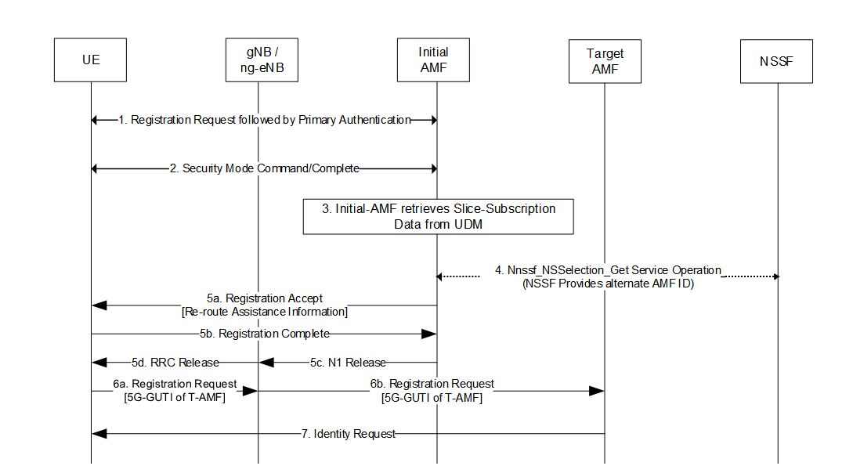
Figure 6.5.2-1: Redirecting UE to Target-AMF
Step #1: UE initiates Registration procedure to connect to the network by sending registration request. RAN forwards the request to Initial-AMF. Initial-AMF may perform Primary authentication procedure.
Step #2: Initial-AMF may perofrm NAS SMC procedure with the UE. From this point onwards, UE only accepts ciphered/protected messages from the network. As part of “Security Mode Complete” message, UE also sends complete Registration Request to the UE, which includes Requested S-NSSAIs.
Step #3: Initial-AMF then initiates Nudm_SDM_Get procedure with UDM to download UE's subscription data. The subscription data includes information about UE's Subscribed S-NSSAIs.
Step #4: Based on UE's Requested S-NSSAIs, Subscribed S-NSSAIs and other (e.g. locally configured) information, Initial-AMF determines if it cannot serve all the S-NSSAI(s) from the Requested NSSAI permitted by the subscription information. If network deploys NSSF, following sequence of events follows:
- Initial-AMF invokes the Nnssf_NSSelection_Get service operation towards NSSF to retrieve Allowed NSSAI. The request to NSSF includes UE's Requested S-NSSAIs, Subscribed S-NSSAIs, current tracking area (TAI) etc.
- NSSF responds to Initial-AMF with an AMF-Set-ID, or a list of AMF nf-Instance-IDs (e.g. of Target-AMF) which are better suited to serve the UE, along with allowed NSSAI.
If network doesn’t deploy NSSF, AMF finds Target-AMF Information by other means (e.g. local config)
Step #5: If Initial-AMF, based on local configuration, determines that it cannot forward the Registration Request to Target-AMF directly and/or may need to go via RAN, it sends a Registration Accept message to the UE. The message includes re-route assistance information containing:
- A 5G-GUTI that is encoded for Target-AMF (set). It comprises of:
- AMF-Set ID in GUAMI set to that of Target-AMF, as returned from NSSF/NRF
- AMF Pointer set to 0xFFFFFF, or a reserved value

- 5G-TMSI set to random number
- An indication that UE needs to re-register to the network using 5G-GUTI provided in re-route assistance information. This may be implicit due to presence of re-route assistance information. Exact details can be decided by Stage-3.
Following this, UE sends Registration Complete, and network releases ngAP/RRC connection.
UE also needs to indicate its support of receiving re-route assistance information in Step #1. Exact details will be decided by Stage-3.
For legacy UEs which do not support such capability, registration accept is sent with following information. Re-route assistance information is not sent in this case.
- 5G-GUTI set as indicated above
- Really short periodic registration timer (e.g. 4 seconds)
Step #6: UE re-initiates Registration procedure by sending Registration Request with 5G-GUTI as received above. via a new RRC Connection towards RAN. RAN forwards the request to Target-AMF.
Step #7: When Target-AMF receives the new Registration Request with new 5G-GUTI, it determines that it neither has UE's context locally, nor can reach the old AMF (e.g. due to presence of reserved value of AMF-Pointer in 5G-GUTI), and deduces that this is a re-routed Registration request. It accordingly proceeds with identity request/response followed by Primary authentication procedure. Since no Inter-AMF routing via RAN is involved now, the registration procedure is able to proceed.
For legacy UEs which may have initiated Registration Request of type "periodic", target AMF rejects registration request which forces it to send Registration Request of type "initial".

*** Next Change ***

6.5.3 Evaluation
Pros:
- Since the solution does not involve routing security context via RAN, or introducing a new NF connecting isolated slices, there is no compromise with security.
Cons:
- Cannot handle Case 2.a.i.
- Legacy UEs cannot handle Case 2.b.i, 2.b.ii.
NOTE: This solution has impacts to SA2 procedures (e.g. as defined in 3GPP TS 23.502, Clause 4.2.2.2.3), and SA2 may need to be requested to review and update their specifications.
- The initial AMF is mandated to assign a GUTI to the UE on behalf of the target AMF (Set).
The target AMF is mandated to run identity request and perform primary authentication.
The target AMF is unable to retrieve UE context from the old AMF. Context loss is inevitable.
This solution removes the option of NAS reroute via RAN. How to solve the registration failure issue when RR is rerouted via RAN is still not solved.
This solution has impact on the UE.
The UE and the network are required to run two registration procedures.
*** End of Changes ***

