3GPP TSG-SA3 Meeting #100e S3-202247

e-meeting, 17 -28 August 2020
CR-Form-v12.0
CHANGE REQUEST
 | 33.535 | CR | 0034 | rev | 1 | Current version: | 16.0.0
For HELP on using this form: comprehensive instructions can be found at
http://www.3gpp.org/Change-Requests.

Proposed change affects: | UICC apps |  | ME |  | Radio Access Network |  | Core Network | X

Title: | Several clarifications and editorials
Source to WG: | Ericsson
Source to TSG: | S3
Work item code: | AKMA |  |  |  |  |  | Date: |  |  | 2020-08-07
Category: | F |  |  |  |  |  | Release: |  |  | Rel-16
 | Use one of the following categories:  F (correction)  A (mirror corresponding to a change in an earlier release)  B (addition of feature),  C (functional modification of feature)  D (editorial modification)  Detailed explanations of the above categories can  be found in 3GPP TR 21.900. |  |  |  |  |  |  |  | Use one of the following releases:  Rel-8 (Release 8)  Rel-9 (Release 9)  Rel-10 (Release 10)  Rel-11 (Release 11)  Rel-12 (Release 12)  Rel-13 (Release 13)  Rel-14 (Release 14)  Rel-15 (Release 15)  Rel-16 (Release 16)
Reason for change: |  | The specification contains several points that need clarification or alignment between figures and text.
Summary of change: |  | The following clarifications are proposed:  - Clarifications on the description of the NEF in clause 4.2.3  - Clarifications on the description of the AUSF in clause 4.2.4  - Removed the authentication method examples and the expression "implict authentication" and referenced the primary authentication methods in TS 33.501 in clause 4.4.  - A new requirement on Ua* is added in clause 4.4.1 in order to align with the KAF refresh procedures clauses. The requirement states that the Ua* protocol shall be able to handle KAF expiration.  - Editorial corrections in clause 4.4.2  - In clause 6.3, the figure is updated to align with the same terms used other parts of the specification with respect to the AF_ID, KAF expiration time.  - The style of the heading of clause 6.5 is corrected in order for the heading to appear in the table of contents.
Consequences if not approved: |  | Unclear specification
Clauses affected: |  | 4.2.3, 4.2.4, 4.4, 4.4.1, 4.4.2, 6.3, 6.5
 |  | Y | N
Other specs |  |  | X | Other core specifications |  |  |  | TS/TR ... CR ...
affected: |  |  | X | Test specifications |  |  |  | TS/TR ... CR ...
(show related CRs) |  |  | X | O&M Specifications |  |  |  | TS/TR ... CR ...
Other comments:
This CR's revision history:

*** 1st CHANGE***

4.2.3 NEF
NEF is defined in TS 23.501 [3] with additional functions:
- NEF enables and authorizes the external AF assessing AKMA service and forwards the request towards the AAnF.
- NEF finds the AAnF.
*** 2nd CHANGE***

4.2.4 AUSF
AUSF is defined in TS 23.501 [3] with additional functions:
- AUSF provides the SUPI and AKMA key material (A-KID, K_{AKMA}) of the UE to the AAnF.

*** 3rd CHANGE***

4.4 Security requirements and principles for AKMA
The following security requirements are applicable to AKMA:
- AKMA shall reuse the same UE subscription and the same credentials used for 5G access.
- AKMA shall reuse the 5G primary authentication procedure and methods (both 5G AKA and EAP AKA' shall be supported) for the sake of implicit authentication for AKMA services.
- The SBA interface between the AAnF and the AUSF shall be confidentiality, integrity and replay protected.
- The SBA interface between AAnF and AF/NEF shall be confidentiality, integrity and replay protected.
- The AKMA Application Key (K_{AF}) shall be provided with a maximum lifetime. When the AKMA Application Key lifetime is expired, it shall be renegotiated.
NOTE: Roaming aspects are not considered in the present document.
*** 4th CHANGE***

4.4.1 Requirements on Ua* Reference point
The Ua* reference point is application specific. The generic requirements for Ua* are:
- Ua* protocol shall be able to carry AKMA Key Identifier (A-KID);
- the UE and the AKMA AF shall be able to secure the reference point Ua* using the AKMA Application Key derived from the AKMA Anchor Key.
NOTE 1: The exact method of securing the reference point Ua* depends on the application protocol used over reference point Ua*.
NOTE 2: Specifying Ua* protocol identifier is not considered in the present document.
- The Ua* protocol shall be able to handle the expiration of K_{AF}

*** 5th CHANGE***

4.4.2 Requirements on AKMA Key Identifier (A-KID)
Requirements for AKMA Key Identifier (A-KID) are:
- A-KID shall be globally unique;
- A-KID shall be usable as a key identifier in protocols used in the reference point Ua*;
- AKMA AF shall be able to identify the AAnF serving the UE from the A-KID.
*** 6th CHANGE***

6.3 AKMA Application Key request via NEF
Figure 6.3-1 shows the procedure used by the AF to request AKMA Application Key from 5GC via NEF, when the AF is located outside the operator's network.

Figure 6.3-1: AKMA Application Key request via NEF
1. When the AF is about to request AKMA Application Key for the UE from the 5GC, e.g. when UE initiates application session establishment request as in clause 6.2, the AF discovers the HPLMN of the UE based on the A-KID and sends the request towards the 5GC via NEF service API.
NOTE: In the case of architecture without CAPIF support, the AF is locally configured with the API termination points for the service. In the case of architecture with CAPIF support, the AF obtains the service API information from the CAPIF core function via the Availability of service APIs event notification or Service Discover Response as specified in TS 23.222 [5].
2. If the AF is authorized by the NEF to request AKMA Application Key, the NEF discovers and selects an AAnF instance based on local configuration or via NRF in the same way as the AF selects the AAnF in clause 6.2.
3. The NEF forwards the AKMA Application Key request to the selected AAnF.
4. The AAnF generates the AKMA Application Key in clause 6.2 and sends the response to the NEF with the K_{AF}, the K_{AF} expiration time and potentially other parameters.
5. The NEF forwards the response to the AF.
Editor's Note: Whether other parameters are to be returned to the AF via NEF is FFS.

*** 7th CHANGE***

6.5 Initiation of AKMA
In case when the UE does not know to use AKMA for a service, then the following procedure applies.
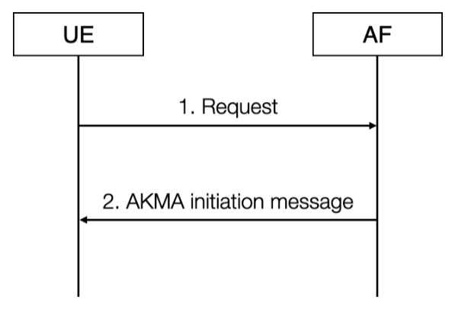
Figure 6.5-1: Initiation of AKMA
1. The UE may start communication over reference point Ua* with the AF with or without any AKMA-related parameters.
2. If the AF requires the use of shared keys obtained by means of the AKMA, but the request from UE does not include AKMA-related parameters, the AF replies with an AKMA initiation message. The form of this initiation message may depend on the particular reference point Ua*.
In case the UE knows to use AKMA for a service, then it directly initiates the procedure in clause 6.2.

*** END OF CHANGES***

