3GPP TSG-SA WG3 Meeting #100e S3-201734

e-meeting, 17 – 28 August 2020
CR-Form-v11.2
CHANGE REQUEST
 | 33.501 | CR | 0892 | rev | - | Current version: | 15.9.0
For HELP on using this form: comprehensive instructions can be found at
http://www.3gpp.org/Change-Requests.

Proposed change affects: | UICC apps |  | ME |  | Radio Access Network |  | Core Network

Title: | SUPI Type Clarification in R15
Source to WG: | Huawei, Hisilicon
Source to TSG: | S3
Work item code: | 5GS_Ph1-SEC |  |  |  |  |  |  | Date: |  | 2020-8-16
Category: | F |  |  |  |  |  |  | Release: |  | Rel-15
 | Use one of the following categories:  F (correction)  A (mirror corresponding to a change in an earlier release)  B (addition of feature),  C (functional modification of feature)  D (editorial modification)  Detailed explanations of the above categories can  be found in 3GPP TR 21.900. |  |  |  |  |  |  |  | Use one of the following releases:  Rel-8 (Release 8)  Rel-9 (Release 9)  Rel-10 (Release 10)  Rel-11 (Release 11)  Rel-12 (Release 12)  Rel-13 (Release 13)  Rel-14 (Release 14)  Rel-15 (Release 15)  Rel-16 (Release 16)
Reason for change: |  | Derivation parameters SUPI are clarified in SA#88, it is clarified that:  “  For P0, when the SUPI type is IMSI, P0 shall be set to IMSI as defined in clause 2.2 of TS 23.003 [19]. For P0, when the SUPI type is network specific identifier, the P0 shall be set to Network Access Identifier (NAI) as defined in clause 28.7.2 of TS 23.003 [19]. When the SUPI type is GLI, P0 shall be set to GLI taking format of NAIas defined in clause 28.15.2 of TS 23.003 [19]. When the SUPI type is GCI, P0 shall be set to GLI taking format of NAIas defined in clause 28.16.2 of TS 23.003 [19]. P0 shall be represented as a character string as specified in B.2.1.2 of TS 33.220 [28], for both SUPI types.  ”  It means that the SUPI value not SUPI (which includes both SUPI type and SUPI value) is used for key derivation. However, some other texts of the whole specification TS 33.501 shall be consistent with the change made on key derivation clause A.7.0 and F.3.
qu
Summary of change: |  | Replace SUPI to SUPI value for key derivation.
Consequences if not approved: |  | Misalignment in SA3 specification.
Clauses affected: |  | 3.1, 6.1.3.1, 6.1.3.2.0, 6.2.2.1, 6.2.2.2
 |  | Y | N
Other specs |  |  | X | Other core specifications |  |  | TS/TR ... CR ...
affected: |  |  | X | Test specifications |  |  | TS/TR ... CR ...
(show related CRs) |  |  | X | O&M Specifications |  |  | TS/TR ... CR ...
Other comments:

********** START OF 1st CHANGE **********

3.1 Definitions
For the purposes of the present document, the terms and definitions given in 3GPP TR 21.905 [1] and the following apply. A term defined in the present document takes precedence over the definition of the same term, if any, in 3GPP TR 21.905 [1].
SUPI value: the value dependent on the value of SUPI type as defined in TS 23.003 [19], e.g. IMSI, network specific identifier, GCI, GLI, etc.
********** END OF 1st CHANGE **********

********** START OF 2nd CHANGE **********

6.1.3.1 Authentication procedure for EAP-AKA'
EAP-AKA' is specified in RFC 5448 [12]. The 3GPP 5G profile for EAP-AKA' is specified in the normative Annex F.
Editor’s Note: The reference to RFC 5448 will be superseded by the internet draft referred to in [67] when it becomes an RFC.
The selection of using EAP-AKA' is described in sub-clause 6.1.2 of the present document.
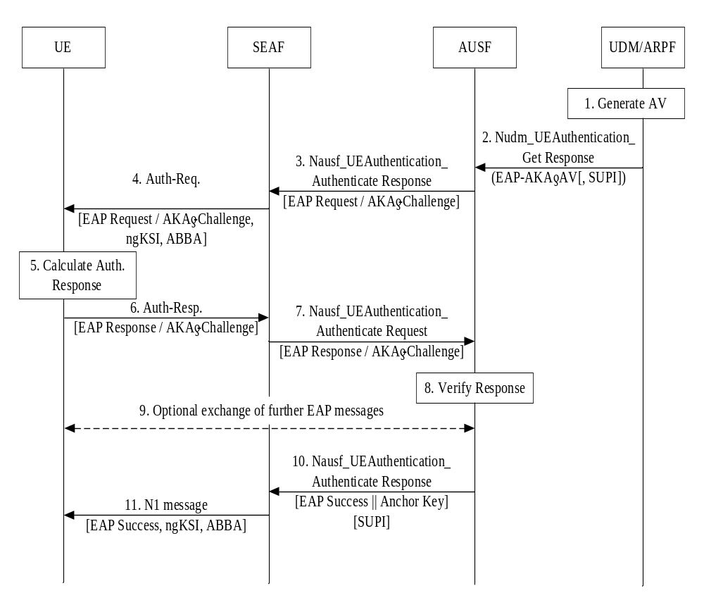Figure 6.1.3.1-1: Authentication procedure for EAP-AKA'
The authentication procedure for EAP-AKA' works as follows, cf. also Figure 6.1.3.1-1:
1. The UDM/ARPF shall first generate an authentication vector with Authentication Management Field (AMF) separation bit = 1 as defined in TS 33.102 [9]. The UDM/ARPF shall then compute CK' and IK' as per the normative Annex A and replace CK and IK by CK' and IK'.
2. The UDM shall subsequently send this transformed authentication vector AV' (RAND, AUTN, XRES, CK', IK') to the AUSF from which it received the Nudm_UEAuthentication_Get Request together with an indication that the AV' is to be used for EAP-AKA' using a Nudm_UEAuthentication_Get Response message.
NOTE: The exchange of a Nudm_UEAuthentication_Get Request message and an Nudm_UEAuthentication_Get Response message between the AUSF and the UDM/ARPF described in the preceding paragraph is the same as for trusted access using EAP-AKA' described in TS 33.402 [11], sub-clause 6.2, step 10, except for the input parameter to the key derivation, which is the value of <network name>. The "network name" is a concept from RFC 5448 [12]; it is carried in the AT_KDF_INPUT attribute in EAP-AKA'. The value of <network name> parameter is not defined in RFC 5448 [12], but rather in 3GPP specifications. For EPS, it is defined as " access network identity " in TS 24.302 [71], and for 5G, it is defined as "serving network name" in sub-clause 6.1.1.4 of the present document.

In case SUCI was included in the Nudm_UEAuthentication_Get Request, UDM will include the SUPI in the Nudm_UEAuthentication_Get Response.
The AUSF and the UE shall then proceed as described in RFC 5448 [12] until the AUSF is ready to send the EAP-Success.
3. The AUSF shall send the EAP-Request/AKA'-Challenge message to the SEAF in a Nausf_UEAuthentication_Authenticate Response message. 4. The SEAF shall transparently forward the EAP-Request/AKA'-Challenge message to the UE in a NAS message Authentication Request message. The ME shall forward the RAND and AUTN received in EAP-Request/AKA'-Challenge message to the USIM. This message shall include the ngKSI and ABBA parameter. In fact, SEAF shall include the ngKSI and ABBA parameter in all EAP-Authentication request message. ngKSI will be used by the UE and AMF to identify the partial native security context that is created if the authentication is successful. The SEAF shall set the ABBA parameter as defined in Annex A.7.1. During an EAP authentication, the value of the ngKSI and the ABBA parameter sent by the SEAF to the UE shall not be changed.
NOTE 1: The SEAF needs to understand that the authentication method used is an EAP method by evaluating the type of authentication method based on the Nausf_UEAuthentication_Authenticate Response message.
5. At receipt of the RAND and AUTN, the USIM shall verify the freshness of the AV' by checking whether AUTN can be accepted as described in TS 33.102 [9]. If so, the USIM computes a response RES. The USIM shall return RES, CK, IK to the ME. If the USIM computes a Kc (i.e. GPRS Kc) from CK and IK using conversion function c3 as described in TS 33.102 [9], and sends it to the ME, then the ME shall ignore such GPRS Kc and not store the GPRS Kc on USIM or in ME. The ME shall derive CK' and IK' according to Annex A.3.
If the verification of the AUTN fails on the USIM, then the USIM and ME shall proceed as described in sub-clause 6.1.3. 3.
6. The UE shall send the EAP-Response/AKA'-Challenge message to the SEAF in a NAS message Auth-Resp message.
7. The SEAF shall transparently forward the EAP-Response/AKA'-Challenge message to the AUSF in Nausf_UEAuthentication_Authenticate Request message.
8. The AUSF shall verify the message, and if the AUSF has successfully verified this message it shall continue as follows, otherwise it shall return an error to the SEAF. AUSF shall inform UDM about the authentication result (see sub-clause 6.1.4 of the present document for details on linking authentication confirmation).
9. The AUSF and the UE may exchange EAP-Request/AKA'-Notification and EAP-Response /AKA'-Notification messages via the SEAF. The SEAF shall transparently forward these messages.
NOTE 2: EAP Notifications as described in RFC 3748 [27] and EAP-AKA Notifications as described in RFC 4187 [21] can be used at any time in the EAP-AKA exchange. These notifications can be used e.g. for protected result indications or when the EAP server detects an error in the received EAP-AKA response.
10. The AUSF derives EMSK from CK’ and IK’ as described in RFC 5448[12] and Annex F. The AUSF uses the most significant 256 bits of EMSK as the K_{AUSF} and then calculates K_{SEAF} from K_{AUSF} as described in clause A.6. The AUSF shall send an EAP Success message to the SEAF inside Nausf_UEAuthentication_Authenticate Response, which shall forward it transparently to the UE. Nausf_UEAuthentication_Authenticate Response message contains the K_{SEAF}. If the AUSF received a SUCI from the SEAF when the authentication was initiated (see sub-clause 6.1.2 of the present document), then the AUSF shall also include the SUPI in the Nausf_UEAuthentication_Authenticate Response message.
NOTE 3: For lawful interception, the AUSF sending SUPI to SEAF is necessary but not sufficient. By including the SUPI value as input parameter to the key derivation of K_{AMF} from K_{SEAF}, additional assurance on the correctness of SUPI value is achieved by the serving network from both, home network and UE side.
11. The SEAF shall send the EAP Success message to the UE in the N1 message. This message shall also include the ngKSI and the ABBA parameter. The SEAF shall set the ABBA parameter as defined in Annex A.7.1.
NOTE 4: Step 11 could be NAS Security Mode Command or Authentication Result.
NOTE 5: The ABBA parameter is included to enable the bidding down protection of security features that may be introduced later.
The key received in the Nausf_UEAuthentication_Authenticate Response message shall become the anchor key, K_{SEAF} in the sense of the key hierarchy in sub-clause 6.2 of the present document. The SEAF shall then derive the K_{AMF} from the K_{SEAF}, the ABBA parameter and the SUPI value according to Annex A.7 and send it to the AMF. On receiving the EAP-Success message, the UE derives EMSK from CK’ and IK’ as described in RFC 5448 and Annex F. The ME uses the most significant 256 bits of the EMSK as the K_{AUSF} and then calculates K_{SEAF} in the same way as the AUSF. The UE shall derive the K_{AMF} from the K_{SEAF}, the ABBA parameter and the SUPI value according to Annex A.7.
NOTE 6: As an implementation option, the UE creates the temporary security context as described in step 11 after receiving the EAP message that allows EMSK to be calculated. The UE turns this temporary security context into a partial security context when it receives the EAP Success. The UE removes the temporary security context if the EAP authentication fails.

The further steps taken by the AUSF upon receiving a successfully verified EAP-Response/AKA'-Challenge message are described in sub-clause 6.1.4 of the present document.
If the EAP-Response/AKA'-Challenge message is not successfully verified, the subsequent AUSF behaviour is determined according to the home network's policy.
If AUSF and SEAF determine that the authentication was successful, then the SEAF provides the ngKSI and the K_{AMF} to the AMF.
********** END OF 2nd CHANGE **********

********** START OF 3rd CHANGE **********

6.1.3.2.0 5G AKA
5G AKA enhances EPS AKA [10] by providing the home network with proof of successful authentication of the UE from the visited network. The proof is sent by the visited network in an Authentication Confirmation message.
The selection of using 5G AKA is described in sub-clause 6.1.2 of the present document.
NOTE 1: 5G AKA does not support requesting multiple 5G AVs, neither the SEAF pre-fetching 5G AVs from the home network for future use.
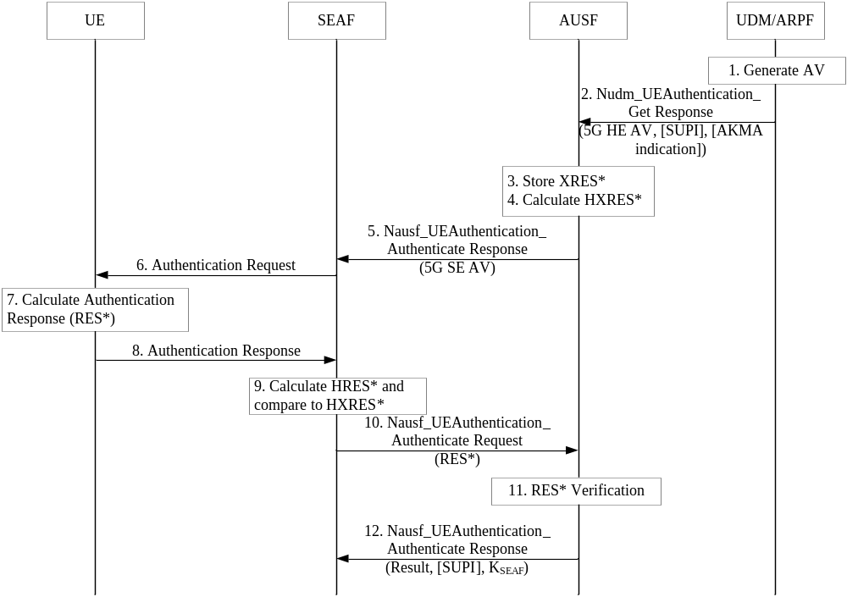
Figure 6.1.3.2-1: Authentication procedure for 5G AKA
The authentication procedure for 5G AKA works as follows, cf. also Figure 6.1.3.2-1:
1. For each Nudm_Authenticate_Get Request, the UDM/ARPF shall create a 5G HE AV. The UDM/ARPF does this by generating an AV with the Authentication Management Field (AMF) separation bit set to "1" as defined in TS 33.102 [9]. The UDM/ARPF shall then derive K_{AUSF} (as per Annex A.2) and calculate XRES* (as per Annex A.4). Finally, the UDM/ARPF shall create a 5G HE AV from RAND, AUTN, XRES*, and K_{AUSF}.
2. The UDM shall then return the 5G HE AV to the AUSF together with an indication that the 5G HE AV is to be used for 5G-AKA in a Nudm_UEAuthentication_Get Response. In case SUCI was included in the Nudm_UEAuthentication_Get Request, UDM will include the SUPI in the Nudm_UEAuthentication_Get Response.
If a subscriber has an AKMA subscription, the UDM shall include the AKMA indication in the Nudm_UEAuthentication_Get Response.
3. The AUSF shall store the XRES* temporarily together with the received SUCI or SUPI. 4. The AUSF shall then generate the 5G AV from the 5G HE AV received from the UDM/ARPF by computing the HXRES* from XRES* (according to Annex A.5) and K_{SEAF} from K_{AUSF}(according to Annex A.6), and replacing the XRES* with the HXRES* and K_{AUSF} with K_{SEAF} in the 5G HE AV.
5. The AUSF shall then remove the K_{SEAF} return the 5G SE AV (RAND, AUTN, HXRES*) to the SEAF in a Nausf_UEAuthentication_Authenticate Response.
6. The SEAF shall send RAND, AUTN to the UE in a NAS message Authentication -Request. This message shall also include the ngKSI that will be used by the UE and AMF to identify the K_{AMF} and the partial native security context that is created if the authentication is successful. This message shall also include the ABBA parameter. The SEAF shall set the ABBA parameter as defined in Annex A.7.1. The ME shall forward the RAND and AUTN received in NAS message Authentication Request to the USIM.
NOTE 2: The ABBA parameter is included to enable the bidding down protection of security features that may be introduced later.
7. At receipt of the RAND and AUTN, the USIM shall verify the freshness of the 5G AV by checking whether AUTN can be accepted as described in TS 33.102[9]. If so, the USIM computes a response RES. The USIM shall return RES, CK, IK to the ME. If the USIM computes a Kc (i.e. GPRS Kc) from CK and IK using conversion function c3 as described in TS 33.102 [9], and sends it to the ME, then the ME shall ignore such GPRS Kc and not store the GPRS Kc on USIM or in ME. The ME then shall compute RES* from RES according to Annex A.4. The ME shall calculate K_{AUSF} from CK||IK according to clause A.2. The ME shall calculate K_{SEAF} from K_{AUSF} according to clause A.6. An ME accessing 5G shall check during authentication that the "separation bit" in the AMF field of AUTN is set to 1. The "separation bit" is bit 0 of the AMF field of AUTN.
NOTE 3: This separation bit in the AMF field of AUTN cannot be used anymore for operator specific purposes as described by TS 33.102 [9], Annex F.
8. The UE shall return RES* to the SEAF in a NAS message Authentication Response.
9. The SEAF shall then compute HRES* from RES* according to Annex A.5, and the SEAF shall compare HRES* and HXRES*. If they coincide, the SEAF shall consider the authentication successful from the serving network point of view. If not, the SEAF proceed as described in sub-clause 6.1.3.2.2. If the UE is not reached, and the RES* is never received by the SEAF, the SEAF shall consider authentication as failed, and indicate a failure to the AUSF.
10. The SEAF shall send RES*, as received from the UE, in a Nausf_UEAuthentication_Authenticate Request message to the AUSF.
11. When the AUSF receives as authentication confirmation the Nausf_UEAuthentication_Authenticate Request message including a RES* it may verify whether the AV has expired. If the AV has expired, the AUSF may consider the authentication as unsuccessful from the home network point of view. Upon successful authentication, the AUSF shall store the K_{AUSF.} AUSF shall compare the received RES* with the stored XRES*. If the RES* and XRES* are equal, the AUSF shall consider the authentication as successful from the home network point of view.AUSF shall inform UDM about the authentication result (see sub-clause 6.1.4 of the present document for linking with the authentication confirmation).
12. The AUSF shall indicate to the SEAF in the Nausf_UEAuthentication_Authenticate Response whether the authentication was successful or not from the home network point of view. If the authentication was successful, the K_{SEAF} shall be sent to the SEAF in the Nausf_UEAuthentication_Authenticate Response. In case the AUSF received a SUCI from the SEAF in the authentication request (see sub-clause 6.1.2 of the present document), and if the authentication was successful, then the AUSF shall also include the SUPI in the Nausf_UEAuthentication_Authenticate Response message.
If the authentication was successful, the key K_{SEAF} received in the Nausf_UEAuthentication_Authenticate Response messageshall become the anchor key in the sense of the key hierarchy as specified in sub-clause 6.2 of the present document. Then the SEAF shall derive the K_{AMF} from the K_{SEAF}, the ABBA parameter and the SUPI value according to Annex A.7. The SEAF shall provide the ngKSI and the K_{AMF} to the AMF.
If a SUCI was used for this authentication, then the SEAF shall only provide ngKSI and K_{AMF} to the AMF after it has received the Nausf_UEAuthentication_Authenticate Response message containing SUPI; no communication services will be provided to the UE until the SUPI is known to the serving network.
The further steps taken by the AUSF after the authentication procedure are described in sub-clause 6.1.4 of the present document.
********** END OF 3rd CHANGE **********

********** START OF 4th CHANGE **********

6.2.2.1 Keys in network entities
Keys in the ARPF
The ARPF shall process the long-term key K and any other sensitive data only in its secure environment. The key K shall be 128 bits or 256 bits long.
During an authentication and key agreement procedure, the ARPF shall derive CK' and IK' from K in case EAP-AKA' is used and derive K_{AUSF} from K in case 5G AKA is used. The ARPF shall forward the derived keys to the AUSF.
The ARPF holds the Home Network Private Key that is used by the SIDF to deconceal the SUCI and reconstruct the SUPI. The generation and storage of this key material is out of scope of the present document.
Keys in the AUSF
In case EAP-AKA' is used as authentication method, the AUSF shall derive a key K_{AUSF} from CK' and IK' for EAP-AKA' as specified in clause 6.1.3.1. The K_{AUSF} may be stored in the AUSF between two subsequent authentication and key agreement procedures.
The AUSF shall generate the anchor key, also called K_{SEAF}, from the authentication key material received from the ARPF during an authentication and key agreement procedure.
Keys in the SEAF
The SEAF receives the anchor key, K_{SEAF}, from the AUSF upon a successful primary authentication procedure in each serving network.
The SEAF shall never transfer K_{SEAF} to an entity outside the SEAF. Once K_{AMF} is derived K_{SEAF} shall be deleted.
The SEAF shall generate K_{AMF} from K_{SEAF} immediately following the authentication and key agreement procedure and hands it to the AMF.
NOTE 1: This implies that a new K_{AMF}, along with a new K_{SEAF}, is generated for each run of the authentication and key agreement procedure.
NOTE 2: The SEAF is co-located with the AMF.
Keys in the AMF
The AMF receives K_{AMF} from the SEAF or from another AMF.
The AMF shall, based on policy, derive a key K'_{AMF} from K_{AMF} for transfer to another AMF in inter-AMF mobility. The receiving AMF shall use K'_{AMF} as its key K_{AMF}.
NOTE 3: The precise rules for key handling in inter-AMF mobility can be found in clause 6.9.3.
The AMF shall generate keys K_{NASint} and K_{NASenc} dedicated to protecting the NAS layer.
The AMF shall generate access network specific keys from K_{AMF}. In particular,
- the AMF shall generate K_{gNB} and transfer it to the gNB.
- the AMF shall generate NH and transfer it to the gNB, together with the corresponding NCC value.
The AMF may also transfer an NH key, together with the corresponding NCC value, to another AMF, cf. clause 6.9.
- the AMF shall generate K_{N3IWF} and transfer it to the N3IWF when K_{AMF} is received from SEAF, or when K’_{AMF} is received from another AMF.
Keys in the NG-RAN
The NG-RAN (i.e., gNB or ng-eNB) receives K_{gNB} and NH from the AMF. The ng-eNB uses K_{gNB} as K_{eNB}.
The NG-RAN (i.e., gNB or ng-eNB) shall generate all further access stratum (AS) keys from K_{gNB} and /or NH.
Keys in the N3IWF
The N3IWF receives K_{N3IWF} from the AMF.
The N3IWF shall use K_{N3IWF} as the key MSK for IKEv2 between UE and N3IWF in the procedures for untrusted non-3GPP access, cf. clause 11.
Figure 6.2.2-1 shows the dependencies between the different keys, and how they are derived from the network nodes point of view.

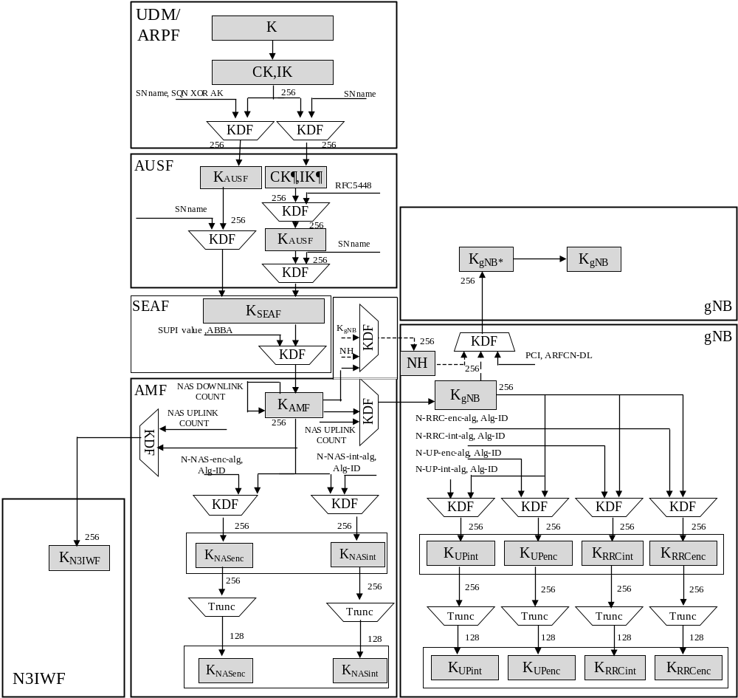

Figure 6.2.2-1: Key distribution and key derivation scheme for 5G for network nodes
NOTE 4: The key derivation and distribution scheme for standalone non-public networks, when an authentication method other than 5G AKA or EAP-AKA' is used, is given in Annex I.2.3.
********** END OF 4th CHANGE **********

********** START OF 5th CHANGE **********

6.2.2.2 Keys in the UE
For every key in a network entity, there is a corresponding key in the UE.
Figure 6.2.2-2 shows the corresponding relations and derivations as performed in the UE.

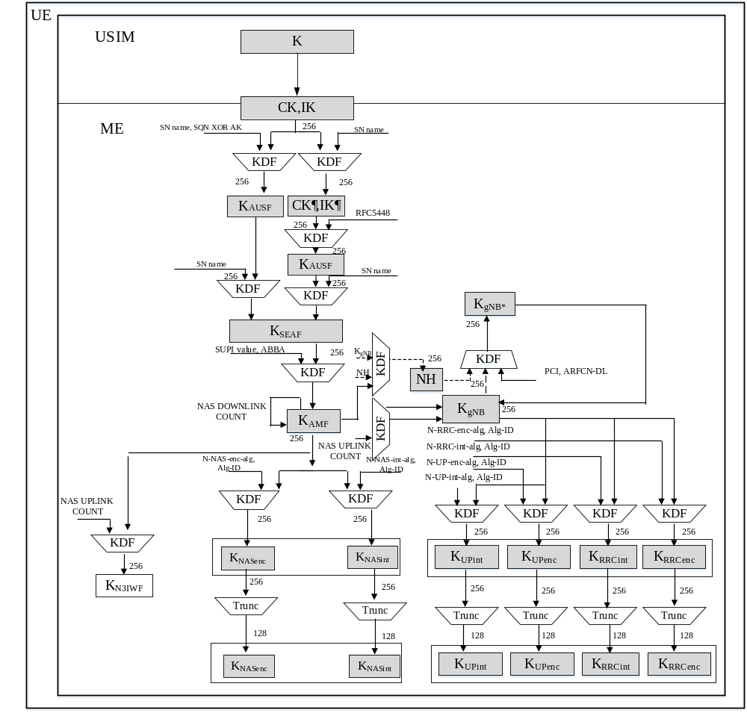
Figure 6.2.2-2: Key distribution and key derivation scheme for 5G for the UE
Keys in the USIM
The USIM shall store the same long-term key K that is stored in the ARPF.
During an authentication and key agreement procedure, the USIM shall generate key material from K that it forwards to the ME.
If provisioned by the home operator, the USIM shall store the Home Network Public Key used for concealing the SUPI.
Keys in the ME
The ME shall generate the K_{AUSF} from the CK, IK received from the USIM. The generation of this key material is specific to the authentication method and is specified in clause 6.1.3.
When 5G AKA is used, the generation of RES* from RES shall be performed by the ME.
The UE shall store the K_{AUSF} . If the USIM supports 5G parameters storage, K_{AUSF} shall be stored in the USIM. Otherwise, K_{AUSF} shall be stored in the non-volatile memory of the ME.
The ME shall perform the generation of K_{SEAF} from the K_{AUSF}. If the USIM supports 5G parameters storage, K_{SEAF} shall be stored in the USIM. Otherwise, K_{SEAF} shall be stored in the non-volatile memory of the ME.
The ME shall perform the generation of K_{AMF}. If the USIM supports 5G parameters storage, K_{AMF} shall be stored in the USIM. Otherwise, K_{AMF} shall be stored in the non-volatile memory of the ME.
The ME shall perform the generation of all other subsequent keys that are derived from the K_{AMF}.
Any 5G security context, K_{AUSF} and K_{SEAF} that are stored at the ME shall be deleted from the ME if:
a) the USIM is removed from the ME when the ME is in power on state;
b) the ME is powered up and the ME discovers that the USIM is different from the one which was used to create the 5G security context;
c) the ME is powered up and the ME discovers that there is no USIM is present at the ME.
NOTE 1: The key derivation and distribution scheme for standalone non-public networks, when an authentication method other than 5G AKA or EAP-AKA' is used, is given in Annex I.2.3.
********** END OF 5th CHANGE **********

