3GPP TSG SA WG2 Meeting #79 TD S2- 10xxxx
10 - 14 May 2010, Kyoto, Japan

Source: Sierra Wireless
Title: Broadcasting MTC Group Access Control for Overload Control
Document for: Approval/Discussion
Agenda Item: 9.7
Work Item / Release: NIMTC/Rel-10
Abstract of the contribution: This contribution introduces a solution for MTC requirements for Overload Control when caused by an identifiable group of MTC applications. This solution does not impact the operation of behaving MTC and non-MTC applications.
Discussion
SA2#78 introduced the key issue of signalling congestion control. Requirements were introduced to provide functionality to reduce the signalling load on the SGSN/MME and GGSN/PGW from a particular MTC Group and/or MTC application without affecting other customers (both MTC and non-MTC). Solutions were introduced to allow the SGSN/MME and/or GGSN/PGW to reject attachment or connection requests targeted at a particular MTC application that is causing the bulk of the signalling congestion.
However, during SA2#78, the concern was raised that rejecting an attachment or connection request may be too late if the impacted network node(s) are already overwhelmed with signalling and/or data traffic. The attachment or connection request to be rejected will add to the cumulative signalling. In some cases, requests to be rejected may not be handled due to a critical overload on one or more network node(s). This may cause the MTC Devices sending the requests to resend the requests again and again.
An additional solution that can greatly reduce the cumulative signalling and/or data congestion impact from a group of MTC Devices is to pre-emptively broadcast MTC access control restrictions targeted to the group of MTC Devices associated with the MTC application causing the bulk of the congestion. These access control restrictions can efficiently (i.e. 1-to-many signalling) stop and prevent cumulative congestion from the group of MTC Devices.
For signalling congestion, when the network determines an identifiable group of MTC Devices is in risk of congesting the network with abnormal signalling requests, an MTC Group access control restriction is broadcasted targeting the offending MTC Group. The restriction shall prevent additional signalling attempts from the targeted MTC Group for a minimum specified back-off time and randomization shall be used to determine when to start any initial access to the network before the expiration of the restriction.
For data congestion, when the network determines a significant number of MTC Devices of an identifiable group is exceeding a data traffic congestion policy limits for the group, an MTC Group access control restriction is broadcasted targeting the offending MTC Group to stop, throttle the rate or limit the duration of data traffic for each MTC Device of the group until the expiration of the restriction.
This solution has the advantage of allowing a higher watermark for signalling and data traffic loads than would be possible if only 1-to-1 signalling was used to reject or reduce the traffic from each MTC Device of the group. For signalling congestion, this is because the network does not need to reserve as much signalling resources for almost simultaneously rejecting requests from every MTC Device in the group. For data congestion, this is because the group of MTC Devices will reduce or suppress their overloading data traffic much faster than if 1-to-1 signalling was required to reach each device.
Though this solution employs broadcasting, it does not punish MTC Devices that are not members of the misbehaving group. However, the trade-offs are that the size of message to broadcast will be slightly larger, in order to include the MTC Group ID, and multiple sets of MTC Group access control information that may need to be broadcasted together if more than one MTC Group needs to be targeted simultaneously. The latter concern can be alleviated with broadcasting locally (e.g. only in RAN areas where MTC Devices of the specific group are known/expected to be) and with nested group IDs (e.g. All M2M ID, Electric Co ABC ID, Meter’s in Electric Co ABC ID).
Proposal
It is proposed to add the below text in 3GPP TR 23.888.
* * * First Change * * * *

Key Issue – Signalling Congestion Control

5.12.1 Use Case Description
MTC related signalling congestion is an urgent issue that network operators are currently facing. Not only network operators that are providing MTC services, but also network operators in which MTC Devices are roaming can be affected by MTC related signalling congestion.
MTC related signalling congestion can be caused by:
- a malfunctioning in the MTC application and/or MTC Server.
- an external event triggering massive numbers of MTC Devices to attach/connect all at once.
- recurring applications that are synchronised to the exact (half/quarter) hour.
Though some of the signalling congestion issues could be avoided if MTC applications behave more mobile network operator friendly, there is little a network operator can do to influence the application developers. It is important that the mobile network operator has the capability to control signalling network congestion independent of the application providers.
Signalling network nodes that may suffer from MTC related signalling congestion include all PS domain control plane nodes and gateways. With large scale attach requests, mainly the SGSN/MME is vulnerable. With connection requests, also the SGSN/MME is vulnerable as this node has a relative large load per connection request. GGSNs/PGWs are especially vulnerable as often M2M applications use a dedicated APN which will be terminated at one GGSN/PGW. All connection requests for that particular application will then have to be handled by a single GGSN/PGW.
In order to combat signalling congestion, network nodes shall be able to reject and prevent attach or connection requests. The challenge is to block the traffic of the particular MTC application(s) that is causing the congestion, without restricting non-MTC traffic or traffic from other MTC applications that are not causing a problem. A dedicated APN or a MTC Group Identifier are possible identifiers to indicate particular large scale MTC applications. How to identify applications that are causing recurring signalling congestion (e.g. mail applications, buddy finders, etc) that are often downloaded applications on a smart phone is still a challenge.
Care shall be taken that rejecting connection requests or attach requests does not result in a MTC Device immediately re-initiating the same request. The network should be able to instruct MTC Devices not to initiate a similar request until after a back off time. This back off time may also be used to instruct MTC Devices with recurring applications to change their timing of attach/connection requests.
Care shall be taken that preventing attachment or connection requests by a targeted group of MTC Devices does not immediately or sometime thereafter result in the same group of MTC Devices almost simultaneously attempting signalling or data interactions with the network. Randomization shall be applied to spread any resultant network access attempts by the group.

5.12.2 Required Functionality
- It shall be possible to reduce signalling load of connection requests for a specific APN or from MTC Devices belonging to a particular MTC Group on the SGSN/MME and/or GGSN/PGW.
- It shall be possible to reduce SGSN/MME signalling load of attach requests from MTC Devices belonging to a particular MTC Group.
- It shall be possible to prevent a MTC Device to repeatedly re-initiate a connection request or attach request.
- It shall be possible to reduce (quarter/half) hourly signalling peaks from recurring MTC applications
NOTE: The relation of this key issue with the key issue Time controlled is for further study especially regarding the treatment of MTC devices that are sending/signaling during their assigned time period is FFS. it is FFS whether overload control should affect the established PDP/PDN connections.
* * * Second Change * * * *

6.X Solution – Broadcasting MTC Group Access Control

6.X.1 Problem Solved / Gains Provided
See clause 5.12, “Key Issue – Signalling Congestion Control”

6.X.2 General
For signalling congestion, when the network determines an identifiable group of MTC Devices is in risk of congesting the network with abnormal signalling requests, an MTC Group access control restriction is broadcasted targeting the offending MTC Group. The restriction shall prevent additional signalling attempts from the targeted MTC Group for a minimum specified back-off time and randomization shall be used to determine when to start any initial access to the network before the expiration of the restriction.
For data congestion, when the network determines a significant number of MTC Devices of an identifiable group is exceeding a data traffic congestion policy limit for the group, an MTC Group access control restriction is broadcasted targeting the offending MTC Group to stop, throttle the rate or limit the duration of data traffic for each MTC Device of the group until the expiration of the restriction.
A MTC Group access control restriction can be triggered by the SGSN/MME and/or GGSN/PGW to target the MTC Devices using a particular APN or a particular MTC Group. When a MTC application uses a dedicated APN or MTC Group ID, the specific MTC application can thus be targeted. The RAN is responsible for managing and broadcasting received or internally triggered MTC Group access control restrictions as system information to the UEs.
Triggering
MTC Group access control restrictions could be triggered by signalling or data group congestion thresholds in the RAN, SGSN/MME and/or GGSN/PGW. In the case of the GGSN/PGW, the GGSN/PGW informs the SGSN/MME when a group congestion threshold is exceeded for a particular APN or a MTC Group ID. When a SGSN/MME needs to trigger a MTC Group access control restriction on its own or on the behalf of the GGSN/PGW, the SGSN/MME uses the set of RAs/TAs for which the MTC Devices of the MTC Group are currently registered in order to determine which RNS/BSC/eNodeBs to send the trigger to.
The request sent to each RAN should contain the targeted MTC Group ID, the minimum back-off time for signalling control, a stop order, a throttling rate or a duration limit for data control and expiration time of the restriction. As congestion eases, the restriction parameters can be reduced through successive MTC Group access control triggers.

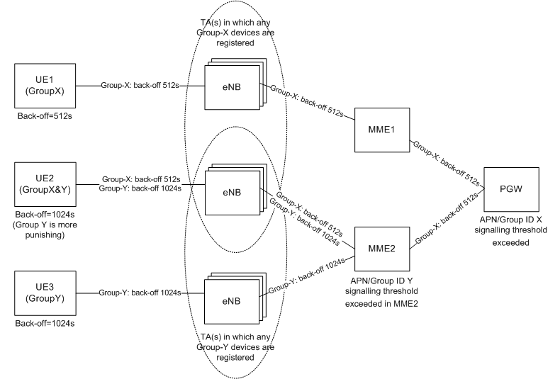
Figure 6.X.2-2: MTC Group Access Control triggering, broadcasting and acquisition
Broadcasting and Acquisition
The RAN receives MTC Group access control triggers from the SGSN/MME and may possibly determine a MTC Group access control restriction is required on its own (assuming the associated MTC Group ID(s) are reported from each MTC Device). When one or more unexpired MTC Group access control restrictions exist, the RAN sets a MTC Group Access Control bit transmitted in one of the highly frequent system information blocks (e.g. every ~200ms) broadcast to the UEs. This single bit quickly indicates to MTC Devices the set of unexpired MTC Group access control restrictions are broadcasting in a less frequent system information block (e.g. every ~2s) that contains the specifics of the current set of MTC Group access control restrictions. Non-MTC Devices can ignore the MTC Group Access Control bit altogether.
The RAN is responsible for managing the expiration of each triggered MTC Group access control restriction. The RAN shall stop transmitting a MTC Group Access Control restriction upon its expiration. The RAN is responsible for handling conflicting triggers from different network node(s) (i.e. for the same MTC Group ID). The RAN should broadcast the most punishing signalling and data traffic restrictions that have yet to expire for each MTC Group ID.
When the MTC Group Access Control bit is enabled, upon acquisition of the current set of MTC Group access control restrictions, the MTC Device will immediately adhere to all restrictions broadcasted for MTC Group ID(s) for which the MTC Device is associated with. Signalling traffic restrictions shall prevent additional signalling attempts from the MTC Device for a minimum specified back-off time and randomization shall be used to determine when to start any initial access to the network before the expiration of the restriction. Data traffic restrictions shall stop the MTC Device from transmitting data traffic until the expiration of the restriction, throttle the rate of data traffic from the MTC Device until the expiration of the restriction or limit the total duration of data traffic from the MTC Device until the expiration of the restriction.
When the MTC Device is associated with more than one MTC access control restriction, the MTC Device shall adhere to both the most punishing signalling restriction that has not expired and most punishing data restriction that has not expired. The MTC Device should continue to monitor and comply with any changes to the current set of broadcasted restrictions associated with the MTC Device.

6.X.3 Impacts on existing nodes or functionality

6.X.4 Evaluation
* * * End of Change * * * *

