SA WG2 Meeting #161 S2-2402944
February 26 – March 1, 2024, Athens

Source: CableLabs
Title: KI#4: New Sol: Policy Control of individual non-3GPP devices behind a UE/5G-RG
Document for: Approval
Agenda Item: 19.8
Work Item / Release: FS_UIA_ARC / Rel-19
Abstract: This paper proposes a solution for KI #4: Identifying non-3GPP Devices Connecting behind a UE or RG (5G-RG).

Introduction
TR 23.700-32 includes KI#4 agreed in SA2#160-AH-e as follows:

5.4 Key Issue #4: Identifying non-3GPP Devices Connecting behind a UE or RG (5G-RG)

5.4.1 Description
This key issue will study whether and how 5GC identifies individual non-3GPP devices connecting behind a UE or 5G-RG and whether and how to provide policy control for the traffic associated with individual non-3GPP devices.
The use case that is associated with this key issue is the case where non-3GPP devices behind a UE or 5G-RG need to be identified.
The objective of this key issue is how an identifier is used by the network to control the traffic to/from UE or 5G-RG when the traffic is associated with the non-3GPP devices. This objective differs from existing support for AUN3 devices in TS 23.316 [7] because the objective is to enable the non-3GPP devices to be identified and to use only the subscription of the UE or 5G-RG to access the 5GC (i.e. the UE or 5G-RG should have to maintain only a NAS Context itself and not for each non-3GPP device).
Solutions to this key issue will address:
- whether and how the 5GC identifies individual non-3GPP devices connecting behind a UE or 5G-RG. (e.g. in order to charge the individual non-3GPP devices),
- whether and how to provide policy control for the traffic of individual non-3GPP devices connecting behind a UE or 5G-RG. Including whether and how to trigger policy control for the traffic of individual non-3GPP devices via PCF and NEF APIs, including whether and how to support concurrent services with differing QoS requirements launched by the different non-3GPP devices.
Editor's note: It is FFS whether to include "whether and how the operator restricts the number of simultaneously active non-3GPP devices per SUPI (i.e. per subscription) " in this key issue.
NOTE 1: Changes to the layer 1 or layer 2 protocols of non-3GPP devices are not in scope of this study. 5G authentication for non-3GPP devices behind 5G-RG is not assumed in this study.
NOTE 2: Conclusions related to an 5G-RG should be shared with the Broadband Forum (BBF) and CableLabs.
NOTE 3: Solutions for Ethernet PDU Session should work in the presence of randomized MAC addresses.

2. Proposal
This contribution proposes to include Solution X in TR 23.700-32 clause 6.X and to update Table 6.0-1 accordingly.
Start of changes

2 References
The following documents contain provisions which, through reference in this text, constitute provisions of the present document.
- References are either specific (identified by date of publication, edition number, version number, etc.) or non-specific.
- For a specific reference, subsequent revisions do not apply.
- For a non-specific reference, the latest version applies. In the case of a reference to a 3GPP document (including a GSM document), a non-specific reference implicitly refers to the latest version of that document in the same Release as the present document.
[1] 3GPP TR 21.905: "Vocabulary for 3GPP Specifications".
[2] 3GPP TS 22.101: "Service aspects; Service principles".
[3] 3GPP TS 22.115: "Service aspects; Charging and billing".
[4] 3GPP TS 23.501: "System Architecture for the 5G System (5GS); Stage 2".
[5] 3GPP TS 23.502: "Procedures for the 5G System; Stage 2".
[6] 3GPP TS 23.503: "Policy and charging control framework for the 5G System (5GS); Stage 2".
[7] 3GPP TS 23.316: "Wireless and wireline convergence access support for the 5G System (5GS)".
[x] Liaison Statement from IEEE 802.11 Working Group to Wireless Broadband Alliance, https://www.ieee802.org/11/Liaisons/2024-01-04-Liaison%20statement%20from%20IEEE%20802-11%20Working%20Group%20to%20WBA%20re%20P802.11bh.pdf
Next change

6.0 Mapping of Solutions to Key Issues
Table 6.0: Mapping of Solutions to Key Issues
Solutions
 | <Key Issue #1> | <Key Issue #2> | <Key Issue #3> | Key Issue #4
#1
#2
#X |  |  |  | X

Start of next change (all new text)

6.X Solution #X: RG-initiated PDU Modification to support differentiated QoS for device behind RG

6.X.1 Key Issue mapping
This solution addresses Key Issue #4 on how to provide policy control of individual non-3GPP device behind a UE or 5G-RG.
5GC may have information on a QoS policy applied to a non-3GPP device behind a 5G-RG or UE where a User Identifier is used between 5GC and the 5G-RG/UE to identify the QoS policy, and maps that policy to non-3GPP access between the non-3GPP device and the 5G-RG/UE. 5GC may store the QoS policy based on network exposure with an external operator portal or AF.

6.X.2 Description

Rel-18 WWC study/work item identified and specified a solution to handle non-3GPP devices behind 5G-RG based on Connectivity Group IDs, where a Connectivity Group ID is applied based on a SSID or Ethernet port. Typically, there are only a few SSIDs available (e.g., SSID#1 for home devices and SSID#2 for guest devices), thereby leading to certain limitations in Rel-18 features to allow providing different QoS/parental control over devices sharing a same SSID.
To provide differentiated QoS provisioning for non-3GPP devices behind a 5G-RG/UE, 5G-RG/UE should be able to identify individual non-3GPP devices as well as 5GC should be able to provision separately for individual non-3GPP device. To allow separate provision by 5GC for each non-3GPP device, a User Identifier (for non-3GPP devices) is necessary, where the User Identifier may be different from a MAC address of the non-3GPP device. Various known implementation techniques such those based on OpenWrt or CableLabs Micronets could be considered for a User Identifier/identification. In recent progress in IEEE 802.11bh working group (D1.0 draft) [x] to support various use cases with randomized MAC addresses, IEEE identified two solutions, namely, device ID and identifiable random MAC address (IRM). Using device ID mechanism, a 5G-RG or UE may provide an identifier to a non-3GPP device that may be used by the non-3GPP device where the device ID is constant in ESS regardless of the MAC address used by the non-3GPP device. Using IRM, a non-3GPP device may provide a random MAC address to a 5G-RG or a UE where the IRM MAC address will be used as transmitted address. For example, when the device ID mechanism is used, the device ID may be used as a User Identifier of the non-3GPP device. When IRM is used, the operator may assign a User Identifier of the non-3GPP device that is associated with a current IRM address and is updated by the 5G-RG or the UE when changes occur. Another example of a User Identifier is based on EAP credentials if a non-3GPP device supports EAP authentication, where EAP authentication may be performed outside of 5GC.
Such a User Identifier known to a 5G-RG or UE will be mapped to the local non-3GPP device information (e.g., device ID or current MAC address by 802.11bh, or credentials used in WLAN) by the 5G-RG or UE, though the exact mechanisms of how the 5G-RG maps the User Identifier to local non-3GPP device information would be implementation-specific or operator-choice, which are outside of 3GPP scope.
To support this, however, the 5G-RG is pre-configured with or receives policy from the 5GC on QoS policy for non-3GPP devices, where the QoS policy for each non-3GPP device has the following information:
- QoS parameters for the device (e.g., bit rate requirements)
- User Identifier
Based on non-3GPP device identification by the 5G-RG or UE, a separate QoS flow can be configured for each non-3GPP device. Based on Rel-18 feature of Connectivity Group IDs, a group of non-3GPP devices may share a same connectivity group e.g., based on SSID. The 5G-RG may establish a separate PDU session for each connectivity group. Each device in each connectivity group may be further differentiated based on separate QoS flow as shown in Figure 6.X.2-1.
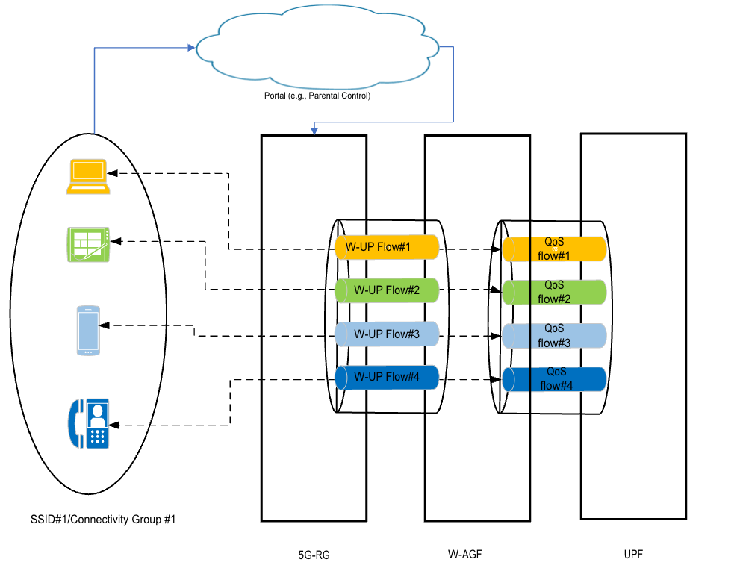
Figure 6.X.2-1: Differentiated QoS for each non-3GPP device

6.X.3 Procedures
The procedure for the provisioning of non-3GPP device information is shown below:

Fig. 6.X.3-1 High-level procedure of the solution for W-AGF and 5G-RG

0: A policy for a non-3GPP device may be registered to an operator portal (e.g., via AF, register parental control for kids iPad). During the policy registration, a User Identifier of the non-3GPP device is determined (e.g., either by assigning by operator portal or 5G-RG provides the User Identifier) and stored in a 5G-RG associated with the non-3GPP device. For example, based on a device ID technique, the non-3GPP device and the 5G-RG use the device ID which maps to the User Identifier in the operator portal for future communications. In case IRM is used, the 5G-RG maintains a random MAC address to the User Identifier so that when the non-3GPP device uses a random MAC address, the 5G-RG identifies the non-3GPP device and maps it to the User Identifier. The 5G-RG information would be known to the operator portal (e.g., 5G-RG GPSI is known to the operator portal).
0a-0c: Upon creating a policy for the non-3GPP device, the operator portal or AF updates the policy associated with the 5G-RG based on the policy configuration via NEF procedure (e.g., extending Service specific parameter procedure in clause 4.15.6.7 of TS 23.502 [5] for non-3GPP policy information). If AF or the operator portal is trusted or within the PLMN domain, AF or the operator portal may directly communicate with the PCF without NEF. This step may be optional such that UDR may not maintain policy information for non-3GPP devices. In this case, step 5-6 may be replaced by procedure in clause 4.16.5.1 of 23.502 [5].
These steps may occur before the non-3GPP is being provisioned by the 5GC, and this step may occur once.
- The 5G-RG registers to 5GC as specified in clause 7.2.1.1 of TS 23.316 [7].
- The non-3GPP device establishes L2 connection (e.g., WLAN connection) to the 5G-RG.
- The non-3GPP device is authenticated via local authentication (e.g., PKS). The non-3GPP device may be authenticated using EAP authentication via external EAP-server depending on the device capability.
During steps 2-3, 5G-RG maps the non-3GPP local information (e.g., a current MAC address) to the User Identifier. 5G-RG detects the non-3GPP device with the User Identifier is connected.
4-8. PDU session modification procedure based on clause 4.3.2.2 of TS 23.502 [5] with addition of indication of User Identifier and device info (such as IP address of the device) to apply appropriate QoS flow to the non-3GPP device.

6.X.4 Impacts on services, entities and interfaces
NEF:
- Extensions to the NEF Service Parameter Service to allow an AF to provision non-3GPP device information.
UDR:
- Extensions to the Application Data in UDR to store non-3GPP device information (e.g., User Identifier, policy for non-3GPP).
PCF:
- Ability to retrieve non-3GPP device information from UDR and take it into account for policy decisions.
It is assumed that the 5G-RG can identify a device behind it based on an implementation solution or a solution outside of 3GPP scope.
End of changes

