3GPP TSG-SA WG2#161 S2-2402099
Athens, Greece, 26 Feb - 1 Mar 2024 (was S2-24)

Source: Xiaomi
Title: KI#1, New solution: N3 backhaul PDU session management
Document for: Approval
Agenda Item: 19.6
Work Item / Release: FS_VMR_Ph2 / Rel-19
Abstract of the contribution: This contribution proposes a new solution on N3 backhaul PDU session management for Study on architecture enhancements for vehicle-mounted relays Phase 2.

1. Discussion
Based on the definition of mobile gNB with wireless access backhaul, MWAB provides wireless connection to the 5GC through an IP connectivity provided by a PDU session; hence, both N2 interface and N3 interface are carried over the PDU session(s) between MWAB-UE and 5GC.
mobile gNB with wireless access backhaul: A mobile base station acts as a gNB for other UEs and provide access to the 5G networks, i.e., providing a NR access link to UEs and connected wirelessly to the 5GC (using NR) through an IP connectivity provided by a PDU sessions established via a NG-RAN cell that the mobile gNB can camp on. The PDU session is provided either by a Terrestrial Network or by a Non-Terrestrial Network. Such mobile gNB may be mounted on a moving vehicle and serve UEs that can be located inside or outside the vehicle (or entering/leaving the vehicle).
At least one PDU session is established between MWAB-UE and 5GC for both N2 interface and N3 interface:
- Single PDU session for both N2 and N3 if serving AMF and serving UPF of the MWAB-UE are in the same DNN
- PDU session(s) for N2 and PDU session(s) for N3 are separated.
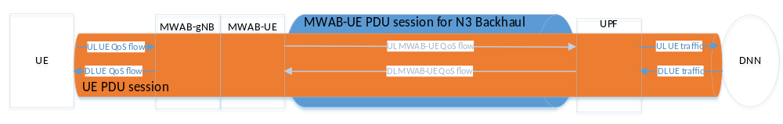
Figure 1: UE PDU session mapping to the MWAB-UE PDU session
As shown in Figure 1, the UE PDU session is carried over MWAB-UE PDU session for N3 backhaul, thus they need to share common characteristics, e.g. S-NSSAI(s), DNN, PDU Session Type, SSC mode, etc. Additionally, the UE QoS flow andthe MWAB-UE QoS flow have to be mapped to each other for the transmission to/from 5GC over MWAB-UE Uu interface and over UE Uu interface.
This paper proposes solutions on how to manage the N3 backhaul PDU session for KI#1.

2. Text proposal
It is proposed to agree the following changes to TR 23.700-06:

* * * * First change * * * *

2 References
The following documents contain provisions which, through reference in this text, constitute provisions of the present document.
- References are either specific (identified by date of publication, edition number, version number, etc.) or non-specific.
- For a specific reference, subsequent revisions do not apply.
- For a non-specific reference, the latest version applies. In the case of a reference to a 3GPP document (including a GSM document), a non-specific reference implicitly refers to the latest version of that document in the same Release as the present document.
[1] 3GPP TR 21.905: "Vocabulary for 3GPP Specifications".
[2] 3GPP TS 23.501: "System Architecture for the 5G System; Stage 2".
[3] 3GPP TS 22.261: "Service requirements for the 5G system; Stage 1".
[4] 3GPP TS 38.300: "NR; NR and NG-RAN Overall Description".
[5] 3GPP TS 38.401: "NG-RAN Architecture description".
[6] 3GPP TS 23.273: "5G System (5GS) Location Services (LCS); Stage 2".
[X] 3GPP TS 23.502: "Procedures for the 5G System (5GS); Stage 2".
[Y] 3GPP TS 23.503: " Policy and charging control framework for the 5G System (5GS) ; Stage 2".

* * * * Next change * * * *

6.0 Mapping of solutions to key issues
Editor's note: This clause describes the mapping between solutions and key issues.
 | Key Issues
Solutions | 1 | 2 | 3 | 4 | 5 | 6
X | X

* * * * Next change (All new text) * * * *

6.X Solution #X: N3 backhaul PDU session management

6.X.1 General
This solution is to address KI#1 about how to provide the backhaul link using a PDU sessions for a MWAB to support the N3 interfaces.
MWAB provides wireless connection to the 5GC through an IP connectivity provided by a PDU session; hence, both N2 interface and N3 interface are carried over the PDU session(s) between NWAB-UE and 5GC.
At least one PDU session is established between NWAB-UE and 5GC for both N2 interface and N3 interface depending on the configuration of the MWAB:
- Single b/h PDU session for both N2 and N3
- Multiple b/h PDU session(s) for N2 and PDU session(s) for N3
The PDU sessions of the UEs served by a MWAB are carried over b/h PDU session(s) for N3 backhaul. It is in order to define how the PDU sessions of the UEs and the QoS flows of these PDU sessions are optimally supported by the b/h PDU sessions (e.g. in terms of QoS)

6.X.2 Functional descriptions
This solution assumes that
- MWAB-UE PDU session for N2 backhaul is already established
- One or multiple MWAB-UE PDU session(s) for N3 backhaul is already established, or has not been established. Each MWAB-UE PDU session is associated with the default 5QI and ARP of the QoS Flow associated with the default QoS rule as defined in clause 6.4 of TS 23.503[Y].

For the UL UE traffic, the UE PDU received at MWAB-gNB (i.e. the UE QoS flow) is bound to the MWAB-UE QoS flow (and/or b/h PDU session). The MWAB binds the UE QoS flow to a b/h PDU session based on the UE requested PDU session and the QoS flow characteristics:
- If there is an existing b/h PDU session which is suitable to support the UE PDU session and its QoS flows characteristics, this b/h PDU session is selected and the UE UL PDU session is bound to this b/h PDU session.
- If no existing b/h PDU session suitable, a new b/h PDU session is established based on the UE PDU session and its QoS flows characteristics UEcharacteristics. Alternatively, an existing b/h PDU session is modified to accommodate the new PDU session or QoS flow.
For the DL UE traffic, the UE PDU received at MWAB-UPF (i.e. the UE QoS flow) is bound to the MWAB-UE QoS flow (and/or b/h PDU session). The MWAB-UPF binds the UE QoS flow to a b/h PDU session based on the UE requested PDU session and the QoS flow characteristics:
- If there is an existing b/h PDU session which is suitable to support the UE PDU session and its QoS flows characteristics, this b/h PDU session is selected and the UE UL PDU session is bound to this b/h PDU session.
- If no existing b/h PDU session suitable, a new b/h PDU session is established based on the UE PDU session and its QoS flows characteristics UEcharacteristics. Alternatively, an existing b/h PDU session is modified to accommodate the new PDU session or QoS flow.
Editor’s note; The establishment/modification of MWAB-UE PDU session(s) for N3 backhaul is triggered by the establishment/modification of UE PDU session. How it is triggered and the detail steps are FFS.
Editor’s note; What and how the UE QoS flow characteristics are obtained by the MWAB and MWAB-UPF are FFS.

- 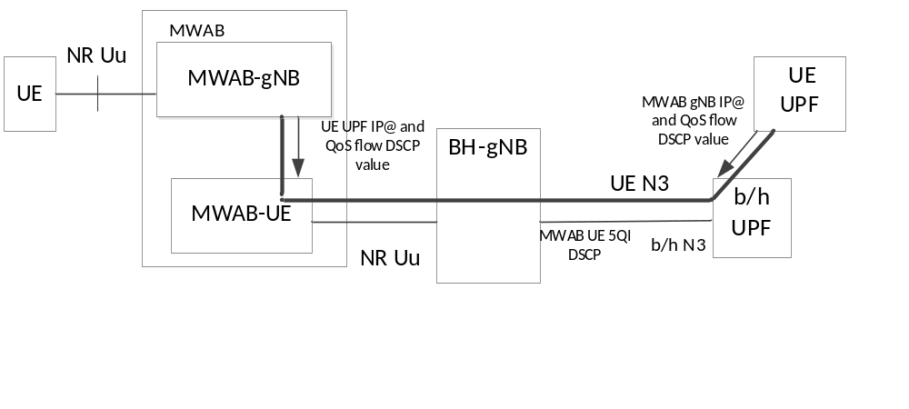
- Figure 6.x.2-1: mapping of QoS flows at MWAB and at B/H UPF
Figure 6.x.2-1 shows that the UE traffic for a specific QoS flow of a UE PDU sessions is carried in GTP-U tunnels for UL and DL that are associated with DSCP values and IP@ of UE UPF (for UL) and IP address of MWAB-gNB (for DL). The DSCP value can be identified at the MWAB-gNB based on policy related to information the MWAB-gNB has in the SM context for the PDU session. The MWAB gNB then requests the MWAB-UE to perform a modification of the b/h PDU session with a specific 5QI/ARP and other QoS parameters that are suitable to handle the SDF of the DL traffic identified by the traffic associated with the IP@ of the MWAB-gNB. This provides the b/h UPF with the packet classification rules it needs to map the DL traffic from the UE UPF to the right QoS flow on the b/h PDU session.

6.X.3 Procedures

6.X.3.1 Handling of a UE PDU session establishment or modification
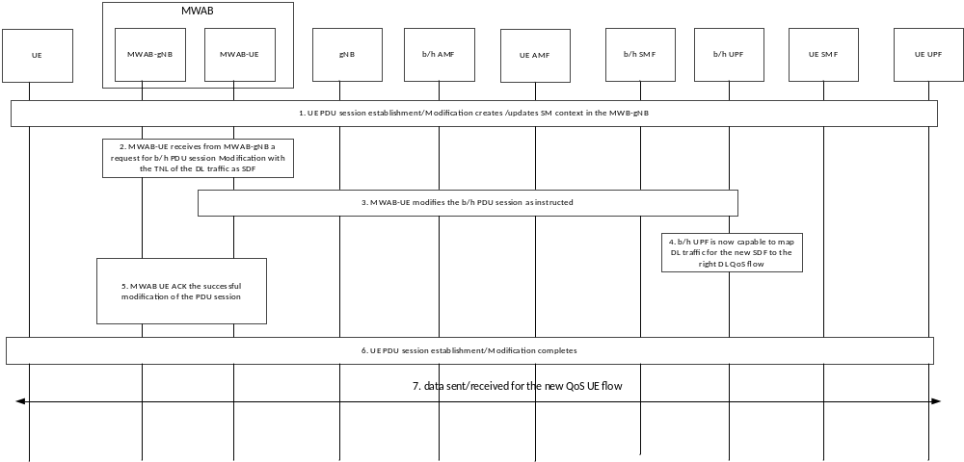

Figure 6.x.3.1-1: handling of a UE PDU session establishment or modification
1. A PDU session is established or modified for a UE as defined in clause 4.3 of TS 23.502 [X], and this causes the MWAB-gNB to receive from SMF a new SM context for a PDU session including at least a QoS flow.
2. For each QoS flow the MWAB-gNB determines the required 5QI/ARP and other QoS parameters in the b/h PDU session and TNL to be used to signal to the b/h SMF the SDF for the QoS rules related to this SDF for DL. For UL the QoS rules are also determined by MWAB and the TNL information determined at the MWAB-gNB is used to classify in UL.
Editor’s note; At which step of UE PDU session establishment/modification MWAB-gNB is triggered to bind UE PDU to the MWAB-UE QoS flow is FFS.
Editor’s note; How 5QI/ARP of the MWAB-UE QoS flow is determined is FFS. How QoS rules of the MWAB-UE is determined is FFS.
Editor’s note; How TNL is determined and is provided to the MWAB is FFS.
3. The MWAB-UE modifies the b/h PDU session as instructed.
4. The UPF of the b/h PDU session is now ready to correctly process DL traffic from the UE UPF.
Editor’s note; How UPF of the b/h PDU session maps DL traffic from the UE UPF to the WMAB-UE QoS flow is FFS.
5. The MWAB-UE acks the correct modification of the b/h PDU session.
6. The MWAB-gNB can complete the establishment of the PDU session.
7. The data for the UE PDU session can be sent/received with the right QoS.

6.X.4 Impacts on services, entities, and interfaces

- MWAB: The MWAB binds the UE QoS flow to a b/h PDU session based on the UE requested PDU session and the QoS flow characteristics
b/h UPF: The b/h UPF binds the UE QoS flow to a b/h PDU session based on the UE requested PDU session and the QoS flow characteristics:

* * * * End of change * * * *

