SA WG2 Meeting #161 - Athens S2-2403250
February 26 – March 1, 2024, Athens (was S2-2402945)

Source: CableLabs
Title: Update Architectural Assumptions for ATSSS_Ph4
Document for: Approval
Agenda Item: 19.13
Work Item / Release: FS_MASSS / Rel-19
Abstract: This pCR proposes updating Architectural Assumptions for ATSSS_Ph4 to include the scenario of a UE behind RG accessing the 5GC via TNGF or N3IWF within the scope of this study.

1. Introduction
Clause 4.10 of TS 23.316 describes the scenario wherein a UE behind a RG connects to the 5GC via N3IWF or TNGF –
An RG connecting via W-5GAN or NG-RAN access towards 5GC can provide connectivity for a UE behind the RG to access an N3IWF or TNGF. It is assumed that the UE is 5GC capable, i.e. supports untrusted non-3GPP access and/or trusted non-3GPP access. This allows the RG, W-5GAN and the RG's connectivity via 5GC to together act as untrusted/trusted N3GPP access to support UEs behind the RG.
Figure 4.10-1 shows the non-roaming architecture for a UE, behind a 5G-RG, accessing the 5GC via TNGF where the combination of 5G-RG, W-5GAN and UPF serving the 5G-RG is acting as a trusted Non-3GPP access network.
Figure 4.10-1: Non-roaming architecture for UE behind 5G-RG using trusted N3GPP access
The UE can be connected to 5GC via trusted non-3GPP access with 5G-RG acting as TNAP, NG-RAN or via both accesses.
Figure 4.10-2a shows the non-roaming architecture for a UE, behind a FN-RG, accessing the 5GC via N3IWF.
Figure 4.10-2a: Architecture for UE behind FN-RG using untrusted N3GPP access
Figure 4.10-2b shows the non-roaming architecture for a UE, behind a 5G-RG, accessing the 5GC via N3IWF.
Figure 4.10-2b: Architecture for UE behind 5G-RG using untrusted N3GPP access
The UE can be connected to 5GC via untrusted non-3GPP access with FN-RG/5G-RG acting as WLAN access point, NG-RAN or via both accesses.
Key Issue #2.2 in TR 23.700-54 studies whether and how to define a functional architecture and procedures for steering, switching, and splitting of traffic not utilizing the TNGF/N3IWF as specified in Rel-18 and earlier releases to simplify the network operation over non-3GPP access, without compromising the security of the 5G network.
A UE could be connected to 5GC via 3GPP access and non-3GPP access, and the non-3GPP access could include either WLAN access connected via N3IWF or TNGF to the 5GC, or wireline access (and a UPF) connected via N3IWF and TNGF to the 5GC as shows in Figure 1.
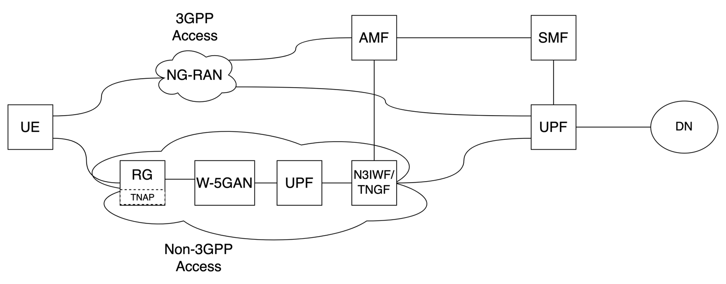
Figure 1: UE connected to 5GC through wireline access via N3IWF/TNGF
Since the scenario of a UE behind RG accessing the 5GC via N3IWF and TNGF has been specified pre-Rel-19, the study in Rel-19 to study alternative architectures not utilizing current N3IWF/TNGF needs to include this scenario within its scope. If this scenario is not included within the scope of this study, the UE might have to support different features in different scenarios. For example, if the study concludes on a solution which eliminates IPsec between the UE and N3IWF/TNGF, and if the UE behind RG scenario is not considered, the UE might need to support IPsec when connected to RG and not support IPsec in other scenarios. Therefore, in order to have a uniform and holistic architecture that works for all different scenarios, the study should consider the UE behind RG connecting to 5GC via N3IWF/TNGF scenario.
The intention behind adding this scenario is not to increase the scope of the study, no specific solutions for this scenario are envisioned. Only consideration for this scenario when solutions are being discussed/concluded and replicating any potential normative work for this scenario.

2. Proposal
This contribution proposes updates to Architectural Assumptions for ATSSS_Ph4 in TR 23.700-54 clause 4.1.2.
Start of changes

4.1.2 Architectural Assumptions for ATSSS_Ph4
The following general assumptions apply:
- The Rel-18 ATSSS as specified in TS 23.501 [3], TS 23.502 [4], and TS 23.503 [5] are regarded as the baseline for this study.
The following assumptions apply to alternative architecture and system level enhancements for ATSSS that do not require the existing non-3GPP interworking/gateway function:
- Current Non-3GPP InterWorking Function (N3IWF) and Trusted Non-3GPP Gateway Function (TNGF) are not used to simplify the operation over non-3GPP access.
- A UE behind RG accessing the 5GC via current TNGF or N3IWF is considered within the scope of the study. Any alternative architecture and system level enhancements would also be applicable for a UE behind an RG.
The following assumptions apply to MPQUIC for non-UDP traffic:
- Any new steering functionality shall be based on the multipath extensions of the QUIC protocols as defined in IETF.
- All ATSSS steering functionalities (existing and new) shall reside in the UE and in an UPF. Steering functionalities outside either of the UE or the UPF are not considered.
- Any new ATSSS capabilities specified for UE would be applicable for ATSSS-capable 5G-RGs, if endorsed by BFF and/or CableLabs; FN-RG are not in the scope of the study.

End of changes

