3GPP SA WG2 Meeting #161 S2-2403398
26 Feb - 01 Mar, 2024, Athens, GR (was S2-2402667)
Source: Intel
Title: KI#2, New Sol: Layer-3 multi-hop Relay based on MANET
Document for: Approval
Agenda Item: 19.7
Work Item / Release: FS_5G_ProSe_Ph3 / Rel-19
Abstract of the contribution: This paper proposes a new solution addressing KI#2.

1 Discussion
KI#2 is defined in TR 23.700-03 as follows:

5.2 Key Issue #2: Support of Layer-3 multi-hop UE-to-UE Relays

5.2.1 General description
This key issue focuses on architecture enhancements to support ProSe multi-hop Layer-3 UE-to-UE Relay over NR PC5 reference point. This key issue intends to support multi-hop Layer-3 UE-to-UE Relays for in coverage and out of coverage operation.
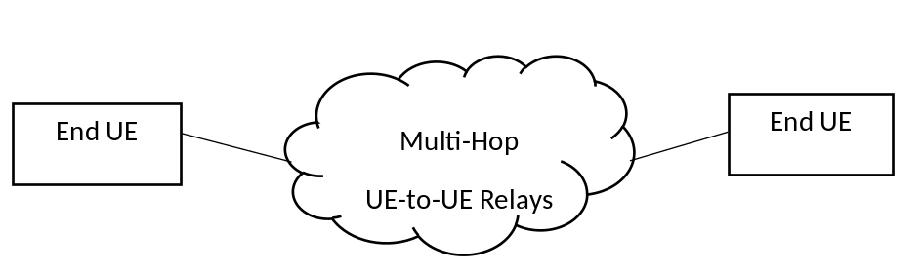
Figure 5.2.1-1: Example scenario of support of Layer-3 multi-hop UE-to-UE Relay
Aspects such as support for relay discovery, selection, authorization, connection establishment and data transfer for single hop ProSe UE-to-UE Relay have been addressed in previous releases and some of those aspects may need to be enhanced to support multi-hop extension. In Release 19, at least the following aspects need to be studied in potential solutions:
- Whether and how to enhance the existing mechanisms for multi-hop UE-to-UE Relay discovery.
- Whether and how to enhance the existing mechanisms for IP address/prefix allocation.
- Whether and how to control the maximum number of hops supported when using multi-hop UE-to-UE relays.
- Whether and how to support path changes or Relay (re)selections, e.g., in the case one or more UE-to-UE Relays become unavailable/suitable.
- Whether and how to support the network control 5G ProSe multi-hops UE-to-UE Relay operations, including at least, authorization, policy and parameters provisioning etc.
- How to manage multi-hop PC5 links, at least including how to establish, modify and release Layer-2 link over PC5 reference point for multi-hop UE-to-UE Relays.
- How to establish the connection between source UE and target UE via multiple 5G ProSe UE-to-UE Relays.
- How to satisfy end-to-end QoS requirements for the End UEs over the path via 5G ProSe multi-hop UE-to-UE Relays, if needed.

2 Proposal
It is proposed to agree the proposed solution for inclusion in TR 23.700-03.

*** BEGIN CHANGES ***

2 References
The following documents contain provisions which, through reference in this text, constitute provisions of the present document.
- References are either specific (identified by date of publication, edition number, version number, etc.) or non-specific.
- For a specific reference, subsequent revisions do not apply.
- For a non-specific reference, the latest version applies. In the case of a reference to a 3GPP document (including a GSM document), a non-specific reference implicitly refers to the latest version of that document in the same Release as the present document.
[1] 3GPP TR 21.905: "Vocabulary for 3GPP Specifications".
[2] 3GPP TR 23.752: "Study on system enhancement for Proximity based Services (ProSe) in the 5G System (5GS)".
[3] 3GPP TR 23.700-33: "Study on system enhancement for Proximity based Services (ProSe) in the 5G System (5GS); Phase 2".
[4] 3GPP TS 23.304: "Proximity based Services (ProSe) in the 5G System (5GS)".
[5] 3GPP TS 22.278: "Service requirements for the Evolved Packet System (EPS); Stage 1".
[6] 3GPP TS 22.261: "Service requirements for next generation new services and markets; Stage 1".
[7] 3GPP TS 22.115: "Service aspects; Charging and billing; Stage 1".
[8] 3GPP TS 23.501: "System Architecture for the 5G System; Stage 2".
[xx] IETF RFC 7181: "The Optimized Link State Routing Protocol Version 2".
[yy] IETF RFC 6130: "Mobile Ad Hoc Network (MANET) Neighborhood Discovery Protocol (NHDP)".
[zz] IETF RFC 5444: "Generalized Mobile Ad Hoc Network (MANET) Packet/Message Format".

*** NEXT CHANGE ***

6.X Solution #X: Layer-3 Multi-hop Relay based on MANET

6.X.1 Key Issue mapping
This solution primarily addresses Key Issue #2 (Support of Layer-3 multi-hop UE-to-UE Relays).
Some considerations are also provided for addressing Key Issue #1 (Support of multi-hop UE-to-Network Relays).

6.X.2 Description
The solution assumes that the Multi-hop ProSe UE-to-UE Relays have a collocated MANET router functionality (IETF RFC 7181 [xx]) that connect with neighbouring MANET routers and establish a mobile ad-hoc network as defined in MANET (IETF RFC 7181 [xx]). The Multi-hop ProSe UE-to-UE Relay relies on a new MANET messages (formatted according to IETF RFC 5444 [zz]) to exchange information about discovered ProSe End UEs. ProSe UE-to-UE Relays also exchange point-to-point signalling messages (related to ProSe Direct Communication establishment and release) with each other over the MANET.
Depicted in Figure 6.X.2-1 is a simple MANET network consisting of five routers (A, B, C, D and E). The participating routers establish links with neighbouring routers and perform the MANET Neighborhood Discovery Protocol (NHDP) by exchanging Hello messages with each adjacent MANET router as defined in IETF RFC 6130 [yy]. The Hello messages are enhanced as defined in the Optimized Link State Routing Protocol Version 2 specification (IETF RFC 7181 [xx]).
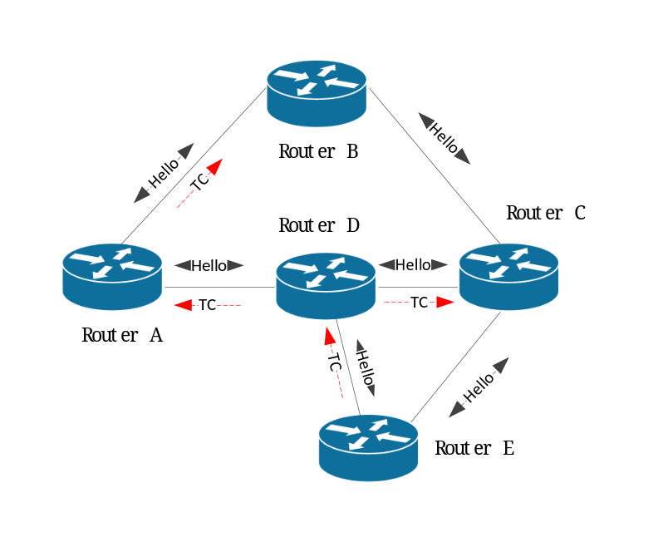
Figure 6.X.2-1: MANET network
Based on the information exchanged in the Hello messages, the participating routers may select a set of “flooding multi-point relays” (flooding MPRs) and a set of “routing multi-point relays” (routing MPRs) in order to achieve flooding reduction and topology reduction, respectively.
- Only flooding MPRs forward control messages flooded through the MANET, thus effecting a flooding reduction, an optimization of the flooding mechanism, known as MPR flooding.
- Routing MPRs are used to effect a topology reduction in the MANET. If no such reduction is required, then a router can select all of its relevant neighbours as routing MPRs.
IETF RFC 7181 [xx] defines a second type of MANET message referred to as Topology Control (TC) message that carries selected topology (link state) information. Contrary to the Hello messages that are exchanged locally between two adjacent MANET routers, the TC messages are diffused throughout the MANET, preferably by using MPR flooding.
As an example, Figure 6.X.2-1 illustrates the diffusion of TC message generated by Router E using MPR flooding. In this example Router E has selected Router D and Router A as MPRs (but not Router C). Please note that the MPR flooding is an optional feature and is not essential for the solution.
Depicted in Figure 6.X.2-2 is a MANET network where the MANET routers also have a collocated ProSe UE-to-UE Relay functionality, as defined in TS 23.304 [4].
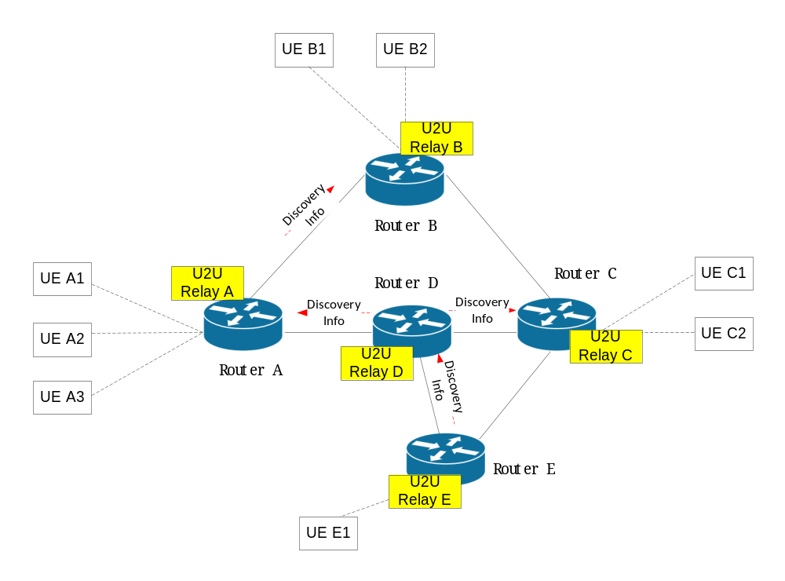
Figure 6.X.2-2: MANET routers with ProSe UE-to-UE Relay functionality
As illustrated in Figure 6.X.2-2, every router (except Router D) is in proximity of a set of End UEs. By performing ProSe Discovery (Model A or Model B) as defined in TS 23.304 [4], each of the U2U Relays discovers the UEs in proximity and obtains a list of locally discovered User Info IDs, as follows:
- U2U Relay A obtains a list of (User Info A1, User Info A2, User Info A3)
- U2U Relay B obtains a list of (User Info B1, User Info B2)
- U2U Relay C obtains a list of (User Info C1, User Info C2)
- U2U Relay D obtains an empty list
- U2U Relay E obtains a list of (User Info E1)
Suppose that End UE A1 wishes to discover End UE E1 and establish a point-to-point communication. Although End UE E1 is reachable via the MANET by U2U Relay A, End UE A1 will not attempt a connection with U2U Relay A, unless U2U Relay A advertises the availability of User Info E1.
To allow U2U Relay A to advertise the availability of User Info E1, there is a need for the lists of discoverable UEs to be shared by all participating routers in the MANET. This can be done by defining a new MANET message called [MANET] Discovery Info, as illustrated in Figure 6.X.2-2. Upon reception of a [MANET] Discovery Info message, the MANET router forwards a copy to the collocated U2U Relay. The U2U Relay updates the list of discovered User Info ID and advertises the updated list to End UEs in proximity.
Editor’s note: It is FFS if the dissemination of [MANET] Discovery Info can be made compatible with Rel-18 security mechanisms for UE-to-UE Relay defined in TS 33.304[4].
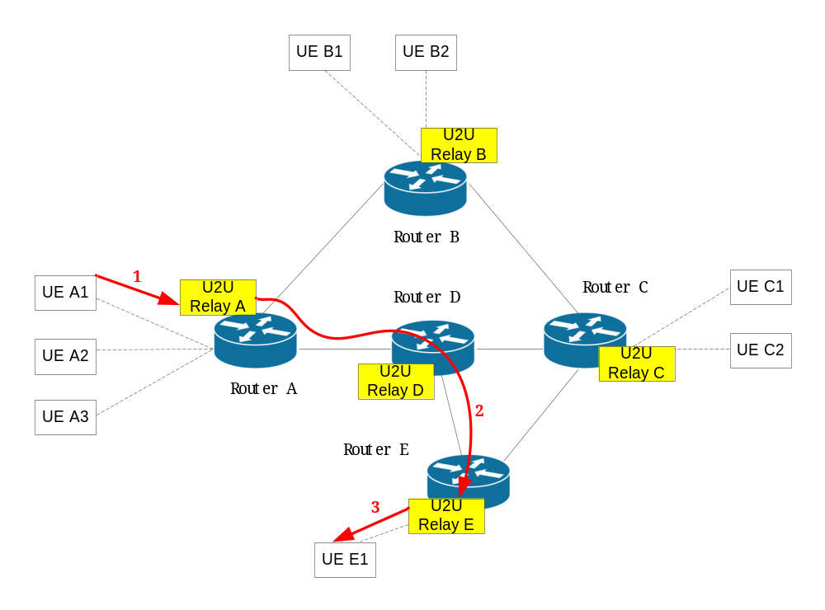
Figure 6.X.2-3: Signalling for connection establishment
Once End UE A1 has determined that it can reach End UE E1 via U2U Relay A, it can send a Direct Communication Request to U2U Relay A, as illustrated with step 1 in Figure 6.X.2-3. The Direct Communication Request needs to be propagated to U2U Relay E (step 2 in Figure 6.X.2-3) and delivered to End UE E1 (step 3 in Figure 6.X.2-3). Similar logic applies to the Direct Communication Accept message in the reverse direction (i.e. from End UE E1 via U2U Relay E via U2U Relay A to End UE A1).
To allow the propagation of Direct Communication messages over the MANET network (i.e. step 2 in Figure 6.X.2-3), there is a need for a point-to-point transport for signalling messages between a pair of U2U Relays.
As a result of the enhancements described above, the entire MANET (with collocated U2U Relays) behaves as a single ProSe UE-to-UE Relay, with no impact on the End UEs.

6.X.3 Procedures
This solution relies on a new MANET message, referred to as [MANET] Discovery Info, that carries:
- Identity of the Relay that is originator of the [MANET] Discovery Info message.
- List of locally discovered User Info IDs (per RSC).
- Signalling Endpoint Address (IP address and port number) that can be used for establishment of point-to-point signalling connection between a pair of U2U Relays over the MANET.
- (optional) Security information related to establishment of point-to-point signalling connection between a pair of U2U Relays over the MANET.
The [MANET] Discovery Info message is diffused throughout the MANET using MPR flooding (as defined in IETF RFC 7181 [xx]), if available. As an example, in reference to Figure 6.X.2-2, by relying on MPR flooding, the [MANET] Discovery Info is transmitted only on a subset of the network interfaces. If MPR is not available, then the [MANET] Discovery Info message is diffused using simple flooding i.e. by transmitting a copy of the [MANET] Discovery Info message on all interfaces (except the one on which the message has been received).
The [MANET] Discovery Info message is formatted according to IETF RFC 5444 [zz]. Specifically, the message originator address (<msg-orig-addr> in IETF RFC 5444 [zz]) and the message sequence number (<msg-seq-num> in IETF RFC 5444 [zz]) are used to enable the MPR flooding mechanism, as defined in IETF RFC 7181 [xx].
Upon reception of a [MANET] Discovery Info message, the MANET router forwards a copy to the collocated U2U Relay. The U2U Relay updates the list of User Info IDs that are reachable via the MANET network. For each stored User Info ID the U2U Relay keeps information of the U2U Relay that originated the information. It is noted that the same User Info ID can be associated with more than one U2U Relays (e.g. in case the UE was discovered by more than one U2U Relays).
NOTE 1: Instead of defining a new MANET message, the content of the [MANET] Discovery Info message described above could be carried as new information element in the existing MANET Topology Control (TC) message. The drawback of this approach is that the frequency of topology updates is different and unrelated from the frequency of End UE discovery events. Another possibility would be to diffuse the content of the [MANET] Discovery Info message described above using a flooding-based signalling protocol that is defined on its own. The drawback of this approach is that it cannot readily re-use the MPR flooding mechanisms that are built-in features in MANET.
The signalling protocol carrying the Direct Communication messages (as defined in 3GPP TS 23.304 [4]) between a pair of U2U Relays can be defined by 3GPP. The only thing needed from the new MANET message (i.e. [MANET] Discovery Info) is to be able to carry the Signalling Endpoint Address (IP address and port number) that uniquely identifies the signalling endpoint of the U2U Relay functionality collocated with the MANET router.
When the local U2U Relay (e.g. U2U Relay A) receives a Direct Communication Request from the source End UE and the target End UE has been discovered by more than one remote U2U Relays (e.g. U2U Relay B and U2U Relay C), the local U2U Relay chooses to which remote U2U Relay to forward the Direct Communication Request based on implementation.
Upon reception of the Direct Communication Accept generated by the target End UE, the remote U2U Relay reserves an IP address/prefix for the target End UE and forwards the Direct Communication Accept towards the local U2U Relay, including the reserved IP address/prefix of the target End UE. The local U2U Relay forwards the Direct Communication Accept message to the source End UE.
Source End UE obtains the IP address/prefix of the target End UE using existing mechanisms described in TS 25.303 [xx].
The IP subnet address/prefix that is used by the U2U Relay to assign IP addresses to End UEs, as well as the Signalling Endpoint Address of the U2U Relay functionality, need to be advertised by the collocated MANET router via MANET Topology Control (TC) messages ahead of time. This is needed to ensure the existence of stable routes prior to the establishment of a signalling connection between a pair of U2U Relays, or prior to the exchange of user plane packets between a pair of distant End UEs.
NOTE 2: The End UE might need to establish a communication link with two (or more) U2U Relays in case the two U2U Relays belong to two disjoint MANET networks. For example, this could be the case where End UE A needs to reach End UE B and End UE C, whereby End UE B is advertised by U2U Relay X only, while End UE C is advertised by U2U Relay Y only. In this case End UE A chooses the link on which to route the outgoing IP packet based on the target End UE address.
If a MANET router happens to include a ProSe UE-to-Network functionality, the [MANET] Discovery Info message indicates that the Relay that is originator of the [MANET] Discovery Info message has UE-to-Network functionality and includes the Relay Service Code (RSC) of the collocated ProSe UE-to-Network Relay. The RSC indicates the connectivity service that the ProSe UE-to-Network Relay provides to the Remote UE.
Editor’s note: When End UE needs to switch to a new U2U Relay (e.g. due to mobility), if there are multiple UE-to-Network Relays associated with the same RSC, it is FFS whether and how the End UE needs to retrieve the same UE-to-Network Relay with which the original connection was established.

6.X.4 Impacts on services, entities and interfaces
ProSe UE-to-UE Relay impact:
- Has a collocated MANET router functionality and is able to initiate or join a mobile ad hoc network as defined in MANET (IETF RFC 7181 [xx]).
- Supports a new MANET message called [MANET] Discovery Info that is used to diffuse information about discovered End UEs to other U2U Relays over the MANET.
- Advertises User Info IDs that have been discovered by any U2U Relay that is part of the MANET.
- Establishes p2p signalling connection with a remote U2U Relay and tunnels Direct Communication messages (for establishment, release, etc.).
End UE impact:
- None.
*** END CHANGES ***

