SA WG2 Meeting #S2-160 S2-2313625
13 - 17 November, 2023, Chicago, USA (was S2-2312126, 3366)

Title: FS_5GSAT_ARCH_Ph3 Architecture assumption updates – UE-satellite-UE communications

Source: vivo, Samsung, Huawei, HiSilicon, Thales

Document for: Approval
Agenda Item: 19.1
Abstract: Propose to add several additional architecture assumptions on UE-satellite-UE communications.

1. Introduction/Discussion
UE-satellite-UE communication is an architecture enhancememnt to reduce the “ground-station-to-space " latency to enable richer applications via satellite access. This communication needs at least gNB onboard, any additional core network functionalities onboard or not is service-oriented, i.e. different service may need different core network functionalities onboard, e.g.:
- LAN service may only need UPF onboard,
- IMS service may need UPF and some IMS core network functionalities onboard
- Video conference service may need DN providing data content onboard, depends on which kind of video conference service. Besides, it may also enfront interoperability problem considering the diversity of video applications, which may further add complexity onboard.
Therefore, a discussion paper S2-2312798 presents a comprehensive analysis of UE-satellite-UE communication. Based on S2-2312798‘s analysis, observations, and proposals, it is suggested to enhance current scope and architecture assumptions to make UE-satellite-UE communication scenario clearer and more straightforward for this release study.
Proposal 1: only IMS service is considered in this release for UE-satellite-UE communication, any other service such as LAN service, video conference are not in scope of this release because of the CN functionality onboard restrictions.
Proposal 2: NGSO (with/without ISL) with CN functionality evenly onboard is considered in this release for UE-satellite-UE communication.
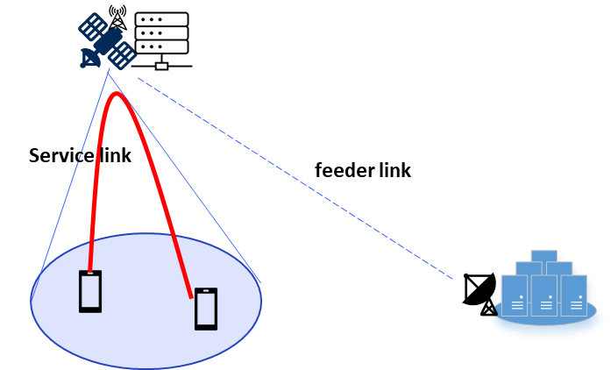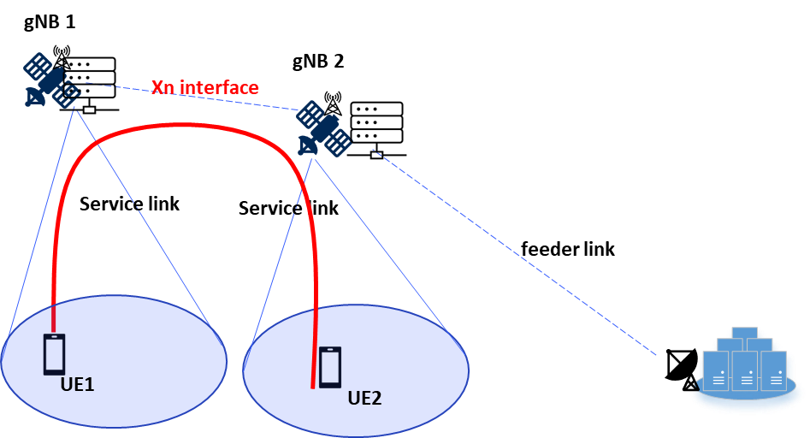
Fig 1: UE1 and UE2 communicates via same satellite Fig 2: UE 1 and UE2 communicates via different satellites via ISL
(every satellite has both gNB and CN functionality onboard, functionality distributed evenly on satellite)

Proposal 3: GEO is not in scope of this Release for optimizing IMS service.
Proposal 4: A feeder link to the ground is always available is assumed, as shown in S2-2312798.
Proposal 5: It is proposed to only consider communication of UEs from same subscription can be shifted to UE-satellite-UE communication.
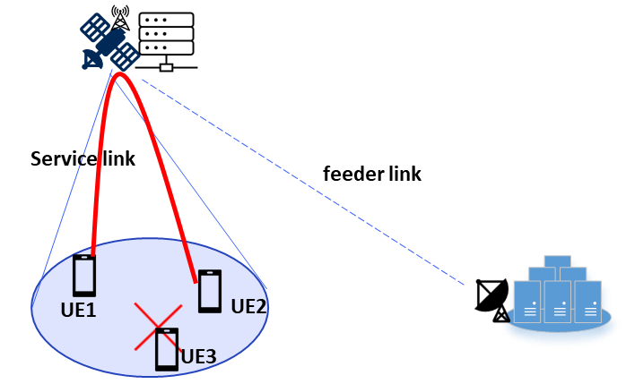
Fig 3: UE1 and UE2 are with MNO 1 subscription, UE3 is with MNO2 subscription
UE3 cannot communicate with UE1 or UE2 via UE-satellite-UE communication link

2. Text Proposal
It is proposed to capture the following changes in TR 23.700-29.

* * * * First Change * * * *

1 Scope
The scope of this Technical Report is to study the following aspects of 5GS/EPS integrating of satellite component in Release 19, including:
- Regenerative payload generic architecture:
- Impact to 5GS and EPS to support gNB/eNB onboard the satellite.
- Store and Forward Satellite operation for delay tolerant services:
- The control plane and user plane enhancements if applicable, including the minimum necessary set of Core Network elements to be embedded in the satellite, to support S&F Satellite operation, both for IoT NTN (EPS) and NR NTN (5GS);
- The parameters needed to characterize and support S&F Satellite operation from a delay tolerant services perspective if applicable, both for IoT NTN (EPS) and NR NTN (5GS).
NOTE: S&F for IoT NTN will be studied first and if there is remaining time available NR NTN can then be studied.
- UE-Satellite-UE communication enhancements for 5GS, supporting NR NTN NGSO constellation with and without ISL, with feeder link always available :
- Following SA1 requirements, study how IMS enablers including mission critical can be supported;
- Minimum necessary set of 5GS network functions onboard the satellite(s) to support such UE-Satellite-UE communication.

* * * * Second Change * * * *

4 Architectural Assumptions and Principles
The following architecture assumptions are applied to the study:
- The 5GC architecture for satellite access for NR as defined in TS 23.501 [2] is used as a baseline.
- The EPC architecture for satellite access for IoT as defined in TS 23.401 [5] and the architecture enhancements to facilitate communications with packet data networks and applications as defined in TS 23.682 [7] are used as a baseline.
- At least eNB/gNB is assumed to be on board the satellite.
- Impacts to UE, network functions and entities are minimised. To the extent possible, existing procedures and functionality is reused.
- Inter-Satellite Links (ISL) and Feeder link are assumed to act only as transport layer links and are not specified in 3GPP, and the use of ISL has no impact on any aspects to the reference points when core network functionalities are onboard.

- Store and Forward Satellite Operation assumes that UE-satellite-ground network connectivity can be intermittent as defined in clause 3.1.
- Store and Forward Satellite Operation shall work without ISL.
- NR UE-Satellite-UE communication assumes a connection to the ground is always available.
- NR UE-Satellite-UE communication assumes only IMS service including MMTEL and mission critical communications is considered.
- NR UE-Satellite-UE communication assumes the minimum set of core network functionalities, including at least the UPF, is present onboard of every serving satellite.
- NR UE-Satellite-UE communication is assumed that the serving satellite will exclusively be of the MEO and LEO.
- GEO satellites is not included in the scope of this study for IMS service.

- NR UE-Satellite-UE communication for MMTEL service assumes communication between two UEs under the coverage of the same satellite or different satellites.

* * * * End of changes * * * *

