SA WG2 Meeting #159 draft S2-2311380

October 9th – 13th, 2023; Xiamen, CN (revision of S2-2311125)

Source: Vodafone
Title: Example network and satellite configurations for WT1 in FS_5GSAT_ARCH_Ph3
Document for: Approval
Agenda Item: 19.1
Work Item / Release: FS_5GSAT_ARCH_Ph3 / Rel-19

1 Discussion
The FS_5GSAT_Ph3 SID objectives read
WT1: Regenerative payload generic architecture study
WT-1.1: Study and identify any impacts on 5GS and EPS for the scenario with gNB/eNB embedded on the satellite.
In order to do this study and identification tasks, it is useful to document some generic scenarios. These scenarios are likely to help identify the topics that need to be solved, either by SA2, or by companion work in the RAN WGs (e.g. RAN 3).
This document does not propose key issues related to these different scenarios, but, some examples of potential issues are:
- S1-AP has the S1-SETUP procedure for connecting up a new eNB to the MME, but there is no S1-DISCONNECT procedure. Without such an eNB disconnection procedure, “paging on the last used cell” will add delay to mobile terminating procedures.
- Impact on functionality relating to paging strategies.
- What cell IDs does the UE see? E.g. does it see a stream of different cell IDs (a, b, c, d, e,…) or does the satellite system’s O&M organize things such that the UE sees alternating cell IDs (a, b, a, b..)?
- Does the UE see a constant TAI or a changing one?
- How are NB-IoT devices handled as they do not support handover.
- How to make NB-IoT WUS work (as it only applies in the cell where the UE last had an RRC connection).
- How to resolve (police and/or Value Added Services) requests for “last known cell ID” into useful information?
- Cell ID based selection of PSAP (emergency call handling centre).
- When the eNB on the satellite does an S1-SETUP to the MME(s), does the eNB indicate all the TACs and cells that it will handle when using that earth station, or does it do S1-MODIFICATION whenever a new cell comes in range or moves out of range of the satellite?
- Impact on user location reporting/ presence reporting areas.
- Impact on Public Warning System (note that CT 1 do not have a study item on this subject).
- (Probably more for RAN 3) use of the Configuration Transfer procedure to remove inter-eNB relations.
- Which scenarios (if any) are likely to cause spikes in signalling load on the core network?
- In 5GS, does RRC_INACTIVE work? What impacts are there?

Other companies are requested to review the diagrams below and consider whether additional issues need to be resolved.

2 Proposals
- It is proposed to update TR 23.700-29 on FS_5GSAT_ARCH_Ph3 as follows (all text is new)

- (* bullet b was not discussed when S2-2311125 was presented *)

*********** start of ALL NEW TEXT : revision marks show the differences from S2-2311125 ***************

Annex Q (Informative) Example network scenarios for regenerative payload generic architecture (e/gNB on LEO satellite)
The following diagrams are examples of scenarios and situations that the 3GPP standards should handle in order to offer good service to UEs when an eNB/gNB is deployed on a LEO satellite.
These examples are not intended to be an exhaustive set.

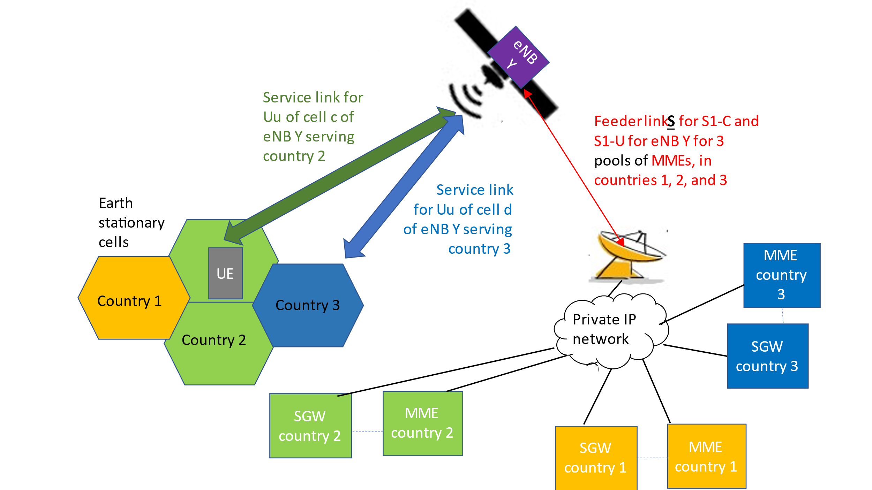Figure Q-1: Basic concept of eNB/gNB on LEO satellite

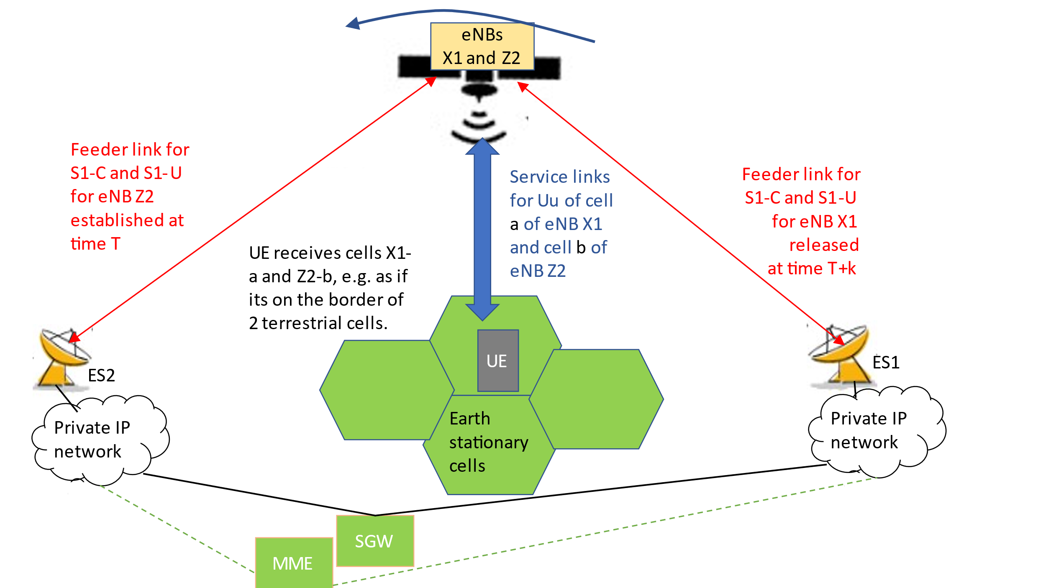
Figure Q-2: Feeder link switch with eNB/gNB on LEO satellite

In figure Q-2, the UE is basically stationary, but as the satellite flies over, the satellite is moving out of range of one earth station (ES1) and into range of another earth station (ES2). At some time before time T, the satellite system’s O&M activates a second eNB (eNB-Z) on the satellite and the S1 interfaces from eNB-Z through ES2 are established at time T. Using methods already discussed in RAN WGs during Release 17/18, the UE can be handed over (e.g. from cell X1-a to cell Z2-b) in the period between time T and time T+k. This handover could be an S1 handover, or, if the eNBs know that they are connected to the same MME, it could be an X2 handover. Note that NB-IoT devices do not support handover.

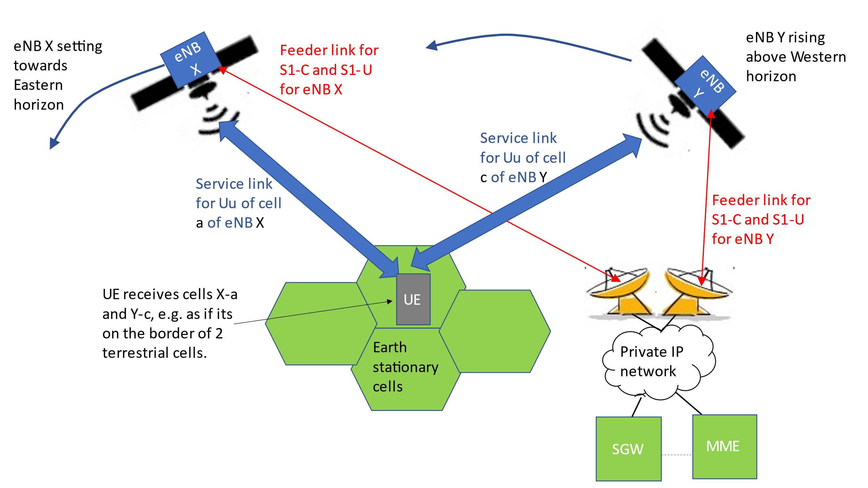

Figure Q-3: Handover between satellites with common earth station location

In figure Q-3, the UE is basically stationary; the satellite with eNB X is going down in elevation angle, but before X becomes unusable, the satellite with eNB Y rises above the horizon and becomes usable. Again, using methods already discussed in RAN WGs during Release 17/18, the UE can be handed over (e.g. from cell X-a to cell Y-c) during the time that the UE’s area is in coverage of both satellites. This handover could be either an X2 or an S1 handover, but note that NB-IoT devices do not support handover.

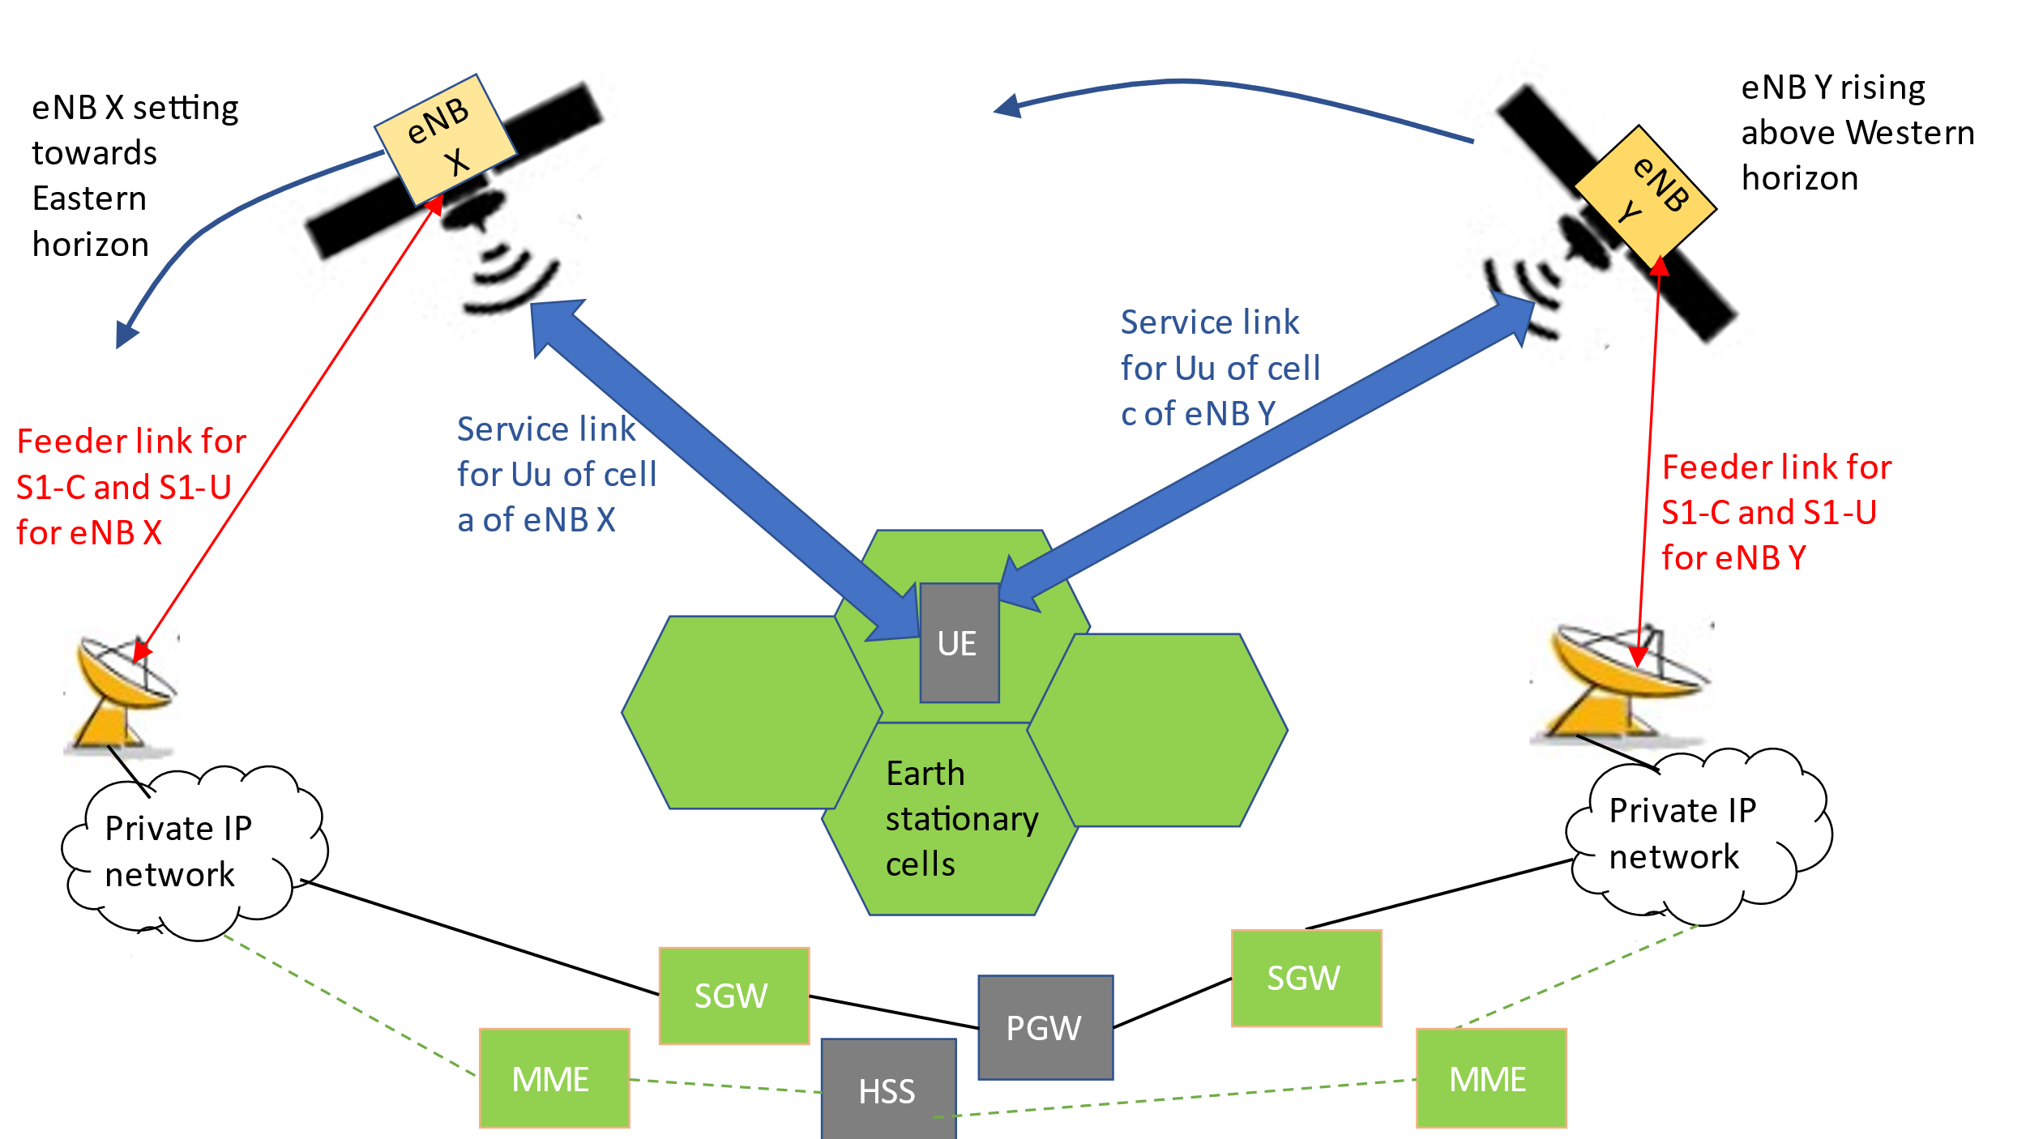
Figure Q-4: Handover between satellites using different earth station location

Figure Q-4 is a combination of the preceding scenarios but needs to be supported.

********** end of new text *****************

