SA WG2 Meeting #149 S2-2311381

October 9th – 13th, 2023; Xiamen, CN (revision of S2-2311201)

Source: Novamint, TNO, Eutelsat, Sateliot, Gatehouse, Intel, CATT, Thales
Title: FS_5GSAT_ARCH_Ph3 TR Definitions
Document for: Approval
Agenda Item: 19.1
Work Item / Release: FS_5GSAT_ARCH_Ph3 / Rel-19
Abstract of the contribution: this paper proposes definitions (terms) and abbreviations for FS_5GSAT_ARCH_Ph3.

1 Discussion
It is proposed to include definitions and abbreviations based on the objectives and topics of the SID and the definitions from SA1.
The present contribution is adding the informative annex from TS 22.261 related to Store and Forward Satellite Operation following the merge with S2-2311177.

2 Proposal
It is proposed to update TR 23.700-29 on FS_5GSAT_ARCH_Ph3 as follows:

* * * * First Change * * * *

3 Definitions of terms and abbreviations

3.1 Terms
For the purposes of the present document, the terms given in TR 21.905 [1], in 23.501 [2] and the following apply. A term defined in the present document takes precedence over the definition of the same term, if any, in TR 21.905 [1] or in 23.501 [2].
serving satellite: a satellite providing the satellite access to a UE. In the case of NGSO (Non-Geosynchronous Orbit), the serving satellite is covering a given geographic area for a limited period of time due to the nature of the constellation

S&F Satellite operation: operation mode providing connectivity service (in storing and forwarding the data) when satellite connectivity is intermittently/temporarily unavailable, e.g. to provide communication service for UEs under satellite coverage without a simultaneous active feeder link connection to the ground segment.
S&F data retention period: data storage validity period in a serving satellite supporting Store and Forward Satellite operation (e.g. after which undelivered data stored is being discarded).
S&F data storage quota: data storage quota per UE in one or more serving satellites supporting Store and Forward satellite operation (e.g. once the S&F data storage quota is reached, the serving satellite cannot accept anymore data from the UE until the stored data amount for the UE goes below the quota).
UE-Satellite-UE Communication: refers to a communication between several UEs under the coverage of one or more serving satellites, using satellite access without the user traffic transiting through the ground segment.

3.2 Abbreviations
For the purposes of the present document, the abbreviations given in TR 21.905 [1], in 23.501 [2] and the following apply. An abbreviation defined in the present document takes precedence over the definition of the same abbreviation, if any, in TR 21.905 [1] or in 23.501 [2].
ISL Inter-Satellite Link
GSO Geosynchronous Orbit
NGSO Non-Geosynchronous Orbit
NTN Non-Terrestrial Network
S&F Store and Forward

* * * * Next Change * * * *

Annex X:
Store and Forward Satellite operation
NOTE: The text in this Annex is copied from TS 22.261 Annex J and is not supposed to be further updated. In case of discrepancy between this text and TS 22.261, the latter takes precedence.
The Store and Forward Satellite operation in a 5G system with satellite access is intended to provide some level of communication service for UEs under satellite coverage with intermittent/temporary satellite connectivity (e.g. when the satellite is not connected via a feeder link or via ISL to the ground network) for delay-tolerant communication service.
An example of “S&F Satellite operation” is illustrated in Figure X-1, in contrast to what could be considered the current assumption for the “normal/default Satellite operation” of a 5G system with satellite access.
As shown in Figure X-1:
- Under “normal/default Satellite operation” mode, signalling and data traffic exchange between a UE with satellite access and the remote ground network requires the service and feeder links to be active simultaneously, so that, at the time that the UE interacts over the service link with the satellite, there is a continuous end-to-end connectivity path between the UE, the satellite and the ground network.
- In contrast, under “S&F Satellite operation” mode, the end-to-end exchange of signalling/data traffic is now handled as a combination of two steps not concurrent in time (Step A and B in Figure X-1). In Step A, signalling/data exchange between the UE and the satellite takes place, without the satellite being simultaneously connected to the ground network (i.e. the satellite is able to operate the service link without an active feeder link connection). In Step B, connectivity between the satellite and the ground network is established so that communication between the satellite and the ground network can take place. So, the satellite moves from being connected to the UE in step A to being connected to the ground network in step B.

“Normal/default Satellite operation” mode | 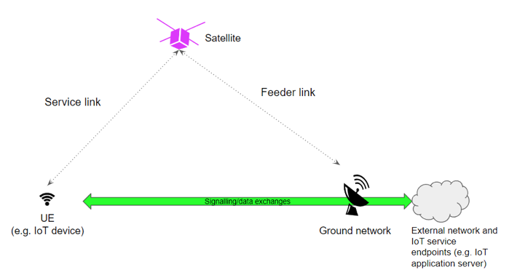
“S&F Satellite operation” mode | 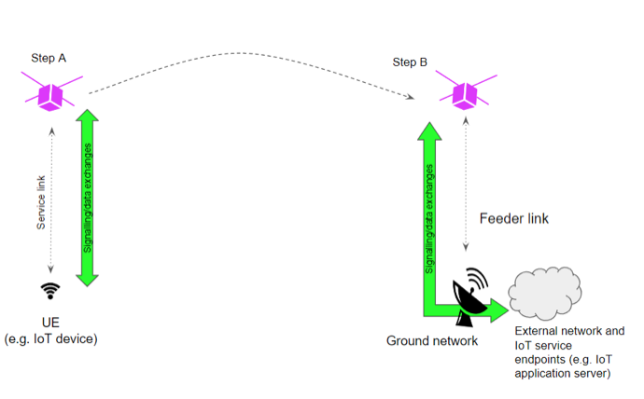
Figure X-1: Illustration of “normal/default operation” and “S&F Satellite operation” modes in a 5G system with satellite access.
The concept of “S&F” service is widely used in the fields of delay-tolerant networking and disruption-tolerant networking. In 3GPP context, a service that could be assimilated to an S&F service is SMS, for which there is no need to have an end-to-end connectivity between the end-points (e.g. an end-point can be a UE and the other an application server) but only between the end-points and the SMSC which acts as an intermediate node in charge of storing and relying.
The support of S&F Satellite operation is especially suited for the delivery of delay-tolerant/non-real-time IoT satellite services with NGSO satellites.

