**3GPP TSG-WG SA2 Meeting #153E e-meeting *S2-2208629***

**Elbonia, October 10th – 17th, 2022 (revision of S2-220xxxx)**

**Source: Huawei, HiSilicon**

**Title: KI#1-7: Update of conclusions**

**Document for: Approval**

**Agenda Item: 9.16**

**Work Item / Release: FS_PIN / Rel-18**

*Abstract: This paper proposes to update conclusions.*

# 1. Introduction

This paper proposes revision of current conclusions.

## AF or not AF?

Figure 1 shows the 5GS architecture for supporting the PIN network.

With regards to whether an AF is required or not, we observe first that the 5G system enables interaction with an AF via capability exposure. Based on the results of the study, the capabilities relevant for PIN are:

* QoS control, e.g. AF session with QoS
* Traffic influence
* 5G VN control
* Traffic influences
* URSP influence

In addition configurations performed via O&M are required as regular procedures, e.g., for PDU session related configuration, etc.

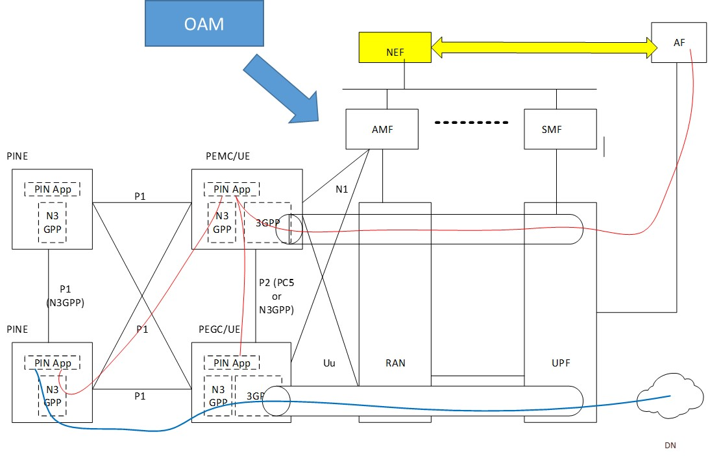

Figure 1: PIN architecture

**Proposal #1: In line with the current 5GS principles the PIN network may be supported via interaction with an AF specific for PIN which uses the 5G exposed capabilities or may use only O&M interactions without any AF. The normative specifications should enable both types of deployment.**

The current R17 specifications support the exposure services listed below which may be reused in order to support PIN network:

- Traffic influence API (29.522 4.4.7/23.502 4.3.6)

- AF session with QoS API (29.522 4.4.9 /23.502 Nnef_AFsessionWithQoS service)

- Nnef_ServiceParameter API, includes the Application guidance for URSP determination API (TS 29.522 “AfGuideURSP” features)

– 5G VN management API.

We believe that the study has overlooked the usage of existing specifications for fulfilling PIN requirements. As an example, we note that the current API defined in 29.522 for URSP creation can be used by a PIN AF to request URSP while giving the possibility to the 5GC to accept or deny the request.

*3)if the "AfGuideURSP" feature is supported, URSP service parameters via:*

*a) contents for the AF guidance on URSP within the "urspGuidance" attribute, which shall include one or more URSP rule requests. Each URSP rule request may include a traffic descriptor within the "trafficDesc" attribute, a relative precedence within the "relatPrecedence" attribute and/or one or more route selection parameter sets within the "routeSelParamSets" attribute. Each route selection parameter set may include a precedence value within the "precedence" attribute, a DNN within the "dnn" attribute, an S-NSSAI within the "snssai" attribute, and a spatial validity condition within the "spatialValidity" attribute. If the request contains only one route selection parameter set, each of the optional attributes "dnn", "snssai", "precedence", and "spatialValidity" that is missing from the request may be complemented by the NEF based on local configuration for the provided AF service identifier. It is up to the NEF to transform the information of the "spatialValidity" attribute into a list of TAIs;*

Similar considerations are applicable to the AF session with QoS API which can address requirement from the AF to request a QoS for a UE acting as a PEMC or PEGC.

## Routing of traffic within the PIN?

The 5GS does not need to be aware of the routing of traffic which remains within the PIN network since it does not impact the 5G system, i.e. the resources of the 5GS. Hence, this traffic shall be managed locally by PEGC according to PEGC functionalities, transport layer and AF indication, if any. Only the traffic going via the PDU session needs to be managed by 5GS.

## QoS considerations?

Current conclusion proposes:

*1) 5G QoS parameters (including QoS characteristics, GFBR/MFBR) may be sent to PEGC to assist the deriving of N3GPP QoS parameters.*

Editor's note: 5G QoS parameters sent to PEGC are based on "Additional QoS Information" specified in clause 9.3.1.1 of TS 24.502, any other parameters are FFS.

*a) Whether and how PEGC performs the deriving of N3GPP QoS parameters and mapping procedure is not specified by 3GPP.*

*b) Whether and how to enforce QoS based on the Non-3GPP QoS assistance information in the non-3GPP network is not specified by 3GPP.*

While we do not disagree with these conclusions, some further considerations are required. The conclusions are based on sol#11 referring to Additional QoS Information" specified in clause 9.3.1.1 of TS 24.502, which are related to parameter sending in IKEv2 *5G_QOS_INFO.*They are related to the QoS to be applied in the N3GPP from the UE to the TNAP and NOT from the UE to the network behind.

* *The 5G_QOS_INFO payload is used to indicate:*
* *a) the PDU session identity;*
* *b) zero or more QFIs;*
* *c) optionally a DSCP value associated with the child SA;*
* *d) whether the child SA is the default child SA; and*
* *e) if trusted non-3GPP access, Additional QoS Information or if untrusted non-3GPP access, optionally Additional QoS Information.*

The mechanism to map the QoS related to the traffic in the PDU session with the QoS in the “transport layer” from the PEGC to the PINE is media specific and the PEGC can use specific implementation mechanism or procedure defined by the Specific N3GPP media to be applied for the mapping of traffic, e.g. based on DSCP to 5G QoS. The PCF is not aware of the specific N3GPP transport layer used between the PINE and the PEGC, hence it cannot provide any reasonable N3GPP QoS assistance information.

**Proposal #2: 5G system does not send any N3GPP QoS information related to the PIN network, but the PEGC will consider the 5G QoS to be applied to the traffic towards the PDU session in order to map the traffic with the most suitable QoS for the specific transport layer used between the PEGC and the PINE.**

## KI#6

The following revision is proposed:

* Bullet 1) in previous conclusions PIN transport layer has been defined as implementation specific and Application information is transported in UP transparently for 5GS. The AF, if present, interacts via exposure capability. Therefore the policy for PIN is outside 3GPP scope.
* Bullet 2.c) removed based on consideration in KI#4 bullet 1 & 2.
* EN removed based on considerations provided in this paper

# 2. Text Proposal

It is proposed to capture the following changes vs. TR 23.700-88.

* * * * First change * * * *

8 Conclusions

8.7 Conclusion on Key Issue #7

The following principles are concluded for Key Issue #7 "Identification of PIN and PIN Elements":

1) The PIN related ID(s) need not be known by 5GS.

2) The 5GC does not need to know the PINE’s information.

Editor’s note from S2-2208267

3) The PEMC and/or AF for PIN are responsible for PIN management and the allocation of PIN/PINE IDs that are used within the PIN.

- The PIN and PINE identifier allocation is out of the SA2 scope.

4) PIN related identifiers may be provisioned in PIN and 5GC with the mechanism concluded in clause 8.4 for KI#4 and 8.6 for KI#6.

Editor’s note from S2-2208466

5) The following principles from Solution #9 will be used for normative work

- The UDM maintains a PIN profile

- The PIN Profile includes a PIN ID that is allocated by the network or a 3rd party AF.

- The PIN Profile may include PINE IDs which are allocated by the network or a 3rd party AF.

- A 3rd party AF allocates / provides the PIN ID and/or PINE IDs by invoking an NEF API.

- The PIN Profile may include the identity of the UE (PEMC) that manages the PIN.

- The PIN Profile may include the identity(s) of the UE (PEGCs) of the PIN.

Editor’s note from S2-2209016

6) Only the PIN ID is known by 5GC.

7) Except IP address, the 5GC does not need to know the PINE’s information.

Editor’s note from S2-2209177

8) PIN identifier is uniquely identifiable to 5G network, which is allocated and managed by 5G network.

9) PINE identifier is uniquely identifiable within a PIN, which is allocated and managed by PEMC via application layer, no impact on SA2.

* * * * End of changes * * * *