3GPP TSG-SA WG2#152E e-meeting S2-220
Elbonia, 17-26 Aug 2022 (was S2-220xxxx)

Source: Xiaomi
Title: Updates to terminologies
Document for: Approval
Agenda Item: 9.20
Work Item / Release: FS_Ranging_SL/Rel-18
Abstract of the contribution: This contribution proposes some updates to terminologies for RAN alignment and the alignments with FS_eLCS_Ph3.

1. Discussion
TR 23.700-86 defined the following terms: Ranging, Reference UE, Target UE, Assistant UE, Located UE, Location Server UE, Sidelink Positioning, Positioning, Relative position, etc, some of which are also defined in RAN WGs and in the FS_eLCS_Ph3 study:
Target UE/Reference UE/Anchor UE
- Target UE (RAN1): UE to be positioned (in this context, using SL, i.e. PC5 interface).
- Target UE (SA2 FS_Ranging_SL): A UE whose distance, direction and/or position is measured comparing to the reference plane, reference direction and/or location of a Reference UE in the Ranging based service and Sidelink positioning.
- Anchor UE (RAN1): UE supporting positioning of target UE, e.g., by transmitting and/or receiving reference signals for positioning, providing positioning-related information, etc., over the SL interface.
- Reference UE (SA2 FS_Ranging_SL): A UE who determines a reference plane and reference direction in the Ranging based service and Sidelink positioning.
- Reference UE (SA2 FS_eLCS_Ph3): A UE with a location assumed known to the network that can obtain location related information of one or more target UE(s), which may assist the network to improve the positioning performance of target UE(s).
For the RAN1 defined Target UE and Anchor UE, the reference plane and reference direction are not necessarily provided by a Reference UE. The positioning of target UE has to be over SL interface.
For the SA2 FS_Ranging_SL defined Target UE and Reference UE, the reference plane and reference direction are provided by the Reference UE. The Reference UE also provides a reference location. The positioning of target UE has to be over SL interface.
For the SA2 FS_eLCS_Ph3 defined Reference UE, its location has to be known to the network, so that it can assist the network to improve the positioning performance of the target UE. The positioning of target UE does not have to be over SL interface.
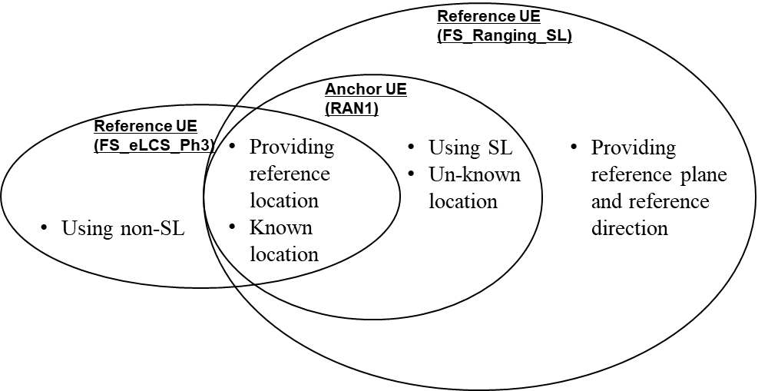
Observation 1: The definition of Target UE is similar between RAN1 and SA2 FS_Ranging_SL.
Observation 2: The definitions of Reference UE/Anchor UE are different with some overlaps among RAN1, SA2 FS_Ranging_SL and SA2 FS_eLCS_Ph3.
Proposal 1: Change the name of Reference UE into SL Reference UE to differentiate with Reference UE used in FS_eLCS_Ph3
Proposal 2: In the definition of SL Reference UE, keep the existing texts to avoid any impact to already defined KI and solutions, and additionally clarify the relationship with Reference UE and the relationship with Anchor UE.
Proposal 3: Clarify in the definition that “ Reference UE” mentioned in KI and Solutions of this TR refers to “SL Reference UE”, and use the term “SL Reference UE” in TS phase.

Ranging/Sidelink Positioning
- Ranging (RAN1): determination of the distance and/or the direction between a UE and another entity, e.g., anchor UE.
- Ranging (SA2 FS_Ranging_SL): refers to the determination of the distance between two UEs or more UEs and/or the direction and/or relative positioning of one UE (i.e. Target UE) from another UE (i.e. Reference UE) via PC5 interface.
- Sidelink positioning (RAN1): Positioning UE using reference signals transmitted over SL, i.e., PC5 interface, to obtain absolute position, relative position, or ranging information.
- Sidelink Positioning (SA2 FS_Ranging_SL): Positioning UE using PC5.

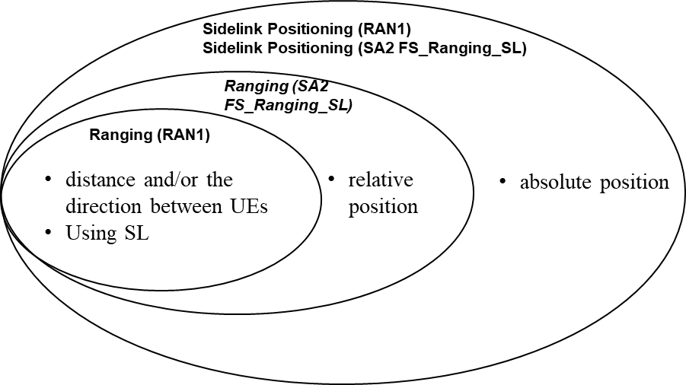
Observation 3: Definition of Sidelink Positioning has the same scope between RAN1 and SA2; definition of Ranging in SA2 has a larger scope than that of RAN1, which includes relative position in addition.
Proposal 4: Since we use the term Ranging/SL Positioning in the KI and Solution descriptions with no differentiations between Ranging and SL Positioning, updating the terminology of Ranging and SL Positioning will not cause any problem, it is proposed to update the definitions in SA2 to be aligned with RAN1.

2. Text proposal
It is proposed to agree the following changes to TR 23.700-86:

* * * * First change * * * *

3.1 Terms
For the purposes of the present document, the terms given in TR 21.905 [1] and the following apply. A term defined in the present document takes precedence over the definition of the same term, if any, in TR 21.905 [1].
Ranging: refers to the determination of the distance between two UEs or more UEs and/or the direction of one UE (i.e. Target UE) from another UE (i.e. Reference UE) via PC5 interface.
SL Reference UE: A UE, supporting positioning of target UE using Sidelink, who determines a reference plane and reference direction in the Ranging based service and Sidelink positioning.
NOTE 1: SL Reference UE can be an anchor UE defined by RAN1, and can be a Reference UE if sidelink is used for the positioning of a target UE.
NOTE X: “ Reference UE” mentioned in KIs and Solutions of this TR refers to “SL Reference UE”.
Target UE: A UE whose distance, direction and/or position is measured comparing to the reference plane, reference direction and/or location of a Reference UE using Sidelink in the Ranging based service and Sidelink positioning.
NOTE 2: Any UE participating in the Ranging/Sidelink Positioning can be both a Target UE and a Reference UE and can switch roles in the same Ranging/Sidelink Positioning session.

Assistant UE: A UE who provides assistance for Ranging/Sidelink Positioning when the direct ranging/Sidelink positioning between a Reference UE and a Target UE cannot be supported.
Located UE: A UE of which the location is known or is able to be known using Uu based positioning. A Located UE can be used to determine the location of a Target UE using Sidelink Positioning.
Editor's Note: Change term Network assisted UE and Second UE to Located UE throughout the document.
Location Server UE: A UE offering location server functionality in lieu of LMF, for Sidelink Positioning and Ranging over Sidelink. It interacts with a Target UE, Reference UEs, Assistant UE and Located UEs as necessary in order to calculate the location of the Target UE.
Sidelink Positioning: Positioning UE using PC5 to obtain absolute position, relative position, or ranging information.
Positioning: A functionality, which detects a geographical location and optionally, velocity (of e.g. a mobile terminal).
Relative position: An estimate of the UE position relative to other network elements or relative to other UEs.
Editor's note: Definition on the terminology of Ranging and Sidelink positioning will be aligned with RAN WGs, and will be revisited when there's any conclusion in RAN WGs.

* * * * End of change * * * *

