SA WG2 Meeting #140E (e-meeting) S2-2005405
August 19 - September 2, 2020, Elbonia (revision of S2-20xxxxx)
Source: Huawei, HiSilicon
Title: KI #1, New Solution: V2X Layer assisted DRX over PC5
Document for: Approval
Agenda Item: 8.12
Work Item / Release: FS_eV2XARC_Ph2 / Rel-17
Abstract of the contribution: This solution specifies how the V2X layer activates or deactivates the discontinuous reception over PC5

1. Proposal
It is proposed to add the following solution to TR 23.776.

After the revision deadline r06 was made on top of r04 (the last version provided before the revision deadline) by Ouyang (Huawei):
- mainly to remove the Wake Up Notification sent by the V-UE.
→ All delta in r06 compared to r04 are highlighted in green.
r07 was made on top r06 by LaeYoung (LGE):
- to modify the solution title.
- to modify "upper layer" to "application layer".
- to remove the remaining texts related to the Wake Up Notification in clause 6.X.1.
- to remove the texts and the figure about the use case in clause 6.X.1.
- to clarify which layer performs which operation in clause 6.X.2.
- to add two ENs to clause 6.X.2.2.
- add the texts to clause 6.X.3.
→ All delta in r07 compared to r06 are tagged with "LaeYoung (LG Electronics)".

* * * * Start of Changes * * * *
All texts are NEW!!

6.X Solution #X: PC5 DRX activation and deactivation

6.X.1 Functional Description
This solution is for Key Issue #1 "Support of QoS aware NR PC5 power efficiency for pedestrian UEs".
This solution specifies how the V2X layer activates or deactivates the discontinuous reception over PC5 for pedestrian UE. Power saving reception can be effective to achieve power efficiency for a pedestrian UE, and two reception modes are introduced as below:
1) Complete Reception Mode: the UE in this mode receives V2X service data continuously, e.g. the radio interface of PC5 is on all the time for a pedestrian UE, which is extremely power consuming; and
2) Incomplete Reception Mode: the UE in this mode receives V2X service data periodically, by setting a reception window length and a reception cycle, to receive V2X service data during the reception window per reception cycle.
Application layer of a pedestrian UE determines whether the Incomplete Reception Mode can be applied, based on collected information (e.g. location, speed, predicted path, curvature etc.) from the received V2X service data. The application layer indicates to the V2X layer of the pedestrian UE to change its reception mode when possible. One example could be the pedestrian is walking in a low safety risk area, e.g. in a park near the road, or along the sidewalk with road side fence. Another example could be the pedestrian UE is in a suburb area or a rural area, where pedestrian occasionally encounters a vehicle passing by.

In order to achieve the mechanism introduced above, following PC5 signalling message is introduced:
1) Incomplete Reception Announcement: a PC5 signalling message to indicate the pedestrian UE is in Incomplete Reception Mode. The pedestrian UE in Incomplete Reception Mode includes its reception window information and user info in the Incomplete Reception Announcement message, the reception window information includes the starting point time value(s) and the length value of the reception window.
The Incomplete Reception Announcement message is broadcasted periodically, e.g., once every second. The vehicle UE’s V2X layer may store the information included in the message when receiving such messages;
NOTE: It is up to the UE implementation in the V-UE to maintain the information of the P-UEs.

6.X.2 Procedures

6.X.2.1 Activation of Incomplete Reception Mode
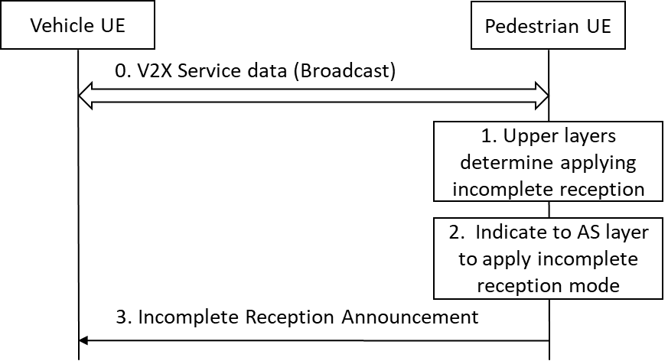
Figure 6.X.2-1: Incomplete Reception Mode activation procedure
0. The UE(s) (i.e. pedestrian UE and vehicle UE) determines the destination Layer-2 ID for broadcast as specified in TS 23.287 clause 5.6.1.2, the UE(s) performs broadcast mode V2X communication (transmit only, receive only or both) as required by application layer. If required by application layer to receive V2X service data, the pedestrian UE starts to receive V2X service data in Complete Reception Mode.
1. If the application layer of pedestrian UE determines the Incomplete Reception Mode can be activated, the application layer indicates to the V2X layer to change into Incomplete Reception Mode. The application layer provides the user info (i.e. pedestrian UE’s application layer ID) and the reception window setting information (e.g. 200ms for every 1s or 200ms for every 500ms). If the reception window setting information is not provided by the application layer, the V2X layer of pedestrian UE uses the default reception window setting values pre-configured.
2. The V2X layer indicates the AS layer to change into Incomplete Reception Mode, by providing the reception window setting information (i.e. reception window length and reception cycle) to the AS layer. The AS layer monitors and receives V2X service data periodically as indicated by the reception window setting information.
3. After the Incomplete Reception Mode is activated, the pedestrian UE sends the Incomplete Reception Announcement message periodically to broadcast the reception window information (as specified in clause 6.X.1), using the self-assigned source Layer-2 ID and the default destination Layer-2 ID (this default destination Layer-2 ID will only be used for this purpose).
On receiving such messages, the V2X layer of Vehicle UE(s) may store the reception window information and the Layer-2 ID for each pedestrian UE (identified by user info).

6.X.2.2 Deactivation of Incomplete Reception Mode
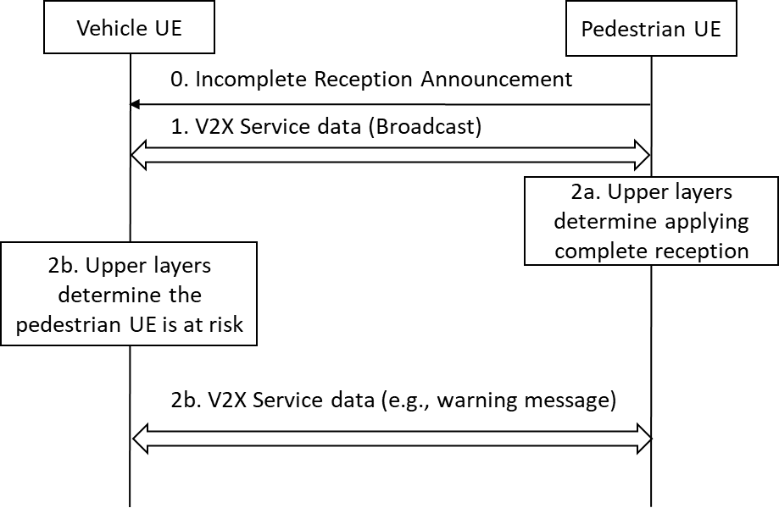Figure 6.X.2-2: Incomplete reception mode deactivation procedure
0. same to clause 6.X.2.1 step 3.
1. The UE(s) perform broadcast mode V2X communication normally as described in clause 6.X.2.1 step 0, the pedestrian UE in Incomplete Reception Mode receives the V2X service data and other possible V2X layer signalling during the reception window.
2a. (Pedestrian UE triggered) If the pedestrian UE’s application layer detects safety risk based on the received V2X service data, the application layer indicates to the V2X layer to change into Complete Reception Mode. The pedestrian UE changes into Complete Reception Mode by indicating the AS layer to change into Complete Reception Mode.
2b. (Vehicle UE triggered) If the application layer of vehicle UE decides to send a V2X message (e.g., warning for potential collision) to a specific pedestrian UE, the application layer provides the user info of the specific pedestrian UE to the V2X layer along with the V2X messages.
If the user info is provided by the application layer and the corresponding reception window information exists in the V2X layer, the V2X layer passes the V2X message along with the reception window information and the Layer-2 ID of the P-UE to the AS layer.
The AS layer of vehicle UE sends the V2X message using the Layer-2 ID of the pedestrian UE as the destination layer-2 ID based on the reception window information provided by the V2X layer.
Editor's note: It is FFS whether and how the application layer of V-UE provides the user info along with the V2X message to the V2X layer.
Editor's note: It is FFS how the V-UE handles the various reception windows when the V-UE has to broadcast a V2X message or send a same V2X message to multiple P-UEs instead of sending a V2X message destined to a specific P-UE.

6.X.3 Impacts on services, entities and interfaces
The solution has the following impacts to the existing entities:
- pedestrian UE:
- Application layer provides reception mode requirements or parameters;
- V2X layer broadcasts an Incomplete Reception Announcement message periodically when the P-UE is in Incomplete Reception Mode;
- support V2X service data reception in Incomplete Reception Mode; and
- switch between Complete Reception Mode and Incomplete Reception Mode.
- vehicle UE:
- the vehicle UE receives the Incomplete Reception Announcement message from P-UE(s) and may store the reception window information of surrounding pedestrian UEs;
- Application layer provides the user info along with the V2X message to the V2X layer to send a V2X message;
- If the user info is provided by the application layer and the corresponding reception window information exists in the V2X layer, the V2X layer passes the V2X message along with the reception window information and the Layer-2 ID of the P-UE to the AS layer; and
- The vehicle UE sends the V2X message using the Layer-2 ID of the pedestrian UE as the destination layer-2 ID based on the reception window information provided by the V2X layer.

* * * * End of Changes * * * *

