SA WG2 Meeting #140E (e-meeting) S2-2005405
August 19 - September 2, 2020, Elbonia (revision of S2-20xxxxx)
Source: Huawei, HiSilicon
Title: KI #1, New Solution: V2X Layer assisted DRX over PC5
Document for: Approval
Agenda Item: 8.12
Work Item / Release: FS_eV2XARC_Ph2 / Rel-17
Abstract of the contribution: This solution specifies how the V2X layer activates or deactivates the discontinuous reception over PC5

1. Proposal
It is proposed to add the following solution to TR 23.776.
* * * * Start of Changes * * * *

6.X Solution #X: V2X Layer assisted DRX over PC5

6.X.1 Functional Description
This solution specifies how the V2X layer activates or deactivates the discontinuous reception over PC5 with guarantee on the safety of pedestrian UE. Power saving reception can be effective to achieve power efficiency for a pedestrian UE, and two reception modes are introduced as below:
1) Complete Reception Mode: the UE in this mode receives V2X service data continuously, e.g. the radio interface of PC5 is on all the time for a pedestrian UE, which is extremely power consuming; and
2) Incomplete Reception Mode: the UE in this mode receives V2X service data periodically, by setting a reception window length and a reception cycle, to receive V2X service data during the reception window per reception cycle.
Upper layers (i.e. application layer) of a pedestrian UE determine whether the Incomplete Reception Mode can be applied, based on collected information (e.g. location, speed, predicted path, curvature etc.) from the received V2X service data. The upper layer indicates to the V2X layer of the pedestrian UE to change its reception mode when possible. For example, if the pedestrian is walking in a low safety risk area, e.g. in a park near the road, or along the sidewalk with road side fence. Another example could be the pedestrian UE is in a suburb area or a rural area, where pedestrian occasionally encounters a vehicle passing by.
In addition, the vehicle UE may notify the pedestrian UE to change into Complete Reception Mode if considered necessary. For example, the vehicle UE keeps on monitoring the pedestrian UE(s) nearby. The vehicle UE detects a collision risk with a pedestrian UE based on the vehicle information (e.g. speed, curvature and predicted path) and information of the pedestrian UE (e.g. information obtained from VAM/PSM messages). In addition , the vehicle UE detects the pedestrian UE is in Incomplete Reception Mode, then the vehicle UE sends V2X layer signalling to notify the pedestrian UE to change into Complete Reception Mode.
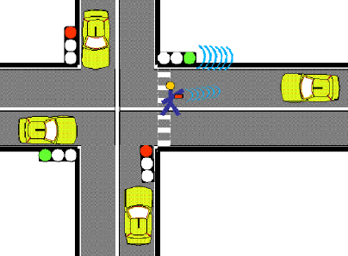
Figure 6.X.1-1: Vulnerable road user warning use case scenario
The figure above is quoted from 3GPP TR 22.885 clause 5.18. It describes a scenario where a pedestrian UE broadcasts V2X service data containing its status, and may also receive and process V2X service data from Vehicle UEs in order to alert the pedestrian based on user choice.
In order to achieve the mechanism introduced above, following PC5 signalling messages are introduced:
1) Incomplete Reception Announcement: a PC5 signalling message to indicate the pedestrian UE is in Incomplete Reception Mode. The pedestrian UE in Incomplete Reception Mode includes its reception window information and user info in the Incomplete Reception Announcement message, the reception window information includes the starting point time value(s) and the length value of the reception window.
The Incomplete Reception Announcement message is broadcasted periodically, e.g., once every second. The Incomplete Reception Announcement message is similar to discovery message in mode A defined in TS 23.303 clause 5.3.2. The vehicle UE’s V2X layer may store the information included in the message when receiving such messages;
NOTE: It is up to the UE implementation in the V-UE to maintain the information of the P-UEs.
2) Wake up Notification: a PC5 signalling message to trigger a pedestrian UE to change into Complete Reception Mode.
Depends on the capability of an RSU UE (e.g. coverage area), the RSU UE may also assist the pedestrian UE to determine whether incomplete reception mode can be applied.

6.X.2 Procedures

6.X.2.1 Activation of Incomplete Reception Mode
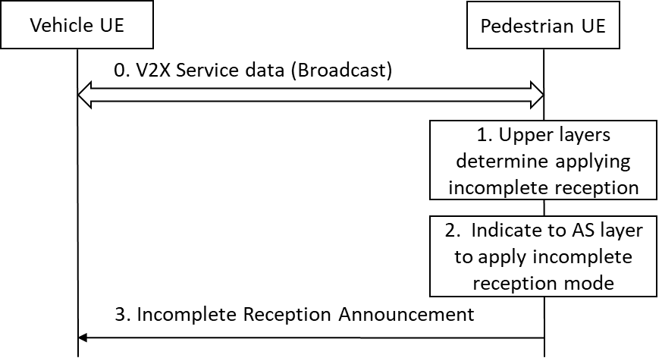
Figure 6.X.2-1: Incomplete Reception Mode activation procedure
0. The UE(s) (i.e. pedestrian UE, RSU UE and vehicle UE) determines the destination Layer-2 ID for broadcast as specified in TS 23.287 clause 5.6.1.2, the UE(s) performs broadcast mode V2X communication (transmit only, receive only or both) as required by upper layers. If required by upper layers to receive V2X service data, the pedestrian UE starts to receive data in Complete Reception Mode.
1. If the upper layers of pedestrian UE determine the Incomplete Reception Mode can be activated, the upper layers indicate to the V2X layer to change into Incomplete Reception Mode. The upper layers provide the user info (i.e. pedestrian UE’s application layer ID) and the reception window setting information (e.g. 200ms for every 1s or 200ms for every 500ms). If the reception window setting information is not provided by the upper layers, the pedestrian UE uses the default reception window setting values pre-configured.
2. The V2X layer indicates the AS layer to change into Incomplete Reception Mode, by providing the reception window setting information (i.e. reception window length and reception cycle) to the AS layer. The AS layer monitors and receives V2X service data periodically as indicated by the reception window setting information.
3. After the Incomplete Reception Mode is activated, the pedestrian UE sends the Incomplete Reception Announcement message periodically to broadcast the reception window information (as specified in clause 6.X.1), using the self-assigned source Layer-2 ID and the default destination Layer-2 ID (this default destination Layer-2 ID will only be used for this purpose).

6.X.2.2 Deactivation of Incomplete Reception Mode
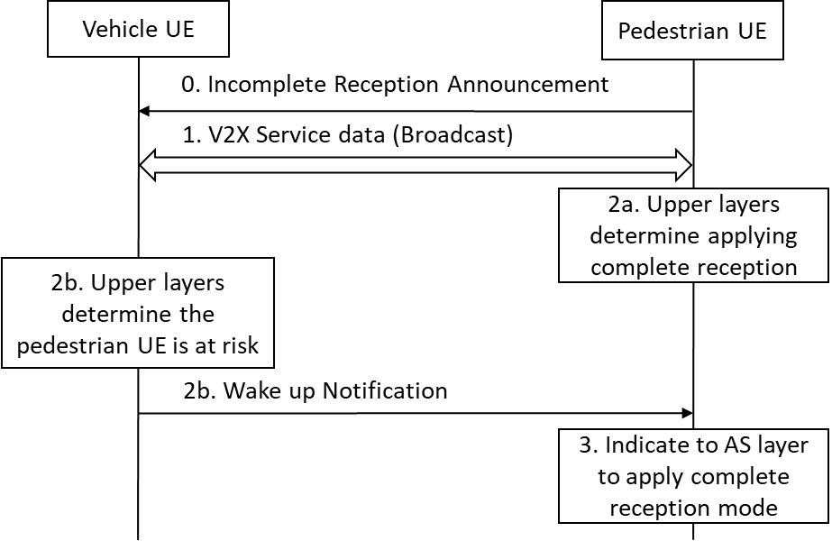
Figure 6.X.2-2: Incomplete reception mode deactivation procedure
0. The pedestrian UE periodically broadcasts Incomplete Reception Announcement messages as described in clause 6.X.2.1 step 3. On receiving such NAS messages, the V2X layer of Vehicle UE(s) may store the reception window information for each pedestrian UE (identified by target user info).
1. The UE(s) perform broadcast mode V2X communication normally as described in clause 6.X.2.1 step 0, the pedestrian UE in Incomplete Reception Mode receives the V2X service data (e.g. CAM messages and DENM messages) and other possible V2X layer signalling during the reception window.
2a. (Pedestrian UE triggered) If the pedestrian UE’s upper layers detect safety risk based on the received V2X service data, the upper layers indicate to the V2X layer to change into Complete Reception Mode. The pedestrian UE changes into Complete Reception Mode by indicating the AS layer to change into Complete Reception Mode.
2b. (Vehicle UE triggered) If the upper layer of vehicle UE decides to send a V2X message(e.g., warning for potential collision) to a specific pedestrian UE, the upper layers provides the user info of the specific pedestrian UE to the V2X layer along with the V2X messages.
If the user info provided by the upper layers exists the corresponding reception window information in the V2X layer, the V2X layer of the V-UE generates a Wake up Notification message, and pass the message along with the reception window information to the AS layer. The vehicle UE sends the Wake up Notification message during the reception window of the pedestrian UE, using the source layer-2 ID of the pedestrian UE as the destination layer-2 ID.
Editor's note: It is FFS whether the Wake Up Notification is necessary.
Editor's note: It is FFS how the V-UE delivers the V2X layer message, when the P-UE is changing its Layer 2 ID.
Editor's note: It is FFS whether and how the Wake Up Notification message can meet the latency requirement.
3. Upon receiving Wake up Notification message, the pedestrian changes into Complete Reception Mode, by indicating the AS layer to deactivate the Incomplete Reception Mode and indicating upper layer that Complete Reception Mode is now applied.

6.X.3 Impacts on services, entities and interfaces
The solution has the following impact to the existing entities:
- pedestrian UE:
- interfaces for upper layers to provide reception mode requirements or parameters;
- support V2X service data reception in Incomplete Reception Mode; and
- switch between Complete Reception Mode and Incomplete Reception Mode.
- vehicle UE:
- the vehicle UE may store the reception window information of surrounding pedestrian UEs; and
- the vehicle UE sends Wake up Notification message when necessary;

* * * * End of Changes * * * *

