TSG-SA Working Group 1 (Services) meeting #4 TSG S1#4 (99)517
Quebec City, Quebec, Canada 6th-9th, July 1999 Agenda Item:
Source: GSMA SERG
Title: 3G Concept Services provided by SERG
Document for: Information _________________________________________________________________________________________

This document presents the first Permanent Reference Document from SERG on 3G Services Concept defined by GSM operators.



Title: 3G Services Concept
Version: 1.0.0
Date: 1st July 1999
GSM MoU Association Classifications
- Nonbinding
- Restricted

The information contained in this document may be subject to change without prior notice. The GSM MoU Association (the “Association”) does not make any representation, warranty or undertaking (express or implied) with respect to, and does not accept any responsibility for, (and hereby disclaims liability for) the accuracy or completeness of the information contained in this document.

Restricted Document

Access to and distribution of this document by the Association is made pursuant to the Regulations of the Association.

Language of original: English

Number of pages: 12
Document History
Version | Date | Brief Description
0.0.1 | 14th June 1999 | First Draft- Jörg Kramer – Mannesmann Mobilfunk joerg.kramer@d2privat.de
0.0.2 | 15th June 1999 | 2nd Draft after SERG#34 discussion
1.0.0 | 1st July 1999 | 3rd Draft including SERG#34 Inputs Docs 70, 75, 76 and 78 from BT Cellnet, T-Mobil and NTTDoCoMo -> SERG Offline Approval

Table of Contents
1 Introduction 4
2 Scope 4
3 SERVICE PERFORMANCE CLASSIFICATION 4
4 UMTS Multi-Media SerVIces and aPI - Requirements 6
5 UMTS sERVICEs AND APPLICATION PLATFORM - REQUIREMENTS 7
6 minimum set of Services when roaming 8
6.1 GSM services to be supported in UMTS 8
6.2 UMTS user roaming onto another 3G (UMTS) network 8
6.3 UMTS user roaming within the 3G Home Environment (UMTS) 8
6.4 UMTS user roaming onto a 2G (GSM) network 8
7 ANNEX A – sERVICES AND Application LIST 8
7.1 Internet / Intranet / Extranet Access 9
7.2 Audio Communications 9
7.3 Video Communications 9
7.4 Multimedia Messaging 9
7.5 Games/Leisure 9
7.6 Location based applications 9
7.7 Electronic Commerce 9
7.8 Information and Education Services 9
7.9 Support of Supplementary Services 9
7.10 Application Sharing 9
7.11 Terminal Maintenance and Software Support 9
8 ANNEX B – GSM Services to be supported by UMTS 10
9 ANNEX C – minimum set of services for 3G (UMTS) roaming 11

Introduction
The convergence of mobile communications and the Internet world is the big challenge for UMTS. An amazing wide variety of services are envisioned. UMTS will deliver these new services to the mass market.
However the successful launch of new UMTS services require the appropriate Service Infrastructure and Service Architecture. For the operator the Service-Creation, -Provisioning, -Management, -Packaging, -Maintenance, and -Charging in a cost efficient way is essential.
For the success of UMTS the following has to be ensured:
- a rapid penetration of mobile multimedia services at the starting phase of UMTS (mass market)
- the end-to-end compatibility between customers using the same services
- the end-to-end quality with limited transcoding and interworking
- Provide the services of the home environment also when roaming (Realise the VHE)
- the ease of use of services
- save network resources (-> money) when providing services

Scope
This PRD covers aspects related to Multimedia Services and Applications and wants to compile the operators’ wishes. It classifies Services and Applications in terms of Quality of Service, sets up requirements on Application Programming Interfaces and the UMTS Service Platform. It proposes the introduction of a minimum set of services for the roaming scenarios and specifies which GSM services should be supported by UMTS.
The following questions related to UMTS Multimedia Services and Applications are covered by this PRD:
- What are the services and applications important for the user? (see Annex A)
- What are the Quality of Service requirements on UMTS Services, and which service performance types can be classified? (see Chapter 3)
- What are the requirements on Application Programming Interfaces, APIs, to allow a wide range of services and applications? (see Chapter 4)
- What are the requirements on the UMTS Service and Application Platform? (see Chapter 5)
- What are the potential roaming service scenarios? And what is the minimum set of services defined for UMTS to ensure roaming interoperability (see Chapter Error: Reference source not found and ANNEX B and C)

SERVICE PERFORMANCE CLASSIFICATION
UMTS shall offer a multitude of different services. Each Service has individual requirements on the UMTS network.
This document describes the requirements with the help of Service Performance parameters. These Service Performance parameters represent an important component of the users’ Service Quality perception (Quality of Service, QoS).
It appears to be a bit tricky in this early stage to predict all possible flavours of UMTS Services and their related service performance characteristics. However, in a first step, it is possible to describe a basic service performance set with the following three parameters:
- Delay / Precedence
- Throughput / Bandwidth
- Reliability
Parameter | Possible Service Requirements
Delay  - Delay  - Delay tolerance/variation | no requirements – low – medium – high
Throughput  - Peak throughput (Octets per second)  - Mean throughput (Octets per hour) | low – medium – high
Reliability  - Bit Error Rate (BER)  - Frame Error Rate (FER)  - Packet Loss Rate  - Order of packets | low – medium – high
Tab. 1: Service Performance Parameters
In the following a simplified Classification of Services defining the three Service Performance Classes REAL TIME, NEAR REAL TIME and NON REAL TIME is proposed. This classification is based on the parameter DELAY.
Within a Service Performance Class the parameters like throughput and reliability may vary. E.g. a speech service requests a very low delay (-> REAL TIME), the bandwidth requirements are low, and the reliability requirements are not strong (eg. BER ~10⁻³). In contrast to speech, messaging services fall into the class of NON REAL TIME services (high delay), but the reliability requirements are high.
UMTS Service Class | Real Time | Near Real Time (Streaming) | Non Real Time
Delay | Low Delay | Medium Delay | High Delay
Delay
Delay Tolerance
Throughput | low – medium - high | low – medium – high | low – medium - high
peak
mean
Reliability | low – medium – high | low – medium – high | low – medium – high
BER
FER
Packet Loss Rate
Example Services and Applications | Speech  Video Telephony  Interactive Games | Video- / Audio Streaming | Store & Forward / Messaging (SMS, Multimedia Mail, e-mail, ...)
Tab. 2: Service Classes
An additional UMTS Service Class might be considered that covers the requirements related to WEB-Browsing. WEB-Browsing demands a more or less immediate network response (e.g. hyperlink clicks). Therefore an Interactive Best Effort Class is envisioned. This class makes high demands on the reliability of data in contrast to e.g. Speech (RealTime).

UMTS Multi-Media SerVIces and aPI - Requirements
Network Operators, Service Providers, terminal manufactures, and third party developers will be keen on creating new services by using application modules/Plug-Ins that run on UMTS terminals/USIM and the appropriate servers. Many applications will be based on Internet technology.
3G terminals should support a very flexible, and open software download approach including an open Terminal Operating System.
The 3G System (including the terminal equipment) should be as far as possible transparent to all MultiMedia services and applications. As far as possible 3G specific solutions that require interworking of applications/services shall be avoided.
The 3G System should provide generic bearers with negotiable attributes and end-to-end QoS as transport channel for MultiMedia applications.
In order to stimulate the market in an early phase of UMTS, to reach a significant market penetration, and to ensure the compatibility of services, especially person-to-person services, it is desirable to define certain standards as default UMTS applications. This approach minimises the additional interworking requirements.
Currently 3GPP S4 decided on the ITU H.324M standard for circuit switched MultiMedia applications. For the 3G-IP arena H.323 based application with codecs commonly used in today’s internet should be defined.
Different classes of terminals will appear on the market. The terminal class describes the ability to accept certain applications. E.g. A class 1 terminal has the capability to support just speech and SMS/Text Messaging application modules due to a text display and memory limitations. A highly sophisticated class n terminal would probably allow the usage of a video application using MPEG4 that requires a colour display, CPU-Power and more memory.
It is essential to clearly define Application Programming Interfaces (APIs) for the access to the Features- and Service Capabilities Domain of the terminal (see figure 1). This shall reduce the risk of incompatibility of services.
A certification process has to ensure that the harm to the network is minimised.
The Basic Features & Service Capabilities Domain builds the basis for applications. These applications are executed in the application domain of the terminal and/or USIM (Terminal OS/Virtual Machine) and shall be able to access the lower domain through an open API in order to invoke certain actions.
The following functionality shall be provided :
- Manage a Multimedia Session. I.e. Set-up, close, add, modify a session or medium
- Enable applications to choose the optimal bearer characteristics*by negotiating and re-negotiating the service performance (Delay, Throughput, Reliability, ...) prior to the session and during the session. This is also necessary during and after the GSM <-> UMTS Handover.
- Provide the adequate security level
- Provide Mobility Management
- Provide Access to other network parameters
- Provide Over The Air - OTA capabilities (application download, codec download, ...)
- Provide information about the terminal capabilities -> input for the VHE adaptation application
- Enable tracing functionality (User action to be reported)
- Enable Journalling functionality (Trace automatic actions)
- Report on errors
- ...
The Application Domain holds the applications and provides the user access via the MMI/User Interface. It also provides means for optimisation of user profiles in terms of chosen preferences and terminal capabilities.
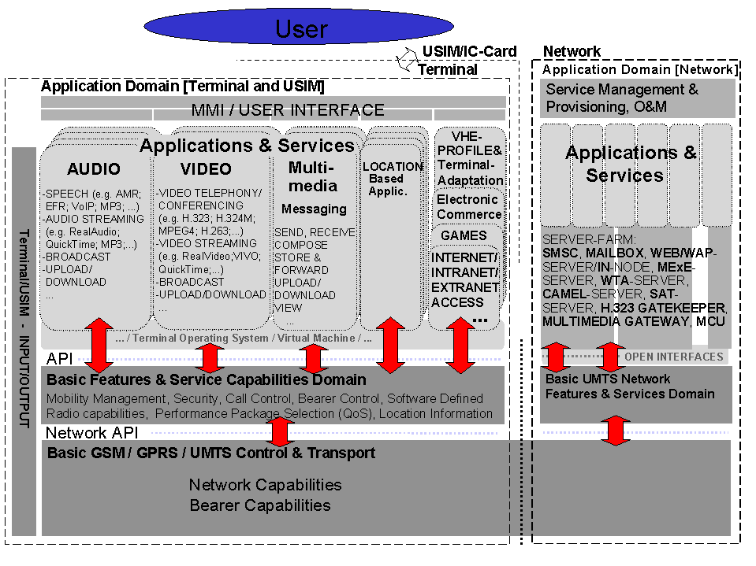
Figure 1: – The UMTS Services Environment

UMTS sERVICEs AND APPLICATION PLATFORM - REQUIREMENTS
The UMTS Service and Application Platform build the basis for Service Creation, Service Provisioning and Service Management.
It has to support all potential UMTS Multimedia Services in a
- cost efficient
- flexible
- scalable
- future proof and
- fast
way, and has to include open interfaces.
The UMTS Service and Application Platform has to allow the smooth integration of different Servers like CAMEL, MExE, SAT, Voicemail, SMSC, WTA, Multimedia Gateway, and many more...
The evolution and standardisation of features like MExE [and Symbian] has to be monitored by the network operators in order to ensure the expected result.
To save costs the usage of standard IP components is promising. The Internet environment allows the fast and cost-efficient service creation.
Internet technology and applications develop and evolve in a very dynamic way and in short time frames. This has to be reflected in the development of the UMTS Service and Application Platform.

minimum set of Services when roaming
To ensure that a roaming UMTS user enjoys consistent services (as required by the VHE concept), it is required that all UMTS networks support a minimum defined service set. It is also important to define a minimum service set that a UMTS roaming user will have when roaming onto GSM networks. The GSM Association aims to give guidance on the recommended minimum set of service for roaming.

GSM services to be supported in UMTS
Which GSM services shall be supported within UMTS?
The answer to this question is also relevant for those operators who would like to offer the full range of GSM services to roamers without having GSM as a basis for 3G (-> Japan)
Table 3 and 4 in ->ANNEX B – GSM Services to be supported by UMTS’ give a list of GSM services and provides a mapping to UMTS.

UMTS user roaming onto another 3G (UMTS) network
An example of a list that indicates a minimum set of services to be provided when roaming onto another 3G (UMTS) network can be found in ANNEX C – minimum set of services for 3G (UMTS) roaming’.
For further study...

UMTS user roaming within the 3G Home Environment (UMTS)
For further study...

UMTS user roaming onto a 2G (GSM) network
What set of services can be provided when a UMTS user roams onto a GSM network?
For further study...

ANNEX A – sERVICES AND Application LIST
This is a list of potential services and applications for UMTS:

Internet / Intranet / Extranet Access
WEB-Browsing, WAP-Browsing, FTP, e-mail, chat, Push, Pull, ...

Audio Communications
Speech, Audio Streaming (Audio On Demand), Audio Broadcast/Multicast/Group Call, Audio Download, Audio Messaging (Voice Mail), Emergency Call, ...

Video Communications
Video Telephony, Video Conferencing, Video Streaming (Video On Demand), Video Broadcast/Multicast /Group Call, Video Download, Video surveillance, ...

Multimedia Messaging
SMS, SMS-Broadcast/Multicast, Voice-Mail, Video-Mail, Electronic Postcard, Facsimile-Mail, Unified Messaging, ...

Games/Leisure
Multi Party Interactive Networking Games, Karaoke Conference, Game download, ...

Location based applications
Telematics, Road Traffic Assistance, Fleet Management, Travel Assistance, Remote Surveillance, Positioning Service, Location Tracking, Navigation Support, ...

Electronic Commerce
Mobile Banking, Micropayment, Online Shopping, Stock Trading, ...

Information and Education Services
Yellow Pages, Elections, Votings, Search Engines, Bookings, Reservations, Virtual School, Online Publication service, Online Book (e-book), Remote Consultation, ...

Support of Supplementary Services
Either by using GSM mechanisms or Service toolkits

Application Sharing

Terminal Maintenance and Software Support
User Profiles, Distributed Phonebook, Enhanced Addressing, Scheduler-Synchronization, Adaptive Terminal User Interface, Bug Fixing, Announcements, ...
... to be extended ...

ANNEX B – GSM Services to be supported by UMTS
It is clearly defined that UMTS shall support GSM services as well as new services such as high speed bearer services. Table 3 provides a mapping of all relevant 2G tele- and bearer- services to UMTS. Table 4 shows the Supplementary Services of GSM to be supported in UMTS and the applicability to the tele- and bearer services.
Support of GSM services in UMTS
Dominant attribute | Category of  Tele-/Bearerservice |  | Individual Tele-/Bearerservice |  |  | Support in UMTS
Type of user in- formation | No | Name | No | Name
Speech | 1 | Speech trans-mission | TS11  TS12 | Telephony  Emergency Calls |  | Required  Required
Short message | 2 | Short message service | TS21  TS22  TS23 | Short message MT/PP  Short message MO/PP  Short message cell broadcast |  | Required  Required  Required
Facsimile | 6 | Facsimile  Trans - | TS61 | Alternate speech and facsimile group 3 | T  NT | ?  ?
 |  | Mission | TS62 | Automatic Facsimile group 3 | T  NT | ?  ?
Data | 7 | All data circuit asynchronous | BS20 | General asynchronous bearer service |  | Required ¹⁾
Data | 8 | All data circuit synchronous | BS30 | General synchronous bearer service |  | Required ¹⁾
Speech | 9 | Voice Group service | TS91  TS92 | Voice Group Call Service  Voice Broadcast Service |  | Not required  Not required
Data | 13 | All GPRS access | BS70 | GPRS bearer service |  | Required ²⁾
Tab 3: Support of GSM services in UMTS
Note 1: Support of a generic bearer service does not imply support of all rates defined in GSM TS02.02.
Note 2: Support of data rates as defined in GSM TS02.60 and peak rates up to 2 Mbit/s.
Applicability of SSs to telecommunication services supported in UMTS
SS | Telephony | Emergency Call | SMS PTP |  | SMS-CB | cct Data | GPRS
 | TS11 | TS12 | TS21 | TS22 | TS 23 | BS20, BS30 | BS 70
EMLPP | Yes | Yes⁶ |  |  |  | Yes
CD | Yes |  |  |  |  | Yes
CLIP | Yes |  |  |  |  | Yes
CLIR | Yes |  |  |  |  | Yes
COLP | Yes |  |  |  |  | Yes
COLR | Yes |  |  |  |  | Yes
CFU | Yes |  |  |  |  | Yes
CFB | Yes |  |  |  |  | Yes
CFNRy | Yes |  |  |  |  | Yes
CFNRc | Yes |  |  |  |  | Yes
CW¹ | Yes |  |  |  |  | Yes
HOLD² | Yes
MPTY | Yes
CUG | Yes |  |  |  |  | Yes
AoCI | Yes |  |  |  |  | Yes
AoCC | Yes |  |  |  |  | Yes
UUS | Yes |  |  |  |  | Yes
BAOC | Yes |  | Yes³ | Yes |  | Yes
BOIC | Yes |  | Yes³ | Yes |  | Yes
BOIC-exHC | Yes |  | Yes³ | Yes |  | Yes
BIC | Yes |  | Yes | Yes³ |  | Yes
BIC-Roam | Yes |  | Yes | Yes³ |  | Yes
ECT | Yes
CCBS | Yes |  |  |  |  | Yes
SPNP | Yes |  | Yes⁴ | Yes⁴ |  | Yes
CNAP | Yes |  | ⁵ | ⁵
MSP | Yes |  | Yes | Yes |  | Yes
NOTE 1: The applicability of Call Waiting refers to the telecommunication service of the active call and not of the waiting call. The incoming, waiting, call may be of any kind.
NOTE 2: If the served mobile subscriber has a call on hold, she may set up another call using the same or a different telecommunication service.
NOTE 3: The SS is applicable, but generally will not be invoked.
NOTE 4: Both the SMS service centre and the mobile destination can be reached by PNP numbers.
NOTE 5: Applicability of SMS PTP to CNAP is for further study.
NOTE 6: The network shall apply a specific or the default priority level to emergency calls. There is no possibility to change this priority by the subscriber.
Pre-emption of an on-going emergency call is not possible.

Tab 4: Applicability of GSM Supplementary Services to Services supported in UMTS

ANNEX C – minimum set of services for 3G (UMTS) roaming
The following table gives an example of a list that defines the minimum services set that will be supported in the 3G roaming case.
SERVICES and Applications for 3G Roaming |  | Support: Yes / No | Comment
Applications
 | Video Communication supporting H.324M
 | Video Communication supporting H.323
 | ...
 | ...to be extended...
Services and Bearers
 | Telephony
 | Emergency Calls
 | Voice Group Call Service, Voice Broadcast Service
 | SMS MT/PP
 | SMS MO/PP
 | SMS Cell Broadcast
 | Alternate speech and facsimile group 3
 | Automatic Facsimile group 3
 | General synchronous bearer service
 | Unrestricted Digital e.g. 64kbit/s
 | GPRS bearer service
 | Packet Data e.g. 384 kbit/s
 | ...to be extended...
Network / Terminal Features
 | CAMEL
 | MExE
 | SAT
 | ...to be extended...
SUPPLEMENTARY SERVICES
 | EMLPP
 | CD
 | CLIP
 | CLIR
 | COLP
 | COLR
 | CFU
 | CFB
 | CFNRy
 | CFNRc
 | CW
 | HOLD
 | MPTY
 | CUG
 | AoCI
 | AoCC
 | UUS
 | BAOC
 | BOIC
 | BOIC-exHC
 | BIC
 | BIC-Roam
 | ECT
 | CCBS
 | SPNP
 | CNAP
 | MSP
 | ...
Tab. 5: Minimum set of services for 3G (UMTS) roaming

*This could mean for instance: Speech application: -> Service Class RealTime (Conversational); [Very low delay, BER ~10⁻³, eg. 8kbit/s] Messaging application(e.g. SMS): -> Service Class NonRealTime (Messaging); [Delay ~2-10 sec, BER very low, low bitrate]

