Espoo January 9th, 2001

TO MEMBERS OF 3GPP

Invitation to the 3GPP TSG SA Workshop on UE in idle mode,
to be held on 7-8 February 2001
in Helsinki, Finland.

Dear Colleagues,

Nokia has the pleasure to inform you of the arrangements for the above-mentioned workshop

The venue of this meeting will be:
Euro Congress Center
Annankatu 41
Helsinki
Finland

Based on the discussions that took place in TSG SA and TSG RAN, need for a workshop addressing the UE operation in idle mode was identified.

The goal of the workshop is to review and address the following topics, both from a requirement and functional point of view:
- PLMN selection
- Cell selection and reselection
- Handovers

It was felt it would be beneficial to have participation from at least the following groups in the workshop:
- TSG RAN WG1, WG2 & WG4
- TSG SA WG1 and WG2
- TSG CN WG1
- TSG GERAN WG1 and WG2

The workshop will take place on 7-8 of February 2001, in Euro Congress Center, Annankatu 41, in downtown Helsinki next to the bus station.

The contributions to the workshop should be submitted 2 days in advance (at the latest) on the TSG SA & TSG RAN reflectors and will be distributed on CD-ROM at the beginning of the meeting. The Tdoc numbers for the contributions will be allocated by the meeting chairman, Niels Andersen. Requests for Tdoc numbers for this workshoip should be sent to: npa001@email.mot.com with a clear indication in the subject field of Request for Tdoc number.

You should register electronically before 28th of January 2001 (see annex below). There will be no separate confirmation done for the meeting registration.

Please make separate reservation for the hotel by Jan. 17th /Feb 1st depending on the hotel you choose. The hotels have a block booking on the first come first served basis. Annexed to this invitation you will find information about booking the hotels.

The Weather In Helsinki: The winters are not terribly cold, averaging around -5°C (+23°F) or so - but great fluctuations are possible, so be prepared.

More information about Helsinki can be found from: http://www.hel.fi/tourism/



I look forward to seeing you in Helsinki!

Yours sincerely,

Antti Toskala
Standardisation Manager
IP Mobility Networks
Nokia Networks
Finland

PS. In case you need a personal invitation for visa purposes, please send your personal details and fax number to: Ext-Anne.Aziz@nokia.com with the subject"3GPP workshop personal invitation"

Hotels with block booking for the 3GPP workshop. Both hotels are within 5 min walking distance from the workshop venue.

1. Hotel Ramada Presidentti
Eteläinen Rautatiekatu 4, 00100 HELSINKI
Phone: 358-9-6911
Fax: 358-9-691 3135
3GPP room rate 650 FIM/Night. Booking deadline Feb 1st.

2. Hotel Radisson SAS Royal
Runeberginkatu 2, 00100 HELSINKI
Tel: +358-9-69580

Fax: +358-9-69587000
3GPP room rate 700FIM/1075FIM (Standard/Business room). Booking deadline Jan. 17th

For Meeting Venue Location, see the attached map. (Annankatu 41,next to the bus station)

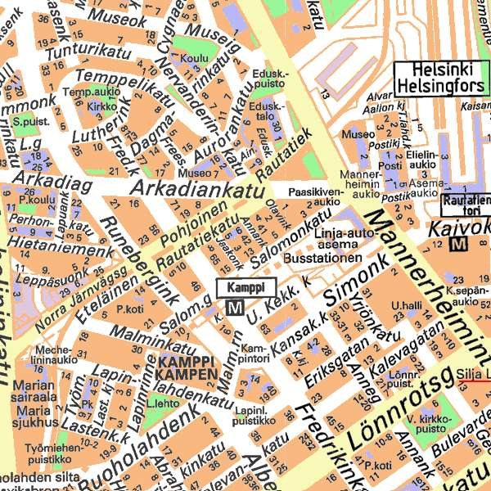

Annex 2. Hotel Reservation form
3GPP TSG SA Workshop on UE in idle mode 7th – 8th February 2001

Hotel Reservation form for the Nokia/3GPP block booking

To book rooms and obtain these special 3GPP/Nokia rates above, please fax this form to the selected hotel by the booking deadline. After that date the block bookings for hotel are no longer valid.

HOTEL: …………………………………….DESIRED ROOM TYPE…………………………………………

FAX: +358-9-……………………………………

Name……………………………………………………………………………………………………………………

Company…………………………………………………………………………………………………………………

Address……………………………………………………………………………………………………………………

Telephone…………………………………………………………………………………………………………………

Fax:……………………………………………………………………………………………………..…………………

Date of Arrival………………………………………………Date of Departure……………………………………….

Credit Card Number……………………………………………Exp. Date…………………………………………….

Date………………………………… Signature…………………………………………………………………………

The hotel booking is available on the first come first served basis.

This same form can be used to book also the hotel if you attend for the other 3GPP workshop 5th -6th of Feb on UTRAN Evolution if you are attending both of them, see separate invitation.

ANNEX 3: ON-LINE MEETING REGISTRATION

An on-line meeting registration tool allows the participants to register for the 3GPP Meetings via a web interface.

You are kindly requested to submit your registration at:
http://webapp.etsi.org/3GPPRegistration/fMain.asp?mid=

