19th March 2007
Kobe International Conference Center

A Free Limousine Bus Service
From the Ferry Terminal @Kobe Airport to Hotels in Kobe

We are pleased to inform you that the free limousine bus service from the ferry terminal @Kobe Airport to hotels in Kobe is provided for all participants to the 3GPP meeting.

Operation schedule is as follows:

Date & Time: Sunday, 6th May 2007, 11:00 ~ 19:00
A limousine bus leaves for hotels in Kobe coupled with the arrival time of the High-Speed Ferry from KIX.
Route:
The Ferry Terminal @Kobe Airport -> Kobe Portopia Hotel -> Quality Hotel Kobe -> Hotel Pearl City Kobe -> Crowne Plaza Hotel Kobe -> JR Sannomiya St. -> The Ferry Terminal @Kobe Airport
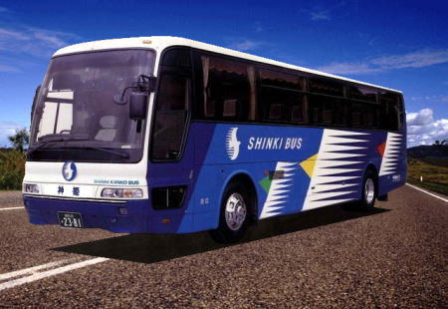
Free Limousine Bus

For your information, we indicate how to get to the High-speed Ferry terminal from KIX below:

- Purchase a ticket from the High-Speed Ferry Ticket Counter at the northern end of the Passenger Terminal Building on the 1st floor. (Fares: 1,500 yen)
- Take the free shuttle bus from Bus Stop No.12 outside the Passenger Terminal Building on the 1st floor.
- 6-8 min of the shuttle ride brings you to the ferry terminal.

High-Speed Ferry Time-Table (It shows daytime only.)
KIX dept. | Kobe Airport Arv. | KIX dept. | Kobe Airport Arv.
10：15 | 10：44 | 15：00 | 15：29
11：00 | 11：29 | 15：45 | 16：14
11：45 | 12：14 | 16：30 | 16：59
12：30 | 12：59 | 17：15 | 17：44
13：30 | 13：59 | 18：00 | 18：29
14：15 | 14：44

