**3GPP TSG-RAN4 Meeting #96-e *R4-2012699***

**Online, , 17th Aug 2020 - 28th Aug 2020**

|  |  |  |  |  |  |  |  |  |
| --- | --- | --- | --- | --- | --- | --- | --- | --- |
| *CR-Form-v12.0* | | | | | | | | |
| **CHANGE REQUEST** | | | | | | | | |
|  | | | | | | | | |
|  | **37.941** | **CR** | **0001** | **rev** | **1** | **Current version:** | **15.0.0** |  |
|  | | | | | | | | |
| *For* [*HE**LP*](http://www.3gpp.org/3G_Specs/CRs.htm#_blank)*on using this form: comprehensive instructions can be found at* [*http://www.3gpp.org/Change-Requests*](http://www.3gpp.org/Change-Requests)*.* | | | | | | | | |
|  | | | | | | | | |

|  |  |  |  |  |  |  |  |  |
| --- | --- | --- | --- | --- | --- | --- | --- | --- |
| ***Proposed change affects:*** | UICC apps |  | ME |  | Radio Access Network | **X** | Core Network |  |

|  |  |  |  |  |  |  |  |  |  |  |
| --- | --- | --- | --- | --- | --- | --- | --- | --- | --- | --- |
|  | | | | | | | | | | |
| ***Title:*** | CR to TR 37.941: Clause 6 Measurement Types | | | | | | | | | |
|  |  | | | | | | | | | |
| ***Source to WG:*** | Ericsson | | | | | | | | | |
| ***Source to TSG:*** | R4 | | | | | | | | | |
|  |  | | | | | | | | | |
| ***Work item code:*** | OTA_BS_testing-Perf | | | | |  | ***Date:*** | | | 2020-08-06 |
|  |  | | | |  | |  | | |  |
| ***Category:*** | F |  | | | | | ***Release:*** | | | Rel-15 |
|  | *Use one of the following categories:* ***F*** *(correction)* ***A*** *(mirror corresponding to a change in an earlier release)* ***B*** *(addition of feature),* ***C*** *(functional modification of feature)* ***D*** *(editorial modification)*  Detailed explanations of the above categories can be found in 3GPP [TR 21.900](http://www.3gpp.org/ftp/Specs/html-info/21900.htm). | | | | | | | | *Use one of the following releases: Rel-8 (Release 8) Rel-9 (Release 9) Rel-10 (Release 10) Rel-11 (Release 11) Rel-12 (Release 12)* *Rel-13 (Release 13) Rel-14 (Release 14) Rel-15 (Release 15) Rel-16 (Release 16)* | |
|  |  | | | | | | | | | |
| ***Reason for change:*** | | Definitions of EIRP/TRP are not inclusive of all test methods | | | | | | | | |
|  | |  | | | | | | | | |
| ***Summary of change:*** | | Updated text with TRP derivation for near and far field intrepretation also generalized TRP defintion by utilizing power density in derivation. | | | | | | | | |
|  | |  | | | | | | | | |
| ***Consequences if not approved:*** | | Near field test methods are excluded from TRP test methods | | | | | | | | |
|  | |  | | | | | | | | |
| ***Clauses affected:*** | | 6.1,6.2,6.3 | | | | | | | | |
|  | |  | | | | | | | | |
|  | | **Y** | **N** |  | | | |  | | |
| ***Other specs*** | |  | **X** | Other core specifications | | | | TS/TR ... CR ... | | |
| ***affected:*** | |  | **X** | Test specifications | | | | TS/TR ... CR ... | | |
| ***(show related CRs)*** | |  | **X** | O&M Specifications | | | | TS/TR ... CR ... | | |
|  | |  | | | | | | | | |
| ***Other comments:*** | |  | | | | | | | | |
|  | |  | | | | | | | | |
| ***This CR's revision history:*** | | Revision of R4-2009970 | | | | | | | | |

[Start of Changes]

# 2 References

The following documents contain provisions which, through reference in this text, constitute provisions of the present document.

- References are either specific (identified by date of publication, edition number, version number, etc.) or non‑specific.

- For a specific reference, subsequent revisions do not apply.

- For a non-specific reference, the latest version applies. In the case of a reference to a 3GPP document (including a GSM document), a non-specific reference implicitly refers to the latest version of that document *in the same Release as the present document*.

[1] 3GPP TR 21.905: "Vocabulary for 3GPP Specifications"

[x] J. Fridén, A. Razavi, and A. Stjernman, “Angular sampling, Test Signal, and Near-Field Aspects for Over-the-Air Total Radiated Power Assessment in Anechoic Chambers”, IEEE Access, 2018, https://ieeexplore.ieee.org/stamp/stamp.jsp?arnumber=8470084.

[Unchanged Sections]

# 6 Measurement types

## 6.1 Spatial definitions

Spatial definitions for classification of the OTA requirements were introduced below. OTA transmitter requirements can be split into either:

1. Directional requirements: The BS manufacturer declares beam(s) and coverage ranges over which the beam can be steered. Directional requirement type does not imply the requirement is defined only in one direction as many directional requirements have a number of compliance directions. It implies that the directional requirement applies to a single direction at a time.
2. TRP requirements: TRP is a requirement, which is defined as the total power radiated by the BS in all radiation space.
3. Co-location requirements: Co-location requirements are based on assumption that the BS is co-located with another BS of the same base station class. Co-location requirements ensure that both co-located systems can operate with minimal degradation to each other.

NOTE: Co-location requirements are only applicable in FR1, i.e. for OTA AAS BS, or for *BS type 1-O*.

## 6.2 Directional measurements

### 6.2.1 General

of therequirements

### Some example directional requirements are defined with respect to an isotropic antenna in terms of EIRP and EIS. EIS is related to the power density of a plane wave incident on the BS when the power level in the receiver is at the sensitivity level. 6.2.2 Beam parameter definitions

A beam (of the antenna) is the main lobe of the radiation pattern of an *antenna array* of the BS. A beam is created by means of a superposition of the signals radiated from different parts of the *antenna array*.

Each *beam direction pair* is associated with half-power contour of the *beam centre direction* and a *beam peak direction*. The EIRP is declared at the *beam peak direction*. The *beam centre direction* is used for describing beam steering.



**Figure 6.2.2-1: Example of *beam direction pair***

In figure 6.2.2-1 left sub-figure shows a symmetrical beam where *beam centre direction* and *beam peak direction* are the same. In figure 6.2.2-1 right sub-figure shows an example of a beam with ripple where the *beam centre direction* and the *beam peak direction* are different.

The number of declared BS beams is for the manufacturer to declare. Some examples of declarations of beams are illustrated in a *directions diagram* in figure 6.2.2-2.



**Figure 6.2.2-2: Examples of BS beam declarations depicted in a *directions diagram***

In figure 6.2.2-2 the shaded areas/points represent the declared EIRP directions set, which may be continuous (top right, bottom right) or not continuous (bottom left), or be restricted to just the points of maximum steering (top left). The red coloured points represent the compliance test points at which EIRP is declared. The maximum EIRP and its accuracy are defined for the declared beams when activated individually on all corresponding RE and the requirements are placed per individual beam.

The maximum radiated transmit power of the BS beam is the mean power level measured at the declared *beam peak direction* at the RF channels B (bottom), M (middle) and T (top) when configured for maximum EIRP value for a specific BS beam of the supported frequency channels declared by the manufacturer.

Another form of directional measurement is the *OTA sensitivity directions declaration(s)* (OSDD) used for the receiver directional requirements. OSDD is declared for OTA sensitivity requirement and described in more details in clause 6.2.3.

### 6.2.3 OSDD

If an OSDD does not include a *receiver target redirection range*, conformance testing is performed for the following five directions, as depicted in the example in figure 6.2.3-1:

- The receiver target reference direction.

- The direction determined by the maximum  value achievable inside the sensitivity RoAoA maintaining the receiver target reference direction  value.

- The direction determined by the minimum  value achievable inside the sensitivity RoAoA maintaining the receiver target reference direction  value.

- The direction determined by the maximum  value achievable inside the sensitivity RoAoA maintaining the receiver target reference direction  value.

- The direction determined by the minimum  value achievable inside the sensitivity RoAoA maintaining the receiver target reference direction  value.

The manufacturer declares the five directions for conformance testing.



Figure 6.2.3-1: OSDD without target redirection capability

In figure 6.2.3-1 a direction diagram shows a RoAoA without *receiver target* redirection capability. The *receiver target reference direction* and the extreme directions subject to conformance testing are marked by red crosses.

If an OSDD includes a *receiver target redirection range*, conformance testing is performed for the following five directions, as depicted in the example in figure 6.2.3-2:

- The receiver target reference direction.

- The direction determined by the maximum  value achievable inside the receiver target redirection range maintaining the receiver target reference direction  value.

- The direction determined by the minimum  value achievable inside the receiver target redirection range maintaining the receiver target reference direction  value.

- The direction determined by the maximum  value achievable inside the receiver target redirection range maintaining the receiver target reference direction  value.

- The direction determined by the minimum  value achievable inside the receiver target redirection range maintaining the receiver target reference direction  value.

The manufacturer declares the five directions for conformance testing, the setting of the AAS BS to achieve conformance at each of the conformance test directions, and the resulting *sensitivity RoAoA* for each of these settings.

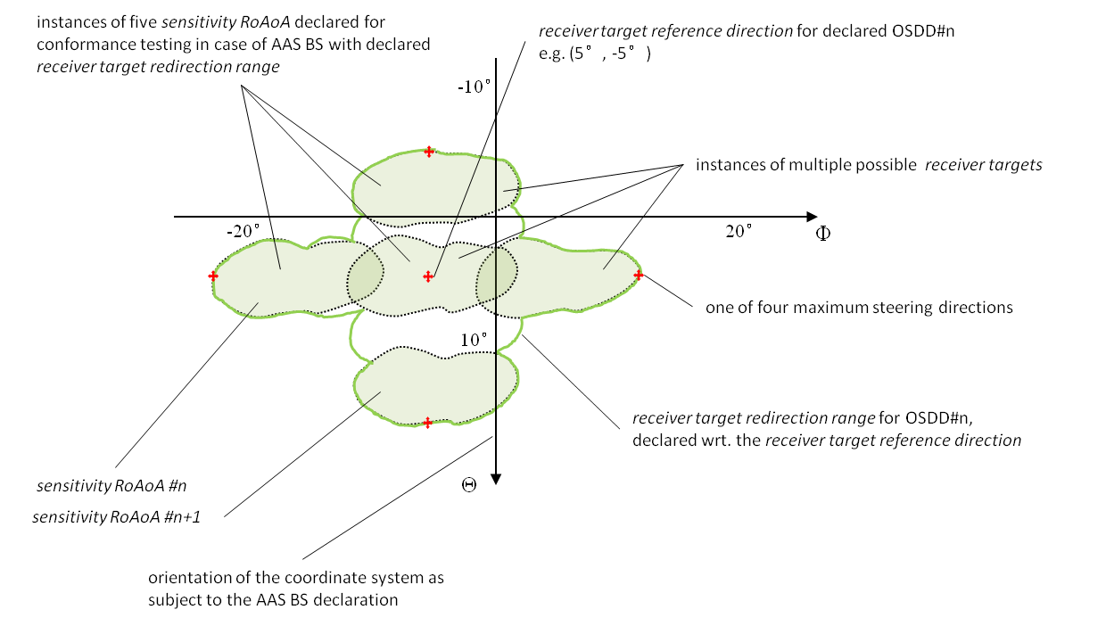

Figure 6.2.3-2: OSDD with target redirection capability

In figure 6.2.3-2, a direction diagram is showing a *receiver target redirection range* (with discrete settings for the *sensitivity RoAoA*). The *receiver target reference direction* and the extreme directions subject to conformance testing are marked by red crosses. The *sensitivity RoAoA* for each conformance test setting is shown as shaded. Note that each *sensitivity RoAoA* is exceptionally small compared to the *receiver target redirection range*, for demonstration purposes.

## 6.3 TRP measurement

### 6.3.1 General

The TRP or the radiated power is simply the total power radiated by a BS. In theory, due to energy conservation, TRP is independent of choice of test distance.

In theory, TRPReference is defined as the integral of the BS’s far field *radiation pattern* over a spherical surface, that is



where *U(θ, ϕ) $U(θ,ϕ)$* is the radiation intensity at each angle in watts per Steradian TRPReference can also be expressed in terms of power flux density

 (6.3.1-1)

 the time average of the Poynting vector (average power density) or the power flux of the electromagnetic field, where $\vec{E}$ and $\vec{H}$  are effective values of the time-harmonic electric- and magnetic-field intensities, respectively. Furthermore, $Re$ denotes real part, denotes the complex conjugate of $H$, and × is vector cross product.

 average power density in watts per square metre, which is a scalar.

 unit vector normal to the closed surface $S$.

 infinitesimal area of the closed surface.

For practical reasons, a sphere of radius $r$ is a common choice for the closed surface, but also other surfaces can be considered e.g. cylinder and planar surface. The spherical coordinate system defined in clause 3 is assumed in this subclause.

In the far-field limit ($r→∞$), the $\vec{E}$ and $\vec{H}$ fields consist of the tangential components ( ${\vec{E}}_{t}$ and ${\vec{H}}_{t}$), respectively and the radial components (${\vec{E}}_{r}$ and ${\vec{H}}_{r}$) are negligible, and, therefore,, where $η$ is the intrinsic impedance of vacuum (i.e. ohms). Thus, the TRP equation becomes



 (6.3.1-2)

, where.

The radiation intensity in the far-field region in watts per steradian is defined as



The power density can be expressed in terms of EIRP as

 (6.3.1-3)

and when r is large, radiation intensity is proportional to 1/r2 hence in the far field region Pd ~ 1/r2 and Pd multiplied with r2 becomes roughly constant value and thus the radiation intensity equation can be defined at 1/r2 as

Thus, the definite integral for TRPReference becomes

Since EIRP is defined only in the far- field. However, in, some occasions the power measurements can be performed at distances less than 2d2/λ (i.e. the traditional approximate far-field distance boundary). In such cases it is may be possible to measure power density in the radiative near- field considering only the magnitude of the tangential part of E field, $\left|E_{t}\left(r,θ,ϕ\right)\right|,$ with an acceptable level of accuracy [2]. Explicitly, it is as demonstrated in [x] that the TRP, i.e., the integration of over a sphere, is well approximated by the integral of ${\left|E_{t}\right|}^{2}/η$ over the same sphere.assuming far field conditions. Thus TRPReference can be expressed as



For near-field measurements use the approximation where $P_{D}\left(r,θ,ϕ\right)=\frac{{\left|E_{t}\left(r,θ,ϕ\right)\right|}^{2}}{η}$ and $η=\sqrt{\frac{μ_{0}}{ε_{0}}}≈377 Ω$ (intrinsic impedance of vacuum).

The minimum distance between the measurement antenna and the smallest sphere enclosing the BS shall be at least 2λ and the test distance shall be at least the far-field distance of the measurement antenna when considering the TRP measurements under far field conditions. More details about the necessary conditions for accurate power density-based measurements close to BS are included in annex F.

When measuring radiated power, at each measurement point, two partial results for two orthogonal polarizations needs to be summed. These can be the θ and ϕ polarizations or any pair of orthogonal polarizations.

The distribution of sampling points on the spherical surface depends on the type of sampling grids applied, the frequency and the size of the radiating source. In the following clauses, several spherical sampling grids which can be applied to EIRP or power density measurements are described.

[End of Text Proposal]