3GPP TSG-RAN WG4 Meeting # 108bis R4-2317282
Xiamen, China, 9th – 13th October 2023

Agenda item: TBA
Source: Ad-hoc chair (Intel Corporation)
Title: Ad-hoc minutes for [232] Reply_LS and [227] NR_redcap_enh
Document for: Approval

Introduction
This document is the ad-hoc minutes for with the following topics covered.
- [232] Reply_LS
- Topic 1: Applicability of pre-configured measurement gaps for RedCap UE (R3-233478)
- Topic 2: Monitoring of paging occasions for CG-SDT with HD-FDD Redcap UEs (R2-2304562)
- Topic 3: LS on CG-SDT RRM test procedure (R5-235340)
- Topic 4: LS on additional UE Gain parameters (R5-233669)
- Topic 5: LS on RRM test cases with testability issues (R5-233782)
- Topic 6: LS on SRS antenna switching for TDD-FDD band combinations. (R1-2308582)
- Topic 7: Reply LS on update for “interBandMRDC-WithOverlapDL-Bands-r16” in 38.306. (R2-2309218)
- [227] NR_redcap_enh

[232] Reply_LS

Topic #1: Applicability of pre-configured measurement gaps for RedCap UE (R3-233478/R4-2311008)
RAN4 #108 agreements:
- Agreement: No RAN4 RRM requirements are specified for Rel-17 RedCap with Rel-17 pre-MG.
- Conclusion: Do not send LS

Open issues
Issue 1-1-1: How to consider Pre-MG for RedCap in RAN4?
- Proposals
  - Proposal 1: RAN4 not to specify applicability of Pre-MG for RedCap in Rel-17 & consider applicability of Pre-MG for eRedCap in Rel-18.
  - Other, please specify.
- Discussion
- Agreement

Issue 1-1-2: Do you agree to consider Pre-MG for RedCap as release independent feature from Rel-17?
- Proposals
  - Proposal 1: Yes
  - Proposal 2: No
- Discussion
- Agreement

Issue 1-1-3: Do you think it necessary to send reply LS regarding R3-233478?
Note: RAN4 is CCed and no action is required in the incoming LS.
- Proposals
  - Proposal 1: Yes, send Reply LS to RAN2 informing RAN2 on the preferred solution of,
    - addition to Rel-18 eRedCap WI scope or
    - addition as release-independent feature to RedCap from Rel-17.
  - Proposal 2: No
- Discussion
- Agreement

Tdoc recommendations
TDoc | Title | Source | Type | For | Agenda item | Recommendations
R4-2316740 | Applicability of Pre-MG for RedCap UE | Nokia, Nokia Shanghai Bell | discussion | Discussion | 7.2.1 | Noted

New tdocs
Title | Source

Topic #2: Monitoring of paging occasions for CG-SDT with HD-FDD Redcap UEs (R2-2304562/R4-2307018)
RAN4#108 agreements
- R4-2314464 Reply LS on Monitoring of paging occasions for CG-SDT with HD-FDD Redcap UEs
  - RAN4 will further update requirements for the case of partial collisions of POs with CG-SDT occasions for HD-FDD RedCap UE within the SI modification period based on RAN2 LS
  - There are no existing RRM requirements for the case when all available POs are colliding with CG-SDT occasions for HD-FDD RedCap UE within the SI modification period.
    - RAN4 is not planning to cover this scenario in Rel-17 or Rel-18 specifications.

Open issues

Issue 2-1-1: If the configured CG-SDT occasions happen to overlap with paging occasions, how to modify RRM requirement?
- Proposals
  - Proposal 1: (Huawei)
For RedCap UE in HD-FDD mode, if paging occasions partially overlap with CG-SDT transmission, the UE is required to monitor for SI change indication in any paging occasion at least once per modification period [2] during SDT if the initial downlink BWP on which the SDT procedure is ongoing is associated with a CD-SSB. There is no requirement in case all available paging occasions overlap with the CG-SDT transmissions.
  - Proposal 2: (Ericsson)
For RedCap UE in HD-FDD mode, if a paging occasion overlaps with CG-SDT transmission within a SI modification period, then the UE shall monitor for paging in any of the paging occasions within the same SI modification period. In this case the UE is allowed to drop the CG-SDT transmission.
  - Proposal 3: (Media Tek)
For RedCap UE in HD-FDD mode, if some of paging occasions overlap with CG-SDT occasions within the SI modification period then it is up to UE implementation whether to monitor the paging during the paging occasions or perform CG-SDT transmissions.
  - Proposal 4: (Nokia)
For RedCap UE in HD-FDD mode, the UE shall monitor paging for SI change indication in any paging occasion at least once per modification period [2] during SDT if the initial downlink BWP on which the SDT procedure is ongoing is associated with a CD-SSB. In case the determined paging occasion overlaps with the CG-SDT transmission, the UE shall determine another paging occasion in the modification period, else if no paging occasion in the modification period is identified, if a paging occasion overlaps with CG-SDT transmission then the UE shall monitor the paging during the paging occasion. In this case
  - Proposal 5: (vivo)
To align RAN1/2/4 specification, prefer to delete the corresponding part “For RedCap UE in HD-FDD mode, if a paging occasion overlaps with CG-SDT transmission then the UE shall monitor the paging during the paging occasion. In this case the UE is allowed to drop the CG-SDT transmission.”

- Recommended WF
  - Based on which proposal is agreeable, the corresponding CR can be used as baseline.
- Discussion
- Agreement

Tdoc recommendations
TDoc | Title | Source | Type | For | Agenda item | Release | Spec | CR category | Recommendations
R4-2315287 | Draft CR to Rel-17 TS 38.133 on monitoring of paging occasions for CG-SDT with HD-FDD Redcap UEs | MediaTek inc. | draftCR | Endorsement | 7.2.2 | Rel-17 | 38.133 | F | Noted
R4-2315288 | Draft CR to Rel-18 TS 38.133 on monitoring of paging occasions for CG-SDT with HD-FDD Redcap UEs (Mirror) | MediaTek inc. | draftCR | Endorsement | 7.2.2 | Rel-18 | 38.133 | A
R4-2315668 | Modification on interruption in paging reception for HD-FDD RedCap Ues R17 | Huawei, HiSilicon | draftCR | Endorsement | 7.2.2 | Rel-17 | 38.133 | F
R4-2315669 | Modification on interruption in paging reception for HD-FDD RedCap Ues R18 | Huawei, HiSilicon | draftCR | Endorsement | 7.2.2 | Rel-18 | 38.133 | A
R4-2316352 | Monitoring of paging occasions for CG-SDT with HD-FDD Redcap UEs | Ericsson | discussion | Discussion | 7.2.2 | Rel-17 |  |  | Noted
R4-2316353 | CR on monitoring of paging occasions for CG-SDT with HD-FDD Redcap UEs | Ericsson | draftCR | Endorsement | 7.2.2 | Rel-17 | 38.133 | F
R4-2316354 | CR on monitoring of paging occasions for CG-SDT with HD-FDD Redcap UEs | Ericsson | draftCR | Endorsement | 7.2.2 | Rel-18 | 36.133 | A
R4-2316605 | Further discussion on reply LS on Monitoring of paging occasions for CG-SDT with HD-FDD Redcap UEs | vivo | discussion | Discussion | 7.2.2 |  |  |  | Noted
R4-2316741 | Draft CR 38.133 Monitoring of paging occasions for CG-SDT with HD-FDD Redcap UEs | Nokia, Nokia Shanghai Bell | draftCR | Endorsement | 7.2.2 | Rel-17 | 38.133 | F
R4-2316742 | Draft CR 38.133 Correction of RedCap UE behaviour in case of overlap of paging occasion and CG-SDT transmission | Nokia, Nokia Shanghai Bell | discussion | Discussion | 7.2.2 | Rel-17 |  |  | Noted

Topic #3: LS on CG-SDT RRM test procedure (R5-235340/R4-2315022)
RAN4 test case for SDT is defined with two test phases, each triggered by an RRC Release message, and UL data is triggered in each phase. The first (positive) phase is to verify that UE correctly conducts CG-SDT Tx in a condition with valid TA, and the second (negative) phase is to verify that UE does not conduct CG-SDT Tx in a condition with invalid TA. UE stays in INACTIVE mode when transitioning from phase 1 to phase 2, i.e. UE receives the second RRC Release message second UL data packets when it is in INACTIVE.
In R5-235240, RAN5 raised an issue on positive check and negative check for CG-SDT test. RAN5 explored triggering 2 separate MO transmissions without the need for UE to return to RRC_CONNECTED and concluded that the simplest way to test the RAN4 requirement for positive and negative check mentioned above is by splitting the test into 2 subtests, each starting in RRC_CONNECTED in time interval TA and ending in time interval TH with different power levels such that subtest 2 is only tested if subtest 1 passes

Open issues
Issue 3-1-1: Whether to split CG-SDT test for positive check and negative check?
- Proposals
  - Proposal 1: Yes (MediaTek, Huawei, Ericsson)
    - Test 1 verifies the positive check to ensure that CG-SDT transmission is performed,
    - Test 2 verifies the negative check to ensure that CG-SDT transmission is not performed.
  - Proposal 1a: [No] (Qualcomm)
    - Subtest 1 and Subtest2 are not independent. Subtest2 is executed only when subtest1 is passed.
    - Test is passed when both subtest1 and subtest2 are passed in single test.
    - Split test for two subtests by updating test description.
  - Proposal 2: No (Nokia)
    - Concerned with the number of tests the proposal results in and the ramifications for test time.
- Recommended WF

Issue 3-1-2: If the answer to Issue 3-1-1 is “yes”, what would be the solution to split CG-SDT test?
- Proposals
  - Proposal 1 (MediaTek):
    - In Sub-test#1, the original time points are reused with removing T5 and deducting W1 from T4. Also, the RRC Release at TH need to be replaced with RRC Resume for returning the UE to connected state. Use the power levels and time points for Sub-test#1 as below:
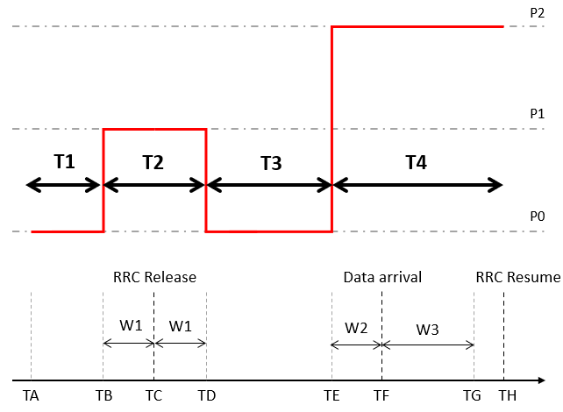
    - In Sub-test#2, the time points are repeated from Sub-test#1 with removing time point TH.Use the power levels and time points for Sub-test#2 as below:
- 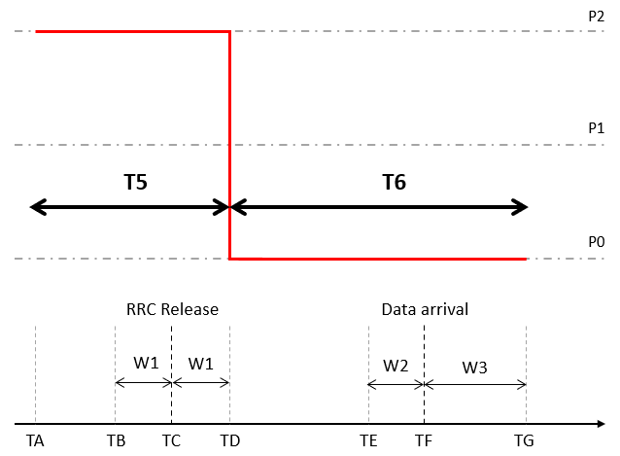

  - Proposal 2 (Huawei):
    - Sub-test#1:
- 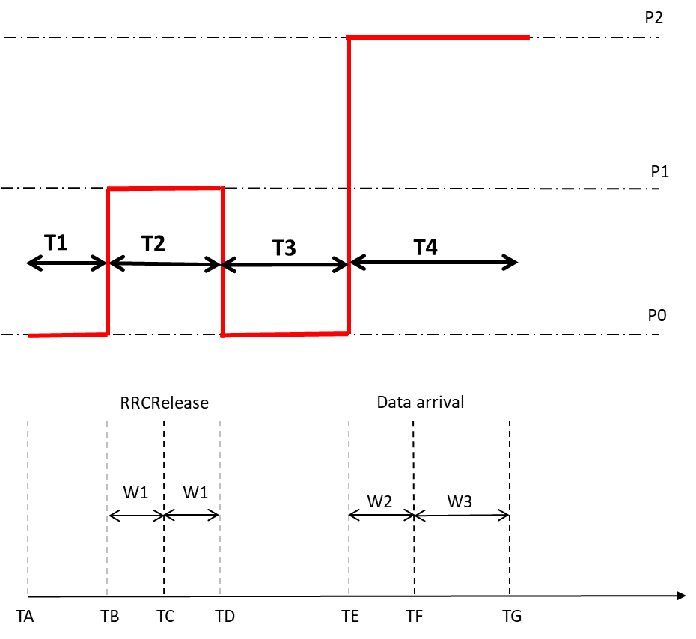

    - Sub-test#2
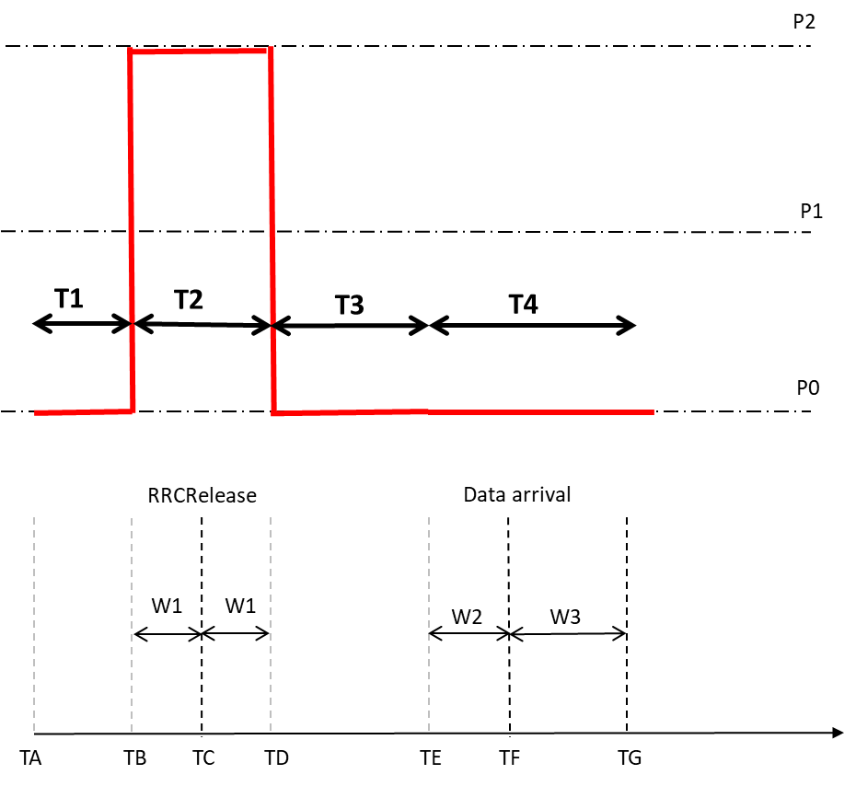

  - Other, please specify.
- Recommended WF

Issue 3-1-3: If the answer to Issue 3-1-1 is “No”, what would be the solution to address the testability issue facing by RAN5?
- Proposals
  - Proposal 1 (Qualcomm): update the current test procedure:
Test is passed when both subtest1 and subtest2 are passed in single test.
- Note: It required go back to RRC CONNECTED after TG and return to RRC INACTIVE state at time point TH.
- Note: If UE does not transmit CG-SDT on TG then subtest2 is not executed, and the test is fail.
- Note: If UE transmit CG-SDT on TG, and UE transmit CG-SDT after TH, then the test is fail.
- Note: Subtest1 and subtest2 are not independent.
RAN4 does not specify time period for RRC transition between subtest1 and subtest2. E.g ) RAN4 does not specify time period between TL and TH.
Power level keep same as P2 during RRC CONNECTED state after TG.
Update T4 definition from TE to TL. Introduce T5’ from TL to TH
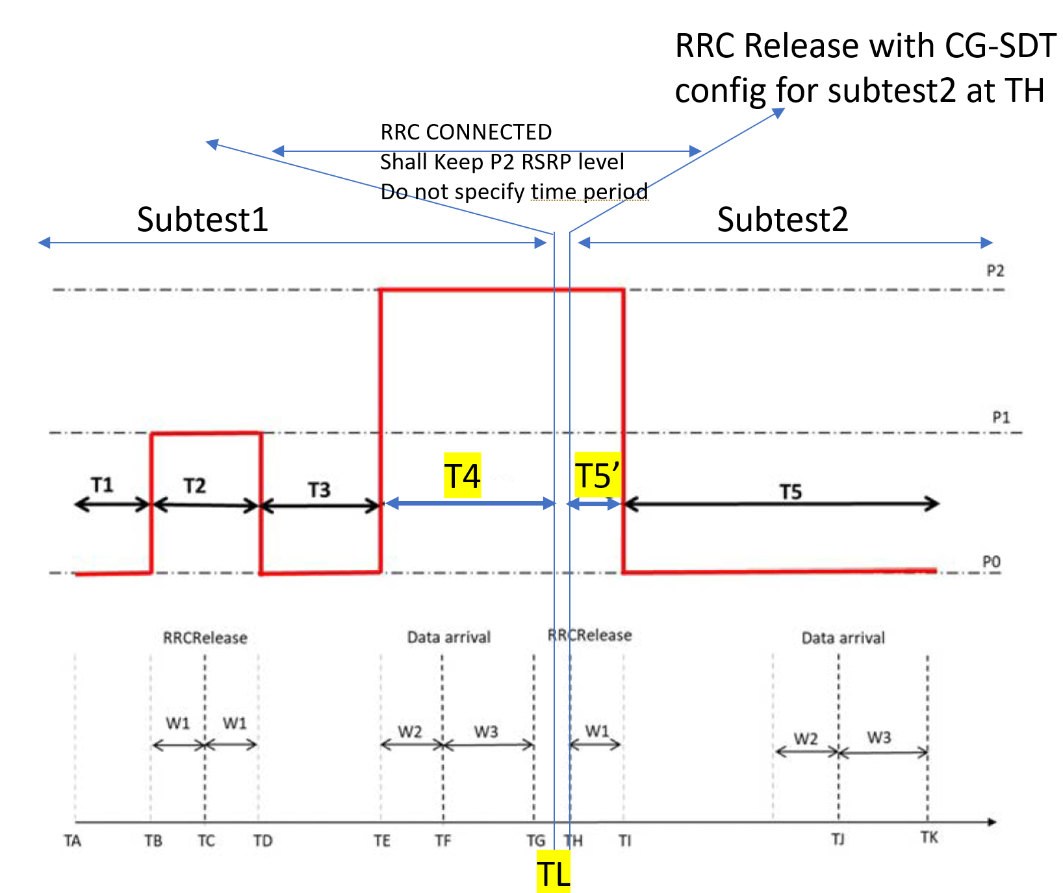

  - Proposal 2 (Nokia):
    - Propose/Suggest RAN5 to add 1 bit to the existing signaling message for UE test loop mode B, repeating T_delay_modeB once upon expiry, reusing same PDU’s for transmission and adapt timer values for the RAN4 tests to ensure sufficient distance between TI and TJ upon second expiry of T_delay_modeB.
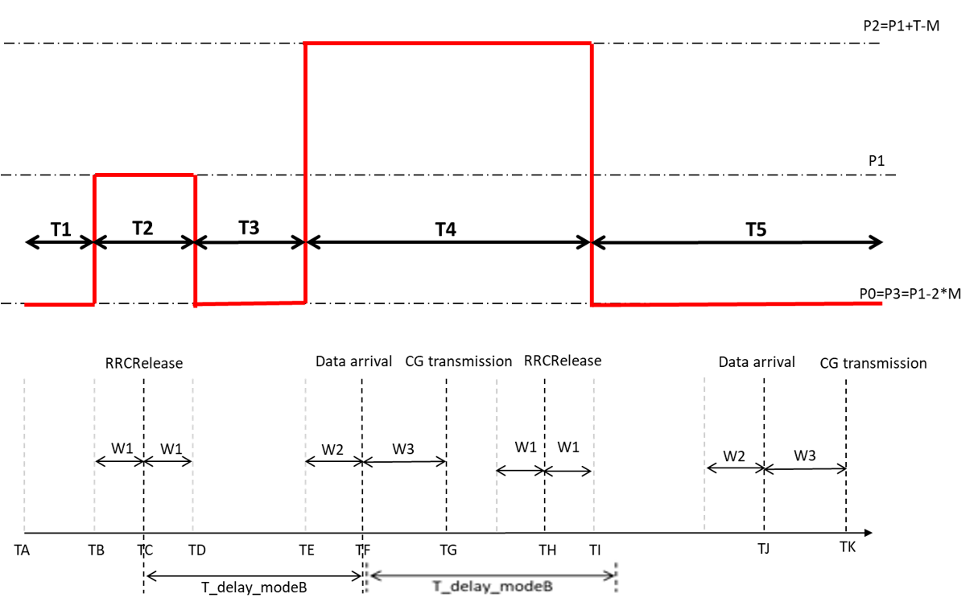
  - Propsoal 3 (Nokia):
    - Re-enter RRC Connected mode between test points TG and TH to re-enter test mode B and start a new T_delay_modeB timer.
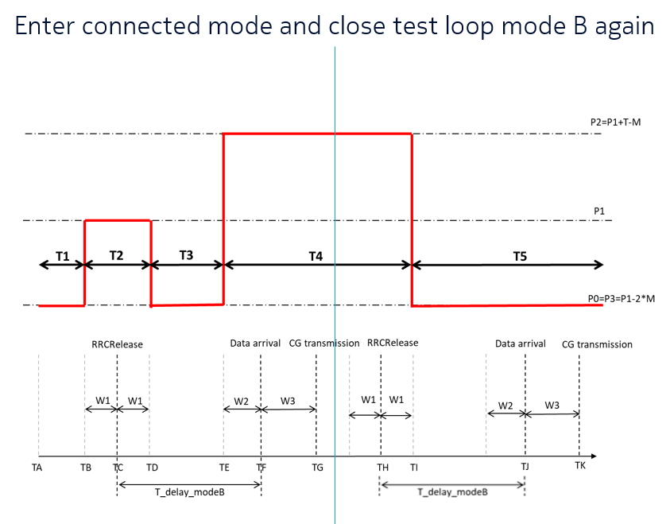
- Recommended WF

Issue 3-1-4: Impact to test cases for other features
- Proposals
  - Proposal 1: Yes (Ericsson, Nokia)
    - RedCap CG-SDT RRM test should be updated accordingly with NR CG-SDT test case.
  - Proposal 2: other, please specify.
- Recommended WF

Tdoc recommendations
TDoc | Title | Source | Type | For | Agenda item | Recommendations
R4-2315289 | Discussion on re-defining SDT test cases | MediaTek inc. | discussion | Discussion | 7.2.4 | Noted
R4-2315290 | Draft CR to Rel-17 TS 38.133 on SDT test cases | MediaTek inc. | draftCR | Endorsement | 7.2.4 | TBA
R4-2315291 | Draft CR to Rel-18 TS 38.133 on SDT test cases (Mirror) | MediaTek inc. | draftCR | Endorsement | 7.2.4 | TBA
R4-2316068 | Discussion on SDT RRM test cases | Huawei, HiSilicon | LS out | Approval | 7.2.4 | Noted
R4-2316069 | draftCR on SDT RRM test cases | Huawei, HiSilicon | draftCR | Endorsement | 7.2.4 | TBA
R4-2316070 | draftCR on SDT RRM test cases R18 | Huawei, HiSilicon | draftCR | Endorsement | 7.2.4 | TBA
R4-2316355 | Discussions on CG-SDT RRM test procedure | Ericsson | discussion | Discussion | 7.2.4 | Noted
R4-2316750 | Discussion on CG-SDT RRM test procedure | Nokia, Nokia Shanghai Bell | discussion | Discussion | 7.2.4 | Noted
R4-2316887 | Discussion on LS on CG-SDT RRM test procedure | Qualcomm Incorporated | discussion | Discussion | 7.2.4 | Noted
R4-2315289 | Discussion on re-defining SDT test cases | MediaTek inc. | discussion | Discussion | 7.2.4 | Noted
R4-2315290 | Draft CR to Rel-17 TS 38.133 on SDT test cases | MediaTek inc. | draftCR | Endorsement | 7.2.4 | TBA
R4-2315291 | Draft CR to Rel-18 TS 38.133 on SDT test cases (Mirror) | MediaTek inc. | draftCR | Endorsement | 7.2.4 | TBA
R4-2316068 | Discussion on SDT RRM test cases | Huawei, HiSilicon | LS out | Approval | 7.2.4 | Noted

Topic #4: LS on additional UE Gain parameters (R5-233669/R4-2311010)
Ad-hoc chair: No tdocs and open issues

Topic #5: LS on RRM test cases with testability issues (R5-233782/ R4-2311012)

Open issues
Issue 4-1-1: Are the modifications in CR 2316189 agreeable?
- Proposals
  - Proposal 1: Yes
  - Other, please specify
- Recommended WF
  - This CR can be treated separately from the CRs on test case list update for A.3.13A.2-1 and A.3.13A.3-1.

Issue 4-1-2: Test case update for Rel-15
- Proposals
  - Proposal 1 (Huawei):
Table A.3.13A.2-1: Test cases UE does not have to pass in current version of specification (EN-DC)
Clause | Test case slogan
A.5.5.3.2 | SCell Activation and deactivation of known SCell in FR1 for 160ms SCell measurement cycle
A.5.5.3.5 | SCell Activation and deactivation of SCell in FR2
A.5.7.1.3 | EN-DC inter-frequency measurement accuracy with FR1 serving cell and FR2 target cell
A.5.5.3.2 | SCell Activation and deactivation of known SCell in FR1 for 160ms SCell measurement cycle
A.5.5.3.5 | SCell Activation and deactivation of SCell in FR2
A.5.5.6.1.2 | E-UTRAN – NR PSCell FR2 with FR2 SCell DL active BWP switch in non-DRX in synchronous EN-DC
A.5.6.2.5 | EN-DC event triggered reporting tests for FR2 cell without SSB time index detection when DRX is not used
A.5.6.2.6 | EN-DC event triggered reporting tests for FR2 cell without SSB time index detection when DRX is used
A.5.6.2.7 | EN-DC event triggered reporting tests for FR2 cell with SSB time index detection when DRX is not used
A.5.6.2.8 | EN-DC event triggered reporting tests for FR2 cell with SSB time index detection when DRX is used
A.5.7.1.3 | EN-DC inter-frequency measurement accuracy with FR1 serving cell and FR2 target cell

Table A.3.13A.3-1: Test cases UE does not have to pass in current version of specification (SA)
Clause | Test case slogan
A.7.5.3.2 | SCell Activation and deactivation for FR1+FR2 inter-band with target SCell in FR2
A.7.5.6.1.2 | NR FR1- NR FR2 DL active BWP switch of PCell with non-DRX in SA
A.7.6.2.5 | SA event triggered reporting tests for FR2 without SSB time index detection when DRX is not used (PCell in FR1)
A.7.6.2.6 | SA event triggered reporting tests for FR2 without SSB time index detection when DRX is used (PCell in FR1)
A.7.6.2.7 | SA event triggered reporting tests for FR2 with SSB time index detection when DRX is not used (PCell in FR1)
A.7.6.2.8 | SA event triggered reporting tests for FR2 with SSB time index detection when DRX is used (PCell in FR1)
A.7.7.1.3 | SA inter-frequency measurement accuracy with FR1 serving cell and FR2 target cell
A.7.3.1.1 | Inter-frequency handover from FR1 to FR2; unknown target cell
A.7.5.3.2 | SCell Activation and deactivation for FR1+FR2 inter-band with target SCell in FR2
A.7.5.6.1.2 | NR FR1- NR FR2 DL active BWP switch of SCell with non-DRX in SA
A.7.5.7.1 | Addition and Release Delay of known NR PSCell
A.7.5.7.2 | Addition and Release Delay of unknown NR PSCell

  - Proposal 2 (Apple):
Table A.3.13A.2-1: Test cases UE does not have to pass in current version of specification (EN-DC)
Clause | Test case slogan
A.5.5.3.2 | SCell Activation and deactivation of known SCell in FR1 for 160ms SCell measurement cycle
A.5.5.3.5 | SCell Activation and deactivation of SCell in FR2
A.5.5.6.1.2 | E-UTRAN – NR PSCell FR2 with FR2 SCell DL active BWP switch in non-DRX in synchronous EN-DC
A.5.6.2.5 | EN-DC event triggered reporting tests for FR2 cell without SSB time index detection when DRX is not used
A.5.6.2.6 | EN-DC event triggered reporting tests for FR2 cell without SSB time index detection when DRX is used
A.5.6.2.7 | EN-DC event triggered reporting tests for FR2 cell with SSB time index detection when DRX is not used
A.5.6.2.8 | EN-DC event triggered reporting tests for FR2 cell with SSB time index detection when DRX is used
A.5.7.1.3 | EN-DC inter-frequency measurement accuracy with FR1 serving cell and FR2 target cell
Table A.3.13A.3-1: Test cases UE does not have to pass in current version of specification (SA)
Clause | Test case slogan
A.7.3.1.1 | Inter-frequency handover from FR1 to FR2; unknown target cell
A.7.5.3.2 | SCell Activation and deactivation for FR1+FR2 inter-band with target SCell in FR2
A.7.5.6.1.2 | NR FR1- NR FR2 DL active BWP switch of PCell with non-DRX in SA
A.7.5.7.1 | Addition and Release Delay of known NR PSCell
A.7.5.7.2 | Addition and Release Delay of unknown NR PSCell
A.7.6.2.5 | SA event triggered reporting tests for FR2 without SSB time index detection when DRX is not used (PCell in FR1)
A.7.6.2.6 | SA event triggered reporting tests for FR2 without SSB time index detection when DRX is used (PCell in FR1)
A.7.6.2.7 | SA event triggered reporting tests for FR2 with SSB time index detection when DRX is not used (PCell in FR1)
A.7.6.2.8 | SA event triggered reporting tests for FR2 with SSB time index detection when DRX is used (PCell in FR1)
A.7.7.1.3 | SA inter-frequency measurement accuracy with FR1 serving cell and FR2 target cell

- Recommended WF
  - Depending on which proposal is agreeable, use either R4-2315650 or R4-2316573 as baseline.

Issue 4-1-3: Test case update for Rel-16
- Proposals
  - Proposal 1 (Huawei):
Table A.3.13A.2-1: Test cases UE does not have to pass in current version of specification (EN-DC)
Clause | Test case slogan
A.5.5.2.7 | E-UTRAN – NR FR2 interruptions at E-UTRA SRS carrier based switching
A.5.5.3.2 | SCell Activation and deactivation of known SCell in FR1 for 160ms SCell measurement cycle
A.5.5.3.5 | SCell Activation and deactivation of SCell in FR2
A.5.5.3.6 | Multiple SCell Activation and deactivation of one unknown SCell and one known SCell in FR2
A.5.5.6.4.2 | E-UTRAN – NR FR1 PSCell SCell dormancy switch of two FR2 SCells outside active time
A.5.7.1.3 | EN-DC inter-frequency measurement accuracy with FR1 serving cell and FR2 target cell
A.5.5.6.1.2 | E-UTRAN – NR PSCell FR2 with FR2 SCell DL active BWP switch in non-DRX in synchronous EN-DC
A.5.6.2.5 | EN-DC event triggered reporting tests for FR2 cell without SSB time index detection when DRX is not used
A.5.6.2.6 | EN-DC event triggered reporting tests for FR2 cell without SSB time index detection when DRX is used
A.5.6.2.7 | EN-DC event triggered reporting tests for FR2 cell with SSB time index detection when DRX is not used
A.5.6.2.8 | EN-DC event triggered reporting tests for FR2 cell with SSB time index detection when DRX is used
A.5.5.3.6 | Multiple SCell Activation and deactivation of one unknown SCell and one known SCell in FR2
A.5.5.6.4.2 | E-UTRAN – NR FR1 PSCell SCell dormancy switch of two FR2 SCells outside active time

Table A.3.13A.3-1: Test cases UE does not have to pass in current version of specification (SA)
Clause | Test case slogan
A.7.5.3.2 | SCell Activation and deactivation for FR1+FR2 inter-band with target SCell in FR2
A.7.5.6.1.2 | NR FR1- NR FR2 DL active BWP switch of PCell with non-DRX in SA
A.7.5.6.4.2 | NR FR1 PCell SCell dormancy switch of two FR2 SCells outside active time
A.7.6.2.5 | SA event triggered reporting tests for FR2 without SSB time index detection when DRX is not used (PCell in FR1)
A.7.6.2.6 | SA event triggered reporting tests for FR2 without SSB time index detection when DRX is used (PCell in FR1)
A.7.6.2.7 | SA event triggered reporting tests for FR2 with SSB time index detection when DRX is not used (PCell in FR1)
A.7.6.2.8 | SA event triggered reporting tests for FR2 with SSB time index detection when DRX is used (PCell in FR1)
A.7.7.1.3 | SA inter-frequency measurement accuracy with FR1 serving cell and FR2 target cell
A.7.3.1.1 | Inter-frequency handover from FR1 to FR2; unknown target cell
A.7.5.3.2 | SCell Activation and deactivation for FR1+FR2 inter-band with target SCell in FR2
A.7.5.6.1.2 | NR FR1- NR FR2 DL active BWP switch of SCell with non-DRX in SA
A.7.5.7.1 | Addition and Release Delay of known NR PSCell
A.7.5.7.2 | Addition and Release Delay of unknown NR PSCell
A.7.3.1.4 | Inter-band inter-frequency synchronous DAPS handover from FR1 to FR2
A.7.3.1.5 | Inter-band inter-frequency asynchronous DAPS handover from FR1 to FR2
A.7.5.6.4.2 | NR FR1 PCell SCell dormancy switch of two FR2 SCells outside active time

  - Proposal 2 (Apple):
Table A.3.13A.2-1: Test cases UE does not have to pass in current version of specification (EN-DC)
Clause | Test case slogan
A.5.5.2.7 | E-UTRAN – NR FR2 interruptions at E-UTRA SRS carrier based switching
A.5.5.3.2 | SCell Activation and deactivation of known SCell in FR1 for 160ms SCell measurement cycle
A.5.5.3.5 | SCell Activation and deactivation of SCell in FR2
A.5.5.3.6 | Multiple SCell Activation and deactivation of one unknown SCell and one known SCell in FR2
A.5.5.6.1.2 | E-UTRAN – NR PSCell FR2 with FR2 SCell DL active BWP switch in non-DRX in synchronous EN-DC
A.5.5.6.4.2 | E-UTRAN – NR FR1 PSCell SCell dormancy switch of two FR2 SCells outside active time
A.5.6.2.5 | EN-DC event triggered reporting tests for FR2 cell without SSB time index detection when DRX is not used
A.5.6.2.6 | EN-DC event triggered reporting tests for FR2 cell without SSB time index detection when DRX is used
A.5.6.2.7 | EN-DC event triggered reporting tests for FR2 cell with SSB time index detection when DRX is not used
A.5.6.2.8 | EN-DC event triggered reporting tests for FR2 cell with SSB time index detection when DRX is used
A.5.7.1.3 | EN-DC inter-frequency measurement accuracy with FR1 serving cell and FR2 target cell

Table A.3.13A.3-1: Test cases UE does not have to pass in current version of specification (SA)
Clause | Test case slogan
A.7.3.1.1 | Inter-frequency handover from FR1 to FR2; unknown target cell
A.7.3.1.4 | Inter-band inter-frequency synchronous DAPS handover from FR1 to FR2
A.7.3.1.5 | Inter-band inter-frequency asynchronous DAPS handover from FR1 to FR2
A.7.5.3.2 | SCell Activation and deactivation for FR1+FR2 inter-band with target SCell in FR2
A.7.5.6.1.2 | NR FR1- NR FR2 DL active BWP switch of PCell with non-DRX in SA
A.7.5.6.4.2 | NR FR1 PCell SCell dormancy switch of two FR2 SCells outside active time
A.7.5.7.1 | Addition and Release Delay of known NR PSCell
A.7.5.7.2 | Addition and Release Delay of unknown NR PSCell
A.7.6.2.5 | SA event triggered reporting tests for FR2 without SSB time index detection when DRX is not used (PCell in FR1)
A.7.6.2.6 | SA event triggered reporting tests for FR2 without SSB time index detection when DRX is used (PCell in FR1)
A.7.6.2.7 | SA event triggered reporting tests for FR2 with SSB time index detection when DRX is not used (PCell in FR1)
A.7.6.2.8 | SA event triggered reporting tests for FR2 with SSB time index detection when DRX is used (PCell in FR1)
A.7.7.1.3 | SA inter-frequency measurement accuracy with FR1 serving cell and FR2 target cell

- Recommended WF
  - Depending on which proposal is agreeable, use either R4-2315651 or R4-2316574 as baseline.

Issue 4-1-4: Test case update for Rel-17
- Proposals
  - Proposal 1 (Huawei):
Table A.3.13A.2-1: Test cases UE does not have to pass in current version of specification (EN-DC)
Clause | Test case slogan
A.5.5.2.7 | E-UTRAN – NR FR2 interruptions at E-UTRA SRS carrier based switching
A.5.5.3.2 | SCell Activation and deactivation of known SCell in FR1 for 160ms SCell measurement cycle
A.5.5.3.5 | SCell Activation and deactivation of SCell in FR2
A.5.5.3.6 | Multiple SCell Activation and deactivation of one unknown SCell and one known SCell in FR2
A.5.5.6.4.2 | E-UTRAN – NR FR1 PSCell SCell dormancy switch of two FR2 SCells outside active time
A.5.7.1.3 | EN-DC inter-frequency measurement accuracy with FR1 serving cell and FR2 target cell
A.5.5.6.1.2 | E-UTRAN – NR PSCell FR2 with FR2 SCell DL active BWP switch in non-DRX in synchronous EN-DC
A.5.6.2.5 | EN-DC event triggered reporting tests for FR2 cell without SSB time index detection when DRX is not used
A.5.6.2.6 | EN-DC event triggered reporting tests for FR2 cell without SSB time index detection when DRX is used
A.5.6.2.7 | EN-DC event triggered reporting tests for FR2 cell with SSB time index detection when DRX is not used
A.5.6.2.8 | EN-DC event triggered reporting tests for FR2 cell with SSB time index detection when DRX is used
A.5.5.3.6 | Multiple SCell Activation and deactivation of one unknown SCell and one known SCell in FR2
A.5.5.6.4.2 | E-UTRAN – NR FR1 PSCell SCell dormancy switch of two FR2 SCells outside active time
A.5.3.3.1 | Handover with PSCell with known FR2 target PSCell
A.5.3.3.3 | PUCCH SCell Activation and deactivation of known SCell in FR2
A.5.3.3.4 | PUCCH SCell Activation and deactivation of unknown SCell in FR2
A.5.3.3.5 | Multiple SCell activation and deactivation of one known PUCCH SCell and one unknown SCell in FR2
A.5.3.3.6 | SCell Activation and deactivation of unknown PUCCH SCell and unknown DL SCell in FR2 in non-DRX

Table A.3.13A.3-1: Test cases UE does not have to pass in current version of specification (SA)
Clause | Test case slogan
A.7.5.3.2 | SCell Activation and deactivation for FR1+FR2 inter-band with target SCell in FR2
A.7.5.3.7 | PUCCH SCell activation and deactivation delay requirements of FR2 unknown cell with FR1 PCell
A.7.5.6.1.2 | NR FR1- NR FR2 DL active BWP switch of PCell with non-DRX in SA
A.7.5.6.4.2 | NR FR1 PCell SCell dormancy switch of two FR2 SCells outside active time
A.7.6.2.5 | SA event triggered reporting tests for FR2 without SSB time index detection when DRX is not used (PCell in FR1)
A.7.6.2.6 | SA event triggered reporting tests for FR2 without SSB time index detection when DRX is used (PCell in FR1)
A.7.6.2.7 | SA event triggered reporting tests for FR2 with SSB time index detection when DRX is not used (PCell in FR1)
A.7.6.2.8 | SA event triggered reporting tests for FR2 with SSB time index detection when DRX is used (PCell in FR1)
A.7.7.1.3 | SA inter-frequency measurement accuracy with FR1 serving cell and FR2 target cell
A.7.3.1.1 | Inter-frequency handover from FR1 to FR2; unknown target cell
A.7.5.3.2 | SCell Activation and deactivation for FR1+FR2 inter-band with target SCell in FR2
A.7.5.6.1.2 | NR FR1- NR FR2 DL active BWP switch of SCell with non-DRX in SA
A.7.5.7.1 | Addition and Release Delay of known NR PSCell
A.7.5.7.2 | Addition and Release Delay of unknown NR PSCell
A.7.3.1.4 | Inter-band inter-frequency synchronous DAPS handover from FR1 to FR2
A.7.3.1.5 | Inter-band inter-frequency asynchronous DAPS handover from FR1 to FR2
A.7.5.6.4.2 | NR FR1 PCell SCell dormancy switch of two FR2 SCells outside active time
A.7.3.1.6 | Handover with PSCell from SA to EN-DC; unknown FR2 target cell
A.7.3.1.7 | HO with PSCell from FR1 NR-SA to EN-DC with known E-UTRA PCell and known FR2 PSCell
A.7.3.1.8 | NR PSCell change delay in HO with PSCell from NR-DC to NR-DC
A.7.3.1.11 | Inter-frequency handover from FR1 to FR2-2; unknown target cell
A.7.5.3.6 | PUCCH SCell activation and deactivation for FR1+FR2 inter-band with target SCell in FR2 and known
A.7.5.3.12 | PSCell RACH-less based Activation and deactivation for FR1+FR2 inter-band with target PSCell in FR2
A.7.5.3.15 | PSCell RACH-less based Activation and deactivation for FR1+FR2 inter-band with target PSCell in FR2
A.7.5.7.3 | Addition and Release Delay of known NR PSCell in FR2-2
A.7.5.7.4 | Addition and Release Delay of unknown NR PSCell in FR2-2
A.7.5.12.1 | Addition and Release Delay of PSCell
A.7.6.2.16 | SA event triggered reporting tests for FR2-2 without SSB time index detection when DRX is not used (PCell in FR1)
A.7.6.2.17 | SA event triggered reporting tests for FR2-2 without SSB time index detection when DRX is used (PCell in FR1)
A.7.6.2.18 | SA event triggered reporting tests for FR2-2 with SSB time index detection when DRX is not used (PCell in FR1)
A.7.6.2.19 | SA event triggered reporting tests for FR2-2 with SSB time index detection when DRX is used (PCell in FR1)
A.7.6.3.6 | Inter-cell SSB based L1-RSRP measurements on FR2 SCell when DRX is not used

  - Proposal 2 (Apple):
Table A.3.13A.2-1: Test cases UE does not have to pass in current version of specification (EN-DC)
Clause | Test case slogan
A.5.3.3.1 | Handover with PSCell with known FR2 target PSCell
A.5.5.2.7 | E-UTRAN – NR FR2 interruptions at E-UTRA SRS carrier based switching
A.5.5.3.2 | SCell Activation and deactivation of known SCell in FR1 for 160ms SCell measurement cycle
A.5.5.3.5 | SCell Activation and deactivation of SCell in FR2
A.5.5.3.6 | Multiple SCell Activation and deactivation of one unknown SCell and one known SCell in FR2
A.5.5.3.9 | PUCCH SCell Activation and deactivation of known SCell in FR2
A.5.5.3.10 | PUCCH SCell Activation and deactivation of unknown SCell in FR2
A.5.5.3.11 | Multiple SCell activation and deactivation of one known PUCCH SCell and one unknown SCell in FR2
A.5.5.3.12 | SCell Activation and deactivation of unknown PUCCH SCell and unknown DL SCell in FR2 in non-DRX
A.5.5.6.1.2 | E-UTRAN – NR PSCell FR2 with FR2 SCell DL active BWP switch in non-DRX in synchronous EN-DC
A.5.5.6.4.2 | E-UTRAN – NR FR1 PSCell SCell dormancy switch of two FR2 SCells outside active time
A.5.6.2.5 | EN-DC event triggered reporting tests for FR2 cell without SSB time index detection when DRX is not used
A.5.6.2.6 | EN-DC event triggered reporting tests for FR2 cell without SSB time index detection when DRX is used
A.5.6.2.7 | EN-DC event triggered reporting tests for FR2 cell with SSB time index detection when DRX is not used
A.5.6.2.8 | EN-DC event triggered reporting tests for FR2 cell with SSB time index detection when DRX is used
A.5.7.1.3 | EN-DC inter-frequency measurement accuracy with FR1 serving cell and FR2 target cell

Table A.3.13A.3-1: Test cases UE does not have to pass in current version of specification (SA)
Clause | Test case slogan
A.7.3.1.1 | Inter-frequency handover from FR1 to FR2; unknown target cell
A.7.3.1.4 | Inter-band inter-frequency synchronous DAPS handover from FR1 to FR2
A.7.3.1.5 | Inter-band inter-frequency asynchronous DAPS handover from FR1 to FR2
A.7.3.1.6 | Handover with PSCell from SA to EN-DC; unknown FR2 target cell
A.7.3.1.7 | HO with PSCell from FR1 NR-SA to EN-DC with known E-UTRA PCell and known FR2 PSCell
A.7.3.1.8 | NR PSCell change delay in HO with PSCell from NR-DC to NR-DC
A.7.3.1.11 | Inter-frequency handover from FR1 to FR2-2; unknown target cell
A.7.5.3.2 | SCell Activation and deactivation for FR1+FR2 inter-band with target SCell in FR2
A.7.5.3.6 | PUCCH SCell activation and deactivation for FR1+FR2 inter-band with target SCell in FR2 and known
A.7.5.3.7 | PUCCH SCell activation and deactivation delay requirements of FR2 unknown cell with FR1 PCell
A.7.5.3.12 | PSCell RACH-less based Activation and deactivation for FR1+FR2 inter-band with target PSCell in FR2
A.7.5.3.15 | PSCell RACH-less based Activation and deactivation for FR1+FR2 inter-band with target PSCell in FR2
A.7.5.6.1.2 | NR FR1- NR FR2 DL active BWP switch of PCell with non-DRX in SA
A.7.5.6.4.2 | NR FR1 PCell SCell dormancy switch of two FR2 SCells outside active time
A.7.5.7.1 | Addition and Release Delay of known NR PSCell
A.7.5.7.2 | Addition and Release Delay of unknown NR PSCell
A.7.5.12.1 | Addition and Release Delay of PSCell
A.7.6.2.5 | SA event triggered reporting tests for FR2 without SSB time index detection when DRX is not used (PCell in FR1)
A.7.6.2.6 | SA event triggered reporting tests for FR2 without SSB time index detection when DRX is used (PCell in FR1)
A.7.6.2.7 | SA event triggered reporting tests for FR2 with SSB time index detection when DRX is not used (PCell in FR1)
A.7.6.2.8 | SA event triggered reporting tests for FR2 with SSB time index detection when DRX is used (PCell in FR1)
A.7.6.2.16 | SA event triggered reporting tests for FR2-2 without SSB time index detection when DRX is not used (PCell in FR1)
A.7.6.2.17 | SA event triggered reporting tests for FR2-2 without SSB time index detection when DRX is used (PCell in FR1)
A.7.6.2.18 | SA event triggered reporting tests for FR2-2 with SSB time index detection when DRX is not used (PCell in FR1)
A.7.6.2.19 | SA event triggered reporting tests for FR2-2 with SSB time index detection when DRX is used (PCell in FR1)
A.7.6.3.6 | Inter-cell SSB based L1-RSRP measurements on FR2 SCell when DRX is not used
A.7.7.1.3 | SA inter-frequency measurement accuracy with FR1 serving cell and FR2 target cell

- Recommended WF
  - Depending on which proposal is agreeable, use either R4-2315652 or R4-2316575as baseline.

Tdoc recommendations
TDoc | Title | Source | Type | For | Agenda item | Recommendations
R4-2315649 | Discussion on RRM test cases with testability issues | Huawei, HiSilicon | discussion | Discussion | 7.3.2
R4-2315650 | Draft CR on RRM RRM test cases with testability issues R15 | Huawei, HiSilicon | draftCR | Endorsement | 7.3.2
R4-2315651 | Draft CR on RRM RRM test cases with testability issues R16 | Huawei, HiSilicon | draftCR | Endorsement | 7.3.2
R4-2315652 | Draft CR on RRM RRM test cases with testability issues R17 | Huawei, HiSilicon | draftCR | Endorsement | 7.3.2
R4-2315653 | Draft CR on RRM RRM test cases with testability issues R18 | Huawei, HiSilicon | draftCR | Endorsement | 7.3.2
R4-2316189 | Draft CR on RRM RRM test cases with testability issues R15 | OPPO | draftCR | Endorsement | 7.3.2
R4-2316190 | Draft CR on RRM RRM test cases with testability issues R15 | OPPO | draftCR | Endorsement | 7.3.2
R4-2316571 | Discussion on RAN5 LS on RRM test cases with testability issues | Apple | discussion | Discussion | 7.3.2
R4-2316572 | Reply LS on RRM test cases with testability issues | Apple | LS out | Approval | 7.3.2
R4-2316573 | CR on RRM test cases with testability issues - R15 | Apple | draftCR | Endorsement | 7.3.2
R4-2316574 | CR on RRM test cases with testability issues - R16 | Apple | draftCR | Endorsement | 7.3.2
R4-2316575 | CR on RRM test cases with testability issues - R17 | Apple | draftCR | Endorsement | 7.3.2
R4-2316576 | CR on RRM test cases with testability issues - R18 | Apple | draftCR | Endorsement | 7.3.2

Topic #6: LS on SRS antenna switching for TDD-FDD band combinations. (R1-2308582)
Ad-hoc chair: No tdocs and open issues

Topic #7: Reply LS on update for “interBandMRDC-WithOverlapDL-Bands-r16” in 38.306. (R2-2309218/ R4-2315017)
In the incoming LS from RAN2, 3 questions are raised as following:
Question 1: For UE supporting and not supporting interBandMRDC-WithOverlapDL-Bands-r16, what are the requirements in NE-DC operation respectively?
Question 2: For FDD-FDD inter-band EN-DC with overlapping frequency, if UE does not report interBandMRDC-WithOverlapDL-Bands-r16, what are the MRTD requirements for asynchronous operation? And are there any differences on MRTD requirements in asynchronous operation for UE(s) supporting and not supporting interBandMRDC-WithOverlapDL-Bands-r16?
Question 3: For FDD-FDD inter-band EN-DC with overlapping frequency, if UE does not report interBandMRDC-WithOverlapDL-Bands-r16, what are the MTTD requirements for both synchronous and asynchronous operations? And for asynchronous operation, are there any differences on MTTD requirements for UE(s) supporting and not supporting interBandMRDC-WithOverlapDL-Bands-r16?

Open issues

Issue 7-1-1: For UE supporting and not supporting interBandMRDC-WithOverlapDL-Bands-r16, what are the requirements in NE-DC operation respectively?
- Proposals
  - Proposal 1 (Apple):
It is proposed to reuse inter-band synchronous NE-DC MRTD/MTTD requirement in 7.6.5.1/7.5.5.1 for UE indicating capable of interBandMRDC-WithOverlapDL-Bands-r16, and same requirement as in 7.6.3/7.5.3 for UE not indicating capable of interBandMRDC-WithOverlapDL-Bands-r16.
  - Proposal 2 (Ericsson):
The requirements for NE-DC are the same as for EN-DC.
  - Proposal 3 (Samsung):
Till present, RAN4 has not yet specified any inter-band NE-DC band combination with overlapping DL frequency, which leads to RAN4’s 2nd priority treatment on the requirement for inter-band NE-DC band combination with overlapping DL frequency. Until RAN4 has identified any operator’s request on inter-band NE-DC band combination with overlapping DL frequency, RAN2 can remove the contents related to inter-band NE-DC with overlapping DL frequency.
- Recommended WF

Issue 7-1-2: For FDD-FDD inter-band EN-DC with overlapping frequency, if UE does not report interBandMRDC-WithOverlapDL-Bands-r16, what are the MRTD requirements for asynchronous operation? And are there any differences on MRTD requirements in asynchronous operation for UE(s) supporting and not supporting interBandMRDC-WithOverlapDL-Bands-r16?
- Proposals
  - Proposal 1 (Apple):
For FDD-FDD inter-band EN-DC with overlapping downlink frequency, the requirement applicability depends on UE capability reporting.
    - If asyncIntraBandENDC is reported, the current requirement for asynchronous EN-DC as specified in Table 7.6.2-1 apply.
    - If asyncIntraBandENDC is not reported,
      - The current requirement for synchronous inter-band EN-DC as specified in 7.6.2.1 (to be modified) should apply for UE reporting capable of interBandMRDC-WithOverlapDL-Bands-r16 (corresponding to non-collocated scenario). But it is not specified in 38.133 yet.
      - The current requirement for synchronous intra-band collocated EN-DC as specified in 7.6.3 should apply for UE not reporting capable of interBandMRDC-WithOverlapDL-Bands-r16 (corresponding to collocated scenario).

  - Proposal 2 (Ericsson):
The MRTD requirements for FDD-FDD inter-band EN-DC with overlapping frequency are the same if UE reports interBandMRDC-WithOverlapDL-Bands-r16 or not. This is the nature of asynchronous operation.
  - Proposal 3 (Samsung):
For FDD-FDD inter-band EN-DC with overlapping frequency, there is no differences on MTTD/MRTD requirements for UE(s) supporting and not supporting interBandMRDC-WithOverlapDL-Bands-r16, i.e., MTTD/MRTD requirements defined in Table 7.5.2-1/Table 7.6.2-1 for asynchronous operation and MTTD/MRTD requirements defined in Table 7.5.2.1-1/Table 7.6.2.1-1 for synchronous operation. It should be noted that whether or not UE support asynchronous FDD-FDD inter-band EN-DC with overlapping frequency depends on the Rel-15 introduced capability IE asyncIntraBandENDC.
- Recommended WF

Issue 5-1-3: For FDD-FDD inter-band EN-DC with overlapping frequency, if UE does not report interBandMRDC-WithOverlapDL-Bands-r16, what are the MTTD requirements for both synchronous and asynchronous operations? And for asynchronous operation, are there any differences on MTTD requirements for UE(s) supporting and not supporting interBandMRDC-WithOverlapDL-Bands-r16?
- Proposals
  - Proposal 1 (Apple):
For FDD-FDD inter-band EN-DC with overlapping downlink frequency, the requirement applicability depends on UE capability reporting.
  - If asyncIntraBandENDC is reported, the current requirement for asynchronous EN-DC as specified in Table 7.5.2-1 apply.
  - If asyncIntraBandENDC is not reported,
    - The current requirement for synchronous inter-band EN-DC as specified in 7.5.2.1 (to be modified for FDD) should apply for UE reporting capable of interBandMRDC-WithOverlapDL-Bands-r16 (corresponding to non-collocated scenario). But it is not specified in 38.133 yet.
    - The current requirement for synchronous intra-band collocated EN-DC as specified in 7.5.3 should apply for UE not reporting capable of interBandMRDC-WithOverlapDL-Bands-r16 (corresponding to collocated scenario).
  - Proposal 2 (Ericsson):
The MTTD requirements for FDD-FDD inter-band EN-DC with overlapping frequency are the same if UE reports interBandMRDC-WithOverlapDL-Bands-r16 or not. This is the nature of asynchronous operation.
  - Proposal 3 (Samsung):
For FDD-FDD inter-band EN-DC with overlapping frequency, there is no differences on MTTD/MRTD requirements for UE(s) supporting and not supporting interBandMRDC-WithOverlapDL-Bands-r16, i.e., MTTD/MRTD requirements defined in Table 7.5.2-1/Table 7.6.2-1 for asynchronous operation and MTTD/MRTD requirements defined in Table 7.5.2.1-1/Table 7.6.2.1-1 for synchronous operation. It should be noted that whether or not UE support asynchronous FDD-FDD inter-band EN-DC with overlapping frequency depends on the Rel-15 introduced capability IE asyncIntraBandENDC.
- Recommended WF

Issue 5-1-4: Please comment on the CR in R4-2315491, agreeable or not?
- Proposals
  - Option 1: Yes
  - Option 2: other, please specify
- Recommended WF

Issue 5-1-5: Reply LS on update for “interBandMRDC-WithOverlapDL-Bands-r16” in 38.306
- Proposals
  - Option 1 (Apple): LS in R4-2315494
  - Option 2 (Ericsson): LS in R4-2316488
  - Option 3 (Samsung): LS in R4-2316599
- Recommended WF
  - Depending on discussion for issue 5-1-1~5-1-3.

Issue 5-1-6: LS on update for “asyncIntraBandENDC“.
- Proposals
  - Option 1 (Apple): LS in R4-2315495
- Recommended WF
  - Depending on discussion for issue 5-1-1~5-1-3.

Tdoc recommendations
TDoc | Title | Source | Type | For | Agenda item | Recommendations
R4-2315490 | On RRM requirements applicability for interBandMRDC-WithOverlapDL-Bands-r16 | Apple | discussion | Discussion | 7.3.5
R4-2315491 | On MRTD/MTTD requirement for inter-band non-collocated EN-DC/NE-DC (R16) | Apple | draftCR | Endorsement | 7.3.5
R4-2315492 | On MRTD/MTTD requirement for inter-band non-collocated EN-DC/NE-DC (R17) | Apple | draftCR | Endorsement | 7.3.5
R4-2315493 | On MRTD/MTTD requirement for inter-band non-collocated EN-DC/NE-dC (R18) | Apple | draftCR | Endorsement | 7.3.5
R4-2315494 | Reply LS on update for “interBandMRDC-WithOverlapDL-Bands-r16” in 38.306 | Apple | LS out | Approval | 7.3.5
R4-2315495 | LS on update for “asyncIntraBandENDC” | Apple | LS out | Approval | 7.3.5
R4-2316488 | Reply LS on update for “interBandMRDC-WithOverlapDL-Bands-r16” in 38.306 | Ericsson | LS out | Approval | 7.3.5
R4-2316599 | Discussion on update for “interBandMRDC-WithOverlapDL-Bands-r16” in 38.306 and draft reply LS | Samsung | LS out | Approval | 7.3.5

[227] NR_redcap_enh

Open issues

Issue 1-1: Transition requirements: transition between long short INACTIVE eDRX (≤10.24s) and long INACTIVE eDRX (20.48s)
- Proposals
  - Option 1 (CATT, Xiaomi, ZTE, HW, MTK, Apple, Nokia): No new transition requirements are needed.
    - Legacy transition requirements are reused.
  - Option 1a (Ericsson): RAN4 to revise the legacy transition requirements to cover the transition when any of the eDRX parameters of eDRX_IDLE and eDRX_INACTIVE are changed.
  - Option 1b (Apple): Legacy principle can be reused to design the transition requirement for case 1:
      - transition between Rel-17 INACTIVE eDRX and Rel-18 INACTIVE eDRX
      - transition between Rel-18 INACTIVE eDRX and INACTIVE RAN DRX.
- Recommended WF
  - All companies support reusing the legacy principle for defining the transition requirements.
  - Option 1a suggest to revise the wording in legacy requirements to cover change of parameters of eDRX_IDLE and eDRX_INACTIVE.
  - Option 1c suggest to also include the transition between Rel-18 INACTIVE eDRX and INACTIVE RAN DRX which is also a valid case.
Moderator therefore suggests following revised option:
“If UE is configured with eDRX_INACTIVE ≥ 20.48s, when the UE transitions between any two states when changing eDRX_IDLE cycle length, eDRX_INACTIVE cycle length, INACTIVE RAN DRX length or changing PTW configuration, the UE shall meet the transition requirement, which is the less stringent requirement of the two requirements corresponding to the first state and the second state, during the transition time interval which is the time corresponding to the transition requirement. After the transition time interval, the UE shall meet the requirement corresponding to the second state.”
- Discussion
  - TBA
- Agreements
  - TBA

Issue 1-2: Transition requirements: UE moves from a cell that supports and configures Rel-18 INACTIVE eDRX to a cell that supports only Rel-17 INACTIVE eDRX and vice versa.
- Proposals
  - Option 1 (Apple): No requirement is specified.
- Discussion
  - TBA
- Agreements
  - TBA

Tdoc recommendations
TDoc | Title | Source | Type | For | Agenda item | Recommendations
R4-2315117 | Discussion on RRM requirements for eRedCap | CATT | discussion | Discussion | 5.31.2 | Noted
R4-2315426 | Discussion on RRM core requirements for eRedCap | Xiaomi | discussion | Discussion | 5.31.2 | Noted
R4-2315578 | Discussion on impacts to RRM requirements for eRedCap | ZTE Corporation | other | Approval | 5.31.2 | Noted
R4-2315664 | Discussion on measurement requirements for eRedCap UE | Huawei, HiSilicon | discussion | Discussion | 5.31.2 | Noted
R4-2315665 | CR on measurements of inter-RAT E-UTRAN cells for eRedCap UE | Huawei, HiSilicon | draftCR | Endorsement | 5.31.2 | Noted
R4-2316244 | Discussion on further NR RedCap UE complexity reduction | MediaTek inc. | discussion | Discussion | 5.31.2 | Noted
R4-2316245 | Draft CR for measurement and evaluation of serving cell measurements for RedCap enhancements | MediaTek inc. | draftCR | Endorsement | 5.31.2 | TBA
R4-2316349 | Discussions on enhanced eDRX for release 18 RedCap | Ericsson | discussion | Discussion | 5.31.2 | Noted
R4-2316350 | Draft CR for introducing intra-frequency neighbour cell measurement requirements for releae 18 RedCap UE | Ericsson | draftCR | Endorsement | 5.31.2 | TBA
R4-2316583 | Remaining issues on RRM for eRedCap | Apple | discussion | Discussion | 5.31.2 | Noted
R4-2316584 | Draft CR on measurements of inter-frequency NR cells for eRedCap | Apple | draftCR | Endorsement | 5.31.2 | TBA
R4-2316720 | RRM Core Requirements for Enhanced RedCap | Nokia, Nokia Shanghai Bell | discussion | Discussion | 5.31.2 | Noted

New tdocs
Title | Source
WF on RRM requirements for R18 NR eRedCap | [Ericson]

