**3GPP TSG-RAN WG4 Meeting # 106-bis-e** **R4-230xxxx**

**Electronic Meeting, 17 April –26 April, 2023**

**Title:** WF on NR ATG RRM requirements

**Agenda Item:** 5.14.6

**Source:** CMCC

**Document for:** Approval

# General

**Issue 1-1: Band grouping table**

**Agreement:**

* The frequency band grouping tables from the legacy bands are reused for R18 ATG

**Issue 1-3: How to involve ATG RRM core requirements in TS38.133**

* Option 1: Based on further conclusions on ATG specific RRM requirements to be introduced
  + Update the specification like HST that to make the ATG specific changes when the requirement is different from legacy one in existing sections (HW (if number of ATG specific RRM requirements is limited), CMCC (if location-based cell reselection and location-based CHO mechanism are not introduced))
  + Create ATG specific sections for ATG requirements like NTN (HW (if considerable number of ATG specific RRM requirements), CMCC (if location-based cell reselection and location-based CHO mechanism are introduced))
* Option 2: ATG specific RRM requirements are defined in separate sections in TS 38.133. (Ericsson)

Following part will be moved to 2nd summary, and be deleted in the official version

Please provide your comments. **Based on WP, CR will be provided in next meeting, so this issue should be resolved in this meeting.**

|  |  |
| --- | --- |
| Company | Comments |
|  |  |

# Mobility

# Mobility in RRC_IDLE/INACTIVE

**Issue 2-1-1-1: Cell re-selection mechanism**

* Option 1: Introduce distance-based triggering as an additional condition for intra- and inter-frequency cell measurement as NTN, whether and how to configure the feature is up to network implementation. (CMCC, LGE, CATT, Nokia (If distance threshold is available), ZTE (open to discuss))
  + If Srxlev > S(non)IntraSearchP and Squal > S(non)IntraSearchQ, **and the distance between UE and serving cell reference location is smaller than distanceThresh** if distanceThresh is configured and UE has location information, then the **UE shall search for inter/intra-frequency layers of higher priority**.
  + If Srxlev ≤ S(non)IntraSearchP or Squal ≤ S(non)IntraSearchQ, **or the distance between UE and serving cell reference location is larger than distanceThresh** if distanceThresh is configured and UE has location information, then the **UE shall search for and measure inter/intra-frequency layers of higher, equal or lower priority in preparation for possible reselection.**
* ~~Option 2: (Ericsson)~~ 
  + ~~The UE is allowed to~~ **~~not perform neighbour cell measurements based on the distance~~** ~~between the aircraft and a reference location~~
* ~~Option 3: For cell reselection mechanism, following distance-based mechanism shall be considered together with legacy RSRP based reselection since the near-far effect is not clearly observed in blind area ATG BS. (LGE)~~
  + ~~If the distance between UE and BS location is~~ **~~smaller than threshold for blind area~~**~~, UE shall search for and measure inter/intra-frequency layers of higher, equal or lower priority in preparation for possible reselection in preparation for possible reselection~~
  + ~~If the distance between UE and BS location is~~ **~~larger than threshold for blind area and smaller than distanceThresh~~**~~, the UE shall search for inter/intra-frequency layers of higher priority.~~
  + ~~If the distance between UE and serving cell reference location is~~ **~~larger than distanceThresh~~**~~, UE shall search for and measure inter/intra-frequency layers of higher, equal or lower priority in preparation for possible reselection~~
* Option 4: (LGE)
  + If ATG UE **altitude** higher than certain threshold, ATG UE perform measurement
  + If ATG UE **altitude** lower than certain threshold, ATG UE may not perform measurement
* Option 5: No need to specify distance, altitude or speed-based enhancements to cell re-selection mechanism during Release 18. (QC, HW, ZTE, CATT, Nokia)
  + If needed, such mechanisms may be discussed in future releases.

Friday’s offline GTW Agreements

Candidate options:

* Option 1
* Option 1+4
* Option 5

Please provide your comments.

|  |  |
| --- | --- |
| Company | Comments |
|  |  |

**Issue 2-1-1-2: If Cell re-selection mechanism as Option 1/2/3 is agreed, how does network signal the reference location and distance threshold to UE**

* First wait for RAN2’s response on the LS in R4-2303684
* If location-based cell-reselection is supported, further discuss whether the legacy referencelocation-r17 can be reused for ATG, referencelocation-r17 related information are as follows:

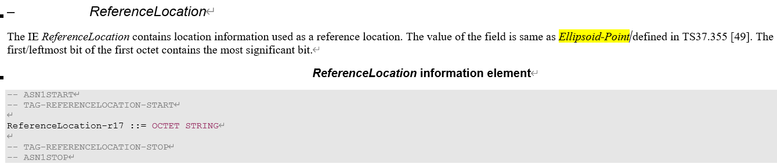

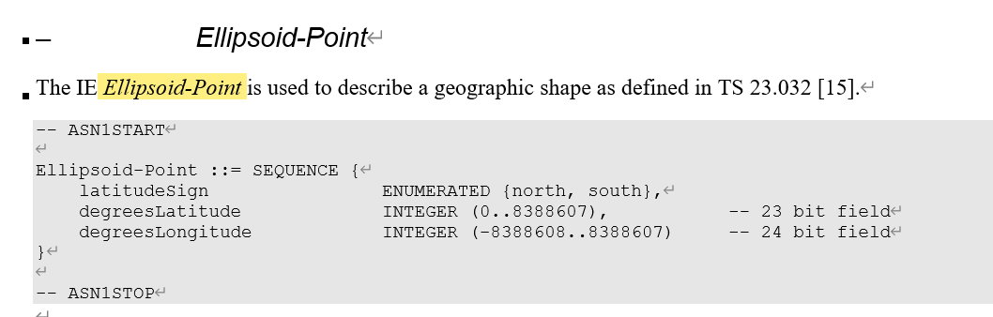

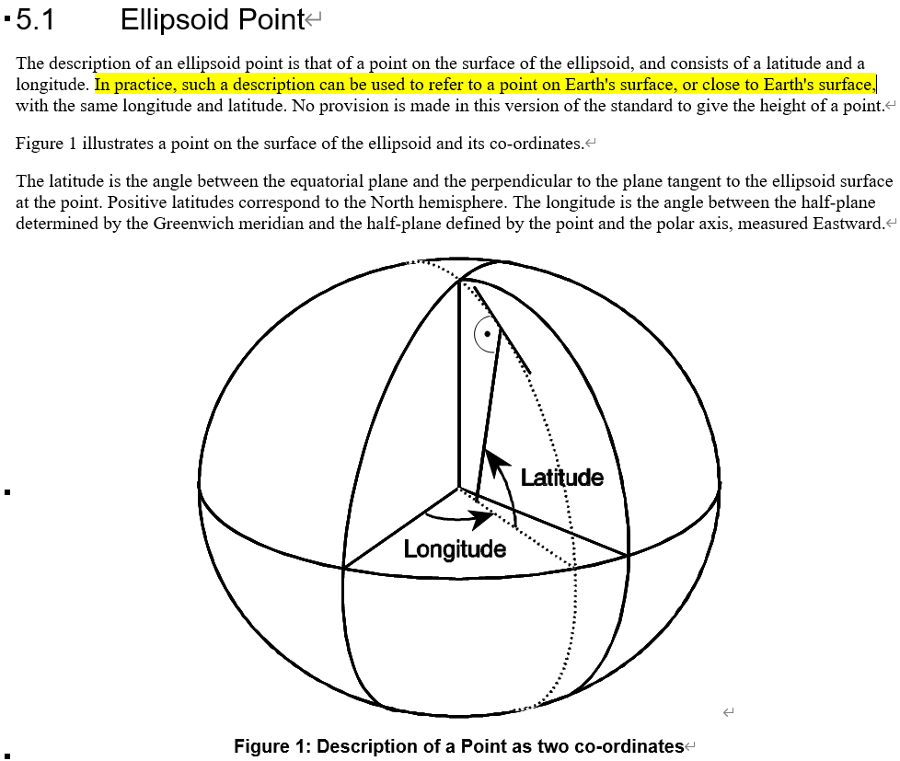

**Issue 2-1-1-3: UE assistance information for cell reselection**

* Option 1: Do not introduce enhancements related to UE assistance information for cell reselection. (Nokia, ZTE)
* Option 2: Assistance information is related to changes in the UE [altitude, flight path and speed] is introduced for ATG. (Ericsson, CATT)
  + The UE is allowed to skip IDLE/INACTIVE mode neighbour cell measurements under stable flight operation mode which is defined as the time when UE does not detect any changes in [altitude, speed or flight path].
  + The UE should resume the neighbor cell measurement in normal manner without any relaxation when the condition on distance between the aircraft and the reference location is no longer met.
* Option 3: Discuss after agreement for Issue 2-1-1-1 is made (QC, LGE, Nokia, HW)

This part will be moved to 2nd summary, and be deleted in the official version

Please provide your comments.

|  |  |
| --- | --- |
| Company | Comments |
|  |  |

**Issue 2-1-1-4: Cell re-selection measurement requirements**

* Option 1: (QC)
  + Apply **legacy cell reselection requirements for intra -frequency** neighbour cell measurement/detection/evaluation, (Nokia)
  + UE shall be capable of monitoring at least, depending on UE capability, **[3] NR inter-frequency carriers** for idle mode cell re-selection. (Nokia open to discuss)
  + Apply **legacy cell reselection requirements for inter -frequency** neighbour cell measurement/detection/evaluation. (Nokia)
* Option 2: In set 2 cell reselection measurement requirements, no need to meet the neighbour cell measurement requirements (Ericsson)
* Option 3: Follow the agreements in last meeting (CMCC, Ericsson, HW)
  + Agreement in last meeting:
    - Define two set of requirements for ATG
      * Set 1: legacy R15 cell-reselection requirement
      * Set 2: R16 HST cell-reselection requirement
      * Details of signalling, associated UE capabilities and how to switch between the two sets of requirements are FFS

Friday’s offline GTW Agreements

[Keep previous agreements for number of carriers to be monitored.]

* Note: remove the [] after check the previous agreements

For intra-frequency measurement, apply legacy R15 cell-reselection requirement

For inter-frequency measurement, if legacy number of monitored carriers is kept

* + - Define two set of requirements for ATG
      * Set 1: legacy R15 cell-reselection requirement
      * Set 2: R16 HST cell-reselection requirement
      * Details of signalling, associated UE capabilities and how to switch between the two sets of requirements are FFS

Please provide your comments

|  |  |
| --- | --- |
| Company | Comments |
|  |  |

**Issue 2-1-1-5: Signalling for Cell re-selection measurement requirements**

**Agreement:**

* New NW configuration flag and optional UE capability for enhanced requirements should be introduced for ATG network (CMCC, QC, Ericsson, CATT, Nokia, HW, ZTE)

<Moderator> This issue will be removed if Option 1 of Issue 2-1-1-4 is agreed.

Please provide your comments.

|  |  |
| --- | --- |
| Company | Comments |
|  |  |

**Issue 2-1-1-6: How to switch between the two sets of cell re-selection requirements**

* Option 1: If UE is configured with [NW configuration flag for enhanced requirements], and the UE supports [capability for enhanced requirements], the R16 HST cell-reselection requirement should be applied. For other cases, the legacy R15 cell-reselection requirement should be applied. (CMCC)
* Option 2: network indicates which requirements apply to a particular cell (Ericsson, QC, ZTE, CATT)
  + Option 2-1: indicates via system information, which requirements apply to a particular cell. (QC, Nokia)
    - For a particular cell, network can indicate Set 1(Legacy R15 cell-reselection requirement) or set 2 (R16 HST cell-reselection requirement) based on the ISD information and DRX configuration.
  + Option 2-2: Configure one of the sets via RRC configuration (ZTE)
  + Option 2-3: UE to meet the **more stringent requirements (e.g. HST without neighbour cell measurements)** when an ATG indicator is received from the NW. Otherwise, the UE shall meet the Rel-15 cell reselection requirements. (Ericsson)

<Moderator>

This issue will be removed if Option 1 of Issue 2-1-1-4 is agreed.

* Could the proponents of Option 2 help clarify that whether UE capability is mandatory (implicitly)?
* Because the proponents of Option 2 also the proponents of Option 1 in Issue 2-1-1-5. It seems that some misalignment between your opinion of these two issues.

Please provide your comments.

|  |  |
| --- | --- |
| Company | Comments |
|  |  |

**Issue 2-1-2: SDT**

**Agreements:**

* The Rel-17 SDT requirements apply for ATG, but RAN4 is not going to define ATG specific enhancements in Rel-18

# Mobility in RRC_CONNECTED

**Issue 2-2-1: location-based CHO mechanism**

* Option 1: For the location-based CHO, reusing the procedure in R17 NTN for R18 ATG (combines RSRP and location based triggering condition) (Nokia, CMCC, ZTE, HW), (CATT, ZTE (if the reference location is available))
* Option 2: Location based CHO is supported for A2G in Rel-18, and details of requirements are FFS (Ericsson)
* Option 3: Using BS location information and UE location information, CHO can be used for UE located on the blind area of ATG BS. (LGE)
* Option 4: Not to specify location-based CHO, such mechanism can be specified in future releases (QC)

Please provide your comments.

|  |  |
| --- | --- |
| Company | Comments |
|  |  |

**Issue 2-2-2: Clarification on reference location for location-based CHO**

* reference locations (referencelocation1 and referencelocation2) refer to the reference location of the serving cell and the candidate target cell, which is up to network configuration.
* Further discuss whether the legacy referencelocation-r17 can be reused for ATG, which can be discussed together with Issue 2-1-1-2.

Please provide your comments, if any

|  |  |
| --- | --- |
| Company | Comments |
|  |  |

**Issue 2-2-3: Requirement for location-based CHO if agreed to be introduced**

* Option 1: For the requirement of location-based CHO, the definition of Tmeasure should be revised, others can reuse the legacy. (CMCC)
  + DCHO = TRRC + TEvent_DU + Tmeasure + Tinterrupt + TCHO_execution
  + For Tmeasure of intra-frequency handover,
    - If both condition D1-1 and condition D1-2 are fulfilled earlier than TEvent_DU + Tidentify_intra_with_index or TEvent_DU + Tidentify_intra_without_index, then the measurement time delay equal to Tidentify_intra_with_index or Tidentify_intra_without_index.
    - If both condition D1-1 and condition D1-2 are fulfilled is later than TEvent_DU plus Tidentify_intra_with_index or Tidentify_intra_without_index for intra-frequency handover, then the measurement time delay equal to the time from the end of Tevent_DU until time when both condition D1-1 and condition D1-2 are fulfilled.
  + For Tmeasure of inter-frequency handover,
    - If both condition D1-1 and condition D1-2 are fulfilled earlier than TEvent_DU + Tidentify_inter_with_index or TEvent_DU + Tidentify_inter_without_index, then the measurement time delay equal to Tidentify_inter_with_index or Tidentify_inter_without_index.
    - If both condition D1-1 and condition D1-2 are fulfilled later than TEvent_DU plus Tidentify_inter_with_index or Tidentify_inter_without_index, then the measurement time delay equal to the time from the end of Tevent_DU until time of both condition D1-1 and condition D1-2 are fulfilled.

Please provide your comments.

|  |  |
| --- | --- |
| Company | Comments |
|  |  |

# Timing and frequency adjustment

# Timing requirements

**Issue 3-1-1: How to acquire reference location information (e.g. BS location information)**

**Agreements:**

* Wait the feedback from RAN2

**Issue 3-1-2: GNSS error assumption for initial transmit timing requirements Te_ATG**

**Friday’s offline GTW Agreement:**

* 40m for GNSS accuracy assumption
* Do not define 60KHz UL Te requirements

**Issue 3-1-3: Initial transmit timing requirements Te_ATG**

**Agreements:**

* Exclude the 60 kHz SCS
* If 50m error for ATG UE GNSS, then Te, GNSS_error = 10x64xTc
* If 30m error for ATG UE GNSS, then Te, GNSS_error = 6x64xTc

Provide comments, if any

|  |  |
| --- | --- |
| Company | Comments |
|  |  |

**Issue 3-1-4: Gradual timing adjustment**

* Option 1: Tq_ATG and Tp_ATG should be 5.5*64*Tc for all SCSs (CATT, Ericsson (assumes that the NTN open loop mechanism can compensate for the aircraft track and speed))
* Option 2: Tq_ATG and Tp_ATG should be 9.5*64*Tc in FR1 and all SCSs (CMCC, ZTE, HW)

**Tentative Agreements:** Considering that RAN4 didn’t assume that UE could track its location in real-time

* Tq_ATG and Tp_ATG should be 9.5*64*Tc in FR1 and all SCSs

Check whether the tentative agreements can be agreed. Provide comments, if any

|  |  |
| --- | --- |
| Company | Comments |
|  |  |

# Guard period as Large TDD cell impaction

**Issue 3-2-1: Whether co-existence and overhead issues due to large GP need to be addressed in R18 ATG**

* Option 1: (Ericsson)
  + Large TDD cells are inefficient due to large GP, if we switch often.
  + The largest cell radius will define the GP for all TDD cells and UL/DL configuration has to be the same for all coexisting (overlapping) TDD networks
* Option 2: How to configure a suitable GP is up to network. There is no need to discuss it. (HW, CMCC)

Companies please provide your comments

|  |  |
| --- | --- |
| Company | Comments |
|  |  |

**Issue 3-2-2: How to address the large guard period issue for ATG**

* Option 1: Utilize the LMF function for estimating the position of the aircraft and enable the calculation of the optimum gap period at the network side is preferred in relation to the uplink-TA-reporting. (Nokia)
* Option 2: ATG UE reports the propagation delay information to ATG gNB, so that DL or UL scheduling restriction can be used by ATG gNB based on the information (Ericsson, LGE)
* Option 3: How to configure a suitable GP is up to network. There is no need to discuss it. (HW, CMCC)

Companies please provide your comments

|  |  |
| --- | --- |
| Company | Comments |
|  |  |

# Signalling characteristics

**Issue 4-1: RLM/BFD relaxation**

**Agreements:**

* Don’t introduce the relaxed RLM/BFD requirement in R18 ATG.

# Measurement

**Issue 5-1: Measurement mechanism**

* Option 1: (LGE, Ericsson)
  + If ATG UE altitude higher than certain threshold, ATG UE perform measurement and measurement report
  + If ATG UE altitude lower than certain threshold, ATG UE may not perform measurement and/or does not perform measurement report
* Option 2: Whether to introduce altitude as a measurement and measurement reporting condition for ATG UE need to be further discussed. (CATT, Nokia)
* Option 3: Wait for the progress in RAN2 for the height-dependent configuration for measurements in connected mode for reusing the framework in ATG. (Nokia, CATT)
* Option 4: Do not introduce height-dependent requirements for measurement procedures for ATG UES (ZTE, QC)
  + Option 4-1: All requirements are applicable for the ATG CPE which is not lower than 3km (ZTE)
* Option 5: De-prioritize new measurement mechanism (HW, QC, CMCC, CATT, Nokia, ZTE)

**Tentative agreements:**Moderator sees a majority view of Option 5

* De-prioritize new measurement mechanism

Check whether tentative agreements can be agreed.

|  |  |
| --- | --- |
| Company | Comments |
|  |  |

**Issue 5-2: Measurement requirement:**

* Option 1: Further discuss whether the assumption of a directional antenna affects the measurement requirements. (LGE)

Further discuss based on comments in 1st round.

|  |  |
| --- | --- |
| Company | Comments |
|  |  |

**Issue 5-3: Scheduling restriction**

* Option 1: (CATT, CMCC, HW, ZTE)
  + The legacy scheduling restriction requirement can be reused for ATG.
    - When it is enabled, the restriction is on SSB symbols and 1 data symbol before and after.
    - When it is disabled, the restriction is on all symbols in SMTC.
* Option 2: (Ericsson)
  + When NW enables the deriveSSB-IndexFromCell, the UE is allowed to not transmit or receive data more than 1 symbols before and after SSB symbols to be measured. The dedicated symbol value can be indicated by NW.
  + When NW disables the deriveSSB-IndexFromCell, the UE is allowed to not transmit or receive data more than 1 symbols before and after SMTC to be measured. The dedicated symbol value can be indicated by NW.
* Option 3: (LGE)
  + Legacy scheduling restriction to measure neighbor cell is not suitable, so RAN4 needs to decide how to define scheduling restriction considering
    - Alt 1: define scheduling restriction based on maximum ISD in ATG
    - Alt 2: define scheduling restriction based on the difference of propagation delay from serving cell and neighbor cells

Please provide your comments.

|  |  |
| --- | --- |
| Company | Comments |
|  |  |

**Issue 5-4: Pre-configured measurement gap**

* Option 1: No need to introduce the pre-configured measurement gap for R18 ATG. (CATT, CMCC, QC, LGE, HW)
* Option 2: (Ericsson)
  + Pre-MG shall be introduced in ATG network to improve the total system performance.
  + Pre-MG can be activated/deactivated autonomously based on UE’s location information.
* Option 3: So as to realize the dynamic activation/deactivation of pre-configured MG along with the aircraft movement, new trigger events are needed, which would increase the workload. Prefer to consider such optimization in future release. (ZTE)

**Tentative agreements:**Moderator sees a majority view of Option 1

* No need to introduce the pre-configured measurement gap for R18 ATG. Prefer to consider such optimization in future release.

Check whether tentative agreements can be agreed.

|  |  |
| --- | --- |
| Company | Comments |
|  |  |