3GPP TSG-RAN WG4 Meeting # 104bis-e Rev. of R4-2215908

Electronic Meeting, Oct. 10-Oct. 19, 2022

CR-Form-v12.2
CHANGE REQUEST
 | 38.101-1 | CR | 1200 | rev | 1 | Current version: | 17.7.0
For HELP on using this form: comprehensive instructions can be found at
http://www.3gpp.org/Change-Requests.

Proposed change affects: | UICC apps |  | ME | X | Radio Access Network |  | Core Network

Title: | Corrections on the definition of RedCap UE
Source to WG: | ZTE Corporation
Source to TSG: | R4
Work item code: | NR_redcap-Core |  |  |  |  |  | Date: |  |  | 2022-09-27
Category: | F |  |  |  |  |  | Release: |  |  | Rel-17
 | Use one of the following categories:  F (correction)  A (mirror corresponding to a change in an earlier release)  B (addition of feature),  C (functional modification of feature)  D (editorial modification)  Detailed explanations of the above categories can  be found in 3GPP TR 21.900. |  |  |  |  |  |  |  | Use one of the following releases:  Rel-8 (Release 8)  Rel-9 (Release 9)  Rel-10 (Release 10)  Rel-11 (Release 11)  …  Rel-16 (Release 16)  Rel-17 (Release 17)  Rel-18 (Release 18)  Rel-19 (Release 19)
Reason for change: |  | In current TS38.101-1, the definition for Redcap UE is:  RedCap UE: A UE capable of supporting RedCap [IE].  Obviously, the definition is unclear.  Actually, the definition for RedCap UE is elaborated in TS38.306, which is:  RedCap UE: The UE with reduced capabilities as specified in clause 4.2.21.1.  The contents in clause 4.2.21.1 in TS38.306 are captured below:  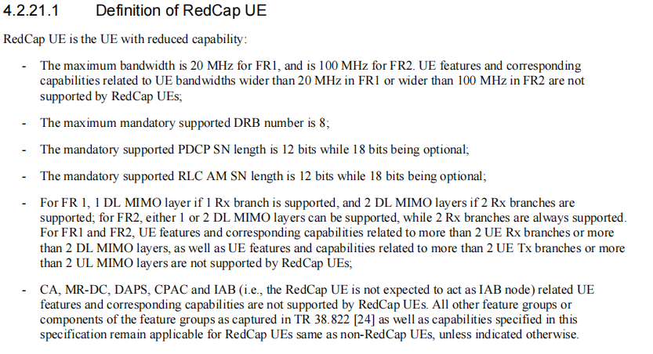  Therefore, the RedCap UE definition in TS38.101-1 should be corrected.  It is proposed to refer the reduced capabilities as specified in TS38.306.
Summary of change: |  | Correction on the RedCap UE definition.
Consequences if not approved: |  | The current RedCap UE definition is unclear.
Clauses affected: |  | 3.1
 |  | Y | N
Other specs |  |  | X | Other core specifications |  |  |  | TS/TR ... CR ...
affected: |  | X |  | Test specifications |  |  |  | TS/TR ... CR ... 38.521-1
(show related CRs) |  |  | X | O&M Specifications |  |  |  | TS/TR ... CR ...
Other comments:
This CR's revision history: |  | This CR is revised from R4-2215908.

<< Start of change >>

3.1 Definitions
For the purposes of the present document, the terms and definitions given in 3GPP TR 21.905 [1] and the following apply. A term defined in the present document takes precedence over the definition of the same term, if any, in 3GPP TR 21.905 [1].
Aggregated Channel Bandwidth: The RF bandwidth in which a UE transmits and receives multiple contiguously aggregated carriers.
Carrier aggregation: Aggregation of two or more component carriers in order to support wider transmission bandwidths.
Carrier aggregation band: A set of one or more operating bands across which multiple carriers are aggregated with a specific set of technical requirements.
Carrier aggregation bandwidth class: A class defined by the aggregated transmission bandwidth configuration and maximum number of component carriers supported by a UE.
Carrier aggregation configuration: A combination of CA operating band(s) and CA bandwidth class(es) supported by a UE.
Con-current operation: The simultaneous transmission and reception of sidelink and Uu interfaces while operation is agnostic of the service used on each interface.
Contiguous carriers: A set of two or more carriers configured in a spectrum block where there are no RF requirements based on co-existence for un-coordinated operation within the spectrum block.
Contiguous resource allocation: A resource allocation of consecutive resource blocks within one carrier or across contiguously aggregated carriers. The gap between contiguously aggregated carriers due to the nominal channel spacing is allowed.
Contiguous spectrum: Spectrum consisting of a contiguous block of spectrum with no sub-block gaps.
Inter-band carrier aggregation: Carrier aggregation of component carriers in different operating bands.
NOTE: Carriers aggregated in each band can be contiguous or non-contiguous.
Intra-band contiguous carrier aggregation: Contiguous carriers aggregated in the same operating band.
Intra-band non-contiguous carrier aggregation: Non-contiguous carriers aggregated in the same operating band.
RedCap UE: The UE with reduced capabilities as defined in clause 4.2.21.1 from TS38.306 [15].
Sub-band: For a UE that supports shared spectrum channel access in wideband operation, a sub-band is the set of RBs within an approximately 20 MHz segment of the channel where the wideband channel is uniformly divided into an integer number of 20 MHz sub-bands. Sub-bands may be separately allocated in uplink and downlink.
Sub-block: This is one contiguous allocated block of spectrum for transmission and reception by the same UE. There may be multiple instances of sub-blocks within an RF bandwidth.
Sub-block bandwidth: The bandwidth of one sub-block.
Sub-block gap: A frequency gap between two consecutive sub-blocks within an RF bandwidth, where the RF requirements in the gap are based on co-existence for un-coordinated operation.
UE transmission bandwidth configuration: Set of resource blocks located within the UE channel bandwidth which may be used for transmitting or receiving by the UE.
Vehicular UE: A UE embedded in a vehicle, permanently connected to an embedded antenna system that radiates externally for NR operating bands.
NOTE: Vehicular UE does not refer to other UE form factors placed inside the vehicle.
Wideband operation: For a UE that supports shared spectrum channel access, wideband operation refers to operation within a channel larger than 20 MHz in which intra-cell guard bands may be configured to distinguish individual RB-sets

<< End of change >>

