**3GPP TSG-****RAN WG4 Meeting** **#103-e R4-2208321  
E-meeting, May 09 – May 20, 2022**

**Agenda item: 9.1.2.1**

**Source:** **CAICT**

**Title: Summary of FR1 MIMO OTA lab alignment results**

**Document for: Discussion**

# 1 Introduction

The NR MIMO OTA WI is scheduled to finalize FR1 MIMO OTA lab alignment and reviewing the PAD measurement results during RAN4 #103e meeting in May 2022 [1].

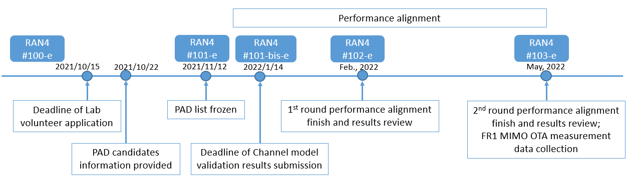

Up to now, 5 labs have completed PAD measurement and submitted lab alignment results [2-6]. The last lab (Apple) has not received the PADs yet due to COVID, and thus is not able to submit the results currently.

This contribution presents a summary and analysis of the submitted PAD measurement results. This contribution can be updated based on discussion outcomes of RAN4 #103e meeting, and will be updated in the future to include Apple’s PAD measurement results.

# 2 Discussion

The reference values and pass/fail limits for FR1 MIMO OTA lab alignment have been discussed in prior RAN4 meetings, the agreements are as below:

**Framework for** **FR1 MIMO OTA lab alignment activity** [7]

* + The reference value of each PAD should be the average of the PAD measurement results submitted on or before 12:00 UTC 30th April 2022, based on the condition at least 3 labs’ results collected. Submission with measurement data after 12:00 UTC 30th April can be considered for lab alignment, but will not change the reference TRMS value.

**Issue 2-1-2: Pass/fail limit for FR1 MIMO OTA lab alignment** [8]

*Agreements:*

The pass/fail limit for lab PAD alignment: the maximum deviation of TRMS between each performance alignment lab and Reference Value

* + Starting point: +/- 0.75MU, i.e., +/- 2.25 dB for band <3GHz and +/- 2.55 dB for band >3GHz.
    - RAN4 aims to minimize the limit into reasonable range based on the collected lab alignment data
  + Further check is allowed after having some PAD test results next RAN4 meeting.

The summary and analysis of the lab alignment results are based on the following conditions:

* The reference value of each PAD at each band is the linear average (in dB) of the PAD measurement results submitted by the 5 labs in [2-6]
* The pass/fail limit for lab PAD alignment is +/- 0.75MU, i.e., +/- 2.25 dB for band <3GHz and +/- 2.55 dB for band >3GHz

Summary of submitted FR1 MIMO OTA lab alignment results are shown in Table 1.

**Table 1. Summary of submitted FR1 MIMO OTA lab alignment results**

|  |  |  |  |  |  |  |  |  |  |  |
| --- | --- | --- | --- | --- | --- | --- | --- | --- | --- | --- |
| **Device** | **Band** | **TRMS measurement result [dBm/30kHz]** | | | | | | **Average approach** | **Reference value** | **Max-Min deviation** |
| **Lab 1** | **Lab 2** | **Lab 3** | **Lab 4** | **Lab 5** | **Lab 6** |
| PAD_n41_1 | n41 | -96.43 | -97.61 | -98.20 | -97.45 | -96.88 | NA | Linear average | -97.31 | 1.77 |
| PAD_n41_2 | n41 | -99.30 | -97.80 | -100.02 | -99.96 | -99.62 | NA | -99.34 | 2.22 |
| PAD_n41_3 | n41 | -96.31 | -97.39 | -97.81 | -96.53 | -96.74 | NA | -96.96 | 1.50 |
| PAD_n78_1 | n78 | -96.02 | -96.54 | -96.44 | -96.10 | -96.53 | NA | -96.33 | 0.52 |
| PAD_n78_2 | n78 | -95.42 | -95.95 | -96.11 | -96.48 | -96.66 | NA | -96.12 | 1.24 |
| PAD_n78_3 | n78 | -99.06 | -97.42 | -99.53 | -99.08 | -99.54 | NA | -98.93 | 2.12 |
| **Device** | **Band** | **TRMS offset [dBm/30kHz]** | | | | | | **Pass/fail limit** | | |
| **Lab 1** | **Lab 2** | **Lab 3** | **Lab 4** | **Lab 5** | **Lab 6** |
| PAD_n41_1 | n41 | 0.88 | -0.30 | -0.89 | -0.14 | 0.43 | NA | +/- 0.75 MU, i.e., +/- 2.25 dB | | |
| PAD_n41_2 | n41 | 0.04 | 1.54 | -0.68 | -0.62 | -0.28 | NA |
| PAD_n41_3 | n41 | 0.65 | -0.43 | -0.86 | 0.43 | 0.22 | NA |
| PAD_n78_1 | n78 | 0.31 | -0.21 | -0.12 | 0.23 | -0.20 | NA | +/- 0.75 MU, i.e., +/- 2.55 dB | | |
| PAD_n78_2 | n78 | 0.70 | 0.17 | 0.01 | -0.36 | -0.54 | NA |
| PAD_n78_3 | n78 | -0.13 | 1.51 | -0.60 | -0.15 | -0.61 | NA |
| **Lab alignment conclusion** | | **[Pass]** | **[Pass]** | **[Pass]** | **[Pass]** | **[Pass]** | **TBA** |  |  |  |

Figure 2 presents the TRMS measurement results, and Figure 3 illustrates the deviations between TRMS measurement values and reference values.

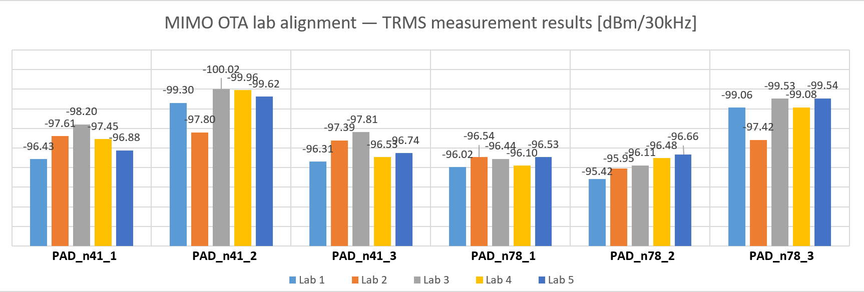

**Figure 1. TRMS measurement results submitted by 5 labs**

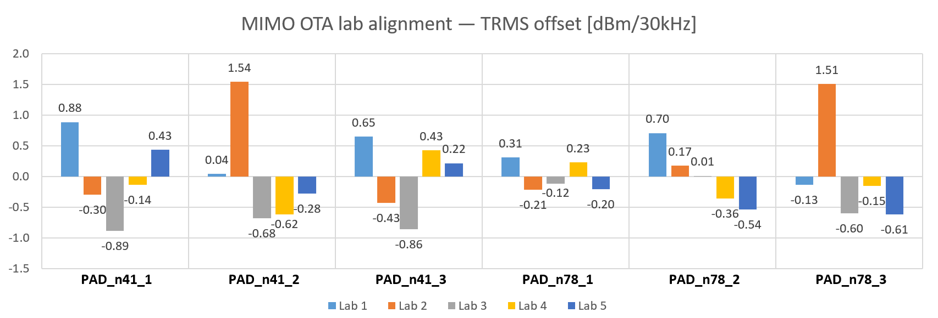

**Figure 2. Deviations between TRMS measurement values and reference values**

**Observation 1: The maximum deviations between TRMS measurement values and reference values are 1.54 dB for band n41 and 1.51 dB for band n78, respectively.**

**Observation 2: 3GPP FR1 MIMO OTA lab alignment among the 5 labs (CAICT, CMCC&BUPT, Huawei, MediaTek, and Xiaomi) can be confirmed based on the following conditions:**

* **The reference value of each PAD at each band is the linear average (in dB) of the PAD measurement results submitted by the above 5 labs**
* **The pass/fail limit for lab PAD alignment is +/- 0.75MU, i.e., +/- 2.25 dB for band <3GHz and +/- 2.55 dB for band >3GHz**

# 3 Conclusion

This contribution presents a summary and analysis of the submitted PAD measurement results.

**Observation 1: The maximum deviations between TRMS measurement values and reference values are 1.54 dB for band n41 and 1.51 dB for band n78, respectively.**

**Observation 2: 3GPP FR1 MIMO OTA lab alignment among the 5 labs (CAICT, CMCC&BUPT, Huawei, MediaTek, and Xiaomi) can be confirmed based on the following conditions:**

* **The reference value of each PAD at each band is the linear average (in dB) of the PAD measurement results submitted by the above 5 labs**
* **The pass/fail limit for lab PAD alignment is +/- 0.75MU, i.e., +/- 2.25 dB for band <3GHz and +/- 2.55 dB for band >3GHz**

# References

1. R4-2120683, “Updated time plan for FR1 lab alignment and requirement development”, CAICT, OPPO, 3GPP RAN4#101e, Nov. 2021.
2. R4-2208320, “CAICT FR1 MIMO OTA lab alignment results”, CAICT, 3GPP RAN4#103e, May 2022.
3. R4-2208412, “PAD testing results of CMCC & BUPT joint lab”, CMCC, BUPT, 3GPP RAN4#103e, May 2022.
4. R4-2207654, “MIMO OTA lab alignment results”, Huawei, 3GPP RAN4#103e, May 2022.
5. R4-2208319, “PAD test results for NR FR1 MIMO OTA lab alignment”, MediaTek, 3GPP RAN4#103e, May 2022.
6. R4-2209514, “3GPP NR FR1 MIMO OTA Lab Alignment Result”, Xiaomi, 3GPP RAN4#103e, May 2022.
7. R4-2203067, “Framework for FR1 MIMO OTA lab alignment activity”, CAICT, 3GPP RAN4#101-bis-e, Jan. 2022.
8. R4-2207300, “WF on NR MIMO OTA”, vivo, CAICT, 3GPP RAN4#102e, Feb. 2022.