**3GPP TSG-RAN WG4 Meeting # 103-e R4-220xxxx**

**Electronic Meeting, May 09 – May 20, 2022**

**Agenda item:** 10.4.4

**Source:** vivo

**Title:** draft WF on DC Location and CA BW class

**Document for:** Approval

# **Topic 1: DC location**

### Sub-topic 1-1 Offset range

**Issue 1-1-4: (refined) How much signalling bits or offset range are needed.**

* Proposals
  + Option 1: 15bits for FR1 & FR2;
    - About +/-250MHz for 15KHz SCS and +/-1000MHz for 60KHz SCS
  + Option 2: Provide specific offset range to RAN2, and leave the detailed bits to RAN2 decision
    - E.g., 600 MHz for FR1 and 2400MHz for FR2
  + Option 3: Reuse 12bits for FR1 & FR2;
  + Option 4: Others

|  |  |  |  |  |  |  |
| --- | --- | --- | --- | --- | --- | --- |
| OFFSET bits | SCS (KHz) | Largest offset (MHz) | Can covered largest FS (MHz) | Largest FS in FR1 spec | Largest FS in FR2-1 spec | [Largest CA bandwidth for FR2-2] |
| 15 bits | 15 | 491 | 983 + 2xCBW | FR1= 600MHz | NA | NA |
| 60 | 1966 | 3932 + 2xCBW | FR2-1= 2400MHz |
| 120 | 3932 | 7894 + 2xCBW | NA | FR2-2 = [2000MHz] |

Note: the largest CA bandwidth for FR2-2 come from WF R4-2202365

* Recommended WF
  + Option 1

### Sub-topic 1-2 Single CC reporting

**Issue 1-2-1: What is the applicability of single CC reporting in Rel-17 DC reporting scheme?**

* Proposals
  + Option 1: Applicable for non-CA case in UL (i.e. UL SCCs not exist or removed by network, only DL CA is configured).
  + Option 2: Applicable in case UL CA are configured, but only one CC is activated. Not applicable for non-CA case in UL, as described in Option 1.
  + Option 3: Applicable for both cases:
    - non-CA case in UL (i.e. UL SCCs not exist or removed by network, only DL CA is configured)
    - UL CA are configured, but only one CC is activated.
  + Option 4: Others
* Recommended WF
  + Option 3

**Issue 1-2-2: Will Rel-15 single CC reporting be still applicable for Rel-17 multiple DC location reporting?**

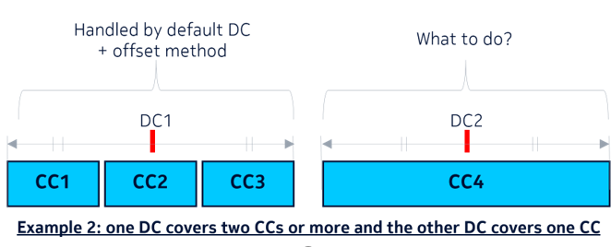

* Proposals
  + Option 1: Only Rel-17 reporting scheme can be used throughout different UL CC groups.
  + Option 2: Rel-15 reporting can also be used in case the UL CC group consists of only one CC.
  + Option 3: Others
* Recommended WF
  + Option 1

### Sub-topic 1-3 Others

**Issue 1-3-1: Whether LO can locate in DL-only spectrum?**

* Proposals
  + Option 1: Yes.
  + Option 2: No
  + Option 3: Others
* Recommended WF
  + TX LO cannot locate in the DL only spectrum
    - the DL only spectrum here means the spectrum described in TS 38.101-2 clause 5.3A.4 and defined by Fsd according to Table 5.3A.4-3.

**Issue 1-3-2: About single CC in one CC group**

* Proposals
  + Proposal 1: Considering current spec restriction (1LO for FR2, maximum 2CCs UL for FR1), limit the CC groups so that each group contains only one UL CC; (Qualcomm: [R4-2207660](https://www.3gpp.org/ftp/TSG_RAN/WG4_Radio/TSGR4_103-e/Docs/R4-2207660.zip))
  + Proposal 2: Clarify CC groups do not always consist of multiple CCs, but it may consist of single CC(Nokia: R4-2208385).
* Recommended WF
  + Proposal 2 is acceptable, but more discussion is needed for proposal 1.

**Issue 1-3-3: About DL&UL fallback behaviour and CC groups. (Qualcomm:** [**R4-2207660**](https://www.3gpp.org/ftp/TSG_RAN/WG4_Radio/TSGR4_103-e/Docs/R4-2207660.zip)**)**

*The question what happens in fallback case here. If one DL CC is deactivated or de-configured, then there is no change in CC grouping since the reason for the second LO was two UL CCs. If the second UL CC is deactivated/deconfigured, the second LO is not needed anymore.*

* Proposals
  + Proposal 1: The fallback case should follow the same CC grouping as the higher level CA configuration where the DC location was signalled for DL CCs.
  + Proposal 2: For the UL CC fallback case, the second LO is not assumed to be present anymore.
* Recommended WF
  + Need more discussion

**Issue 1-3-4: Do we need to inform RAN2 UEs may not have to report all the permutations with DC positions. (Nokia: R4-2208385).**

* Proposals
  + Option 1: Yes
  + Option 2: No
* Recommended WF
  + Need more discussion

# **Topic 2: New CA bandwidth class**

**Issue 2-1-1: How to select the baseline of new CA BW classes and fall back behaviour?**

* Proposals
  + (Modified) Option 2b (Apple):
  + (Modified) Option 2c: (Ericsson’s CR) non-interlaced 100 MHz and 200 MHz.
  + (Modified) Option 3 (Xiaomi’s CR): Define new FBG2 classes V, W, X and Y with associated note 3 as presented in table below.
* Recommended WF
  + Take option 2c as baseline and further discuss the refinement.
  + Option 2c:

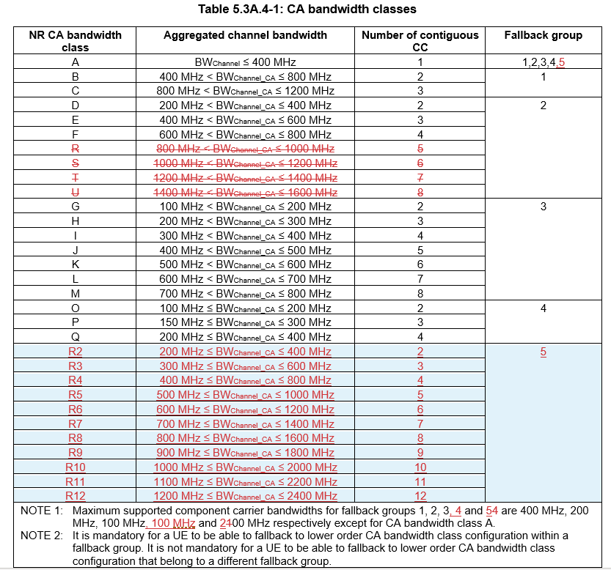

**Issue 2-1-2: (new issue) How to refine the option 2c?**

* Proposals
  + Proposal 1(Xiaomi, ZTE, Apple, ):
    - Retaining R/S/T/U in FBG#2.
  + Proposal 2 (Samsung, MTK):
    - For CA BW class R9, R10, R11, R12 of FBG5, the maximum aggregated BW is limited to 1600MHz in Rel-17.
  + Proposal 3(Qualcomm): Add a clarification in the notes that ‘*explicit indication of support of a BW class in FBG5 does not imply that all possible variants of the lower order BW class must be supported. Only those variants of the lower order BW class that obey fallback rules as described in 38.306 must be supported*’
  + Proposal 4(Qualcomm): Add an IE for the UE to explicitly indicate ‘max Agg. BW capability’ of the UE for any BW class in this FBG. This type of IE, if signaled, would also allow a flexible UE to inform the network that it can support any combination of 100M and 200M non-interlaced channels inside the indicated max. agg. BW, provided the number of CCs is not greater than those associated with the explicitly supported BW class.
  + Proposal 5(Apple):

|  |  |  |  |
| --- | --- | --- | --- |
| NR CA bandwidth class | Aggregated channel bandwidth | Number of contiguous CC | Fallback group |
| A | BWChannel ≤ 400 MHz | 1 | 1,2,3,4,5 |
| B | 400 MHz < BWChannel_CA ≤ 800 MHz | 2 | 1 |
| C | 800 MHz < BWChannel_CA ≤ 1200 MHz | 3 |  |
| D | 200 MHz < BWChannel_CA ≤ 400 MHz | 2 | 2 |
| E | 400 MHz < BWChannel_CA ≤ 600 MHz | 3 |  |
| F | 600 MHz < BWChannel_CA ≤ 800 MHz | 4 |  |
| R | 800 MHz < BWChannel_CA ≤ 1000 MHz | 5 |  |
| S | 1000 MHz < BWChannel_CA ≤ 1200 MHz | 6 |  |
| T | 1200 MHz < BWChannel_CA ≤ 1400 MHz | 7 |  |
| U | 1400 MHz < BWChannel_CA ≤ 1600 MHz | 8 |  |
| G | 100 MHz < BWChannel_CA ≤ 200 MHz | 2 | 3 |
| H | 200 MHz < BWChannel_CA ≤ 300 MHz | 3 |  |
| I | 300 MHz < BWChannel_CA ≤ 400 MHz | 4 |  |
| J | 400 MHz < BWChannel_CA ≤ 500 MHz | 5 |  |
| K | 500 MHz < BWChannel_CA ≤ 600 MHz | 6 |  |
| L | 600 MHz < BWChannel_CA ≤ 700 MHz | 7 |  |
| M | 700 MHz < BWChannel_CA ≤ 800 MHz | 8 |  |
| O | 100 MHz ≤ BWChannel_CA ≤ 200 MHz | 2 | 4 |
| P | 150 MHz ≤ BWChannel_CA ≤ 300 MHz | 3 |  |
| Q | 200 MHz ≤ BWChannel_CA ≤ 400 MHz | 4 |  |
| V2 | 200 MHz ≤ BWChannel_CA ≤ 400 MHz | 2 | 5 |
| V3 | 300 MHz ≤ BWChannel_CA ≤ 600 MHz | 3 |
| V4 | 400 MHz ≤ BWChannel_CA ≤ 800 MHz | 4 |
| V5 | 500 MHz ≤ BWChannel_CA ≤ 1000 MHz | 5 |
| V6 | 600 MHz ≤ BWChannel_CA ≤ 1200 MHz | 6 |
| V7 | 700 MHz ≤ BWChannel_CA ≤ 1400 MHz | 7 |
| V8 | 800 MHz ≤ BWChannel_CA ≤ 1600 MHz | 8 |
| V9 | 900 MHz ≤ BWChannel_CA ≤ 1800 MHz | 9 |
| V10 | 1100 MHz ≤ BWChannel_CA ≤ 2000 MHz | 10 |
| V11 | 1300 MHz ≤ BWChannel_CA ≤ 2200 MHz | 11 |
| V12 | 1500 MHz ≤ BWChannel_CA ≤ 2400 MHz | 12 |
| NOTE 1: Maximum supported component carrier bandwidths for fallback groups 1, 2, 3, 4 and 5 are 400 MHz, 200 MHz, 100 MHz, 100 MHz and 200 MHz respectively except for CA bandwidth class A. For CA bandwidth classes of fallback group 5, requirements apply for non-interlaced 100 MHz and 200 MHz channel bandwidths (each CA bandwidth class consisting of up to two contiguous sub-blocks each with component carriers of a single channel bandwidth).  NOTE 2: It is mandatory for a UE to be able to fallback to lower order CA bandwidth class configuration within a fallback group. It is not mandatory for a UE to be able to fallback to lower order CA bandwidth class configuration that belong to a different fallback group. | | | |

* + Proposal 6 (Nokia): Updating NOTE 2 as follows:
    - NOTE 2: It is mandatory for a UE to be able to fallback to lower order CA bandwidth class configuration within a fallback group that results in a release of at least one component carrier. It is not mandatory for a UE to be able to fallback to lower order CA bandwidth class configuration that belong to a different fallback group.
* Recommended WF
  + Need more discussion