3GPP TSG-WG3 Meeting #Ad Hoc meeting R3-101958
June 29 – July 1, 2010
Beijing, P. R. China

Title: [DRAFT] LS on OAM security and OAM connection issues of RN
Release: Rel-10
Work Item: Relay

Source: Huawei
To: 3GPP TSG SA WG3, 3GPP TSG SA WG5
Cc: 3GPP TSG RAN2

Contact Person:

Name: Wang Yan
Tel. Number: 86-10-82836708

E-mail Address: wangyan1013@huawei.com

Attachments: None

1. Overall Description:
Relay (RN) OAM was discussed in RAN3 Adhoc Beijing meeting. RAN3 took the working assumption of Relay OAM architecture reflected in the figure below:
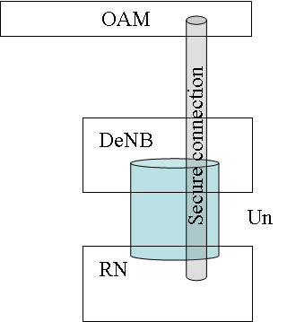
Figure 1 Relay OAM architecture.
The RN has a direct secure connection to its OAM thought the Donor eNB (DeNB may be from a different vendor).This IP transport connection between a RN and its OAM is provided by the DeNB by the mean of the Un Radio interface.

OAM security: it is assumed by RAN3 that’s RN OAM security could be considered equivalent to eNB OAM security. When the secure connection between the RN and its OAM has been established, Relay OAM information will be transported over the secure IP connections; the RN receives commands, configuration data and software downloads (e.g. for equipment upgrades), the RN sends alarms and traffic counter information to its OAM system

OAM connection:
- To provide IP connection over Un interface RAN3 discussed 2 possibilities
  - Establish one or more dedicated OAM Un Bearer
  - Reuse the existing Un Bearer setup to provide IP connection needed for X2/S1 interface between the DeNB and the RN

Question1: Is there some specific requirement on transport of OAM information over IP which justify a dedicated IP connection (i.e. a dedicated OAM Un Bearer) or this IP connection may be shared (i.e. reuse the S1/X2 IP connectivity)?

- It is assumed by RAN3 that’s the criticality and delay sensitivity are not same between OAM alarms, traffic counters and software download. RAN3 thinks there is no need to transport OAM counters in real time in the opposite of the alarms which shall be transported in real time.

Question 2: According to theses assumptions, is there a need to specify additional requirement on low/slow or high/fast transport prioritisation according to the sensitivity of OAM information?

- RAN3 discussed and concluded there is no need to specify a new QCI for OAM signalling.

2. Actions:
To SA3 group.
ACTION: RAN3 invites SA3 to take the above into consideration. RAN3 kindly asks SA3 to indicate if there are any additional security requirements for RN OAM connections.

To SA5 group.
ACTION: RAN3 invites SA5 to take the above into consideration, and kindly asks SA5 to provide input to the two OAM connection questions.

3. Date of Next TSG-WG3 Meetings:
TSG-WG3 Meeting #69 23rd – 27th August 2010 Madrid, Spain.
TSG-WG3 Meeting #69bis 11th – 15th October 2010 Xi’An, P.R. China.

