3GPP TSG-RAN WG3 #109-e R3-20XXXX
17-28 Aug 2020
Online

Agenda item: 31.3.5
Source: ZTE
Title: Management based MDT should not overwrite signaling based MDT
Document for: Discussion and Approval

Introduction
MDT for inactive and idle UE is a left issue for NR MDT.
It is confirmed that the principle that “management based MDT should not overwrite signaling based MDT” is valid for all single connection and EN-DC scenarios
Continue discussion on network-based solution as Rel-16 correction
Possible solutions which have been discussed:
1) For Inactive UEs: A solution can be based on, but not limited to, signaling, from old Serving NG RAN node to new Serving NG RAN node, of an indication of an active Signaling Based Logged MDT configuration at the UE
2) For Idle UEs: A solution can be based on, but not limited to, signaling, from AMF to new Serving NG RAN node. To be continued...
This contribution provides our view on this aspect and provide our solution.

Discussion
During the discussion in Rel-16 NR_SON_MDT, there are multiple solutions for UE in RRC_INACTIVE and for UE in RRC_IDLE. These solutions list below:
For UE in RRC_INACTIVE:
RRC_INACTIVE_Solution 1: An indicator from old NG RAN node to new NG RAN node.
RRC_INACTIVE_Solution 2: Duration timer from old NG RAN node to new NG RAN node
RRC_INACTIVE_Solution 3: An absolute time from old NG RAN node to new NG RAN node
RRC_INACTIVE_Solution 4: Via O&M coordinate.

For UE in RRC_IDLE:
RRC_IDLE_Solution 1: An indicator from AMF to new NG RAN node
RRC_IDLE_Solution 2: Via O&M coordinate.
RRC_IDLE_Solution 3: Management based logged MDT will not triggered for a UE until UE’s stay in the RAN node exceed 120 minutes.

In addition to the solution analysis, it is necessary to consider other related questions, the answer of the question may impact solution selection , these questions including:
1: Can management based MDT overwrite management based MDT?
2: Can signalling based MDT allowed to overwrite management based MDT?
3: How to deactivate a signaling based logged MDT session?
4: Does signalling based MDT overwrite previous signalling based MDT?
5: Can the RAN node obtain information about whether the UE has configured signalling based logged MDT from the core network (e.g. AMF) ?
6:Can the RAN node obtain information about whether the UE has configured signalling based logged MDT from the UDM?
7: Can the RAN node obtain information about whether the UE has configured signalling based logged MDT from the Management system?
8:Logging duration time mismatch between NM/5GS and UE issue for UE in RRC_INACTIVE state.

Can management based MDT overwrite management based MDT?

TS 32.422

4.1.1.9 NG-RAN activation mechanisms

4.1.1.9.1 General
In NG-RAN the Management Based Trace Activation can be fulfilled with the NG-RAN Cell Traffic trace functionality. In this case the Trace Session Activation is done to one or a list NG-RAN cells within one NG-RAN node, where Trace Session is activated.

It is specified in SA5 that management based MDT is only applicable for the cell in one NG-RAN node. Therefore, there is no scenario for a RAN node ‘s Management system trigger trace to overwrite a management based MDT from other RAN node.
Observation 1: In NR, management based MDT will not overwrite management based MDT.

Can signalling based MDT allowed to overwrite management based MDT?
TS 32.422

4.1.5 MDT Trace selection conditions
In Immediate MDT, both in case of signalling based and management based MDT trace activation, it is always the network that evaluates all selection conditions for activating the MDT measurements and deactivating the MDT measurements (this evaluation is done continuously during the selected call session). The network activates and deactivates the MDT measurements toward the UE accordingly via RRC.
In Logged MDT and Logged MBSFN MDT, the network configures UEs for MDT tracing that are eligible based on the specified selection criteria. If area based condition is specified in the trace configuration, it is sent to the UE at configuration time and the UE will evaluate the area condition as it moves in the network in idle mode.
Immediate MDT,Logged MDT and Logged MBSFN MDT measurements shall always be configured as separate trace sessions.
In cases of overlapping MDT configuration request the signaling based request shall override the management based request. For logged MDT and Logged MBSFN MDT, prior to re configuring, the eNB shall retrieve the MDT logs from the UE.
Based on the SA5’s specification, signaling based MDT shall overwrite management based MDT.
Therefore signalling based logged MDT overwrite management based logged MDT is not an issue for Rel-16 MDT.
Observation 2: In NR, Signalling based MDT overwrite management based MDT.
Observation 3: Signalling based logged MDT overwrite management based logged MDT is not an issue for Rel-16 MDT.

How to deactivate a signaling based logged MDT session

32.422

4.1.4.13 5GC deactivation mechanisms for MDT
When the AMF receives a Trace Session Deactivation request for an MDT Trace Session of a UE, it shall act according to the following.
In case of an immediate MDT trace session and the UE being in connected mode, the AMF shall send trace session deactivation toward the eNB/gNB. The eNB/gNB shall deactivate the corresponding MDT RRC measurements in the UE and shall discard the given trace session context.
In case of an immediate MDT trace session and the UE being in idle mode, the AMF shall silently discard the stored trace session context.
In case of an immediate MDT trace session and the UE being in inactive state, the AMF that is aware of inactive state shall silently discard the stored trace session context.
Note: Signaling based deactivation does not apply for logged MDT or Logged MBSFN MDT trace sessions. The logged MDT and Logged MBSFN MDT trace session terminates when logging duration expires.

Observation 4: Signalling based logged MDT can be deactivate when logging duration timer expired.

Does signalling based MDT overwrite previous signalling based MDT?
It is clear from SA5 ‘s specification that signalling based MDT shall overwrite management based. The requirement apply for logged MDT. While in specification of TS32.422, there is no description to guarantee signalling based MDT not overwrite previous signalling based MDT.
It is NM or Core network ’s responsibility to guarantee no signalling based MDT overwrite signalling based MDT.

TS 32.422
Figure 4.1.2.17.2.1: Example of MDT activation procedure in 5GC and NG-RAN

Take MDT activation in 5GC and NG-RAN as an example, if a signalling based logged MDT needed to be trigger, Management system sends request message to UDM. The UDM saves the request and waits for the UE into RRC_CONNECTED state. In turn, UDM sends the request to the AMF then to to RAN node.
Since the trace for the UE has been saved in the UDM, when another request from Management system is received in the UDM, the UDM can detect the overlapping request. With logging duration expired , which means the previous logging session is over, UDM can start the second signalling based logged MDT session to the same UE. In this way , signalling based logged MDT will not overwrite the previous one to the same UE.
Observation 5: UDM can detect overlapping signaling based logged MDT and prevent overwrite.
Observation 6: Signalling based logged MDT overwrite signalling based logged MDT is not an issue for Rel-16 MDT.

Based on above background, when considering the leftover R16 issue whether management based logged MDT will not overwrite signalling based logged MDT, it should consider whether RAN node can obtain about whether the UE has configured signaling based logged MDT from the core network or from UDM or Management system.

In any case , can the RAN node obtain information about whether the UE has configured signalling based logged MDT from the core network (e.g. AMF) ?
Inter AMF scenario is supported for signalling based logged MDT, and as described in TS 32.422 below, it is not allowed for UE’s logged MDT ‘s configuration propagate from old AMF to new AMF.

4.5 Handling of MDT Trace sessions at handover for Logged MDT and Logged MBSFN MDT
In logged MDT and Logged MBSFN MDT mode, no propagation of the MDT configuration is performed.

Therefore, it is possible RAN node can not retrieve signalling based logged MDT indication in case of inter-AMF scenario.
In order to acquire the information from UDM, RAN node at first sends request to AMF it affiliated to. If AMF has saved such information, then AMF send response message to RAN node with indicator. If AMF does not has such information, in case of inter-AMF scenario, the AMF acquires information from UDM and sends response message to the RAN node.
Observation 7: RAN node can not obtain information about whether the UE has configured signalling based logged MDT through the in case of inter-AMF scenario.

Can the RAN node obtain information about whether the UE has configured signalling based logged MDT from the UDM?
There is no direct interface between a RAN node with UDM.
Observation 8: RAN node can not obtain information about whether the UE has configured signalling based logged MDT directly from the UDM.

Can the RAN node obtain information about whether the UE has configured signalling based logged MDT from the Management system?
Based on the description from TS 32.422, it is possible that the MDT trace request received from UDM may come from different Management system. For example, the request may come from a EM of one AMF. The EM of the AMF may not directly connect to the RN node.
It is because logged MDT in RRC_IDLE state may move very far (e.g out of the scope one AMF who trigger the MDT trace). The EM of the RAN node may not able to know in which EM trigger the MDT session.
Therefore, it is not reliable for RAN node to depends on management system coordinate to obtain information about whether the UE has configured signalling based logged MDT.
Observation 9: RAN node can not obtain information about whether the UE has configured signalling based logged MDT directly from the Management system coordinate.

Logging duration time mismatch between NM/5GS and UE issue for UE in RRC_INACTIVE state
After UE receives signalling based logged MDT configuration from the network, the UE end the measurement based on logging duration parameter.
TS 37.320
- configuration of the logging duration. This configuration parameter defines a timer activated at the moment of configuration, that continues independent of state changes, RAT or RPLMN change. When the timer expires the logging is stopped and the configuration is cleared (except for the parameters that are required for further reporting e.g. network absolute time stamp, trace reference, trace recording session reference and TCE Id).

TS 32.422

4.1.2.17 5GC and NG-RAN Activation mechanism for MDT
MDT criteria checking on UE:
- For immediate MDT, there is no need to do MDT criteria checking on UE.
- For logged MDT, the area criteria checking will be done at UE side after UE received the MDT configuration criteria.
In case of logged MDT, after UE receives from gNB the configuration parameters via the message RRC Connection Reconfiguration, it detects whether it stays within the specified area. If yes, the UE will execute measurement job. Otherwise UE will do nothing but waiting.
In case of Immediate MDT trace (e.g., IMSI/IMEI/SUPI based selection), the Immediate MDT trace session context of the UE shall be preserved in the network when the UE enters idle mode or inactive mode.
The Logged MDT trace session is preserved in the UE until the duration time of the trace session expires, including also multiple idle periods interrupted by various state transitions such as idle-connected-idle state transitions.

MDT NR also introduces another type of logged MDT which is event based trigger MDT .In this case, the signalling based MDT duration is infinity until UE power off.
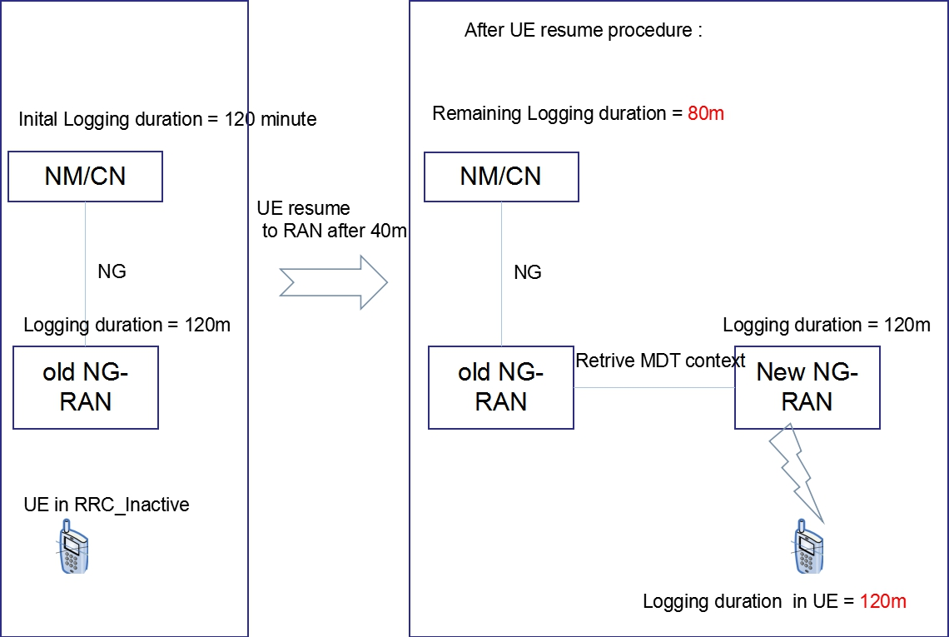
As shown in the above figure, after CN provide MDT configuration to RAN node, the timer is start in CN and/or in NM system. So the CN&NM know when the measurement is end at the UE side and able to trigger another signalling based logged MDT for the same UE.
However, the signalling based MDT is suspended in RAN node due to UE in RRC_INACTIVE state. When UE resume and access to a new RAN node , the New Node retrieve the MDT configuration from the old RAN node and send MDT configuration to the UE. In the procedure, if the source node does not provides remaining timer to the new node, the new node will provide original logging duration parameter to the UE. Then the logging duration is mismatch in UE and Network. In the figure above, the timer in NM/CN is 80 minutes left and the timer in the UE is 120 minutes.
It is possible that MN/CN will trigger another signalling based logged MDT and overwrite the previous on-going one.
RAN2 also need to be informed of remaining timer for inactive UE to update corresponding stage 2 description such as section 5.1.1.4 or 5.4.2 in TS 37.320.
Proposal 1: For XnAP, to introduce remaining timer for logging duration in RETRIEVE UE CONTEXT RESPONSE message.
Proposal 2: Send LS to RAN2 of remaining timer for logging duration for UE in RRC_INACTIVE state.

Solution selection for MDT in RRC_INACTIVE state
 | Description | Pros and Cons
RRC_INACTIVE_Solution 1: | An indicator from old NG RAN node to new NG RAN node. | Can not solve the issue of Logging duration time mismatch between NM/5GS and UE.
RRC_INACTIVE_Solution 2: | Duration timer from old NG RAN node to new NG RAN node | 1:Mitigate the issue of management based MDT overwrite signalling based MDT.  2: Mitigate logging duration time mismatch.
RRC_INACTIVE_Solution 3: | An absolute time from old NG RAN node to new NG RAN node | Same as RRC_INACTIVE_Solution 2.
RRC_INACTIVE_Solution 4: | Via O&M coordinate. | The solution requires EM of new AMF to obtain information of whether the UE has configured signalling based logged MDT from UDM or original EM who configure a logged MDT.  For coordinate with UDM: new interactive between EM and UDM is needed. It is possible EM of new RAN node may not have connection with UDM.  For coordinate with original EM who configure a logged MDT: Not easy for EM of the new AMF to find original EM.

Proposal 3: To select RRC_INACTIVE_Solution 2 as solution for MDT in RRC_INACTIVE state in Rel-16.
Proposal 4: For NGAP, to introduce a logged MDT indicator in INITIAL CONTEXT SETUP REQUEST message.

Solution selection for MDT in RRC_IDLE state
 | Description | Pros and Cons
RRC_IDLE_Solution 1 | An indicator from AMF to new NG RAN node | 1: impact NGAP  2: Interactive between AMF and UDM
RRC_IDLE_Solution 2 | Via O&M coordinate | The solution requires EM of new AMF to obtain information of whether the UE has configured signalling based logged MDT from UDM or original EM who configure a logged MDT.  For coordinate with UDM: new interactive between EM and UDM is needed. It is possible EM of new RAN node may not have connection with UDM.  For coordinate with original EM who configure a logged MDT: Not easy for EM of the new AMF to find original EM.
RRC_IDLE_Solution 3 | Management based logged MDT will not triggered for a UE until UE’s stay in the RAN node exceed 120 minutes | Only impact stage 2 description.

Proposal 5: To select RRC_IDLE_Solution 3 as solution for MDT in RRC_IDLE state in Rel-16. Send LS to RAN2 about impact of stage 2 description.

3. Conclusion
In this contribution , observations and proposals are:
Observation 1: In NR, management based MDT will not overwrite management based MDT.
Observation 2: In NR, Signalling based MDT overwrite management based MDT.
Observation 3: Signalling based logged MDT overwrite management based logged MDT is not an issue for Rel-16 MDT.
Observation 4: Signalling based logged MDT can be deactivate when logging duration timer expired.
Observation 5: UDM can detect overlapping signaling based logged MDT and prevent overwrite.
Observation 6: Signalling based logged MDT overwrite signalling based logged MDT is not an issue for Rel-16 MDT.
Observation 7: RAN node can not obtain information about whether the UE has configured signalling based logged MDT through the in case of inter-AMF scenario.
Observation 8: RAN node can not obtain information about whether the UE has configured signalling based logged MDT directly from the UDM.
Observation 9: RAN node can not obtain information about whether the UE has configured signalling based logged MDT directly from the Management system coordinate.
Proposal 1: For XnAP, to introduce remaining timer for logging duration in RETRIEVE UE CONTEXT RESPONSE message.
Proposal 2: Send LS to RAN2 of remaining timer for logging duration for UE in RRC_INACTIVE state.
Proposal 3: To select RRC_INACTIVE_Solution 2 as solution for MDT in RRC_INACTIVE state in Rel-16.
Proposal 4: For NGAP, to introduce a logged MDT indicator in INITIAL CONTEXT SETUP REQUEST message.
Proposal 5: To select RRC_INACTIVE_Solution 3 as solution for MDT in RRC_IDLE state in Rel-16. Send LS to RAN2 about impact of stage 2 description.

4. References
- R3-204308

